Tyler Korz

CMPEN 472 FA23

HW 10 Report

13 November 2024

Prof Choi

### 

### **Sawtooth Waveform**

* **Mean Value**: 127.5
* **Range**: 0 to 255
* **Characteristics**: This waveform linearly rises from 0 to 255 and then resets to 0, creating a "sawtooth" shape.
* **Frequency**: Observing the pattern, the data shows multiple cycles with a single sawtooth pattern repeating. A full cycle in the sawtooth should complete over a specified number of points, matching the visual representation.

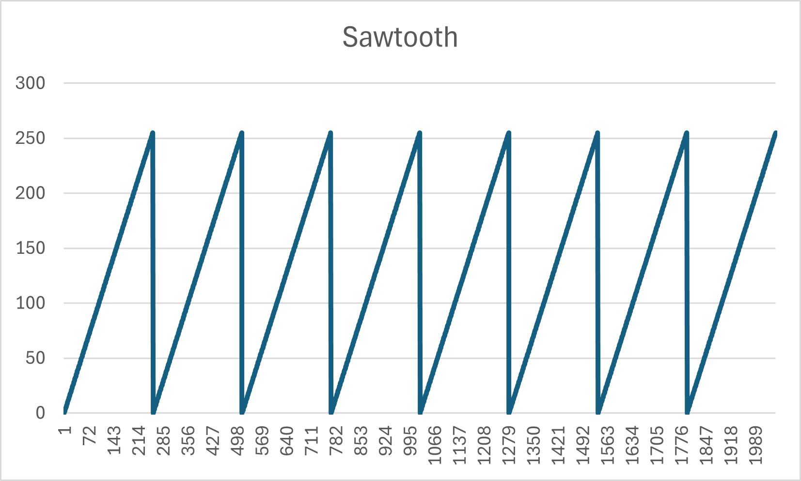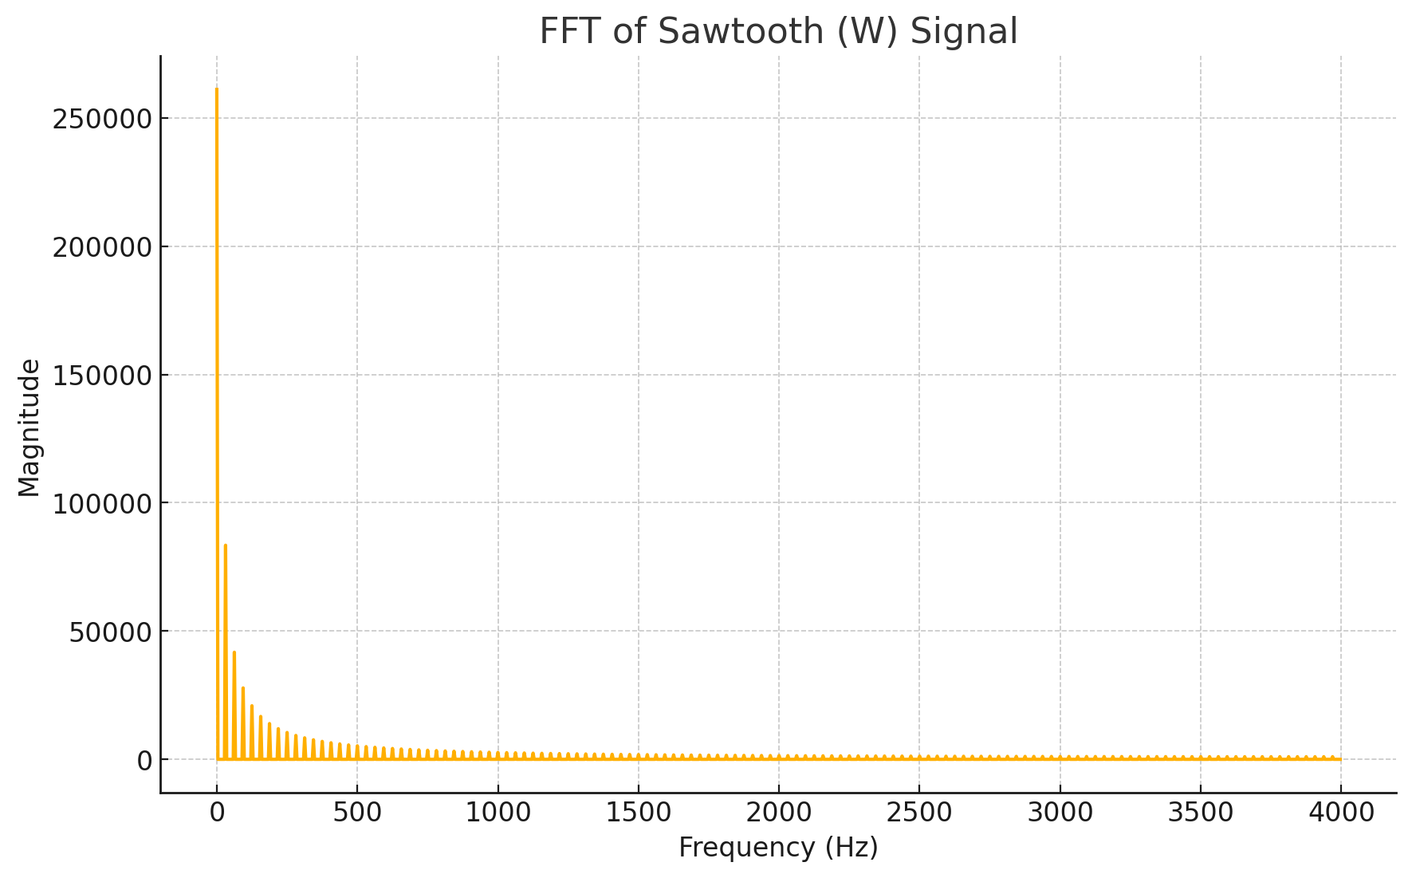

### 

### 

### 

### 

### 

### 

### 

### **Sawtooth 100Hz Waveform**

* **Mean Value**: 125
* **Range**: 0 to 253
* **Characteristics**: This waveform is similar to the sawtooth but oscillates more frequently, indicating a higher frequency (100 Hz).
* **Frequency**: The waveform completes a cycle much more quickly than the regular sawtooth, as expected from the increased frequency.

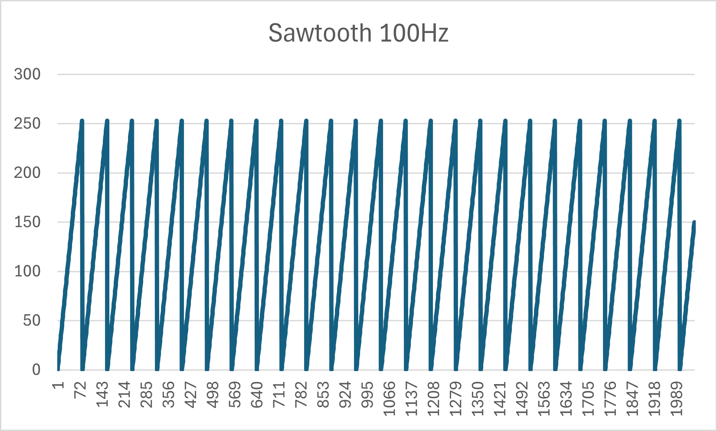

**Triangle Waveform**

* **Mean Value**: 127.5
* **Range**: 0 to 255
* **Characteristics**: The triangle wave oscillates symmetrically between 0 and 255, creating a pattern where it rises and then falls linearly.
* **Frequency**: Each full cycle consists of both a rise and a fall, and the periodic pattern indicates a lower frequency compared to the 100Hz sawtooth wave.

### 

### 

### 

### 

### 

### 

### 

### 

### **Square Waveform**

* **Mean Value**: 127.5
* **Range**: Alternates between 0 and 255
* **Characteristics**: The square wave alternates between 0 and 255, with a "high" and "low" state, representing a digital signal.
* **Frequency**: The waveform shows fewer transitions than the 100Hz version, indicating a lower frequency.

### 

### 

### 

### 

### 

### 

### 

### 

### **Square 100Hz Waveform**

* **Mean Value**: Approximately 125.5
* **Range**: Alternates between 0 and 255
* **Characteristics**: Similar to the regular square wave but transitions between high and low states more frequently, matching the 100Hz frequency.
* **Frequency**: This higher frequency square wave oscillates rapidly, showing more cycles in the same number of data points.

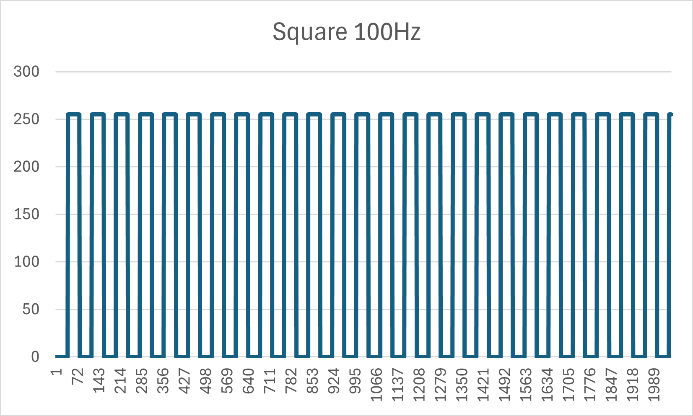

**Sawtooth (W) Signal FFT**:

* The FFT reveals a strong fundamental frequency peak, followed by a series of harmonic peaks that decay gradually.
* This pattern is characteristic of a sawtooth wave, which has a broad harmonic spectrum with harmonics at integer multiples of the fundamental frequency.

**Triangle (T) Signal FFT**:

* The triangle wave FFT shows a fundamental peak and harmonics, but the harmonics decay faster than in the sawtooth wave.
* Triangle waves primarily contain odd harmonics with an amplitude that decreases quadratically, leading to a smoother frequency spectrum.

**Square (Q) Signal FFT**:

* The square wave FFT displays a fundamental peak and a series of odd harmonics with decreasing magnitudes.
* Square waves contain only odd harmonics, with their amplitudes decreasing linearly, resulting in a distinct harmonic pattern.