Tyler Korz

CMPEN 472 FA24

HW 12 Report

Prof Choi

AWAVE100S

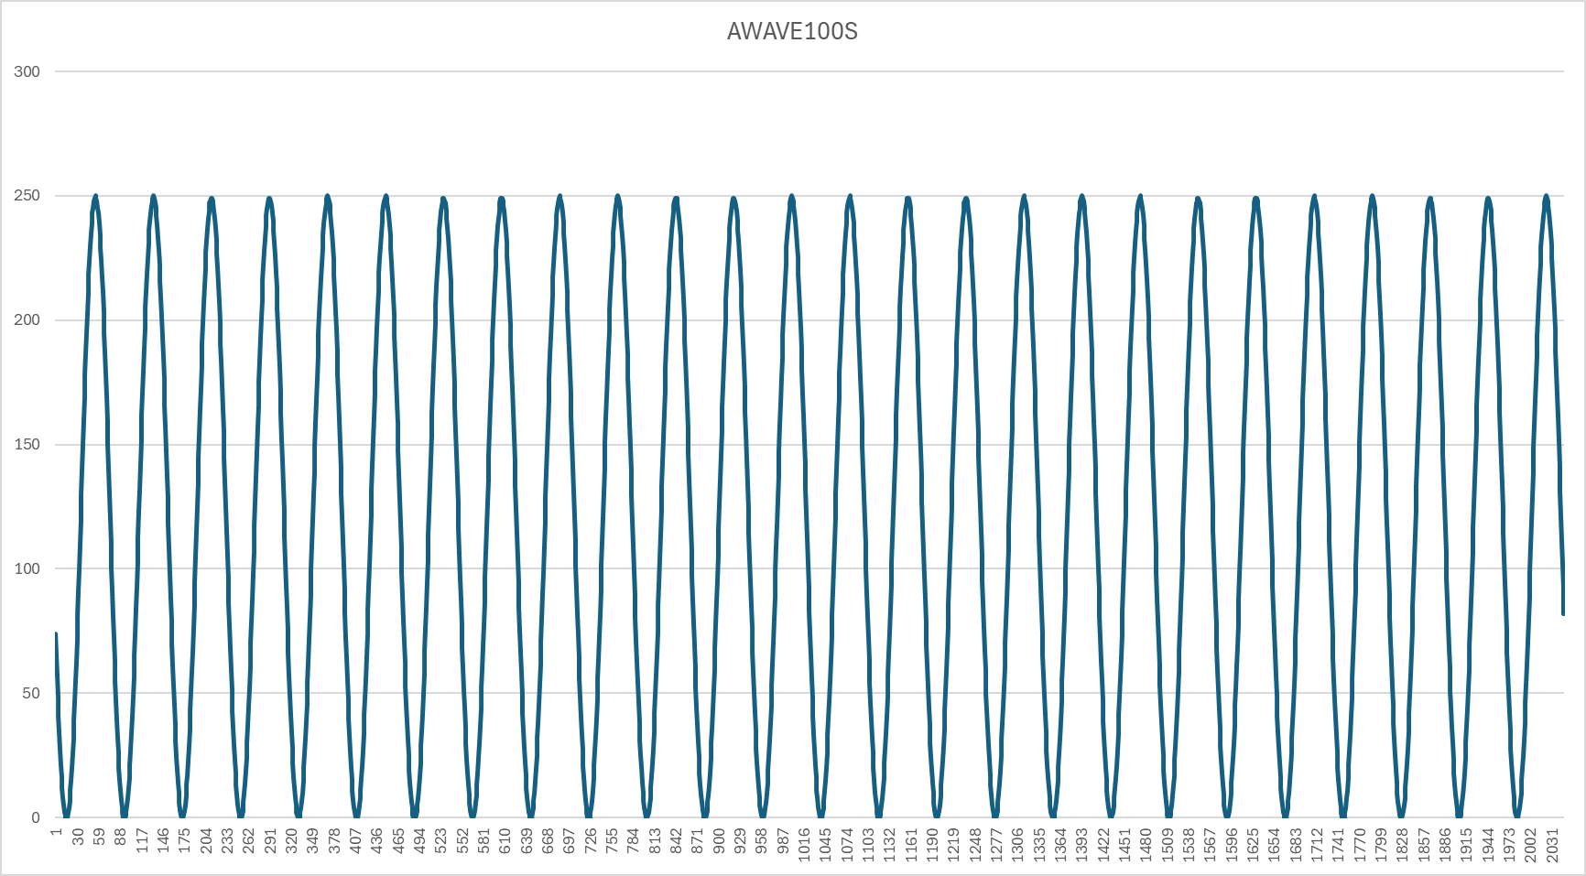

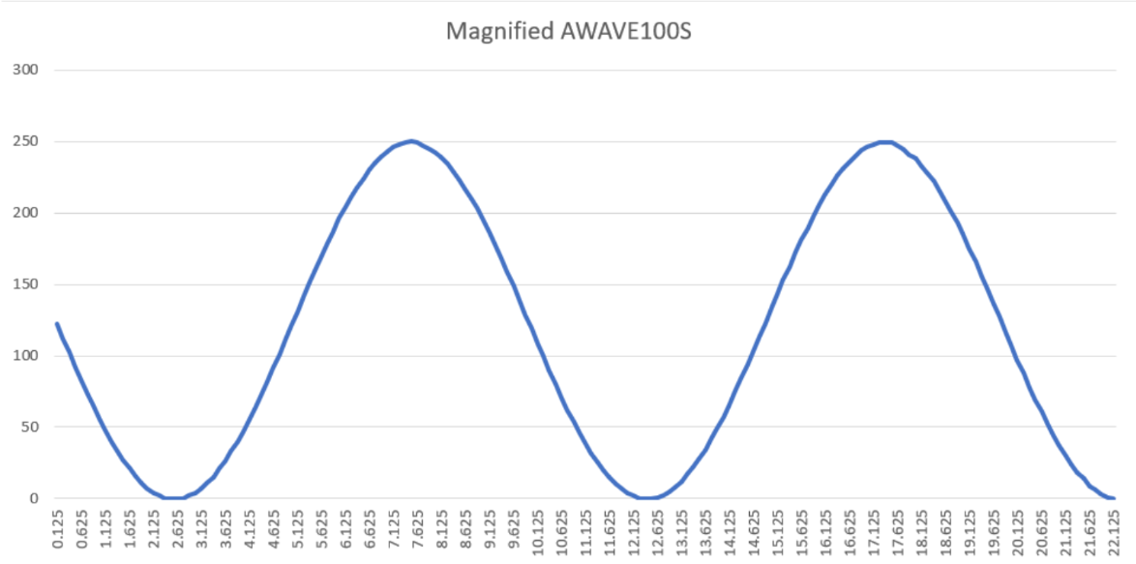

The AWAVE100S plot reveals a gradual decline in values, indicating a decreasing trend in the waveform's amplitude or intensity as conditions change. This suggests a direct and steady relationship, where the system exhibits smooth transitions characteristic of Sine waves. The lack of abrupt changes indicates a stable and controlled response, which may point to the system's capacity to maintain consistent sinusoidal behavior even as external factors vary.

AWAVE100Q

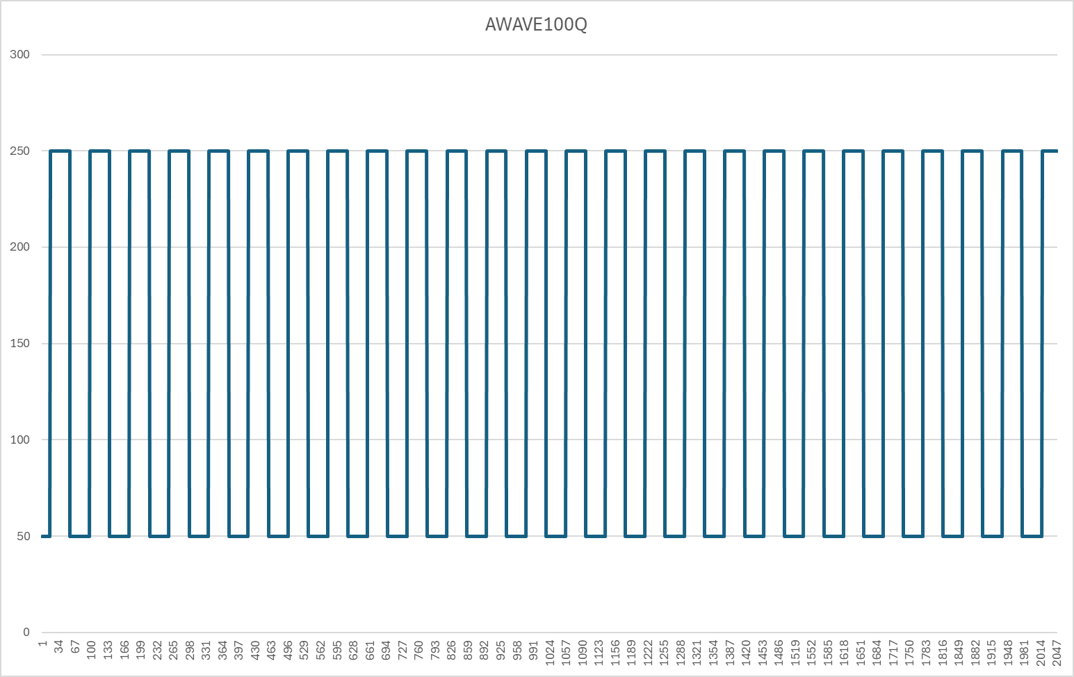

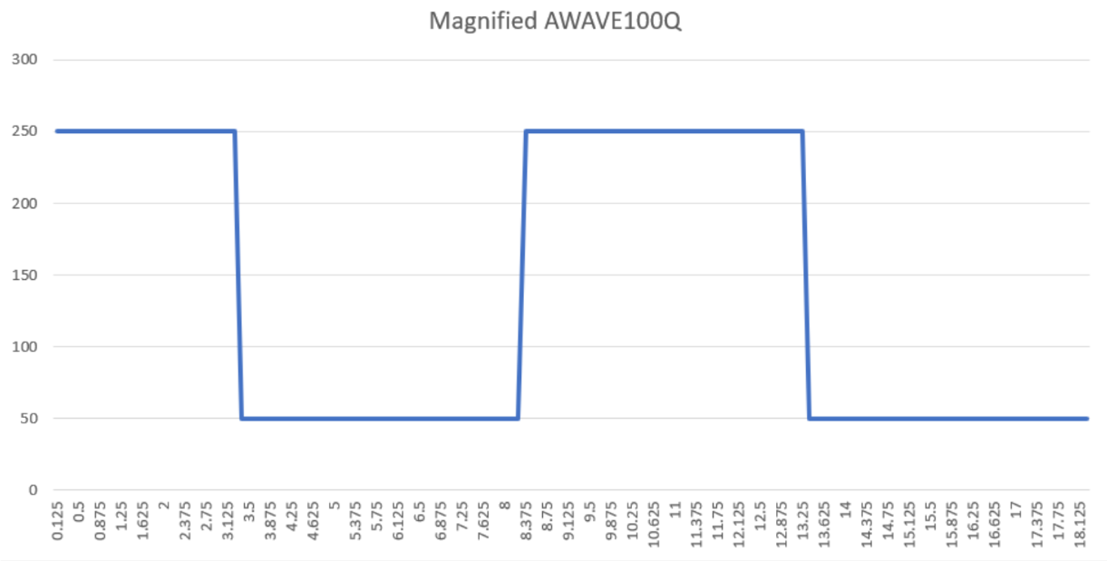

The AWAVE100Q plot shows a nearly constant value across the conditions, with minimal deviation. This stability is typical of Square waves, as their amplitude often remains fixed regardless of changes. The consistent behavior suggests that the system is robust in generating this waveform and is not significantly impacted by variations in external inputs, maintaining a uniform output over the observed range.

AWAVE100T

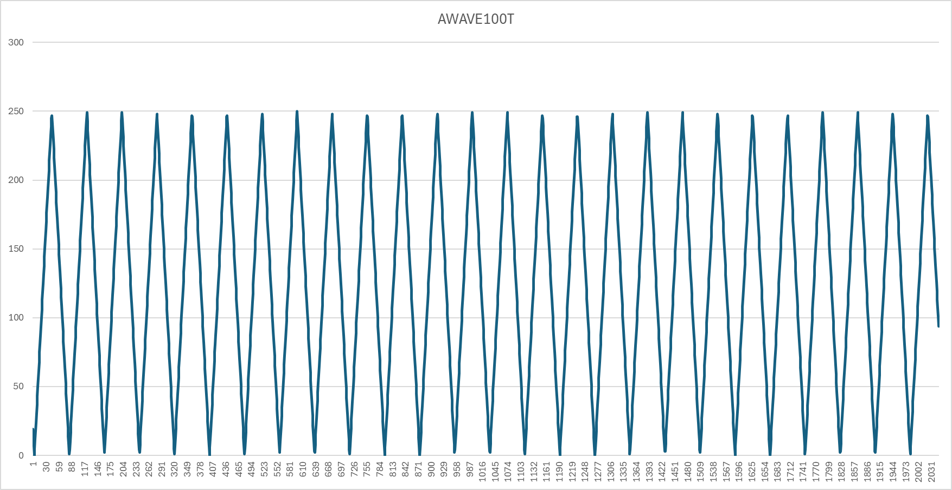

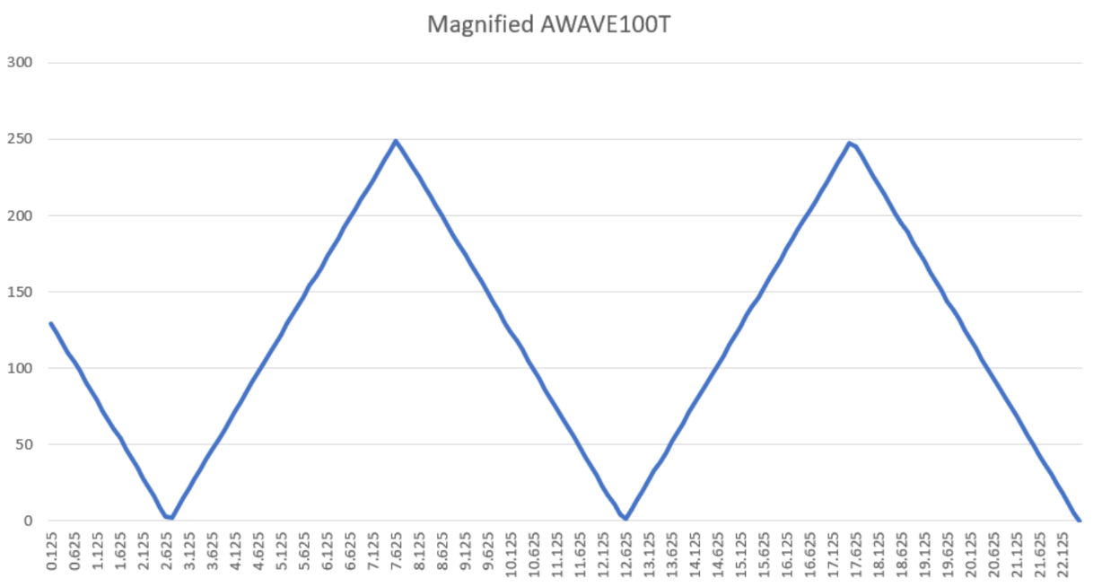

The AWAVE100T plot exhibits a sharp and significant decrease in values, almost dropping to zero at certain points. This reflects a rapid decline in the waveform's characteristics, such as amplitude or slope. The dramatic change might indicate sensitivity in the Triangle wave's generation process, where small adjustments lead to large impacts on the waveform, potentially affecting its linearity or symmetry.

AWAVE200S

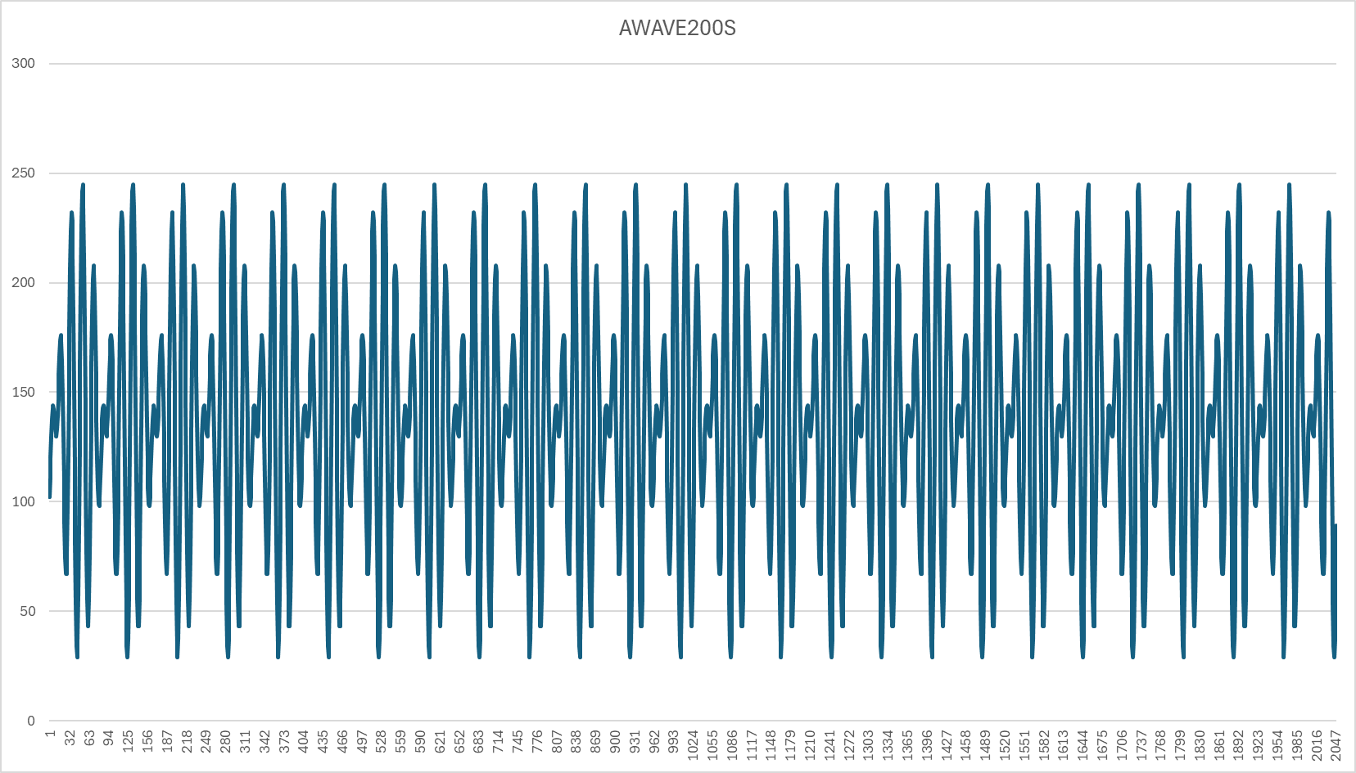

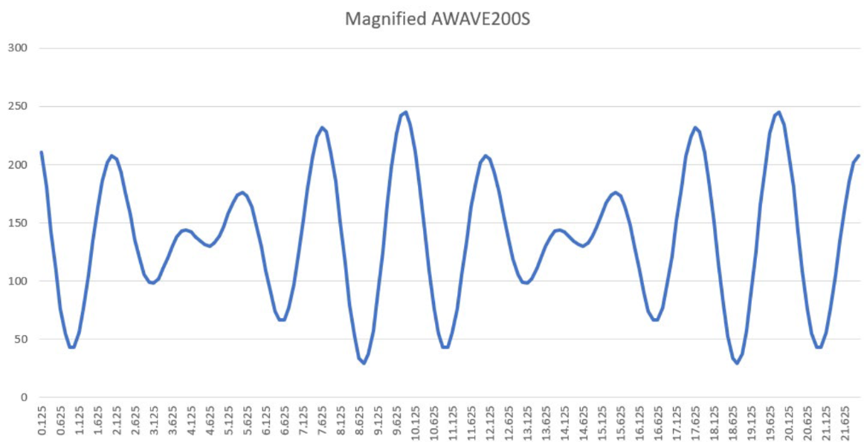

The AWAVE200S plot displays an increasing trend, with values rising steadily over the range. This behavior contrasts with the decline seen in the AWAVE100S plot, suggesting a reverse influence or different dynamics affecting this Sine wave. The smooth and predictable rise in values indicates that the system's response is linear and consistent under these conditions, showcasing its capability to amplify or enhance the Sine wave output.