**Smart Museums**

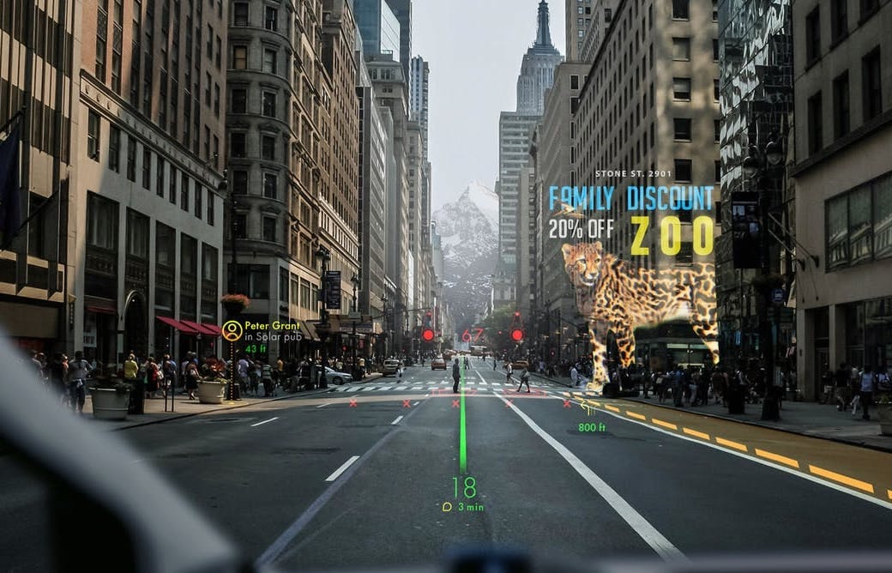

*WayRay’s holographic AR device displays information tailored to drivers and passengers.*

*Credit: WAYRAY*

**Table of content**

1. About Smart Museums
2. What is Augmented Reality (AR)
3. User scenario
4. Used technologies
5. Technical specifications and their implementation
6. Resources
7. System Usability
8. **About Smart Museums**

The development of Smart Museums app started as a group project, meant to encourage teamwork between students and also make them discover and use new technologies. Now we have reached the point where our project has a practical dimension and can be easily integrated in the experience of visiting a local museum. How? Simply view the exhibit you’re interested in through your phone screen and instantly multiple pieces of information will pop up on the screen. The app user will be able to choose between a text description, audio files, browsing through an image gallery of related exhibits, thus finding out even more details of the author’s work. In a society where technology has been gaining ground in more and more areas, we believe our app is a great way to ensure a *friendly* and *smart* experience, regardless the visitor’s age or the contact he has had with similar applications until then.

1. **What is Augmented Reality (AR)**

Augmented reality (AR) is a direct or indirect live view of a physical, real-world environment whose elements are "augmented" by computer-generated perceptual information, ideally across multiple sensory modalities, including visual, auditory, haptic, somatosensory, and olfactory experiences. The overlaid sensory information can be constructive (i.e. additive to the natural environment) or destructive (i.e. masking of the natural environment) and is spatially registered with the physical world such that it is perceived as an immersive aspect of the real environment. In this way, Augmented Reality alters one’s current perception of a real world environment, whereas virtual reality replaces the real world environment with a simulated one. Augmented Reality is related to two largely synonymous terms: mixed reality and computer-mediated reality.

Source: <https://en.wikipedia.org/wiki/Augmented_reality>

It’s only the beginning of the AR computing future. New AR technologies are set to change industries – from construction to retail – and transform the way we interact with the digital world in everyday life.

You might have experienced this on your smartphone if you played the game [Pokémon GO](https://www.pokemongo.com/). Or perhaps you have tried placing furniture in your house using the [IKEA Place](https://www.youtube.com/watch?v=UudV1VdFtuQ) app or the [AR View](https://www.youtube.com/watch?v=uhdOzpblrm0) feature on Amazon’s smartphone app.

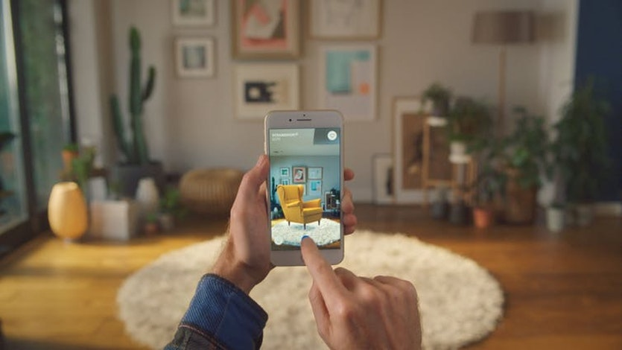

IKEA Place is an augmented reality application that lets people experiment with how furniture would look in their home before they buy it.

But placing objects on the floor near you – whether furniture or monsters – is only a taste of what mainstream AR technologies could offer in the future.

The real potential for this new computing platform comes when computer graphics merge and behave in ways consistent with their physical surroundings.

This is not just a challenge of matching the same lighting, or ensuring physical objects occlude synthetic ones.

User interaction with wearable computers is still tricky, especially when users prefer not to have to hold an input device. And if developers of AR services are not careful to respect the privacy and security desires of their users, they can expect user backlash.

Visual clutter is also an issue. When we make use of virtual augmentation on specific parts of the physical world, there is usually limited real estate. We need solutions that help us manage what we see.

Whoever manages to solve these sorts of challenges first may well own the *de facto* standard of AR computing, and therefore the interface between people and their digital life. It is no surprise that all the major tech companies, and many startups, are rushing to get AR technology to users before anyone else.

Source: <https://theconversation.com/its-time-to-get-ready-for-augmented-reality-89760>

1. **User scenario**

User:

* Waits for the location confirmation;
* Creates an account if it doesn’t exist;
* Logs in with his user name and password;
* Scans the exhibit;
* Has the following options:
  + “Keep Content” – for keeping the menu on the screen while moving the device;
  + “Audio” – for listening an audio file about the exhibit;
  + “Text” – for reading the exhibit’s description; “Gallery” – for looking at pictures with similar exhibits.
  + 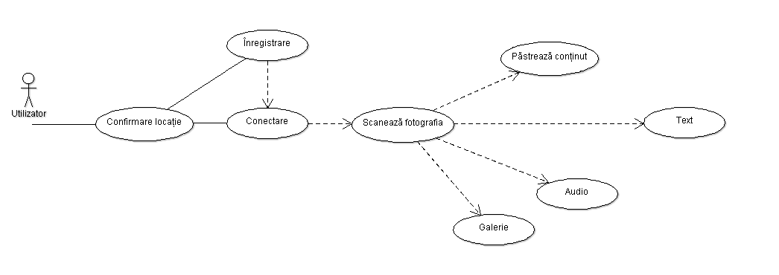“Gallery” – for looking at pictures with similar exhibits.

1. **Used technologies**

In the process of creating the application, we used Vuforia, Unity and a client-server protocol to achieve three of the main functionalities.

Android is a software platform developed by Google. Android is open source and is designed for use on mobile devices, smartphones, tablets, GPS, TV. It provides a rich framework with which to create different applications or games in Java programming language. The framework offers numerous bookstores, documentation, tutorials and an emulator that simulates a mobile device on its own development platform.

**Vuforia SDK**

Vuforia SDK13 is an augmented reality software development kit that uses Computer Vision14 technology to recognize simple 3D images and objects. This image capture capability allows developers to accurately identify real world elements when viewed through a mobile device's camera.

**Unity**

Unity is a gaming platform developed by Unity Technologies, which is mainly used to develop both three-dimensional and two-dimensional video games, as well as computer simulators, consoles, and mobile devices. It was first announced only for OS X at the Apple Developer World Conference in 2005. Since then, it has been extended to target 27 platforms. Six major unit releases were released.

**Client – Server Model**

The client-server model is a distributed application structure or architecture that shares processing between service providers called servers and service requisites called clients. Customers and servers communicate through a computer network, usually via the Internet, with different hardware, but can run on the same physical system. A server (physical) runs one or more server programs that share the existing resources with customers. The client does not share any of its own resources, but uses server features to access server resources. Customers initiate communication with servers and await their messages. In order to maintain the link between the two, regardless of the breaks involved, the session concept is used, which is usually limited in time.

1. **Technical specifications and their implementation**

This role of this part is to create a general image about the application architecture and about its implementation.

The augmented reality deals with the creation of markers that represent a virtual model through which an exhibit or painting is identified. This method of using the markers has been chosen for a simpler and more suggestive use. The Android app is the way to interact with the user, to respond to his commands.

This mode deals with creating activities, manipulating resources, designs and application flow. The most important functionality is to create the content of each activity, for example: we can create an account through which we have access to exhibits and paintings in the museum.

About implementation:

1. Design

The design was made in Adobe Illustrator, which created one frame for each action in the application. Each created component was saved in a “png” format in order to import it into Unity. In Unity based on the exported components of Illustrator, the same frames were available.

For ease of use by all users, we have created a design that is as suggestive and as simple as possible.

The first interaction with the app is represented in Figure 1.1. It shows the login of the user through a user name and a password.

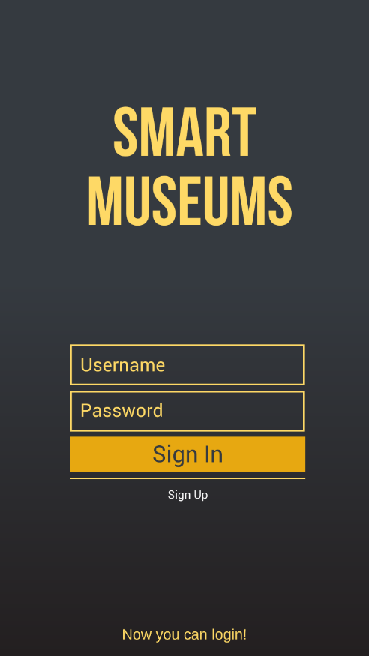

Figure 1.1 Login Screen

The next thing user does is to choose an activity that interests him/her. There are two options that the user can choose: just visit the museum or download information about it.

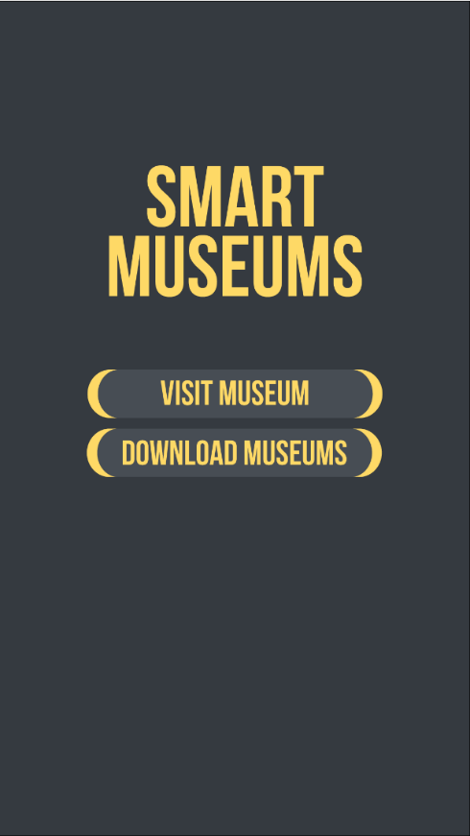

Figure 1.2 Choosing an option

In order to login, the user must:

• Have the location enabled so that the application allows it to log in (Figure 1.3);

• Be within the museum to allow the application to use the information in the museum.

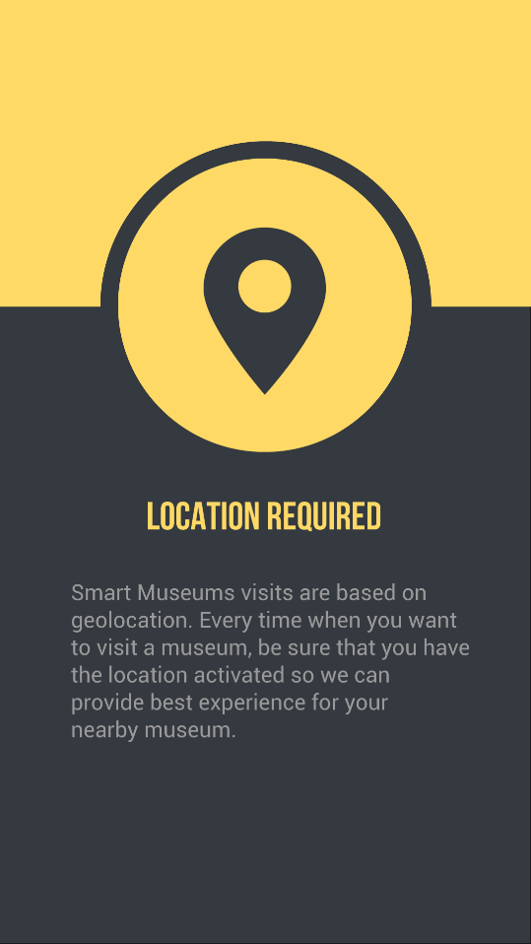

Figure 1.3 Location Issue

Once it enters the application, the camera can recognize the targets using an API from Vuforia. Targets are artworks, sculpture paintings, exhibits from the museum.

  When a target has been recognized, the application shows a number of buttons for doing various activities (Figure 1.4);

At the top of the app, we have the 3 buttons to help you do different things:

• Text if the user wishes to read about the opera / artist;

• Audio if the user wants to hear the text instead of reading it;

• Gallery if the user wants to see pictures of similar exhibits with the recognized one.

At the center of the screen, the user sees the name of the exhibit that was scanned with the phone.

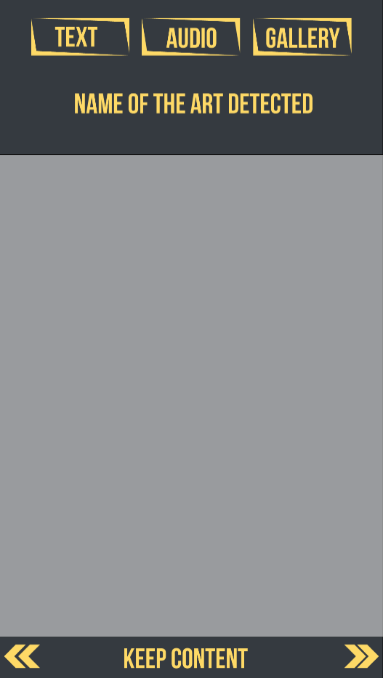

Figure 1.4 The main structure

Below there are two buttons. The left button opens a Quiz. This questions the user about the exhibit and tests his knowledge. The button on the right opens a panel of other works of art similar to the one scanned by the user.

Client-server communication:

The application architecture is based on the client-server model. The two entities have the most effective and fast communication possible.

On the client-server side:

• The server provides information to the client according to requests: login (only the admin of the museum and the user of the application), get-museum (only one museum at a time), get-packet, insert-museum, delete-museum and modify the database with exhibits.

• the C# client is integrated into the Android application and communicates with the C# server to get the information

• The Java application is for the museum admin who can manage the information about the museum (insert, delete, update an exhibit).

The client is a compatible Android app on all mobile devices that have a camera and Android support. User interaction is through the graphical interface. We have classes for Museum, Packet and DataBase that handle objects for their names.

The data is encrypted and compressed for safety and efficiency.

1. **Resources**

For all the needed resources we have used as a reference the Museum “Mihai Eminescu” from Iasşi. We have chosen 10 exhibits and we have created markers for them. Moreover, we have selected pieces of information and photos that are relevant to the exhibits.

For the audio format, we have used the same text. All resources are available in Romanian and English.

1. **System usability**

The System Usability Scale (SUS) (Brooke, 1996) is a questionnaire designed to give a quantitative score of usability, based on a user’s subjective experience with a system. The scale is independent of technology or interface types, so it allows any digital system, or iterations of a single system, to be compared. SUS spans only 10 Likert scale questions, and was described by Brooke (1996) as ‘quick and dirty’. It does not offer an exhaustive evaluation, but “[...] a general indication of the overall level of usability of a system compared to its competitors or predecessors” (p. 3) with low costs, and minimal strain on participants (Brooke, 1996). SUS scores range from 0 to 100 (with 100 being the highest score). A large empirical evaluation of the SUS (based on 2300 individual surveys from over 200 studies) found the scale to be reliable and accurate for measuring usability, and to be useful for iterative design processes. It further introduced a set of acceptability ranges and ‘adjective ratings’ as a tool for interpreting SUS scores. Figure 13 displays the original definition of these ranges, as described by Bangor et al. (2008). Both Brooke (1996) and Bangor et al. (2008) warned against doing analysis on individual SUS questions, as they are very co-dependent. Furthermore, Bangor et al. (2008), recommend that SUS scores should be regarded together with more specific observations and qualitative user statements.

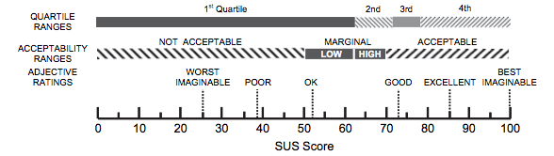 ***Figure 1.*** A comparison of mean System Usability Scale (SUS) scores by quartile, adjective ratings and the acceptability of the overall SUS score  (Bangor et al., 2008, p. 592 ).

According to Brooke (1996), ”respondents should be asked to record their immediate response to each item, rather than thinking about it for a long time” (p. 6), thereby evaluating the system's usability right after use.

Measuring the usability of our application was done in two stages. First measurement was done after we had the first working prototype of the application. The System Usability Scale gave us a score of 76, which according to the Figure 1 above, means a good usability. The second measurement was done after the application integrated all the components specified in the requirements. This time the score was 78, which was not far from the first result. However, the improved mark showed little signs of progress in the good direction.

More testing needs to be done in order to assess the true usability of the application. A big bias that influenced the scores, pushing them higher than in a real scenario. It might have been the users who have done the testing part. The application was tested by the members of our group, directly involved in the development process. Testing needs to be done exclusively on users not involved in the development steps, in a museum scenario where the application is supposed to be used in the first place.