Estimation of the Size of Projects - Function Point Measure .

We suggest that you estimate the size of projects at the outset using Use Cases and/or Entity Diagrams produced as part of your Business Case and Functional Specification.

A couple of observations based on our experience:
- 40 – 50% variation from the initial estimation using usecases
- necessary to do the estimations again at various points in SDLC and see what the variation is
- usecase -> transactions – consistency in usecase modeling would be difficult to achieve
- +/- 15% accuracy when a Researcher conducted this work with algebraic specification
- +-50% with Function Point & Cocomo – with various types of systems from embedded real-time to others

An Unadjusted function point count calculation can be done using Table 1 and Value Adjustment Factor (VAF) below in a simplistic fashion by reporting each of the general system characteristic as average of 0 –6 score of degree of influence (2.5). There is criticism in some circles re: VAF as it is a a subjective measure. Remember always to question a VAF which is high, and a VAF around 1.2 sounds reasonable!

Say, an estimation of resources (time) for a project looks like this:
- Investigation/Requirements/System Specs - 25%
- Development – 50%
- Test – 25%

Say, we determined that for the Investigation/Requirement definition phase, it took 1000 F.P.
and allocate 8-24 hours per F.P. This figure could blow +/- 40%

When the system spec. is ready, we are able to spell out what/how/when. We have the use cases and domain knowledge. At this point, we could do a proper F.P. count and apply estimation models.

The important thing is to start thinking about putting down things which are going to help us measure – right from the Business Case /Use case modeling tasks. Map the things to measure by jotting down the relevant details in a Function Point Count Table ( see Table 1). International Function Point Users Group (IPUG)’s Unadjusted Function Point sheet uses a number of terms although they do talk about grouping these into transactions and data. In the OO and e-world, grouping entities as transactions and data seem appropriate. Mapping from the Use case diagrams to unadjusted function point count is an excellent way of making this calculation happen in a “consistent” way across various groups in a (Uni) Class or in an organization. Mark up the use case diagram as input, output, Query type of Transactions. Count up the database type table information as data. Thus taking care of data and transactions.

A number of things to consider:
- mark up usecases
- use internal logical files (create Table) as the next step after marking up use cases – eg. Create a/c table or use the ones that have been created earlier. Eg. 9 internal logical tables are there for the eg. given below: (see ER Diagram) - all have less than 19 attributes and have been classified as Simple. Data Count is 9x7 = 63.
- Adjustment factors - see Table 3.

Two major criticisms re: this approach are:
- has to be subjective
- adjustment for size

Measurements for size and effort are pulled together here which is not good!
Some researchers suggest that we leave out VAF (Value Adjustment factor). We have not done that. However, we should use a comments column to include justification. Students interested in researching about Estimation metrics and on mapping Function points and Time Estimation should refer to a paper in this area in IEEE, Apr 2001.

Table 1 – Transaction Count Calculation
Transaction List | Transaction type  (I, O, Q) | Complexity  (At this stage, say average – use IPUG table) | Comments
Login | I
Update | I
Delete | I
View about us | Q
View web contents | Q
Submit enrolment form | I
…
Transactions Count (TC) = 18 transactions x 4 = 72 |  |  | 72 (The multiplier by 4 is to stick with standards). Some researchers multiply by 10

In the industry, often, function Points are used with fully developed systems. Consultants use it mainly for productivity assessment and also to check replacement value of systems.

Some points to ponder over:
A telecommunication company report on a project:
- 24 hours per function point – this figure looks lousy
- But it was a great project
A Bank reports on a project:

- 8 hours per function point – tremendous productivity
- But the project was not a success – no documentation and other problems

A simplified function point count is based on two types of analysis: -
- Data from an Entity Relationship diagram, representing internal logical files ie. Each actual entity is one logical file. The complexity of a file/entity is dependant on the number of attributes in each entity. Low complexity =7 (0 to 19 attributes), Average complexity = 10 (20 to 49 attributes) and high complexity = 15 (50 or more attributes). This is the data count (DC). For example, five entities with less than 19 attributes each, give a DC = 5 * 7 = 35.
- Transactions from a Use Case Diagram. Each entity in the use case represents one transaction. We will assume an average complexity of 4. The Transaction count (TC) is given as: TC = 4 * no. of entities
Each project also has a VAF (value adjustment factor) based on other System characteristics of the project. Each characteristic is given a rating from (0 – not important) to (5 – very important); the rating is called the degree of influence (DI).
Table 2 summarises the fourteen system characteristics to be rated:

Table 2 Template Diagram for Counting Function Points

General System Characteristics(GSC’s) | Degree of Influence(DI)  0 (least)- 5 (most)
1 Data communications eg web connection
2 Distributed processing eg client/server
3 Performance eg min. response time
4 Heavily used configuration eg setup likely to change often such as dynamic web content
5 Transaction Rates
6 On line data entry
7 Design for end user efficiency
8 Online updates
9 Complex processing eg calculations/lookups
10. Usable in other applications
11 Installation ease
12 Operational Ease
13 Multiple sites
14 Facilitate change
Total Degrees of Influence (TDI)
Value Adjust Factor (VAF) = (TDI*0.01)+0.65
Data Count (DC)
Transaction Count (TC)

Function Point Count = (DC + TC) * VAF

Example.

The following sample count is based on a project that provides a web site to a school. There is a database to hold some of the web content. There are two user types :- administrator and everybody else. The administrator is able to log in and change some of the database content which is then reflected in the web pages. Everyone else has view only access.

ER diagram showing 9 tables.
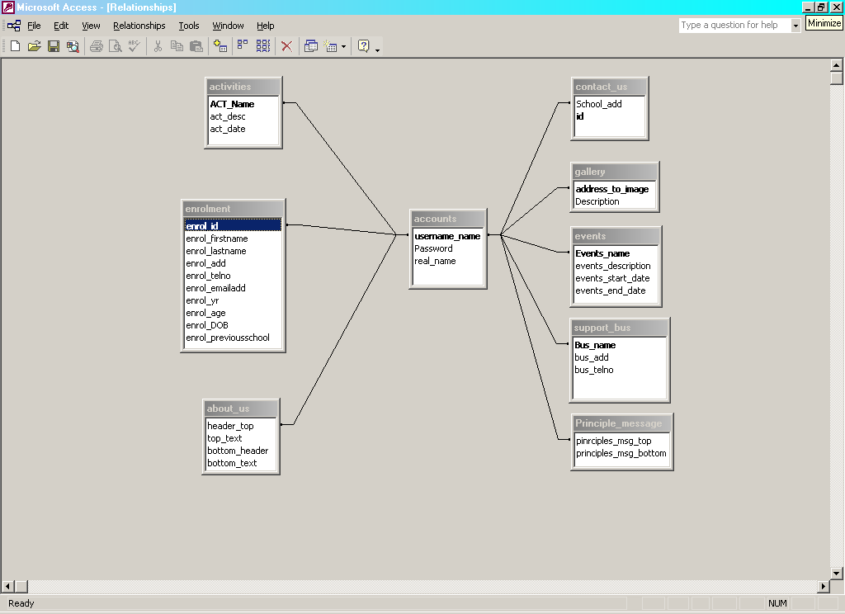

UseCase diagram showing 18 transactions.
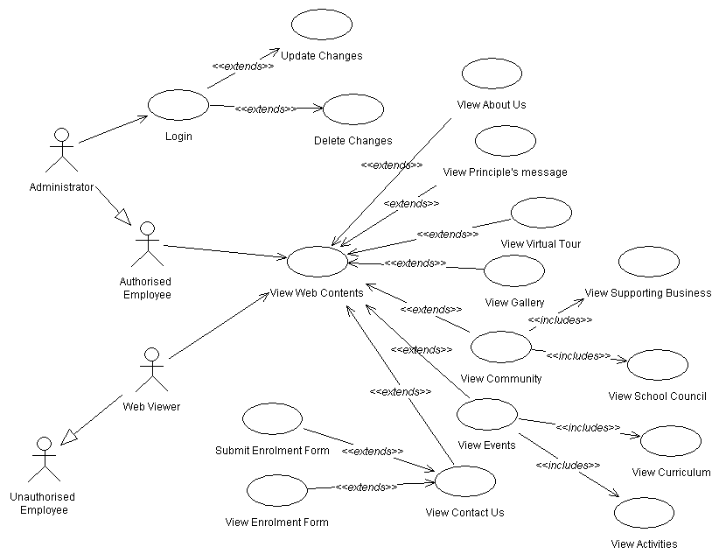
General System Characteristics(GSC’s) | Degree of Influence(DI)  0 (least)- 5 (most)
1 Data communications eg web connection | 1
2 Distributed processing eg client/server | 0
3 Performance eg min. response time | 0
4 Heavily used configuration eg setup likely to change often such as dynamic web content | 3
5 Transaction Rates | 0
6 On line data entry | 3
7 Design for end user efficiency | 5
8 Online updates | 4
9 Complex processing eg calculations/lookups | 0
10. Usable in other applications | 0
11 Installation ease | 2
12 Operational Ease | 4
13 Multiple sites | 0
14 Facilitate change | 3
Total Degrees of Influence (TDI) | 25
Value Adjust Factor (VAF) = (TDI*0.01)+0.65 | (25 * 0.01)+0.65 = 0.9
Data Count (DC) 9 tables | 9 * 7 = 63
Transaction Count (TC) 18 transactions | 18 * 4 = 72
Function Point Count = (DC + TC) * VAF | (63 + 72) * 0.9 = 121.5
Table 3
For this project, the function point count is 122 (rounding 121.5)

Refer to International Functional Point Users Group (IPUG) url: http://www.ifpug.org/

