PROJECT REPORT

# INFO116 Fall 2015

# GROUP ASSIGNMENT



## Group Members:

**#102 #163 #193**

# Introduction

In this report we will go through the different aspects and tasks of the assignment. We want to create an understanding for the choices and results we have made. The report will describe the work process, and then discuss our ontology, SPARQL and also our markup of the targeted html pages. All this will be done with examples, and the files for the different tasks will also be added to the final product.

# Overview of the work process

This report, and all our produced work is the product of three group members. Where the project was done mostly on the university campus at the computer labs, or any room available at the SV building. We used some tools such as Github and Google Drive to share the work, to be able to work from home or at school if we wanted. When we were off campus we communicated through Facebook messenger and used Trello to create a list of work done, and worked that needed to be done. #193 was appointed as the group leader, but the was never any need for a leader as the group very much so worked well. We all contributed in making the ontology where we saw needed. We distributed the articles fairly in the group. #102 was in charge of the ontology and #163 were in charge of the SPARQL as he had most experience in SQL and SPARQL came more natural to him. The remaining work was done together: #102 and #193 were assigned with marking up two articles each and #163 one. #102 marked up *Lecture on Ethics* and *Re-Discovering Wittgenstein*. #193 marked up *Moral Judgement* and *Wittgenstein Early Ethical Thought*. And #163 marked up the last article; *Ethics, Language and the Development of Wittgenstein Thought*. This distribution were used in the Markup in JSON and RDF as well. Each member were assigned one or two SPARQL queries each, but it was more of a group effort to help each other when the queries became challenging. The making of the markup took the most time in this project. We had to redo our ontology a couple of times for this matter, because when we started on the Markup we saw that we did lack quite a bit in the ontology to make the markup somewhat detailed. After we pointed out the lacking content in the ontology we found some interesting queries that we thought could get from our ontology. After each meeting/lab we wrote a log to see what have been done and what we have left. Creating this log also gave us a reminder the next time we met, of what work we wanted to do. This group worked very dynamic, we worked for the majority of time together so that all of the group members were always updated on the other members work. Being together for the most part also was of big help, as through discussion we understood the tasks better and could produce a product all the members were happy with.

# Why was the ontology constructed in the way it was?

The first thing we did, of the four main parts in the project, was the creation of the ontology in Protégé . The first stage was pretty straightforward. We went through the main article and the four Secondary articles and designed the ontology accordingly. We created classes for Person, Source and Subject. We added appropriate Data and Object properties. We tried to cover as much relevant information we were able to find. We then went further. We then added subclasses in these main classes After this stage we decided not to follow the example we got from the Pizza ontology and create our own completely new ontology. One to have a more compatible with the structure of Wittgenstein Lecture on Ethics. We found out later in this project that this was not the best decision, but did not have the time to go back and remake it. As basic we used the pizza ontology as our model from the Owl Tutorial and decided to follow its naming convention. This is why all out named are Like_this, classes starting with a capital letter following with a underline with lower case letter. Just like in the pizza ontology about properties, we decided for more verbose way of naming our predicates which include verbs for example isWrittenby, haveWritten, refersTo etc. This style is more or less self-explanatory and closer to the normal way of speech.

under Person we have the subclass Author were all the members are the one who have been writing the articles. Under Source we added subclasses as Chapter, Primary_source and Secondary_source. The subclass Chapter contains all the chapters in the differents articles and mention the key word of every chapters. The primary_source have another subclass that we named Wittgenstein_source, with another subclass of the article Wittgenstein have written. We found out later that the wittgenstein_source could easily be switched out and only have Primary_source. The subclass Secondary_source lies all the articles that refers to the main articles of wittgenstein. This hierarchy does not have any unnecessary subclasses as we saw in Primary_source. On of the most important subclasses under Source that we used frequently was Issue. Where *Issue*  were contained with all the key word in each articles. We made the haveWritten and isWrittenBy inverse because if the Author have written an articles, then the articles is written by that Author.

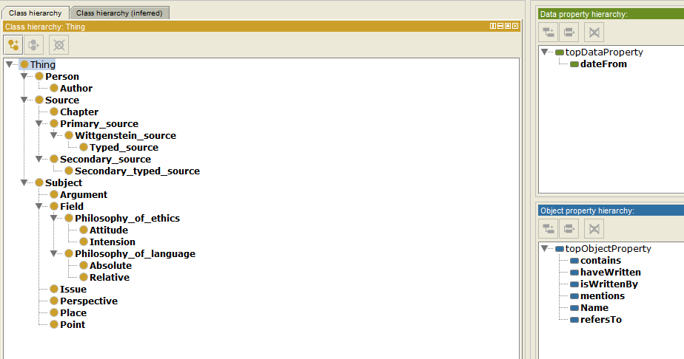

# Markup

After we had made the ontology we could start annotating the HTML-pages. The first thing we had to do then was to learn how to annotate HTML-pages. And after looking at different guides and playing around a bit with RDFA.info/play we thougt we had got the hang of it so we could start actually working on the texts. We chose to annotate the original HTML-pages of the articles instead of just copying the text into a new HTML-document because we thought that was what we were supposed to do. This caused a bit of extra frustration since some of the pages had a terrible HTML and we actually had to use time to fix it up and make it more readable before we could add any markup.

When we finally were ready to start on the markup we started by creating the JSON part for all of the articles. And when that was done we started on annotating the different articles. But after we had annotated a couple of them we realised that we had done it in slightly different ways so we had to discuss what we had done and why so we could agree on one way to do it. And then change the already annotated texts so all of them were annotated in the same way.

After that we thought we were done with the markup, but we discovered a better way to handle the chapters, so we redid the markup once again. But since we already had marked up the HTML-pages it did not take very much time to update it. In the end we put a couple of the pages into RDFA/Play to get some pretty graphs for this report.

## Extracted data using RDFa / Play​:

Moral Judgement:

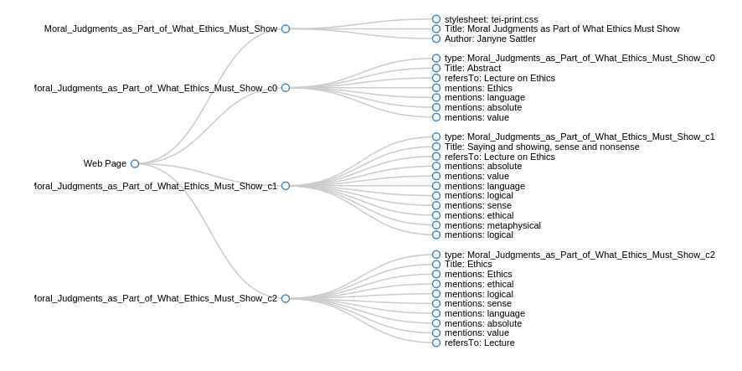

Ethics, Language and the Development of Wittgensteins Thougts in Ms139a:

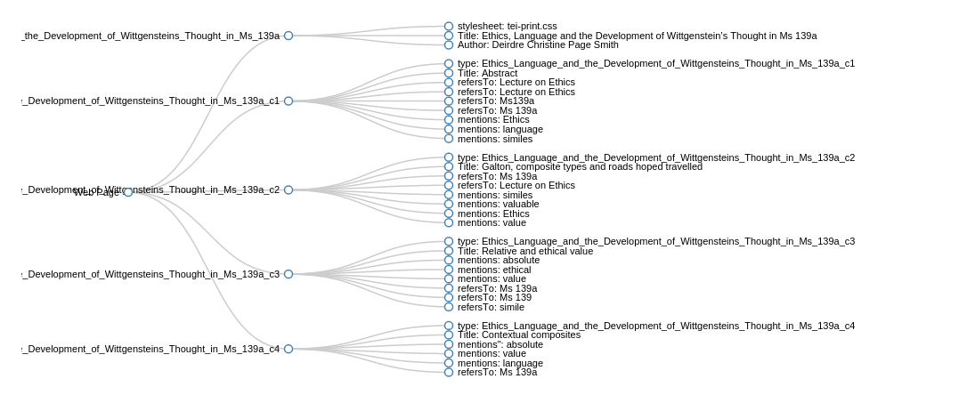

## 

## What can the web site do with the added semantics?

With our added semantics, the websites can basically answer basic and some novite queries about the articles. Who that for an example mentions the word simile in their article. All the author with the article name they are written and the date it have been written. Find out what article that have been written by an author and the date it have been written. What Author that have written an article that refers to another article with the name of that Author. The last queries we made was, what chapter that does not contain the keyword *language,* sorted by source.

# SPARQL queries

One task asked us to create five non trivial SPARQL queries. Underneath this paragraph you can see all the queries we created. The source for the queries were of the ontology we created. Coming up with non trivial queries created some issues for the group. Our imagination combined with our knowledge of SPARQL decided that the queries we created was the most non trivial queries we managed to create.

PREFIX rdf: <http://www.w3.org/1999/02/22-rdf-syntax-ns#>

PREFIX owl: <http://www.w3.org/2002/07/owl#>

PREFIX rdfs: <http://www.w3.org/2000/01/rdf-schema#>

PREFIX xsd: <http://www.w3.org/2001/XMLSchema#>

PREFIX wit: <http://uib.no/INFO116/wittgenstein#>

SELECT ?author ?source

WHERE {

?author a wit:Author.

?source wit:isWrittenBy ?author.

?source wit:mentions

<http://uib.no/INFO116/wittgenstein#simile>.

}



PREFIX rdf: <http://www.w3.org/1999/02/22-rdf-syntax-ns#>

PREFIX owl: <http://www.w3.org/2002/07/owl#>

PREFIX rdfs: <http://www.w3.org/2000/01/rdf-schema#>

PREFIX xsd: <http://www.w3.org/2001/XMLSchema#>

PREFIX wit: <http://uib.no/INFO116/wittgenstein#>

SELECT ?author ?source ?date

WHERE {

?author a wit:Author.

?source wit:isWrittenBy ?author.

?source wit:dateFrom ?date

}

ORDER BY ?date

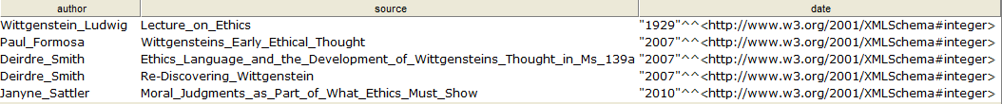

PREFIX rdf: <http://www.w3.org/1999/02/22-rdf-syntax-ns#>

PREFIX owl: <http://www.w3.org/2002/07/owl#>

PREFIX rdfs: <http://www.w3.org/2000/01/rdf-schema#>

PREFIX xsd: <http://www.w3.org/2001/XMLSchema#>

PREFIX wit: <http://uib.no/INFO116/wittgenstein#>

SELECT ?article ?date

WHERE {

?article wit:isWrittenBy

<http://uib.no/INFO116/wittgenstein#Deirdre_Smith>.

?article wit:dateFrom ?date.

}



PREFIX rdf: <http://www.w3.org/1999/02/22-rdf-syntax-ns#>

PREFIX owl: <http://www.w3.org/2002/07/owl#>

PREFIX rdfs: <http://www.w3.org/2000/01/rdf-schema#>

PREFIX xsd: <http://www.w3.org/2001/XMLSchema#>

PREFIX wit: <http://uib.no/INFO116/wittgenstein#>

SELECT ?articleWriter ?article ?source ?sourceWriter

WHERE {

?article wit:isWrittenBy ?articleWriter.

?article wit:refersTo ?source.

?source wit:isWrittenBy ?sourceWriter

}



PREFIX rdf: <http://www.w3.org/1999/02/22-rdf-syntax-ns#>

PREFIX owl: <http://www.w3.org/2002/07/owl#>

PREFIX rdfs: <http://www.w3.org/2000/01/rdf-schema#>

PREFIX xsd: <http://www.w3.org/2001/XMLSchema#>

PREFIX wit: <http://uib.no/INFO116/wittgenstein#>

SELECT ?chapter ?source

WHERE {

?source wit:contains ?chapter.

FILTER NOT EXISTS {

?chapter wit:mentions <http://uib.no/INFO116/wittgenstein#language>

}

}

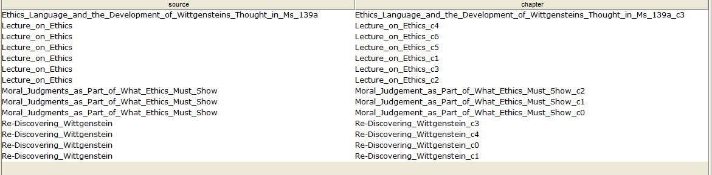

# Used tools

**RDFa / Play**

<http://rdfa.info/play/>

**Trello**

<https://trello.com/>

**Oxygen**

<https://www.oxygenxml.com/>

**Google Drive**

<https://www.google.com/drive/>

**SourceTree**

<https://www.sourcetreeapp.com/>

**Github**

<https://github.com/>

# Conclusion

To conclude the report, we will do a short sum up of the work done. The ontology we have created extracts key concepts of the targeted articles, and can be used for several articles containing similar subjects. After we created the ontology we created five SPARQL queries. The five we came up with was most non trivial queries our imagination together with our limited SPARQL knowledge was able to create. Lastly we annotated the targeted articles using both RDFa and JSON-LD. The markup was the most work, and we as a group spent several hours wrapping our brains on how to solve this task.

# Resources

Sheth, Amit Thirunarayan, Krishnaprasad: (2012): Semantics Empowered Web 3.0: *ManagingEnterprise, Social, Sensor, and Cloud-based Data and Services for Advanced Applications (SynthesisLectures on Data Management)*

SBN 1608457168

Available online at

<http://www.morganclaypool.com/doi/abs/10.2200/S00455ED1V01Y201211DTM031>