**CS673S16 Software Engineering** 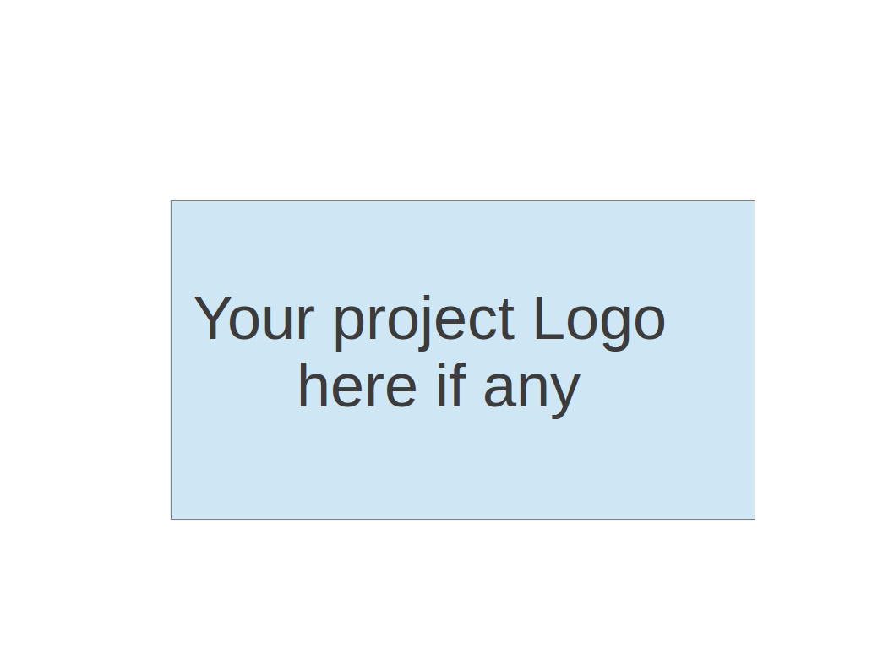

**Team 4 - Project Name**

**Software Design Document**

|  |  |  |  |
| --- | --- | --- | --- |
| Team Member | Role(s) | Signature | Date |
|  |  |  |  |
|  |  |  |  |
|  |  |  |  |
|  |  |  |  |
|  |  |  |  |
|  |  |  |  |
|  |  |  |  |
|  |  |  |  |

**Revision history**

|  |  |  |  |
| --- | --- | --- | --- |
| **Version** | **Author** | **Date** | **Change** |
|  |  |  |  |
|  |  |  |  |

Introduction

Software Architecture

Design Patterns

Key Algorithms

Classes and Methods

References

Glossary

# Introduction

In this section, give an overview of this document, and also address the design goals of your software system.

# Software Architecture

In this section, you will describe the decomposition of your software system, which include each component (which may be in terms of package or folder) and the relationship between components. You shall have a diagram to show the whole architecture, and class diagram for each component. The interface of each component and dependency between components should also be described. If any framework is used, it shall be defined here too. Database design should also be described if used.

# Design Patterns

In this section, you shall describe any design patterns used in your software system.

# Key Algorithms

In this section, you shall describe any key algorithms used in your software system, either in terms of pseudocode or flowchart.

# Classes and Methods

This part can be a reference to automatic generated document for all classes and methods.

# References

# Glossary