Front page

Project description

NTNU  Norges teknisk-naturvitenskapelige universitet | Fakultet for informasjonsteknologi, matematikk og elektroteknikk  Institutt for teknisk kybernetikk  
MASTEROPPGAVE
Kandidatens navn: Morten Sletta
Fag: Teknisk kybernetikk
Oppgavens tittel: Maskinsyn for sanntids deteksjon av skader i oppdrettsnot
Engelsk tittel: Machine vision for real time detection of net damage in sea cages

Oppgavens tekst
Skader på noten i lakseoppdrettsanlegg medfører stor risiko for rømming, et problem som er assosiert med alvorlige økonomiske og miljømessige konsekvenser. I dag brukes dykkere til inspeksjon av noten, men denne aktiviteten kan være både risikofylt, tidkrevende og kostbar. ROV benyttes nå i økende grad som et alternativ til dykkerinspeksjon. Bakgrunnen for denne oppgaven er et ønske om å effektivisere ROV-operatørens arbeid med å inspisere noten og på sikt få automatisert denne arbeidskrevende og monotone operasjonen. Oppgaven tar sikte på å få utviklet robuste algoritmer med utgangspunkt i bildestrømmen fra ROVens kamera (eventuelt eget kamera og belysning) for sanntids deteksjon av skader og svakheter i noten. Oppgaven omfatter følgende punkter:
- Gjennomgang av problemstillingens bakgrunn, identifisering av forskjellige skadescenarier og utarbeidelse av kravspesifikasjon for deteksjonssystemet
- Kartlegging og diskusjon av faktorer som har innvirkning på bildekvaliteten i en typisk oppdrettsmerd, slik som kamerateknologi, belysning, dybdeavhengige lys- og kontrastforhold, fisk, turbiditet, og bølger.
- Gjøre en vurdering av kamerateknologi og belysningsutstyr på aktuell ROV (Argus) i forhold til systemets behov
- Design og utvikling av algoritmer for sanntids bildeanalyse av notpaneler og deteksjon av typiske tilfeller av notskader og -svakheter
- Planlegging og gjennomføring av tester av algoritmen(e) med hensyn til treffsikkerhet og robusthet, både under ideelle og realistiske betingelser
- Diskusjon av resultater og kartlegging av systemets muligheter og begrensninger

Oppgaven gitt: 16. januar 2013
Besvarelsen leveres innen: 12. juni 2013
Utført ved: Institutt for teknisk kybernetikk, NTNU
Veileder: Jo Arve Alfredsen, ITK, NTNU
Per Rundtop, SINTEF Fiskeri og Havbruk

Trondheim, 16. januar 2013

Jo Arve Alfredsen
Faglærer

Preface

Abstract

Contents
Project description i
Preface iii
Abstract iv
List of figures vii
List of tables vii
Nomenclature vii
1. Introduction 1
2. Litterature study 2
Escapes of fishes from Norwegian sea-cage aquaculture: causes, consequences and prevention (Jensen, Dempster, Thorstad, Uglem, & Fredheim, 2010) 2
(Taylor & Kelly, 2010) 3
(Heide & Moe, 2004) 4
3. Theory 5
3.1. Color Spaces 5
3.1.1. CIE RGB 6
3.1.2. CIE XYZ 6
3.1.3. CIE xyY 7
3.1.4. CIE L*a*b 7
3.2. Segmentation methods 7
3.2.1. Naïve Thresholding 8
3.2.2. Adaptive thresholding 8
3.2.3. Otsu’s method 8
3.2.4. Using Edge detection 8
4. Software design 9
4.1. Prototype 9
4.1.1. Color Spaces 9
4.1.2. Segmentation methods 9
4.1.2.1. Otsu’s metod 9
4.1.2.2. Segmentation using edge detection, Sobel 10
4.1.3. Net damage detection 11
4.2. System 1 11
4.2.1. Color Spaces 11
4.2.2. Segmentation Methods 12
4.2.3. Cage damage detection 14
4.2.4. Real Time Considerations 14
4.3. System 2 17
5. Testing and Results 17
5.1. Test 1: ideal conditions 17
5.2. Test 2: real-life conditions 17
Discussion 18
Conclusion 19
Future work 20
Reference list i
Appendices ii
Appendix A – Color space images ii
Prototype color spaces ii

List of figures

List of tables

Nomenclature

CIE – International Commission on Illumination
GUI – Graphical user interface
IDE – Integrated development environment

Introduction
Ll

Literature study
The escaping of fish is a large problem in the aquaculture industry. Not only the loss of fish a direct loss in form of money but also there is the problem of the farmed fish mating with the wild fish. This leads to the degeneration of the wild fish’s genetic material. According to (Rønning, 2011) and (Klima- og forurensningsdirektoratet, 2012) this is a problem because the farmed salmon is bred based on criteria’s such as the ability to grow fast, fat content, flesh color and disease resistance. The qualities needed to survive in the wild however are quite different and more varied. This damage to the genetic material can be irreversible. A salmon that has a genetic material closer to the farmed salmon will not be as resistant to changes in its environment. The smolt production have been found in controlled experiments to be 30% lower for escaped farmed salmon compared to wild salmon.
Another problem that comes from escaped farmed fish is diseases and in particular Lepeophteirus salmonis lice. According to (Direktoratet for naturforvaltning, 2012) Lepeophteirus salmonis is a crustacean that attack salmon, sea trout and char. It is a severe threat to the wild salmon, and in some areas it threatens to eradicate the wild salmon and sea trout populace. Since the total number of farmed fish is many hundred times that of wild fish there is more lice now. The lice releases its eggs into the water where the eggs develop into larvae that follows the current and attack wild salmon and sea trout. As few as 9-11 lice is considered deadly to the young salmon that comes from the rivers and are entering the sea. In the fish farming facilities the lice population is kept down with chemicals and wrasse. There is now a concern that the lice are getting resistant to the chemicals used and the fish farms thereby losing their means to combat this threat.
From (Jensen, Dempster, Thorstad, Uglem, & Fredheim, 2010) many interesting numbers about aquaculture in Norway can be found. In Norway 3.93 million salmon and 0.98 million rainbow trout escaped in the span 2001-2009, while 1.05 million cod escaped in the span 2004-2009. This seems a lot but as an example there was at any given time in 2009 approximately 310 million Atlantic salmon and rainbow trout in sea cages in Norway. It seems that cod is especially hard to prevent from escaping. While the salmon escapes mainly after structural failures of containment equipment the cod escapes more often through holes in the net.
From (Taylor & Kelly, 2010) escaped incidents in Scottish aquaculture are reviewed. In Scottish aquaculture the most common cause of escape incidents is holes in the net. Of the reported incidents from May 2002 to October 2009 57% of the incidents were due to holes in the net, which led to a total of 700.359 escaped fish. Incidents caused by predation and chafe/snag are the two most frequently occurring causes for holes in the net.

Escapes of fishes from Norwegian sea-cage aquaculture: causes, consequences and prevention (Jensen, Dempster, Thorstad, Uglem, & Fredheim, 2010)
Fish escaping is a large problem of the aquaculture industry. In Norway alone 3.93million Atlantic salmon and 0.98million rainbow trout escaped in the span 2001-2009. 1.05million Atlantic cod escaped in the span 2004-2009. It should be noted that at any given time in 2009 approximately 310 million Atlantic salmon and rainbow trout and 25 million cod were held in sea cages in Norway. The percentage of fish escapes are as follows: salmon:0.19%, trout:0.40% and cod: 1.02%.

The sea cages being used are either square cages that have 20 to 40m sides and are 35 m deep. Or circular cages with a circumference of 90-157m nad that are 15-48m deep. Total cage volumes range from 20.000 to 80.000 $m^{3}$.
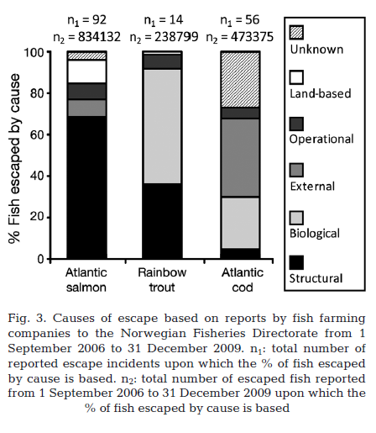
The big biological % for trout was because of a seal tearing through a cage net in order to feed and many trout escaped.
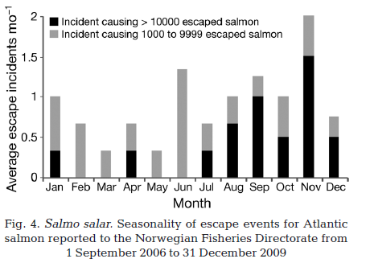
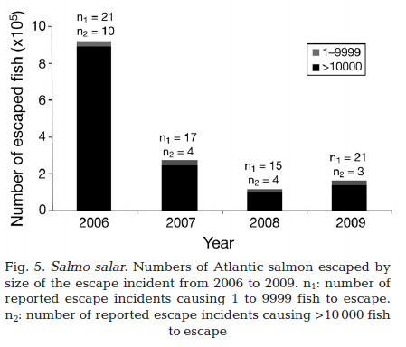

(Taylor & Kelly, 2010)

To inspect the cage net divers can be used for visual inspection. The divers can identify net damage before the damage leads to escape incidents. They recommend that research should be undertaken into devices that could detect holes in the net. Cameras have been found difficult to use for this task.

(Heide & Moe, 2004)
Tears in the cage net with tears that are many meters wide can occur due to a local overload when raising the cage net. The worst kind of tear is the L tear as shown in Figure 1. With a tear like this the fish have a high probability to find a way out of the sea cage. Horizontal tears can also make gaping holes that the fish can escape through while vertical tears don’t make gaping holes and the fish is least likely to escape.
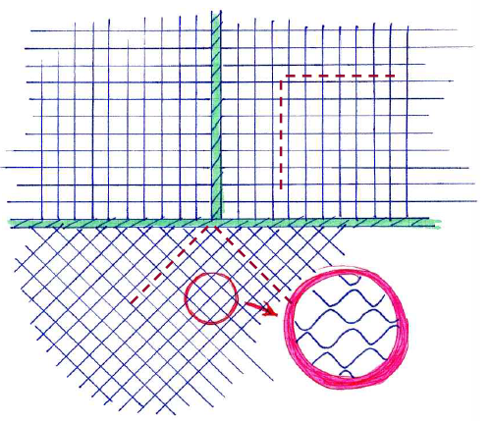
Figure 1: L-tear in sea cage (Heide & Moe, 2004)

Theory
Background theory of some of the important algorithms and methods used

Color Spaces
The first thing to do with an image is to determine the color space to use. There are different reasons for doing this.
One reason is that from the camera, color images are obtained. These images generally have three channels of color information, for example red, green and blue (RGB). Processing all the pixels in an image over all three channels adds computing time that may make the system to not work in real time. To use single or double channel color spaces that obtain all the information needed can reduce computing time significantly.
Another reason to use different color spaces is to use color spaces that gives more or better information for the rest of the system. Making operations like segmentation easier.
It has been long recognized that, as perceived by most human
observers, any color of light can be specified by stating three
numerical values. That is, color is three-dimensional in the
mathematical (not geometric) sense. (Kerr, 2010)
How the eye determines color
It has been determined that (for fairly substantial luminance) the eye
observes each tiny element of the image on the retina with three kinds
of “cones”, which are “photodetectors” 4. Each kind has a different
spectral response, by which we mean a curve that tells how much
“output” the cone delivers from light of a fixed “potency” at each
wavelength over the visible range.
When an area on the retina is bathed in light with a certain spectrum,
in effect, for each of the three kinds of cones:

• The spectrum of the light is multiplied by the spectral response of
the cone, meaning that, for each wavelength, the
“potency” of the light at that wavelength is multiplied by the value
of the spectral response at that wavelength.
• All these products are added together5, giving the output of the
cone.
Figure 2: Eye cone response curve (Kerr, 2010)

CIE RGB
This is the standard color space. Each pixel consists of three values, one for red, one for green and one for blue. When used in computer vision algorithms one can use the channels individually, combinations of two channels or all three channels.
To characterize the response of the human eye a series of experiments were performed in 1931. The basic experiment used a small screen where oine healf of the screen had the light of a test color whle the other half was made up of a composition of three primaries. The primaries had spectrums cvonsisting of only a single wave length. The test person adjusted the three primaries to match the test light. The value of the ormaries were recorded and another tets light shown. Using this method with multiple observers they accumulated a vast amount of data.
In Figure 2 functions for the primaries which is shown. Here the amounts of each primary color is needed to make a specific color wave-length. While they are not equivalent of the curves of Figure 1 there is a mathematical relationship between any set of matching functions and the eye response curves which can be exploited.
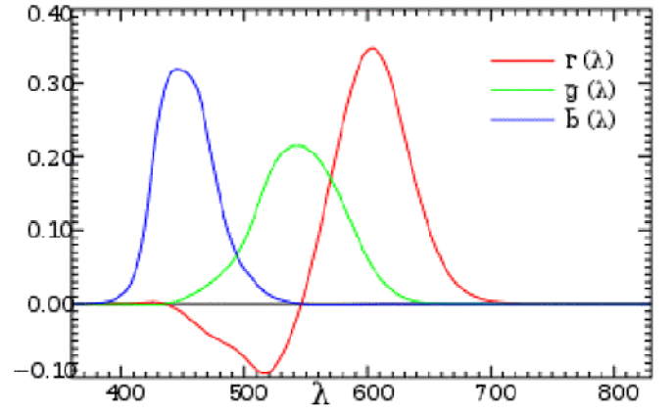
Figure 3: CIE RGB color matching functions (Kerr, 2010)
The three primaries could be described as red, green and blue and consisted of single wavelengths of 200nm, 546.1nm and 435.8nm respectively. This additive color space came to be known as the CIE RGB color space.

CIE XYZ
The XYZ color space is defined by the International Commission on Illumination (CIE). It is an additive color space. A color space where a color is described by the amount of the three primaries needed to combined make that color.
A disadvantage of the RGB color space is that the red primary matching function contains negative values. In the time where the analytical work of multiplicate the light spectrum values by the curve values at different wavelengths were done with calculators and on paper they did not want to use both positive and negative values. Using both positive and negative values could increase the risk of an error in the calculation. They needed a new color space, and thus they created the XYZ color space.

CIE xyY

CIE L*a*b
L*a*b* is a nonlinear transformation of the XYZ color space. In this color space a change in color-coordinate would give an equal perceptual difference. (Hoffmann, 2013). With L*a*b* CIE had a color space which was intended to provide a standard, approximately uniform color space. This color space could be used by everyone to make it easy to compare colors. The L*a*b* is organized as a cube as shown in Figure 4. The L* channel is the luminance channel which ranges from 0(black) to 100(white). The a* channel represents the color on a scale from green to red where positive a* numbers represent red and negative a* numbers represent green. The b* channel represents color in the range from blue to yellow where positive b* numbers represent yellow and negative b* numbers represent blue. In theory the a* and b* axis doesn’t have a maximum and minimum scale, although for practical purposes they are usually limited to a range from -128 to 127 thereby consisting of 256 levels.
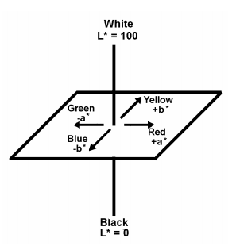
Figure 4: CIE L*a*b* (HunterLab, 2008)

Segmentation methods

From (Gonzalez , Woods, & Eddins, 2009) it is stated that global thresholding methods typically fails when the images are subjected to non-uniform background illumination. When this occurs one can use local statistics to improve the thresholding.

Naïve Thresholding
Thresholding can be done as simple as declaring that all the pixels that are over a certain threshold are foreground and the other pixels are background. This is a naïve approach that to a large degree is prone to error from disturbances, it is however computational cheap to perform and with some smart preprocessing it can be a viable option.

Adaptive thresholding

Otsu’s method
Out’s method is based on choosing an optimal threshold value $k$. The threshold value is optimum in the sense that it chooses the value that maximizes the between-class variance $σ_{B}^{2}\left(k\right)$ defined as:
$$σ_{B}^{2}\left(k\right)= P_{1}\left(k\right){\left[m_{1}\left(k\right)-m_{G}\right]}^{2}+P_{2}\left(k\right){[m_{2}\left(k\right)-m_{G}]}^{2}$$
Where $P_{x}$ is the probability of set $C_{x}$ occuring. $m_{x}$ is the mean intensities of the pixels in the set $C_{x}$ and $m_{G}$ is the global mean intensity of the entire image. (Gonzalez , Woods, & Eddins, 2009)
The idea behind this approach is that the larger the between-class variance is the higher the likelyhood of a proper segmentation of an image. This is a method that can be heavely affected by non-uniform lighting conditions, it can therefore benefit the performance to divide the image up into sub-images to get a better $m_{G}$ value for each part of the image.

Using Edge detection

Software design
For the system design process three systems were made. First of some methods was prototyped in ${Matlab}^{®}$. These methods are described in 4.1 Prototype. After prototyping the first test system were made. This system contains many different methods and the user has the option to change many parameters. This system was to be used during Test 1.
Test system 1 and 2 were made using OpenCV 2.4.0 in Qt Creator 2.6.2. The programming language was C++. With OpenCV many different computer vision algorithms are readily available. They are also optimized so they perform well in a real-time system sense. Qt is a cross-platofrm application and UI framework that made the development of the GUI easier. Qt Creator is the supporting IDE for Qt.

Prototype
To get an understanding of the problem at hand it was decided to start the design process by testing different methods in Matlab before making a working system using Qt with OpenCV.

Color Spaces
In the prototype stage the following color spaces were implemented:
- R, G and B from the original RGB image.
- X, Y and Z from the XYZ color space from (Paschos & Valavanis, 1999)
- x, y and Y from the xyY color space from (Paschos & Valavanis, 1999)
In Appendix A – Color space images the different color spaces are shown on an image from a video of a sea cage inspection, which was given by Per Rundtorp, SINTEF.

Segmentation methods
Of the different color spaces the red from RGB and Y from the XYZ and xyY color spaces were found to be the two most promising ones. Different segmenting methods were tried to segments out the sea-cage from the background.

Otsu’s metod
To test Otsu’s method the image seen in Figure 1 were used. This image was obtained from a video of a sea cage inspection, which was given by Per Rundtorp, SINTEF.
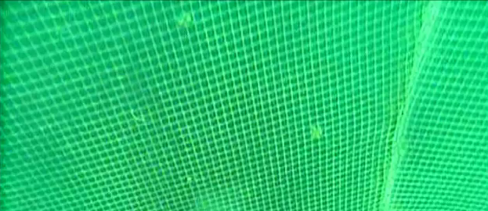
Figure 5: Image used for testing Otsu's method
The image was first filtered with a Gaussian filter and then segmented using Otsu’s method. When using Otsu's method it became apparent that it using it on the whole image led to bad segmentation results. It was therefore tried to segment the image in smaller sub-images. The image was divided into 25 sub-images, which was independently segmented using Otsu’s method and stitched together. The differences between using sub-images or not can be seen in Figure 1 where in the globally image to the left the many of the sea-cage masks are not whole which when further processed will lead to the system believing the net to have holes. In the image segmented with sub-images the masks are better and the thick rope going vertically in the right of the image is more distinct. The differences can be more easily seen after using morphological operations like shown in Figure 2. Here the segmented images have been through one round of dilation followed by thinning and spurring (both until no further changes occurred)
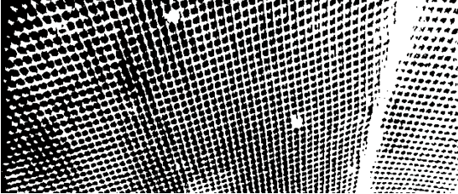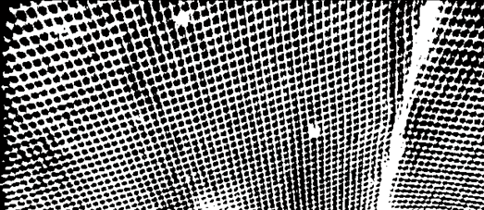
Figure 6: Thresholded image using Otsu's method (left) and using Otsu's method on sub-images (right)
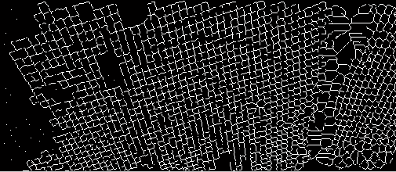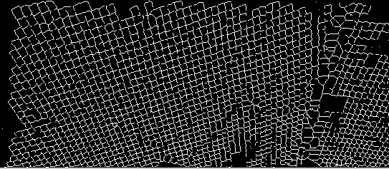
Figure 7: Global Otsu's method (left) and Otsu's method on sub-images (right)
Using Otsu’s method the Y color space gave better results compared to the Red color space when it comes to the masks, the Red color space could however see the rope to the right in the image more clearly. The different color spaces are compared in Figure 4.
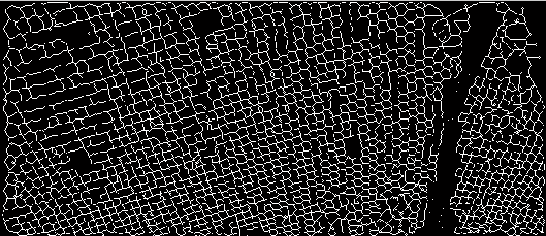
Figure 8: Otsu's method using dilation, thinning, and spurring. Red color space (left) and Y color space (right)

Segmentation using edge detection, Sobel
Another segmentation method that was examined was segmentation using Sobel edge detection. Two new images were made, one where Sobel edge detection had been performed in the x-direction and one in the y-direction. These images were then merged. The resulting image contains too many edges so to get the edges needed only a given percentile of the edges are being used. The given percentile is a parameter that should be adjusted at run-time. Using edge detection with Sobel the system can give more correct results. Using the method it wasn’t necessary to dilate the segmented image before thinning it which gives less erroneous masks. In Figure 5 the difference with and without dilation is shown. With dilation more masks are found, however they don’t have the appearance as the original image. Dilation doesn’t seem to be a desired operation to perform
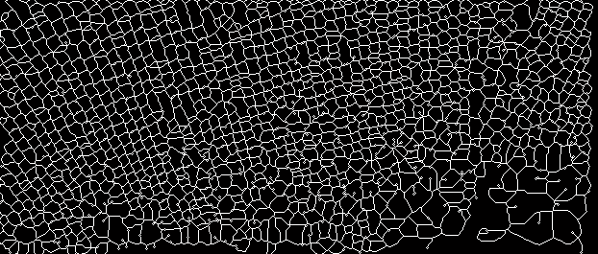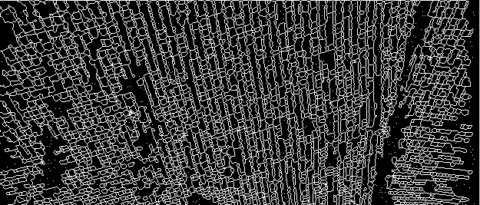
Figure 9: Foreground and background using segmentation with edge detection. Image dilated before thinning and spurring (left) and image not dilated (right)

Net damage detection

System 1
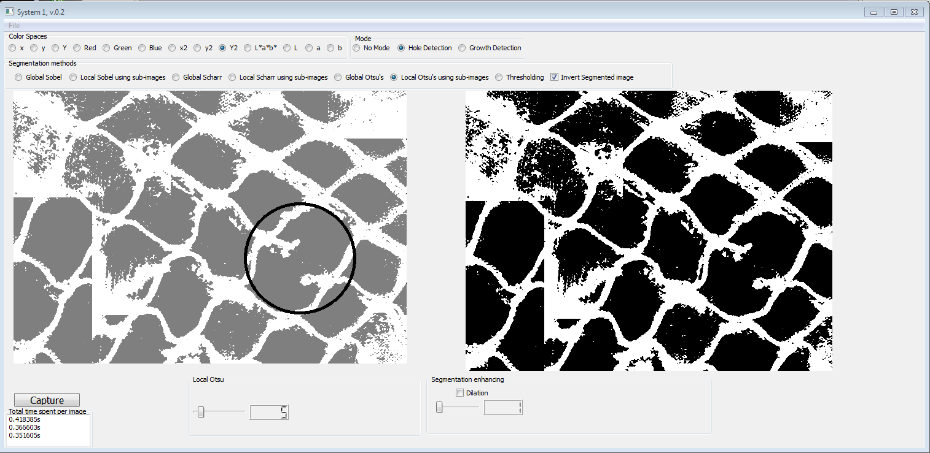
Figure 10: System 1
The first system made was intended to be used in test 1. It has a lot of different options that shall be tested during test 1.

Color Spaces
In the first version of the system the following color spaces were implemented
Single channel images:
- x, y, and Y from the xyY transformation used when developing the prototype.
- R, G and B from the BGR2RGB transform in OpenCV.
- x, y and Y made using the XYZ transform in OpenCV then converted to xyY as explained in 3.1.3 CIE xyY.
- L*, a* and b* using the RGB2Lab transform in OpenCV.
Early testing showed that the luminance (Y and L) part of the different color spaces are the most promising. The L luminance behaves quite differently than the Y’s as can be seen in Figure 8. In this image the shadow from the net makes the left image hard to see. The L luminance seems to mark the sea cage fairly well so one of the segmentation methods that are being tried are just using the L image combined with thresholding.
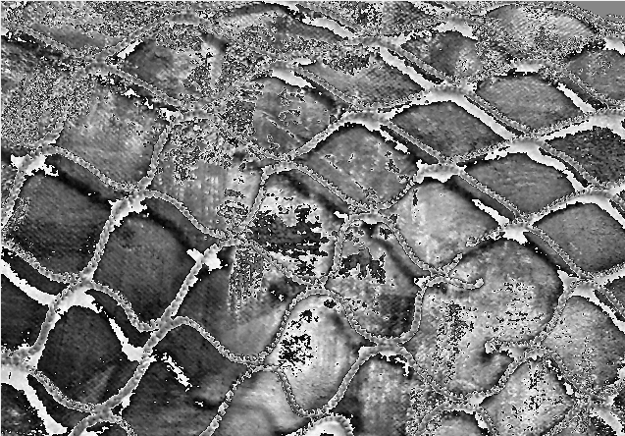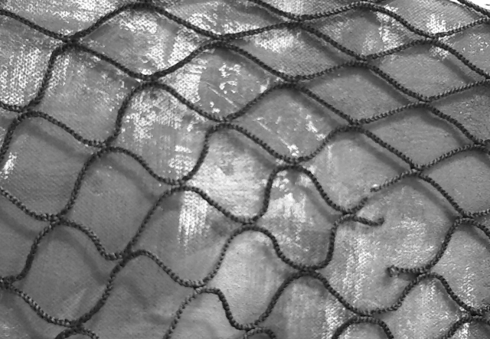
Figure 11: Luminance images, L(left) and Y(right)

Segmentation Methods
In the first version of the system the following segmentation methods were implemented:
- Segmentation using edge detection, Sobel from the prototype.
- Segmentation using edge detection, Scharr.
- Segmentation using Otsu’s method, similar to prototype.
- Segmentation using simple thresholding.
- Segmentation using adaptive thresholding.
Various options
For the different segmentation techniques were made to be able to test different kinds of parameters. The different methods and their respective changeable parameters will be listed here.

Segmentation using edge detection, Sobel

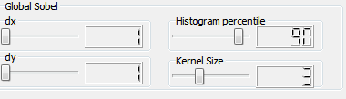
Figure 12: Global Sobel segmentation parameters
In edge detection using global Sobel there are four parameters to adjust. It is possible to take the derivative in both x and y direction (dx and dy), the system can handle from 1st to 6th derivatives. The Kernel size can also be adjusted. It is required that the derivatives are less than the kernel size, i.e. a kernel size of 3 can have 1st and 2nd derivatives. The last parameter is the histogram percentile parameter explained in 4.1.2.2.
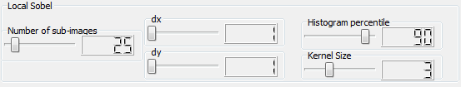
Figure 13: Local Sobel segmentation parameters
For the local Sobel approach the image is divided into sub-images, the number of sub-images is then naturally a parameter that can be adjusted. It has a range from 1(global) to 1600 sub-images with a default value of 25 sub-images. The sub-images are arranged in a grid pattern so with the default 25 sub-images the sub-images are arranged in a 5x5 pattern.

Segmentation using edge detection, Scharr
The Scharr edge detector is a special 3x3 mask that can be made using the OpenCV Sobel function. It can either have the first derivative in the x-direction or the first derivative in the y-direction. In the GUI this is chosen with the dx and dy check boxes. If both are chosen both directions are run and the results are then merged. In the local Scharr method one can select the number of sub-images. The last parameter is the histogram percentile parameter explained in 4.1.2.2.
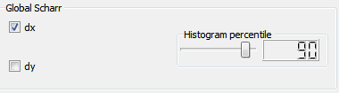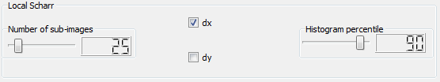
Figure 14: Global Scharr segmentation parameters (left) and Local Scharr segmentation parameters (right)

Segmentation using Otsu’s method
Using Otsu’s method there really aren’t all that many parameters to set. In this function the sub-image split can be imperative for good performance. In a real environment it is believed that light gradients either from lighting or from the sun will affect the segmentation. To be able to study smaller parts of the image can help the performance of Otsu’s method. This is however a dual edged sword, since Otsu’s method always finds background and foreground it can separate an image into foreground and background when there really isn’t a reason to do it. It can also decide that the sea cage is foreground in one sub-image and that it is background in another image. These are questions to be answered during testing.
In Figure 16 the parameter box for the local Otsu method is shown. For the global Otsu there are no parameters to set.
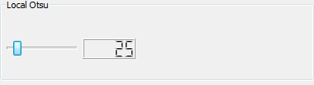
Figure 15: Local Otsu segmentation parameters

Segmentation using simple thresholding
With this segmentation method the pixels are segmented into foreground and background depending on if they are above or below the changeable threshold parameter.
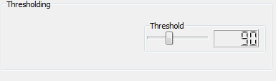
Figure 16: Simple Thresholding segmentation parameters

Segmentation using adaptive thresholding
With this segmentation method the user can choose between the Gaussian or mean adaptive method. In addition to choose the adaptive method the user can change the kernel size that is used to calculate a threshold value. The user can also change C, which is the value that gets subtracted from the weighted sum (if Gaussian) or mean of the pixels neighborhood when calculating the threshold value.
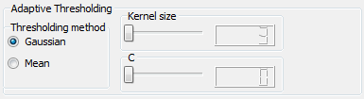
Figure 17: Adaptive Thresholding segmentation parameters

Cage damage detection

Real Time Considerations
When writing software there are other things than just the complexity of the algorithms that affect the processing time used per image. How data is stored and accessed matters a great deal.
When system 1 were first made pixels in the image were accessed like this:
for(int i = 0;i< image.cols;i++)
for(int j = 0; j<image.rows;j++)
{
//Do something with the pixel (j,i) using .at, example:
XYZ_image.at<cv::Vec3b>(j,i)[1] = 0.299*image.at<cv::Vec3b>(j,i)[0] + 0.587*image.at<cv::Vec3b>(j,i)[1] + 0.114*image.at<cv::Vec3b>(j,i)[2];
}
This works, but it can be made to go faster. The .at method can be used for random access of image pixels but according to (Laganière, 2011) it should never be used to scan whole images. The .at method is however easy to implement so all the loops were done this way the first version of System 1.
When comparing the self-written XYZ method to the one in OpenCV it was evident that changes needed to be made to the pixel accessing method. In Figure 15 the run time of the different transformations are compared.
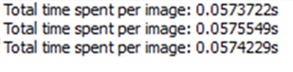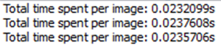
Figure 18: Run time for loading in image and using self-written XYZ transformation using .at(left) or OpenCV’s XYZ transformation(right)
From (Laganière, 2011) different methods for accessing all the pixels in an image are presented. When using a process like this:
XYZ_image.create(image.size(), image.type());
int nl = image.rows;
int nc = image.cols;
if(XYZ_image.isContinuous())
{
nc = nc*nl;
nl = 1; //1D array;
}

//loop exectued only once if the image is continious
for(int j = 0; j<nl;j++)
{
uchar* data = XYZ_image.ptr<uchar>(j);
uchar* old_data = image.ptr<uchar>(j);
for(int i = 0; i<nc;i++)
{

data[3*i+1] = 0.299*old_data[3*i] + 0.587*old_data[3*i+1]+0.114*old_data[3*i+2];//Y channel

}
{

The run time using the self-written XYZ transformation decreased to almost half the previous used time. The run time can be seen in Figure 16.
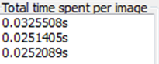
Figure 19: Run time for loading image and using self-written XYZ transformation using pointers

In the next figures the run-time per image processed can be seen for different color spaces and segmentation techniques
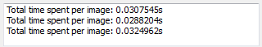
Figure 20: Loading in image and using OpenCVs L*a*b transformation, extracting L
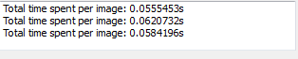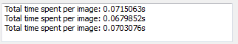
Figure 21: Y and global Sobel(left), Y and local sobel with 5 subimages(right)
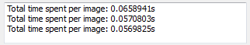
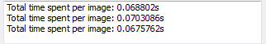
Figure 22: Y and Global Scharr(left), Y and local Scharr with 5 subimages(right)
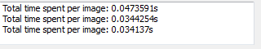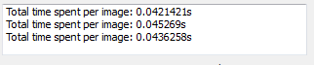
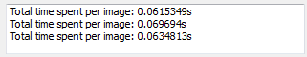
Figure 23: Y nad global Otsu(left), Y and local Otsu with 5 subimages(right), Y and local otsu with 40 subimages (bottom)
The processing time using the luminance function decreased from ~0.0575 to ~0.0295.
Using Y2, Otsu local with 5 sub images and hole detection uses ~0.3seconds, using pointers instead of .at didn’t help much, bringing it down 0.02 seconds to ~0.28seconds.
Kan lage en algo som ser på innvendig kantpixler fra nettet istedenfor å se på tomrommet, bør bli færre søk og mindre tid brukt.

For QList:
Because QList is implemented as an array of pointers, this operation is very fast (constant time). For read-only access, an alternative syntax is to use at():
for (int i = 0; i < list.size(); ++i) {
if (list.at(i) == "Jane")
cout << "Found Jane at position " << i << endl;
}
at() can be faster than operator[](), because it never causes a deep copy to occur.

System 2

Testing and Results

Test 1: ideal conditions

Test 2: real-life conditions

Discussion

Conclusion

Future work

Reference list
Jensen, Ø., Dempster, T., Thorstad, E., Uglem, I., & Fredheim, A. (2010, August 12). Escapes of fishes from Norwegian sea-cage aquaculture: causes, consequences and prevention. Retrieved february 17, 2013, from preventscape.eu: http://preventescape.eu/wp-content/downloads/2010_aei_jensen_et_al.pdf
Kerr, D. A. (2010, March 21). The CIE XYZ and xyY Color Spaces. Hentet March 11, 2013 fra http://dougkerr.net: http://dougkerr.net/pumpkin/articles/CIE_XYZ.pdf
Laganière, R. (2011). OPENCV 2 Computer Vision Application Programming Cookbook. Birmingham: Packt Publishing Ltd.
Paschos, G., & Valavanis, K. P. (1999, February). A Color Texture Based Visual Monitoring System For Automated Surveillance. IEEE TRANSACTIONS ON SYSTEMS, MAN, AND CYBERNETICS--PARTC: APPLICATIONS AND REVIEWS, 29, NO. 2,, ss. 298-307.

Appendices

Appendix A – Color space images

Prototype color spaces
Original image
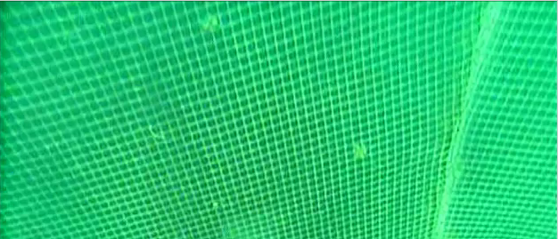
xyY color space
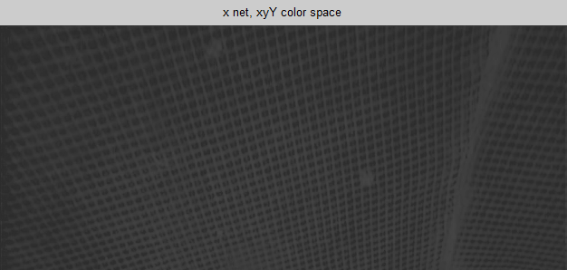
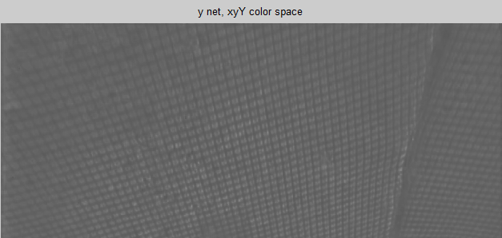
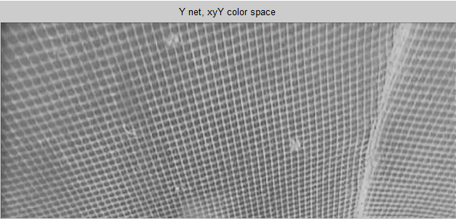

XYZ color space
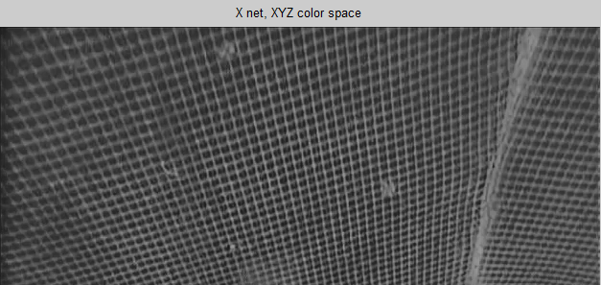
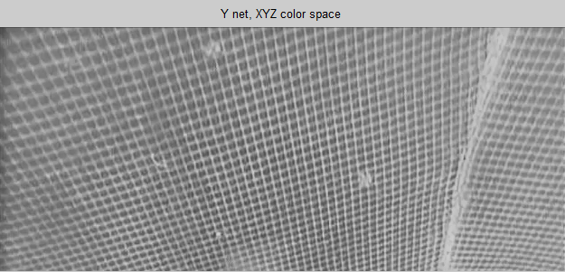
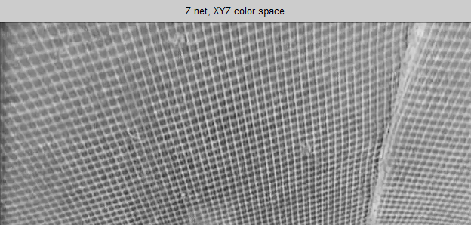

RGB color space
