1. **Verify the results of Table 4.1. You can write a small program based on Fig. 4.5 or use an EXCEL spreadsheet to do this.**  
     
   The following python script recreates Table 4.1. Note, the book incorrectly rounded a few of their figures, my table is more correct.  
   The resultant table, ‘df’, is show below:  
   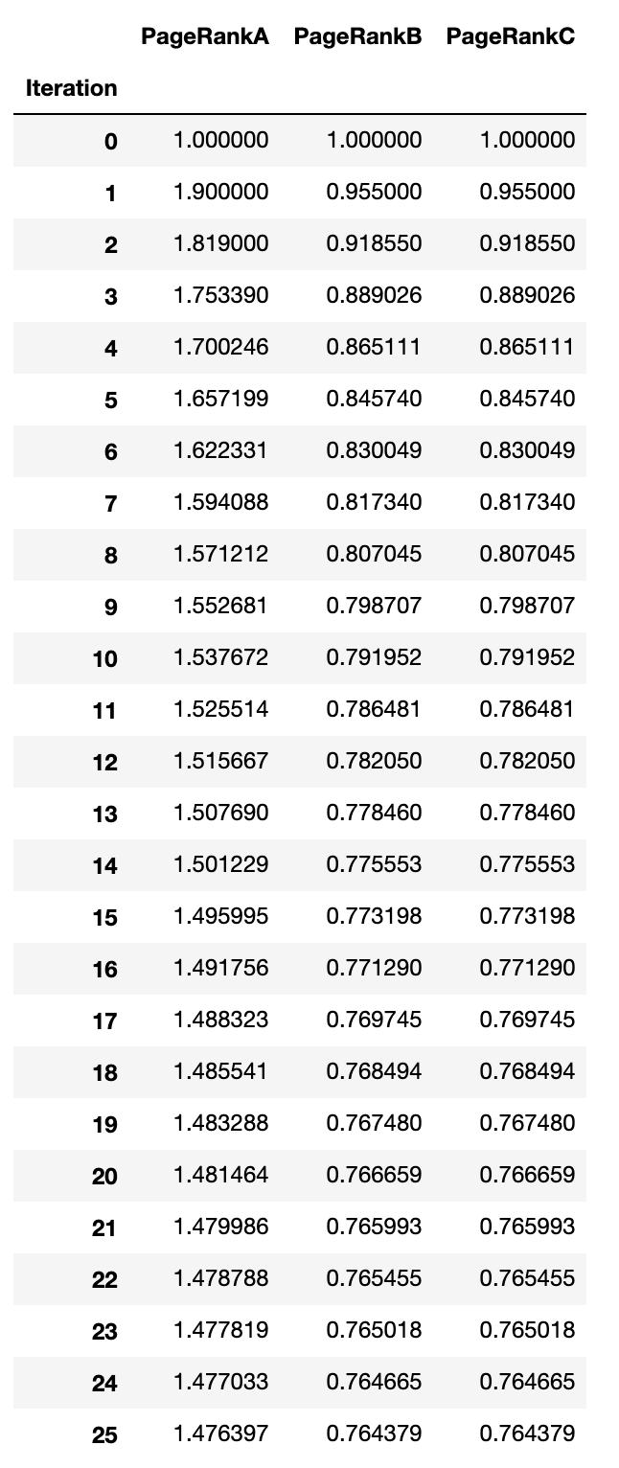

import pandas as pd

class Doc():

def __init__(self, num_links: int):

self.num_links = num_links

self.page_rank = 1

self.children = list()

self.page_ranks = [1]

def calc_page_rank(self, d: float = 0.1):

pr = d + (1 - d) * sum(doc.page_rank/doc.num_links for doc in self.children)

self.page_rank = pr

self.page_ranks.append(pr)

A = Doc(2)

B = Doc(1)

C = Doc(1)

A.children = [B, C]

B.children = [A]

C.children = [A]

for _ in range(25):

A.calc_page_rank()

B.calc_page_rank()

C.calc_page_rank()

df = pd.DataFrame(data={'PageRankA': A.page_ranks,

'PageRankB': B.page_ranks,

'PageRankC': C.page_ranks,})

df.index.name = 'Iteration'

1. **Determine the sense of the ambiguous word “grade” from the gloss vector closest to the sentence vectors using cosine distance or some other similarity measure. Report your results to what extent this method gave a reasonable result or not and links to the web articles you found useful for this assignment.**
   1. “Jeff purchased a new tractor, so he could fix the grade on his gravel road.”
   2. “Professor Jurkat gave me a perfect grade on this homework assignment.”

Using WordNet, I found that the word ‘grade’ had nine different senses for nouns, and four senses for verbs:

Overview of noun grade

The noun grade has 9 senses (first 3 from tagged texts)

1. (17) class, form, grade, course -- (a body of students who are taught together; "early morning classes are always sleepy")

2. (5) grade, level, tier -- (a relative position or degree of value in a graded group; "lumber of the highest grade")

3. (1) grade -- (the gradient of a slope or road or other surface; "the road had a steep grade")

4. grad, grade -- (one-hundredth of a right angle)

5. grade, gradation -- (a degree of ablaut)

6. mark, grade, score -- (a number or letter indicating quality (especially of a student's performance); "she made good marks in algebra"; "grade A milk"; "what was your score on your homework?")

7. grade, ground level -- (the height of the ground on which something stands; "the base of the tower was below grade")

8. degree, grade, level -- (a position on a scale of intensity or amount or quality; "a moderate grade of intelligence"; "a high level of care is required"; "it is all a matter of degree")

9. grade -- (a variety of cattle produced by crossbreeding with a superior breed)

Overview of verb grade

The verb grade has 4 senses (first 1 from tagged texts)

1. (1) rate, rank, range, order, grade, place -- (assign a rank or rating to; "how would you rank these students?"; "The restaurant is rated highly in the food guide")

2. grade -- (level to the right gradient)

3. grade, score, mark -- (assign a grade or rank to, according to one's evaluation; "grade tests"; "score the SAT essays"; "mark homework")

4. grade -- (determine the grade of or assign a grade to)

I then parsed my senses and my sentences, and measured cosine similarity between each of my sentences and all of the senses. Here are the results for sentence 1:

“Jeff purchased a new tractor, so he could fix the grade on his gravel road.”

<Sense> <Cosine Similarity>

NOUN

1. 0.06454972243679027
2. 0.23094010767585027
3. **0.3689323936863109**
4. 0.11547005383792514
5. 0.12909944487358055
6. 0.15811388300841897
7. 0.27824333745610097
8. 0.22247460415730483
9. 0.14322297480788657

VERB

1. 0.10767638041163309
2. 0.11547005383792514
3. 0.23094010767585027
4. 0.3113995776646092

The sense with the highest cosine similarity, 3, matches the definition we expect: “the gradient of a slope or road or other surface; "the road had a steep grade". Next, we can run the same for sentence 2.

“Professor Jurkat gave me a perfect grade on this homework assignment.”

<Sense> <Cosine Similarity>

NOUN

1. 0.07537783614444091
2. 0.20225995873897262
3. 0.18463723646899913
4. 0.13483997249264842
5. 0.15075567228888181
6. 0.2461829819586655
7. 0.10830607221477648
8. 0.2597943666588219
9. 0.16724840200141816

VERB

1. 0.06286946134619315
2. 0.0
3. 0.26967994498529685
4. **0.2727272727272727**

In this case, we found the closest cosine similarity to sense 14, which is: “determine the grade of or assign a grade to”. This is a good result, in that we captured the meaning. However, this sense was a verb, whereas we used grade as a noun in our sentence. A more complex algorithm might take advantage of POS tagging in order to aid matching the right POS. Additionally, I used a bag of words method, and did not employ TFIDF. If we performed this same analysis using TFIDF, sense 6 (which we were targeting) would have scored significantly higher. This is yet another example on why TFIDF would be better than the simple bag of words model.  
  
I did not find useful outside sources for this assignment; it is difficult to find much literature on gloss vectors outside of academic research papers.