Thẻ 2
SALIGUARD
AI-Powered Salinity Intrusion Early Warning System
Red River Delta & Hai Phong Coastal Districts, Vietnam
Asian Hackathon for Green Future 2026 - Track C: Water Resources & Climate-Resilient Agriculture

1. Problem Statement

1.1 A Crisis That Is Getting Worse Every Year
The coastal districts of Hai Phong - including Tien Lang, Vinh Bao, and Kien Thuy - are facing a worsening salinity intrusion crisis. Saltwater from the Red River pushes into farmland every dry season, damaging rice crops and contaminating freshwater supplies. Scientific data from the Hon Dau tide gauge station (1960-2020) shows that sea levels in Hai Phong have been rising at an average rate of 3.56 mm/year, accelerating to 7.78 mm/year during 2002-2020, equivalent to 14.7 cm in just 19 years (Nguyen et al., 2022).
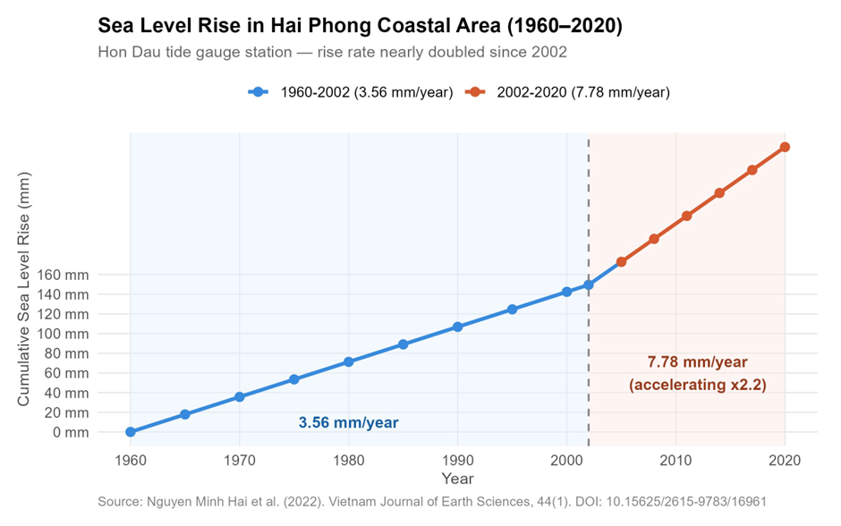
Indicator | Data | Source
Sea-level rise rate (Hai Phong, 1960-2020) | 3.56 mm/year | Nguyen et al., 2022
Sea-level rise rate (Hai Phong, 2002-2020) | 7.78 mm/year (accelerating)
Total sea-level rise in 19 years | 14.7 cm
ENSO influence on Hai Phong sea level | Sea level rises during El Nino (+7.2 cm peak)
Salinity intrusion depth - Red River (current) | Up to 40 km inland | Nguyen et al., 2020
Salinity intrusion depth - Red River (2100, RCP8.5) | Up to 38-40 km for 1% threshold
4‰ danger threshold - Red River (2100, RCP8.5) | Moves 32 km upstream from baseline

1.2 The Real Problem: No Warning
Peer-reviewed studies on the Red River system show that salinity intrusion will continue increasing under all sea-level rise scenarios through 2050 and 2100 (Nguyen et al., 2020). This means the problem is expected to worsen over time.
However, crop losses are driven not only by salinity itself, but by the lack of an early warning system that reaches farmers in time. A farmer who receives a 48-hour warning can close irrigation gates, protect freshwater reserves, and reduce crop losses.
Current government monitoring stations are too sparse and slow to support real-time decisions for smallholder farmers. No affordable, farmer-facing technology currently predicts local salinity intrusion and delivers alerts directly to smartphones. SaliGuard was built to fill this gap.
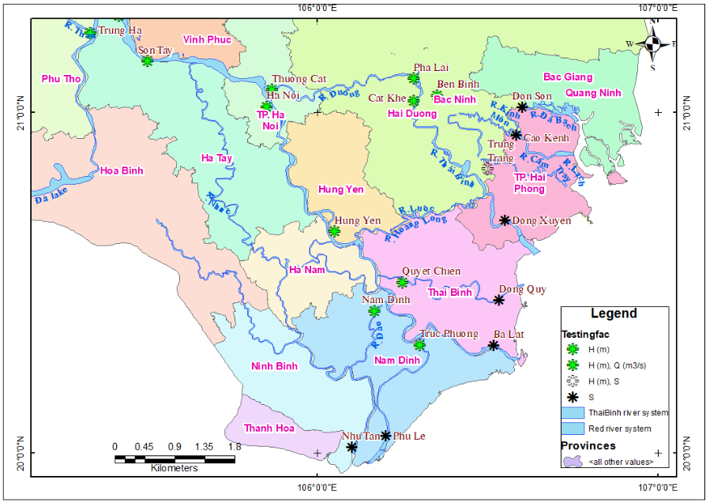
Testing stations used to evaluate model performance for water levels, discharges, and salt concentrations were selected along the river network, as shown in figure, where H denotes water level, Q denotes river discharge, and S denotes salt concentration.
Model Evaluation
Station | River | Variable | Calculated Max | Observed Max | Difference | NSE (%)
Son Tay | Hong | Water level (H) | 5.52 m | 5.50 m | 0.02 m | 98.5
Son Tay | Hong | Discharge (Q) | 2266 m³/s | 2590 m³/s | -324 m³/s | 92.8
Ha Noi | Hong | Water level (H) | 2.40 m | 2.38 m | 0.02 m | 93.2
Ha Noi | Hong | Discharge (Q) | 1420 m³/s | 1530 m³/s | -110 m³/s | 90.3
Hung Yen | Hong | Water level (H) | 1.72 m | 1.62 m | 0.10 m | 86.3

Table X. Calibration performance of hydrodynamic model at Red River monitoring stations (adapted from Nguyen et al., 2020).

Station | Observed Max Salinity (‰) | Calculated Max Salinity (‰) | Time to Peak Difference (hrs) | Relative Error (%)
Ba Lat | 23.5 | 24.3 | 2 | 3.7
Cao Kenh | 1.6 | 1.5 | 1 | 0.3
Table X. Advection–dispersion model calibration results for selected Red River salinity stations (adapted from Nguyen et al., 2020).
The hydrodynamic and salinity models show satisfactory agreement with observations, indicating that the simulation framework is suitable for salinity forecasting in the Red River system.
SALINITY UNDER SEA LEVEL RISE EFFECT
Hydrodynamic simulations indicate that salinity intrusion in the Red River will intensify under both RCP4.5 and RCP8.5 scenarios for 2050 and 2100.
The seawater intrusion front is projected to extend approximately 40 km inland. Under the 2100 RCP8.5 scenario, maximum salinity may reach 9.12‰ at 20 km from the sea. The agriculturally critical 1‰ and 4‰ thresholds are forecast to migrate upstream to 38 km and 32 km, respectively.
Even beyond 40 km from the river mouth, salinity may remain elevated, reaching 2.1‰ under the most severe scenario, increasing freshwater stress in agricultural zones.
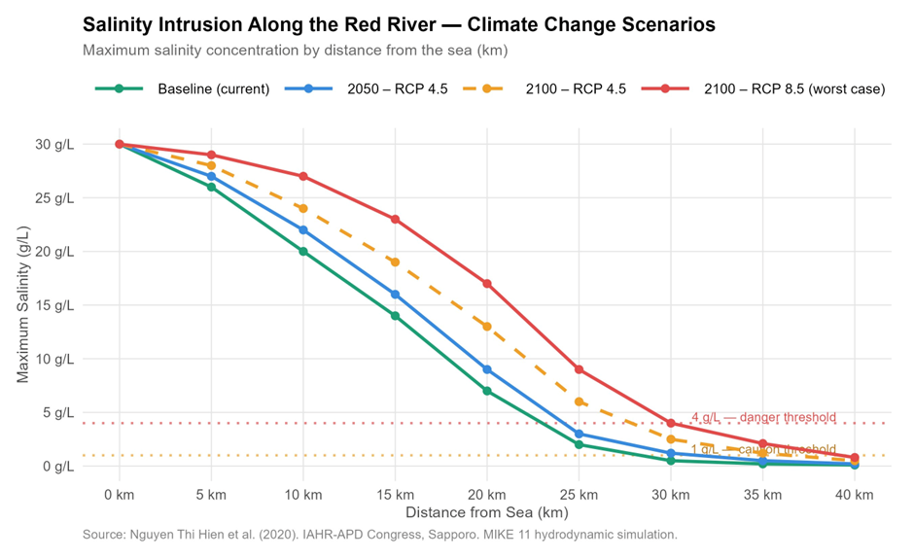
Figure 2. Salinity intrusion along the Red River under different sea level rise scenarios. Source: Nguyen et al. (2020).

Maximum salinity concentration along the mainstream Red River under different sea-level rise scenarios

2. Solution Overview
SaliGuard is an end-to-end IoT and AI early warning system that predicts salinity intrusion 24 to 72 hours in advance and delivers color-coded risk alerts directly to farmers' smartphones - in plain language they can act on immediately.
The system is built on three integrated layers:
• Hardware Layer: A solar-powered, waterproof IoT field unit with an EC (electrical conductivity) sensor, water level sensor, and temperature probe. It transmits real-time data via 4G to the cloud from any riverside location, with no grid power needed.
• Intelligence Layer: An XGBoost machine learning model trained on historical salinity, tidal, and river discharge data - including ENSO cycle patterns that directly affect sea levels in Hai Phong (Nguyen et al., 2022). The model generates salinity forecasts at 24h, 48h, and 72h intervals.
• User Layer: A Flutter mobile app with color-coded risk alerts, a live salinity map, trend charts, and an AI chatbot (Gemini API) that answers farmers' questions in plain Vietnamese - no technical knowledge required.

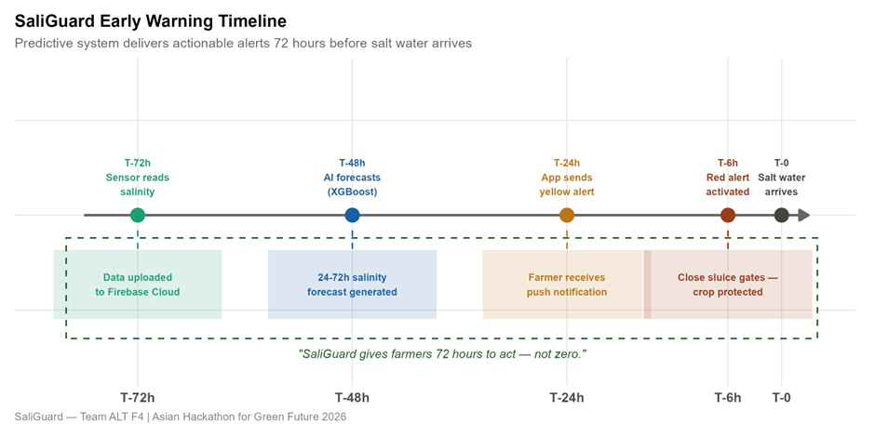

The key difference between SaliGuard and conventional systems is simple: SaliGuard predicts - it does not just detect. While existing systems notify farmers after saltwater has already arrived, SaliGuard gives communities a meaningful window of time to act.

3. Technical Architecture

3.1 Hardware Design
Each SaliGuard field unit is built around a Raspberry Pi single-board computer, which can run lightweight AI inference locally - this means the system still works even when the internet connection is slow or unstable. The unit is fully solar-powered and sealed in a waterproof IP65 enclosure for permanent deployment beside rivers and canals.

Component | What It Does
Raspberry Pi | Main brain - runs AI model and sends data to the cloud
EC Sensor Module | Measures water saltiness (electrical conductivity, 0-20 mS/cm)
Waterproof DS18B20 | Measures water temperature to improve EC accuracy
Ultrasonic HC-SR04 | Measures water level
Cellular SIM Module | Sends data to Firebase cloud in real time
Solar Panel + Li-ion Battery | Fully off-grid - no electricity connection needed
IP68 Waterproof Enclosure | Protects the electronics from rain and flooding

3.2 AI Forecasting Model
SaliGuard uses an XGBoost machine learning model to predict salinity levels 24-72 hours before they arrive. This type of model has been validated in scientific research on Vietnam's river systems and performs very well on hydrological time-series data.
An important feature of SaliGuard's AI model is the inclusion of ENSO (El Nino-Southern Oscillation) data as an input. Research shows that El Nino events cause sea levels at Hai Phong to rise by up to 7.2 cm above normal (Nguyen et al., 2022) - which directly worsens salinity intrusion. By incorporating this signal, SaliGuard can predict higher-risk periods weeks in advance, not just hours.

Alert Level | Salinity | What the Farmer Should Do
Green - Safe | < 1 g/L | Normal irrigation - no action needed
Yellow - Caution | 1 - 4 g/L | Monitor closely - prepare to close irrigation gates
Red - Danger | > 4 g/L | Close sluice gates now - protect freshwater reserves immediately

Note: The 1 g/L and 4 g/L thresholds are based on established Vietnamese agricultural water quality standards, and are the same thresholds used in peer-reviewed research on the Red - Thai Binh River delta (Nguyen et al., 2020).

3.3 Mobile Application
The SaliGuard Flutter app is designed to be used by farmers with no technical background. It uses large icons, simple color coding, and an AI chatbot (powered by Gemini API) that farmers can ask questions in natural Vietnamese - for example: 'Is it safe to water my rice field tomorrow?' or 'When will the salinity go back down?'

4. Innovation & Social Impact
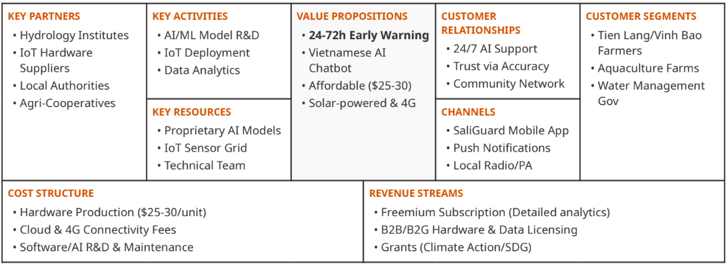

6. Development Roadmap
Phase | Deadline | Goal
Hardware Prototype | April 30 | Field unit assembled; EC sensor readings validated in water
Software Integration | May 5 | App connected to Firebase; AI model returning predictions
Demo Preparation | May 9 | End-to-end demo video recorded
Submission | May 13 | Proposal and intro video submitted
Training Round | June 2-28 | Solution refined with expert mentorship
Final Hackathon | July 2-5, VinUniversity | Full working prototype presented to judges

7. References

Nguyen Minh Hai, Ouillon, S., & Vu Duy Vinh (2022). Sea-level rise in Hai Phong coastal area (Vietnam) and its response to ENSO - evidence from tide gauge measurement of 1960-2020. Vietnam Journal of Earth Sciences, 44(1), 109-126. https://doi.org/10.15625/2615-9783/16961

Nguyen Thi Hien, Nguyen Hai Yen, Balistrocchi, M., Vu Minh Cat, & Ranzi, R. (2020). Salinity Dynamics under Sea Level Rise Scenarios in the Red-Thai Binh River Delta, Vietnam. Proceedings of the 22nd IAHR-APD Congress, Sapporo, Japan.

