

DEPARTMENT OF ELECTRONICS AND COMMUNICATION ENGINEERING
ST JOSEPH ENGINEERING COLLEGE, MANGALURU-575028

REPORT
On

SIGNALS & SYSTEMS INTEGRATED LAB (22ECE43)
2024-2025

OPEN ENDED EXPERIMENT

Semester: 4 Date of Submission:28-04-2025

Submitted By:

Name | USN | Signature
Frenny Chrystal Saldanha | 4SO23EC028
Hani Mohammed Kaif | 4SO23EC034
Kannika D Ambekallu | 4SO23EC043
Kushi Salyan | 4SO23EC048

AIM:

To analyze electroencephalogram (EEG) signals in the time domain to identify and understand patterns associated with different brain states by studying raw EEG data, plotting time-series signals, and segmenting the data into meaningful epochs.

SOFTWARE USED: MATLAB 2023a

ABOUT ECG/EEG/EMG SIGNAL:

ECG, EEG, and EMG are all types of signals that help us understand what's going on inside the human body by recording its electrical activity.
- ECG (Electrocardiogram):
This is a way to see how the heart is working. By placing small sensors (electrodes) on the chest, arms, or legs, we can record the heart's electrical signals as it beats. Doctors use ECGs to check for irregular heart rhythms, heart attacks, and other heart conditions. The signals look like repeating waves (P, QRS, and T waves) that correspond to different phases of the heartbeat. A normal ECG shows a consistent pattern, while any irregularities can indicate a potential issue. ECGs are quick, non-invasive, and widely used in hospitals, ambulances, and even wearable health monitors. They also help in monitoring patients with pacemakers or other cardiac treatments. By analyzing the intervals and shapes of these waves, healthcare professionals can get a detailed picture of the heart's electrical health.
- EEG (Electroencephalogram):
EEG is used to measure brain activity. Small electrodes are placed on the scalp to pick up the tiny electrical signals the brain produces. EEGs are helpful for studying sleep, attention, and mental states, and they’re especially important in diagnosing conditions like epilepsy. The brain’s activity changes depending on whether we’re awake, relaxed, or deeply asleep—and EEG can show these changes.
- EMG (Electromyogram):
EMG records the electrical signals muscles make when they contract. It's used to study how muscles work and to detect problems in the nerves or muscles. For example, it can help doctors figure out why someone has weakness or muscle pain.
In short, these signals give us a window into how our heart, brain, and muscles are working—just by listening to the body’s natural electrical patterns.

MATLAB CODE:

% EEG Signal Time-Domain Analysis
% AIM: Analyze EEG signals for different brain states

clear; close all; clc;

% 1. Load EEG signal
% (Assuming the signal is stored in a .mat file or you can generate a sample)
% Let's create a sample EEG-like signal for demo
Fs = 256; % Sampling frequency (Hz)
t = 0:1/Fs:10; % 10 seconds duration
eeg_signal = 50*sin(2*pi*10*t) + 30*sin(2*pi*20*t) + randn(size(t))*5;

% Alternatively, if you have a real EEG file:
% load('your_eeg_data.mat'); % Ensure your EEG data is in a variable like 'eeg_signal'

% 2. Plot EEG time-series
figure;
plot(t, eeg_signal);
xlabel('Time (s)');
ylabel('Amplitude (\muV)');
title('EEG Time-Series Signal');
grid on;

% 3. Segment the signal into epochs
epoch_length_sec = 2; % Length of each epoch in seconds
epoch_length_samples = epoch_length_sec * Fs; % Convert to samples

num_epochs = floor(length(eeg_signal) / epoch_length_samples);

epochs = zeros(epoch_length_samples, num_epochs);

for i = 1:num_epochs
idx_start = (i-1)*epoch_length_samples + 1;
idx_end = idx_start + epoch_length_samples - 1;
epochs(:, i) = eeg_signal(idx_start:idx_end);
end

% Plot few epochs to visualize
figure;
for i = 1:min(4, num_epochs) % Plot first 4 epochs
subplot(2,2,i);
plot((0:epoch_length_samples-1)/Fs, epochs(:,i));
xlabel('Time (s)');
ylabel('Amplitude (\muV)');
title(['Epoch ' num2str(i)]);
grid on;
end

disp(['Total number of epochs created: ' num2str(num_epochs)]);

Output Waveforms:

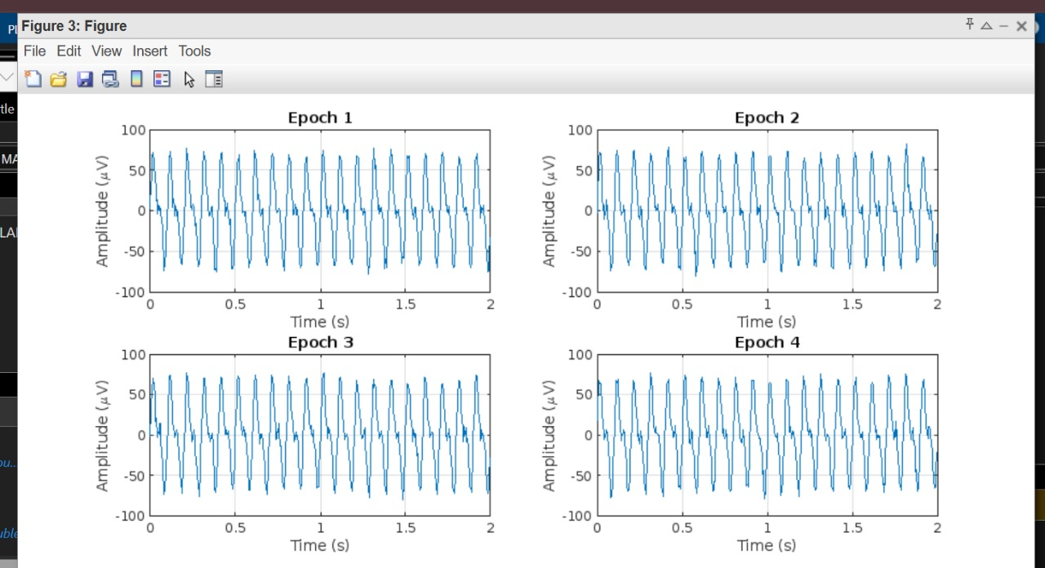
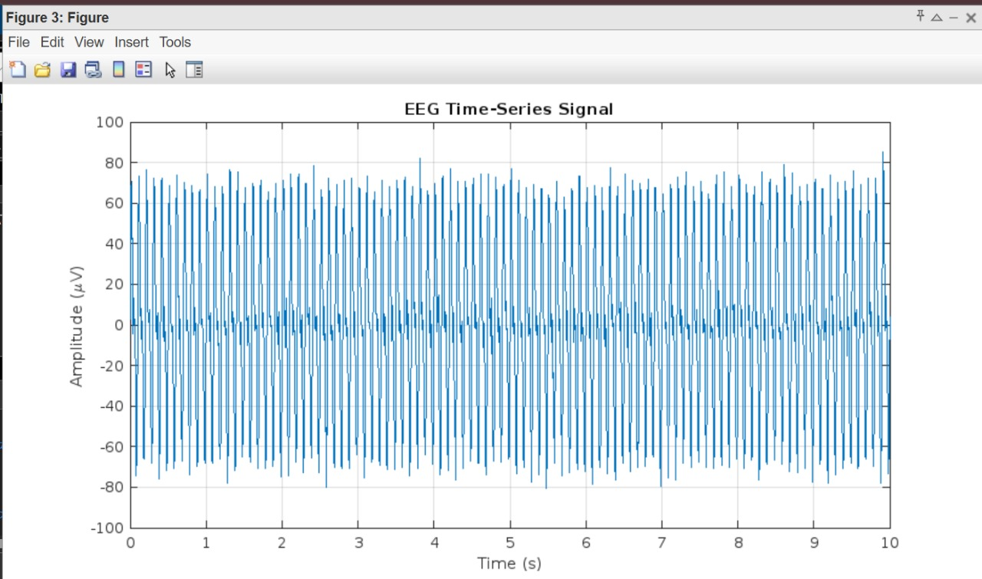

RESULTS & DISCUSSIONS:

Results:

- EEG Time-Series Plot:
  - The time-domain plot of the synthetic EEG signal displayed a combination of rhythmic waveforms and random noise.
  - The main frequency components are clearly visible as oscillations, primarily at 10 Hz and 20 Hz, which were intentionally included in the signal generation.
  - The added noise introduces realistic variability, simulating actual EEG recordings.
- Epoch Segmentation:
  - The 10-second EEG signal was successfully divided into multiple 2-second epochs.
  - Given a sampling frequency of 256 Hz, each epoch contains 512 samples.
  - The number of full epochs created was 5, ensuring each epoch was of equal length and aligned properly with the time series.
- Epoch Visualization:
  - The first four epochs were plotted individually in a grid format.
  - Each epoch displayed consistent waveform patterns, but also showed subtle variations due to the noise, mimicking the dynamic nature of real EEG data.
  - The rhythmic 10 Hz and 20 Hz components remained visible across all epochs.

Discussion:

- This analysis demonstrates how EEG signals can be explored in the time domain by visualizing the full time series and segmenting it into shorter, fixed-length intervals (epochs).
- Epoch segmentation is crucial in EEG analysis because brain states often change over short time periods. By examining the signal in chunks, we can analyze features like amplitude, frequency, and noise characteristics more effectively.
- Even though the EEG signal used in this example is synthetic, the process is directly applicable to real EEG data. In clinical or research settings, these epochs can be further analyzed to detect patterns associated with different mental states (e.g., sleep stages, cognitive load, or seizure activity).
- The use of two known frequency components (10 Hz and 20 Hz) mimics alpha and beta waves in actual EEG recordings. The alpha band (8–13 Hz) is often linked with relaxed states, while beta (13–30 Hz) relates to active thinking and focus.
- Noise in EEG recordings is common due to muscle activity, eye movements, or external electrical sources. In this simulation, white noise was added to reflect that reality.

