INTRODUZIONE
WHY BGP?
Once upon a time, when the Internet was just a tiny cloud, there were only a few networks connected to each other. As a result, routing between network nodes was quite static. All that needed to be done to set up routing was to define network nodes and make connections between them as needed.
As we all know, the Internet didn’t stay small for very long. It began to incorporate more and more networks, which necessitated a more dynamic routing system.
As the Internet continued to expand, it became increasingly difficult to keep track of all the routes from one network to another. The solution was to transition to an Autonomous System (AS) architecture.
An AS can be an Internet Service Provider, a university or an entire corporate network, including multiple locations (IP addresses). Each AS is represented by a unique number called an ASN.
As the number of autonomous systems in the internet grew, the drawbacks of EGP became more pronounced. Its hierarchical structure hampered scalability and made it difficult to connect new networks in an efficient manner. Consequently, it was necessary to define a new exterior routing protocol that would provide enhanced and more scalable capabilities.
In June 1989, the first version of this new routing protocol, known as the Border Gateway Protocol, was formalized.
The Border Gateway Protocol has been in use on the Internet since 1994.
IPv6 BGP was first defined in RFC 1883 in 1995, and it was improved to RFC 2283 in 1998
***metterci che ora siamo al bgp4 per poi dire nelle successive sezioni che l’utilizzo è scarso eprchè per usarelo bisognerebbe aggiornare tutti gli autonomous system e che ciò oltre a essere difficile è costoso?******
WHAT IS BGP?
BGP (Border Gateway Protocol) is the protocol underlying the global routing system of the internet. When one network router is connected to other networks it cannot determine which network is the best network to send its data to by itself. Border Gateway Protocol considers all peering partners that a router has and sends traffic to the router that is closest to the data’s destination. This communication is possible because, at boot, BGP allows peers to communicate their routing information and then stores that information in a Routing Information Base (RIB).
We can think about BGP as a postal service of the Internet. When someone drops a letter into a mailbox, the postal service processes that piece of mail and chooses a fast, efficient route to deliver that letter to its recipient. You can think of an autonomous system in the computer world as a city with many streets. A network prefix is similar to one street with many houses. An IP address is like an address for a particular house in the real world, while a packet is the equivalent of a car travelling from one house to another using the best possible route. So our postal service (BGP) to deliver as fast as can will determinate the best route by different factors, such as traffic congestion, roads temporarily closed for maintenance, etc. The path is calculated dynamically depending on the situation of the network nodes, which are like roads and junctions.
------------------------------------------------------------------------------------------------------------------------
more precisely (detailed, o comunque passando da un linguaggio informale ad uno formale. Si potrebbe fare un’introduzione super veloce su cosa sono egp e igp per così poi introdurre bgp, dato che è un egp tecnicamente. (del tipo, prima di parlare più approfonditamente di gbp dovremmo distinguere egp e igp.) , BGP is an exterior gateway protocol (EGP) that is used to exchange routing information among routers in different autonomous systems (ASs). BGP routing information includes the complete route to each destination. BGP uses the routing information to maintain a database of network reachability information, which it exchanges with other BGP systems. BGP uses the network reachability information to construct a graph of AS connectivity, which enables BGP to remove routing loops and enforce policy decisions at the AS level.
BGP allows for policy-based routing. You can use routing policies to choose among multiple paths to a destination and to control the redistribution of routing information.
BGP uses TCP as its transport protocol, using port 179 for establishing connections. Running over a reliable transport protocol eliminates the need for BGP to implement update fragmentation, retransmission, acknowledgment, and sequencing.
It manages how packets get routed from network to network through the exchange of routing and reachability information among edge routers. BGP directs packets between autonomous systems (AS). BGP creates network stability by guaranteeing routers can adapt to route failures: when one path goes down, a new path is quickly found. BGP makes routing decisions based on paths, defined by rules or network policies set by network administrators.
BGP offers network stability that guarantees routers can quickly adapt to send packets through another reconnection if one internet path goes down. BGP makes routing decisions based on paths, rules or network policies configured by a network administrator. Each BGP router maintains a standard routing table used to direct packets in transit. BGP uses client-server topology to communicate routing information, with the client-server initiating a BGP session by sending a request to the server.

What is an autonomous system?
An autonomous system (AS) is a set of routers that are under a single technical administration and normally use a single interior gateway protocol and a common set of metrics to propagate routing information within the set of routers. To other ASs, an AS appears to have a single, coherent interior routing plan and presents a consistent picture of what destinations are reachable through it. If we continue to think of BGP as the postal service of the Internet, AS’s are like individual post office branches. A town may have hundreds of mailboxes, but the mail in those boxes must go through the local postal branch before being routed to another destination. The internal routers within an AS are like mailboxes, they forward their outbound transmissions to the AS, which then uses BGP routing to get these transmissions to their destinations. The structure of the Internet is constantly changing, with new systems popping up and existing systems becoming unavailable. Because of this, every AS must be kept up to date with information regarding new routes as well as obsolete routes. This is done through peering sessions where each AS connects to neighboring AS’s with a TCP/IP connection for the purpose of sharing routing information. Using this information, each AS is equipped to properly route outbound data transmissions coming from within.
Here’s where part of our analogy falls apart: Unlike post office branches, autonomous systems are not all part of the same organization. As such, they have no reason to be friendly to each other and are often times business competitors! For this reason, BGP routes sometimes will not only consider the the shortest AS path to reach the destination but it will also take business considerations into account. Autonomous Systems often charge each other to carry traffic across their networks, and the price of access can be factored into which route is ultimately selected.

HOW BGP WORK?
To guarantee the reliability of transmission, BGP is encapsulated into a TCP connection, meaning that two routers that want to establish a BGP session must have prior IP reachability. After establishing a TCP connection, the two routers – hereafter called BGP peers – agree on the parameters to use in the BGP session via BGP open messages, and then start exchanging routes. These routes can be generated by the peer itself or they can be learned by the peer via other BGP sessions, and each of them is announced via BGP update messages. Whenever a route is received from an AS, the route is subject to a filtering process where it can be discarded or accepted and, if required, its path attributes are manipulated. Then a BGP decision process is applied to select the best route for each IP destination network, since an AS may receive multiple routes toward the same IP network from different peers.
The BGP decision process is composed of a sequence of steps that allow the AS to choose the best route by analyzing the path attributes of each of the candidates, in order to apply criteria that range from pure commercial (e.g. prefer a cheaper provider over the other) to technical reasons (e.g. transit traffic to reach a destination via the smallest number of ASes). Each best route is then installed in the routing table of the router and used to forward traffic. Eventually, after a proper attribute manipulation, each best route is propagated to the all other BGP peers, or a subset of them depending upon the output filtering process applied.

FINE INTRODUZIONE GENERALE – SI PASSA ALLE VULNERABILITÀ- QUESTE POCHE RIGHE SONO DA COLLANTE
Having this general knowledge about routing we are now able to understand how Border Gateway Protocol (BGP) works. Based on this general knowledge from we now are able to discuss the specific security issues with BGP. The biggest problem, however, is that BGP is extremely vulnerable to both malicious attacks and human error. There are roughly 65,000 AS’s that make up the global internet, and little to no oversight for how each AS peering filters must be configured. This means that if a new, bogus route (aka a bogon prefix) is announced (either through intentional hijacking or just a typo) it sends traffic to the wrong network, and can spread like wildfire across the internet.

VULNERABILITÀ

It is clear that the Internet is vulnerable to attack through its
routing protocols and BGP is no exception. Faulty, misconfigured, or
deliberately malicious sources can disrupt overall Internet behavior
by injecting bogus routing information into the BGP-distributed
routing database (by modifying, forging, or replaying BGP packets).
The same methods can also be used to disrupt local and overall
network behavior by breaking the distributed communication of
information between BGP peers. The sources of bogus information can
be either outsiders or true BGP peers.

Cryptographic authentication of peer-peer communication is not an
integral part of BGP. As a TCP/IP protocol, BGP is subject to all
TCP/IP attacks, e.g., IP spoofing, session stealing, etc. Any
outsider can inject believable BGP messages into the communication
between BGP peers, and thereby inject bogus routing information or
break the peer-peer connection. Any break in the peer-peer
communication has a ripple effect on routing that can be widespread.
Furthermore, outsider sources can also disrupt communications between
BGP peers by breaking their TCP connection with spoofed packets.
Outsider sources of bogus BGP information can reside anywhere in the
world.
BGP speakers themselves can inject bogus routing information, either
by masquerading as any other legitimate BGP speaker, or by
distributing unauthorized routing information as themselves.
Historically, misconfigured and faulty routers have been responsible
for widespread disruptions in the Internet. The legitimate BGP peers
have the context and information to produce believable, yet bogus,
routing information, and therefore have the opportunity to cause
great damage. The cryptographic protections of [TCPMD5] and
operational protections cannot exclude the bogus information arising
from a legitimate peer. The risk of disruptions caused by legitimate
BGP speakers is real and cannot be ignored.

Bogus routing information can have many different effects on routing
behavior. If the bogus information removes routing information for a
particular network, that network can become unreachable for the
portion of the Internet that accepts the bogus information. If the
bogus information changes the route to a network, then packets
destined for that network may be forwarded by a sub-optimal path, or
by a path that does not follow the expected policy, or by a path that
will not forward the traffic. Consequently, traffic to that network
could be delayed by a path that is longer than necessary. The
network could become unreachable from areas where the bogus
information is accepted. Traffic might also be forwarded along a
path that permits some adversary to view or modify the data. If the
bogus information makes it appear that an autonomous system
originates a network when it does not, then packets for that network
may not be deliverable for the portion of the Internet that accepts
the bogus information. A false announcement that an autonomous
systems originates a network may also fragment aggregated address
blocks in other parts of the Internet and cause routing problems for
other networks.

The damages that might result from these attacks include:

starvation: Data traffic destined for a node is forwarded to a
part of the network that cannot deliver it.

network congestion: More data traffic is forwarded through some
portion of the network than would otherwise need to carry the
traffic.
blackhole: Large amounts of traffic are directed to be forwarded
through one router that cannot handle the increased level of
traffic and drops many/most/all packets.

delay: Data traffic destined for a node is forwarded along a path
that is in some way inferior to the path it would otherwise take.

looping: Data traffic is forwarded along a path that loops, so
that the data is never delivered.

eavesdrop: Data traffic is forwarded through some router or
network that would otherwise not see the traffic, affording an
opportunity to see the data.

partition: Some portion of the network believes that it is
partitioned from the rest of the network, when, in fact, it is
not.

cut: Some portion of the network believes that it has no route to
some network to which it is, in fact, connected.

churn: The forwarding in the network changes at a rapid pace,
resulting in large variations in the data delivery patterns (and
adversely affecting congestion control techniques).

instability: BGP becomes unstable in such a way that convergence
on a global forwarding state is not achieved.

overload: The BGP messages themselves become a significant portion
of the traffic the network carries.

resource exhaustion: The BGP messages themselves cause exhaustion
of critical router resources, such as table space.

address-spoofing: Data traffic is forwarded through some router or
network that is spoofing the legitimate address, thus enabling an
active attack by affording the opportunity to modify the data.

These consequences can fall exclusively on one end-system prefix or
may effect the operation of the network as a whole.

-------------------------------------------------------------------------------------------------------------------------
BGP protocol has allowed network operators to apply and enforce the most varied inter-AS routing policies during the past 30 years. It is amazing how this protocol efficiently sustained the ever-increasing number of subnets and AS’s, as well as the evolution of the Internet from a mostly hierarchical structure made of customers and providers to a structure where peering and IXPs become more important every day.
Despite all its good qualities, BGP shows several vulnerabilities which, if exploited, can cause ripple effects all over the Internet.
The root of the problem is that BGP was conceived in an early development stage of the Internet when there were only a few players. Consequently, its design didn’t consider protection against deliberate or accidental errors, so malicious or misconfigured sources can potentially propagate fake routing information all over the Internet, exploiting this lack of protection. Even worse, the source of fake or malicious routing information could be either a real BGP peer or a fake peer, since BGP runs on TCP/IP and is consequently subject to every classic TCP/IP attack such as IP spoofing.
Part of the problem can be solved applying cryptographic authentication on each BGP peer, but this won’t help stop bogus information spreading all over the Internet from legitimate misconfigured sources (route leaks), from legitimate sources which either didn’t apply cryptographic authentication at all, or from sources that deliberately announced bogus routing information (prefix hijacks).

---------------------------------

Prefix Hijack Attacks
Prefix hijacks are deliberate intentional generation of bogus routing information; the reasons behind them are of a multitude that is difficult to fathom.
The attacker could announce routes to disrupt the services running on top of the IP space covered by the routes, or hijack the traffic to analyze confidential information flowing towards that service. The attacker could also simply announce routes with a crafted AS path to show fake neighboring connections in famous websites Or even worse, the attacker could hijack the traffic to manipulate the flowing packets at his/her will, or simply want to exploit unused routes to generate spam.

Let’s consider the above scenario to better understand how prefix hijacks can be performed; we will consider the following topology in this and in the following examples. AS 5 is a malicious attacker and is connected to the Internet via two providers: AS 2 and AS 3. AS 1 is customer of AS 2 and provider of AS 3, while AS 4 is a peer of AS 2 and AS 2 is provider of AS 3. Finally, we assume that AS 2 has properly set its incoming BGP filters, while AS 1 and AS 3 have a loose filter configuration (if any).
In this first scenario, AS 5 will announce networkP , which is owned and already announced by AS 4. Due to the filter configurations described above, the Update message announced by AS 5 will be dropped by AS 2, while it will be accepted by AS 3. AS 3 will then announce that to its providers (AS 1 and AS 2). AS 2 will again drop the packet due to the filters, while AS 1 will accept it. If the BGP decision process of AS 1 will select as best route the path from AS 5, then traffic from AS 1 to AS 5 will be sent to the attacker instead of towards the proper owner.
***Il problema qua è copiare palesemente anche le immagini, forse è meglio evitare esempi per far capire meglio? Oppure si potrebbe rielaborare la parte successiva che porta lo scenario alla situazione reale. Forse la cosa migliore sarebbe fregarci la’immagine perchè si può copiare l’immagine, ma rielaborare quello che dice con parole nostre, così non sembra palesemente copiato***
Consider now this example to be composed of about 65,000 AS’s, each with its own filter policy, if any. The consequence is that part of the Internet will redirect its traffic towards the attacker, while the rest will redirect its traffic towards the proper origin. The amount of AS’s redirecting their traffic towards the attacker will depend on two factors: the quality of the filters applied by the providers, and the BGP decision process output of each AS.
Note that in this scenario it is possible to identify the attacker by checking BGP packets involving P either from route collectors (with a proper post-mortem analysis), via dedicated real-time BGP monitoring systems, and via customer complaints, since traffic is not re-directed to the original owner.
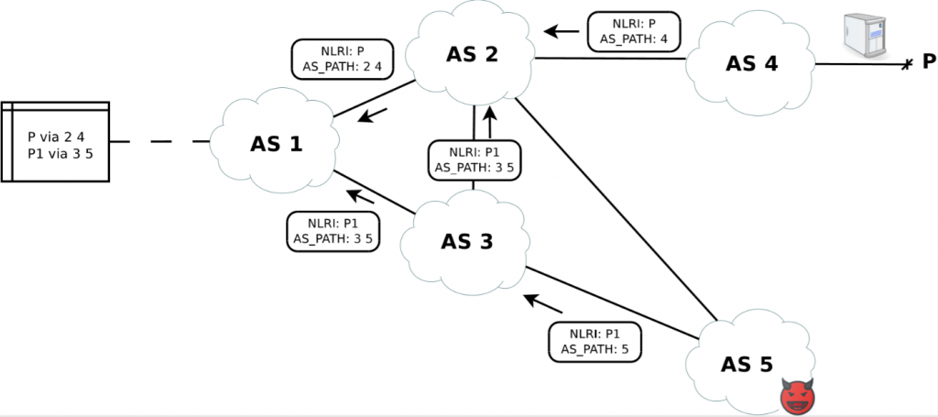
Let’s now consider another scenario on the very same topology. AS 5 will now announce network P1 subnet of network P, still owned by AS 4 but never advertised by AS 4. For example, consider P to be 10.0.0.0/23, then P1 could either be 10.0.0.0/24 or 10.0.1.0/24. AS 5 will announce it only to AS 3, knowing that AS 3 filters are loose. In addition, AS 5 will know that AS 2’s filters are tight and will exploit that to keep a safe route towards the destination.
In this scenario, P1 will propagate the same way as P in the previous scenario. The slight difference is that now every affected AS will have two different routes for the IP space covered by P: P and P1. Let’s focus on AS 1. Even if a proper route to P is installed in AS 1’s router, only a portion of traffic of the original P will be directed to the proper owner due to the longest prefix match. Please note that since AS 5 kept one of its providers explicitly out of the hijack, AS 5 can now route traffic received from AS 1 directed to P1 to the proper owner, after analyzing and/or manipulating each packet.
Now consider again this real-world example and imagine that AS 4 is hosting on P1 some servers of a bank. Consider now that the attacker is interested in collecting data from the bank, and that he/she studied the problem deeply enough to know that P1 is the ideal target for its purposes and starts announcing it.Differently from the previous scenario, the bogus routing information spread will now depend only on the quality of the filters applied by AS’s, since the subnet P1 and P will not interfere with each other in BGP decision processes. As soon as everything is set up, then AS 5 will be able to receive data from the affected portion of the world, while keeping a safe routing leg to forward traffic and (hopefully for him/her) get unnoticed.
Again, note that in this scenario it is still possible to identify the attacker by checking BGP packets involving P and any subnet of P either from route collectors or via dedicated real-time BGP monitoring systems. However, the network operator can’t identify the attack from the complaints received by his/her customers if the delay introduced by the attacker is short enough to go unnoticed.
An example of a route leak which falls perfectly in this scenario is the infamous hijack of YouTube prefixes by Pakistan Telecom back in late February 2008. In that case, Pakistan Telecom attempted to blackhole traffic towards 208.65.153.0/24 by announcing routes where Pakistan Telecom was appearing as the origin AS to fulfill a censorship request from the Pakistan government. The problem is that they also announced this route to its provider PCCW, which didn’t apply proper filters and caused a domino effect, causing about 3 hours of service disruption to YouTube.
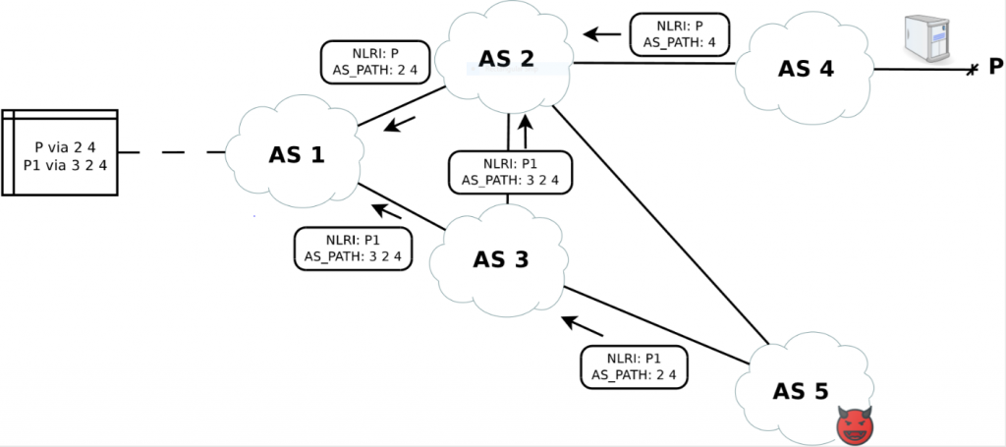
Consider now the above scenario. AS 5 is now smart enough to forge a fake AS path in the Update message by keeping the AS of the real owner at the end of the AS path as well as the original provider of the real owner (AS 2).
The propagation of the attack is the same as the previous examples, but now the detection of the attack is much harder. It is still possible to check BGP packets involving P and any subnet of P either from route collectors or via dedicated real-time BGP monitoring systems, but now the detection of the attack must also rely on additional pieces of information, such as the knowledge of each relationship between each pair of AS’s in the AS path. Indeed, in this example it would have been possible to detect that since AS 3 is customer of AS 2, and the AS path 3 2 4 detected at AS 1 would have shown the involvement of AS 3 as transit of AS 2 for P1, which is against the valley-free property.

Route Leaks and Fat Finger Syndrome
Route leaks are unintentional generation of bogus routing information caused by router misconfigurations, such as typos in the filter configuration or mis-origination of someone’s else network (fat finger). Even if unintentional, the consequences of a route leak can be the same as the prefix hijacks.
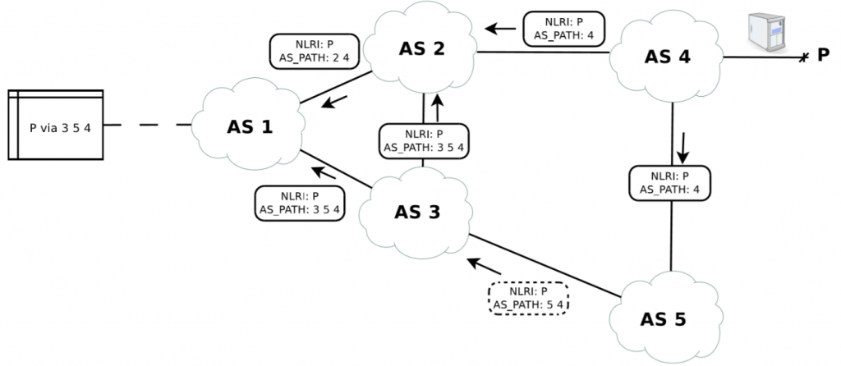Consider the very same topology we used in the prefix hijack examples, with the difference that AS 5 is now a normal network operator which simply applied wrong BGP filters, such as “accept everything from my provider, announce everything to my provider.” This is sadly not an uncommon case, and it is an error that several AS’s can do when switching from a single provider (where this rule works fine) to multiple providers (where this rule would make the AS a transit of each provider).
Due to that mistake, now AS 5 will propagate everything it receive from its provider towards another provider, clearly against the valley-free property. This piece of routing information will then spread all over the Internet and AS’s will start routing traffic depending on the result of the BGP decision process of each AS.
Now think again about the 65,000 AS’s in the Internet and imagine that AS 4 is a rural service provider with few resources, both technical and economic. This would mean that probably the upstream connection he/she bought from his/her providers is very limited, thus making the two links a bottleneck in this route leak scenario. In this case it is possible that AS 5 will not be able to handle the amount of traffic directed to P, causing not only an additional delay, but also several packet losses.
-------------------------------------------------------------------------------------------------------------------------------
Attacks

BGP, in and of itself, is subject to the following attacks. (The
list is taken from the IAB RFC that provides guidelines for the
"Security Considerations" section of RFCs [SecCons].)

confidentiality violations: The routing data carried in BGP is
carried in cleartext, so eavesdropping is a possible attack
against routing data confidentiality. (Routing data
confidentiality is not a common requirement.)

replay: BGP does not provide for replay protection of its
messages.

message insertion: BGP does not provide protection against
insertion of messages. However, because BGP uses TCP, when the
connection is fully established, message insertion by an outsider
would require accurate sequence number prediction (not entirely
out of the question, but more difficult with mature TCP
implementations) or session-stealing attacks.

message deletion: BGP does not provide protection against
deletion of messages. Again, this attack is more difficult
against a mature TCP implementation, but is not entirely out of
the question.

message modification: BGP does not provide protection against
modification of messages. A modification that was syntactically
correct and did not change the length of the TCP payload would in
general not be detectable.

man-in-the-middle: BGP does not provide protection against man-
in-the-middle attacks. As BGP does not perform peer entity
authentication, a man-in-the-middle attack is child's play.

denial of service: While bogus routing data can present a denial
of service attack on the end systems that are trying to transmit
data through the network and on the network infrastructure itself,
certain bogus information can represent a denial of service on the
BGP routing protocol. For example, advertising large numbers of
more specific routes (i.e., longer prefixes) can cause BGP traffic
and router table size to increase, even explode.
Vulnerabilities and Risks

The risks in BGP arise from three fundamental vulnerabilities:

(1) BGP has no internal mechanism that provides strong protection of
the integrity, freshness, and peer entity authenticity of the
messages in peer-peer BGP communications.

(2) no mechanism has been specified within BGP to validate the
authority of an AS to announce NLRI information.

(3) no mechanism has been specified within BGP to ensure the
authenticity of the path attributes announced by an AS.
3.1. Vulnerabilities in BGP Messages

***roba che non sò se serve copiare perchè andiamo troppo nello specifico***
3.1.1. Message Header

Event 21: Each BGP message starts with a standard header. In all
cases, syntactic errors in the message header will cause the BGP
speaker to close the connection, release all associated BGP
resources, delete all routes learned through that connection, run its
decision process to decide on new routes, and cause the state to
return to Idle. Also, optionally, an implementation-specific peer
oscillation damping may be performed. The peer oscillation damping
process can affect how soon the connection can be restarted. An
outsider who could spoof messages with message header errors could
cause disruptions in routing over a wide area.
***roba che non sò se serve copiare perchè andiamo troppo nello specifico***

ALTRO PARAGRAFO/CAPITOLO
Protection of BGP Sessions
The following subsections list the major points to TCP session protection for BGP operation

Protection of TCP Sessions Used by BGP

Attacks on TCP sessions used by BGP (aka BGP sessions), for example, sending spoofed TCP RST packets, could bring down a BGP peering. Following a successful ARP spoofing attack (or other similar man-in-the-middle attack), the attacker might even be able to inject packets into the TCP stream (routing attacks).
BGP sessions can be secured with a variety of mechanisms. MD5 protection of the TCP session header was the first such mechanism. It has been obsoleted by the TCP Authentication Option, which offers stronger protection. While MD5 is still the most used mechanism due to its availability in vendors' equipment, TCP-AO should be preferred when implemented.
IPsec could also be used for session protection.
The drawback of TCP session protection is additional configuration and management overhead for the maintenance of authentication information (for example, MD5 passwords). Protection of TCP sessions used by BGP is thus NOT REQUIRED even when peerings are established over shared networks where spoofing can be done (like IXPs), but operators are RECOMMENDED to consider the trade-offs and to apply TCP session protection where appropriate.
Furthermore, network administrators SHOULD block spoofed packets (packets with a source IP address belonging to their IP address space) at all edges of their network . This protects the TCP session used by Internal BGP (IBGP) from attackers outside the Autonomous System.
BGP TTL Security (GTSM)

BGP sessions can be made harder to spoof with the Generalized TTL
Security Mechanisms (GTSM aka TTL security).
Instead of sending TCP packets with TTL value of 1, the BGP speakers
send the TCP packets with TTL value of 255, and the receiver checks
that the TTL value equals 255. Since it's impossible to send an IP
packet with TTL of 255 to an IP host that is not directly connected,
BGP TTL security effectively prevents all spoofing attacks coming
from third parties not directly connected to the same subnet as the
BGP-speaking routers. Network administrators SHOULD implement TTL
security on directly connected BGP peerings.

GTSM could also be applied to multi-hop BGP peering as well. To
achieve this, TTL needs to be configured with a proper value
depending on the distance between BGP speakers (using the principle
described above). Nevertheless, it is not as effective because
anyone inside the TTL diameter could spoof the TTL.

Like MD5 protection, TTL security has to be configured on both ends
of a BGP session.

