Programming Assignment 2 Report

|  |  |
| --- | --- |
| Student: | Fredric Eriksson Sepulveda fe222pa@lnu.se |

# Project Idea

Made by Fredric Eriksson

System that stores data for a library, the user who is supposed to be the clerk would be able to see all books, if said book is being lend and time until the book is back.

The book data comes from this website <https://gist.github.com/jaidevd/23aef12e9bf56c618c41>and generated names <https://extendsclass.com/csv-generator.html>

This idea might be fit for a clerk because it allows them to add new books and check their availability at the moment

# Schema Design

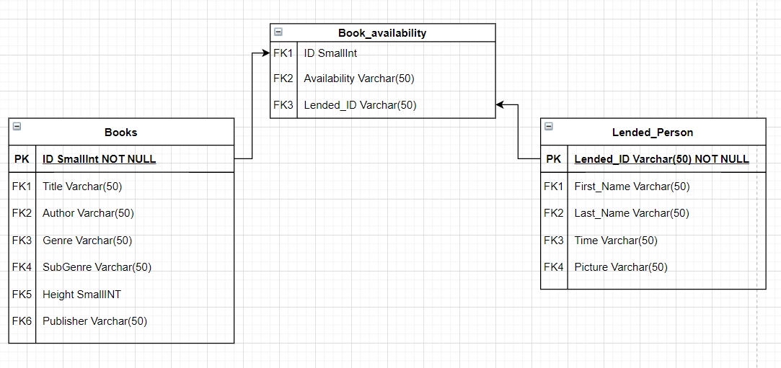

The table Books is meant to keep all information regarding the books that are in the library, each Title has their own unique ID which is used by the next table.

Book_availability: Is the table that tracks if a book is taken, and saves IDs from the lent person

Lended_Person saves all information about customers that have made a previous book loan, they have their own table because it may be possible that customers with the same name to loan different books, that is why each have their own loan IDs to prevent confusion. Picture column is just a reference to a folder in the pc and I am using the term “PlaceHolderImage.png” because I lack 50 pictures of people and I rather not get in trouble by posting peoples faces without their consent, but in a real library this picture would be of the persons ID so the clerk can identify the person.

# SQL Queries

Q1 Find the number books as per genre (In order to know how many Bookshelves, the library needs, the clerk needs per genre since different bookshelves per genre)

select count(Title) as Amount_of_Books_per_Genre, Genre from books

group by Genre

Q2 Find if book “X” is available

Select books.Title, book_availability.availability, book_availability.lended_ID From books

Inner Join book_availability

On books.id = book_availability.id where Title = "X"

In addition this linked is linked to a View Function with the name of Book_Storage Create View Book_Storage as

Select books.Title, book_availability.availability, book_availability.lended_ID

From books

Inner Join book_availability

On books.id = book_availability.id

Which the clerk is meant to use

Select * from book_storage Where Title = "X"

Q3 Until When book “X” should be returned (in order to only show the time until the book should be back, also helps with potential security breaches because it does not show any user information at all)

Select lended_person.Time, book_storage.Title from lended_person

Inner Join book_storage

On book_storage.Lended_ID = lended_person.Lended_ID

View function is called Deadlines (same procedure as explained before)

Create View Deadlines as

…

Select * From Deadlines Where Title = "X"

Q4 Find all information of customers related to the title of “X” book

// create View Customers_data as

Select book_storage.title, lended_person.First_name, lended_person.Last_name, lended_person.Picture

from book_storage

inner Join lended_person

On book_storage.Lended_id = lended_person.Lended_id

Select * from Customers_data Where Title = “X”

Q5 To Identify how many customers tomorrow are supposed to deliver a book the next day select count(Lended_id) as Tomorrows_deliveries, Time

from lended_person where time = "(date)" group by time

# Discussion and Resources

A more realistic approach would be to consider if there are more than 1 of the same book, I decided to keep it simple by following the advice of the hints. But surely it would be an implementation I would add in a real-life scenario

Source Code [https://github.com/Sample587/1DV503-Assignment-2-] Video demonstration: [https://[www.youtube.com/watch?v=EGr-ccMZhl0](http://www.youtube.com/watch?v=EGr-ccMZhl0)]