**TRINITY PRIMARY SCHOOL-BUKOTO**

|  |  |
| --- | --- |
| **For examiner’s use only** | |
| **A** |  |
| **B** |  |
| **TOTAL** |  |

**REVISION WORK**

**CLASS: P.3**

**LEARNING AREA: LITERACY**

**TIME ALLOWED: 2HOURS 15 MINUTES**

Name __________________________________________Stream __________

**SECTION A 40MARKS**

1. Name one thing found in a classroom.

_______________________________________________________

1. Mention one room found in a house.

________________________________________________________

1. How is a clock useful in a classroom**?**

________________________________________________________

1. Name this important place in a community.

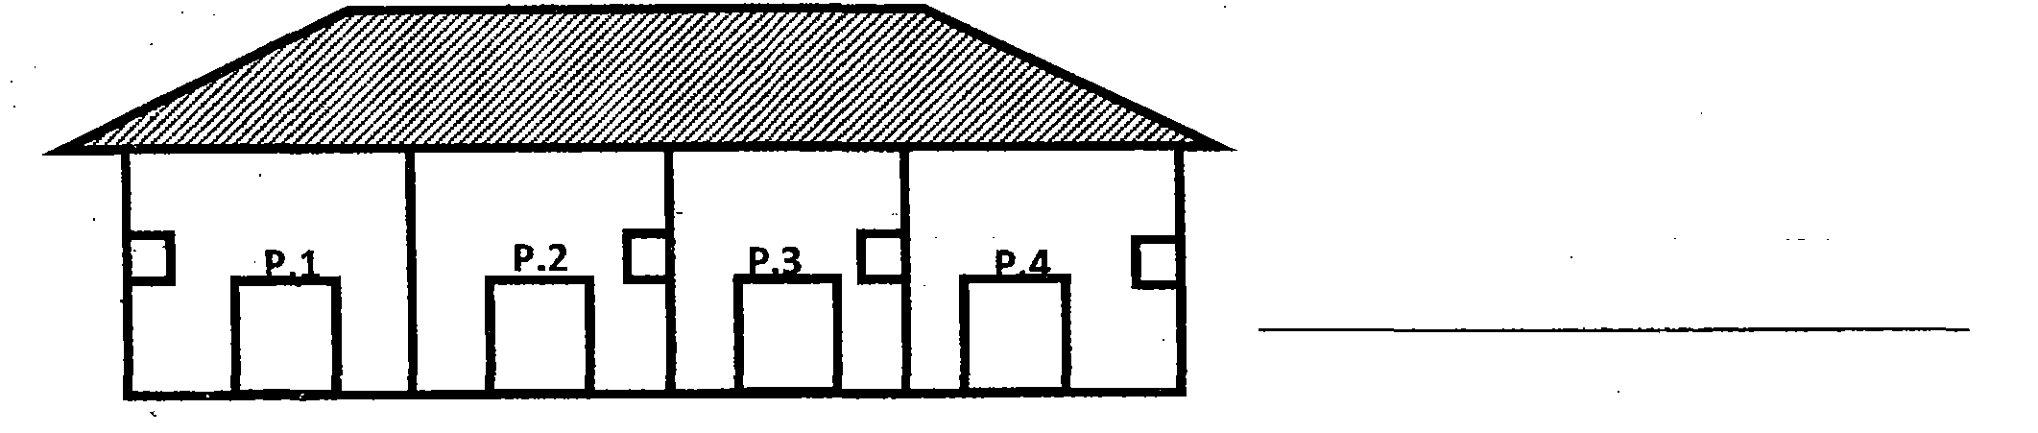

1. Why do we keep cows at home**?**

_________________________________________________________

1. Mention one activity done by children at school.

_______________________________________________________

1. Who breast feeds a baby at home**?**

______________________________________________________

1. Name any one person found in a nuclear family.

_______________________________________________________

1. Why do we need doctors in a community**?**

_____________________________________________________

1. Draw and name any one play object found in our school.

|  |
| --- |
|  |
|  |

1. How do people care for plants in their homes**?**

___________________________________________________

1. Who heads a school**?**

____________________________________________________

1. Which people keep security at school**?**

____________________________________________________

1. Name one bird kept at home.

_______________________________________________________

1. ­­­­­­Give one use of a house.

_____________________________________________________

1. Write the name of your school.

________________________________________________________

1. Draw these things we find in the dining room.

|  |  |
| --- | --- |
|  |  |
| plate | spoon |

1. Write one important person who works in a hospital.

_________________________________________________

1. Name these things made by a carpenter.

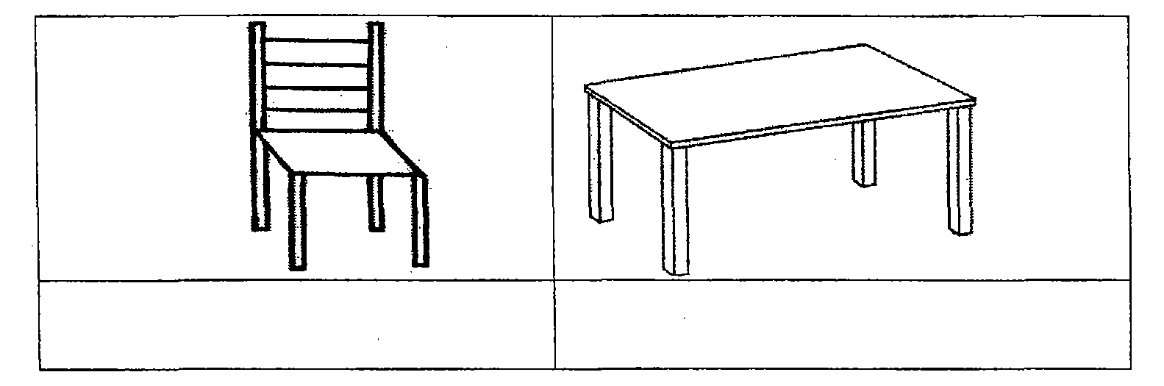

1. Name the item we use for sweeping.

_______________________________________________________

**SECTION B (60 marks)**

1. **Match correctly.**

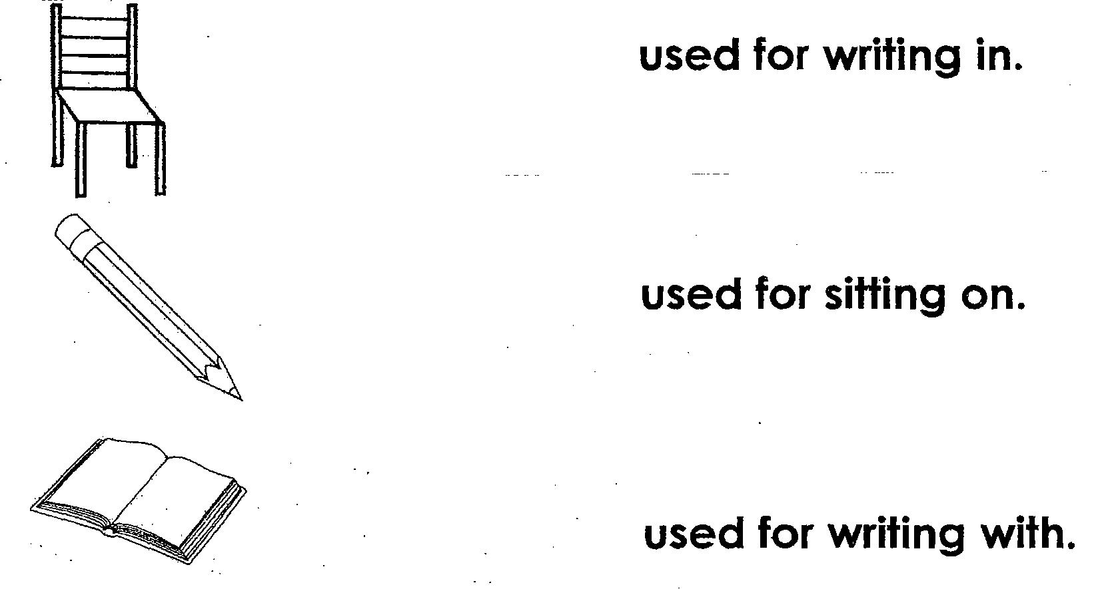

1. (a) Name two types of weather.
   1. ________________________________________________

(ii) ________________________________________________

1. Write two things we can use on a rainy day.
2. ________________________________________________

(ii)_________________________________________________

1. (a) Give two common diseases at school.
   1. ____________________________________________
   2. ____________________________________________

(b) Write two insects which spread diseases to people.

(i) __________________________________________________

(ii) __________________________________________________

1. (a) Name these uses of water at home.

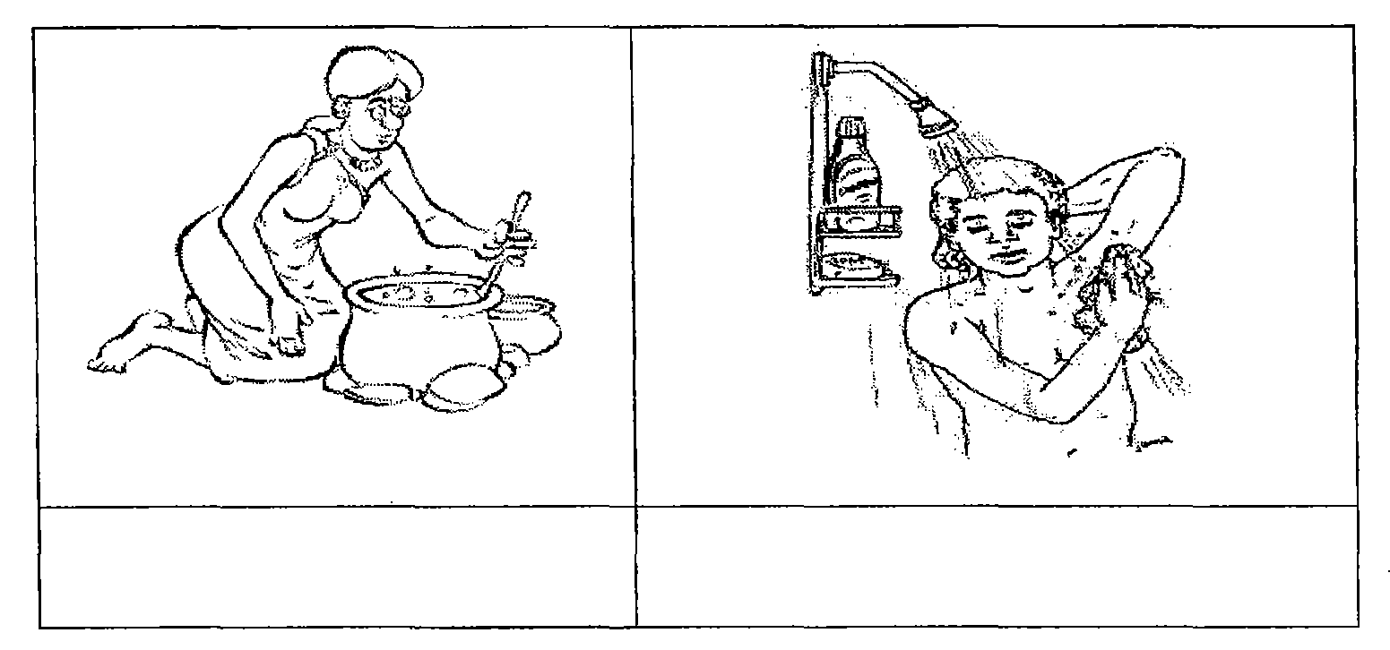

(b)Draw these road signs.

|  |  |
| --- | --- |
|  |  |
| Parking | Zebra crossing |

1. **Match correctly.**

**Item Made from**

pot hides

chair palm leaves

mat wood

bag clay

1. (a)How many legs do these animals have?
   1. Sheep ___________________________________
   2. Duck ____________________________________

(b) How do these animals move?

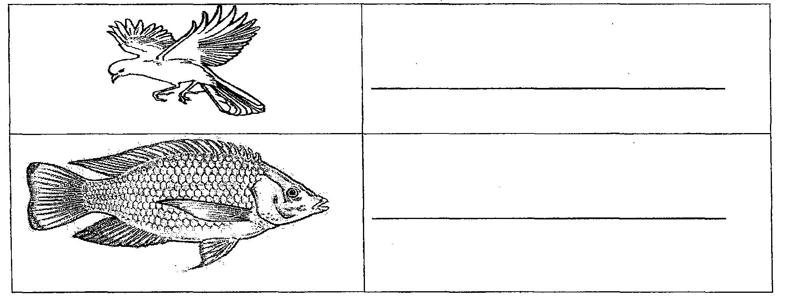

1. (a) How can you keep these parts of the body

clean**?**

* 1. teeth ______________________________________
  2. hands _____________________________________

(b) Give one use of the following;

* 1. eyes _______________________________________
  2. nose _______________________________________

1. (a) Name the parts of the house.

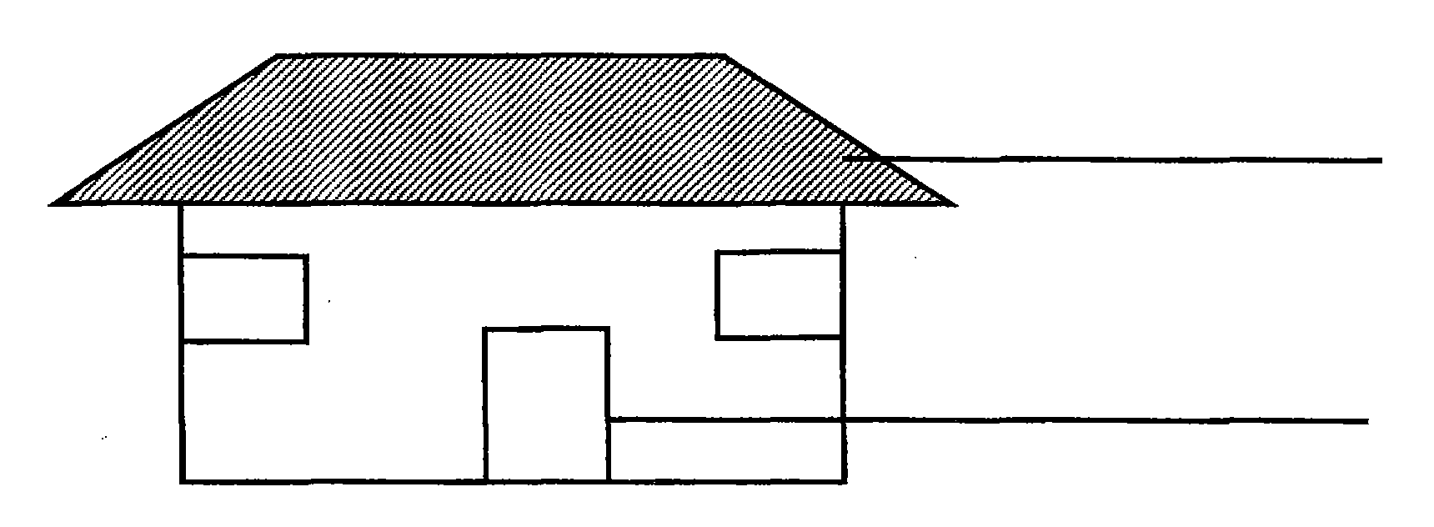

(b) Write two things people use to build houses.

(i) ____________________________________________

(ii) ____________________________________________

1. (a) Name two plants people grow in the garden.

(i) _________________________________________________

(ii) _________________________________________________

(b) Name this part of a plant.

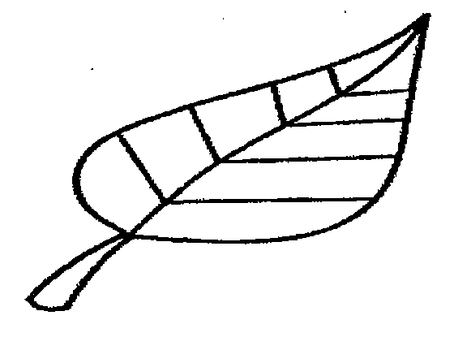_____________________________

(b) How are plants useful to people**?**

_____________________________________________________

1. (a) Name these wild animals

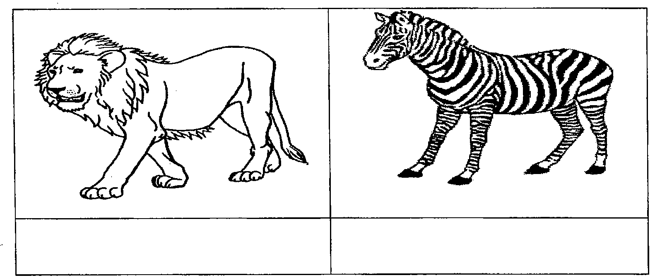

(b) How are wild animals dangerous to people**?**

___________________________________________________**_**

(c) Write one place where wild animals live.

_____________________________________________________

1. (a)Name these things found in a home.

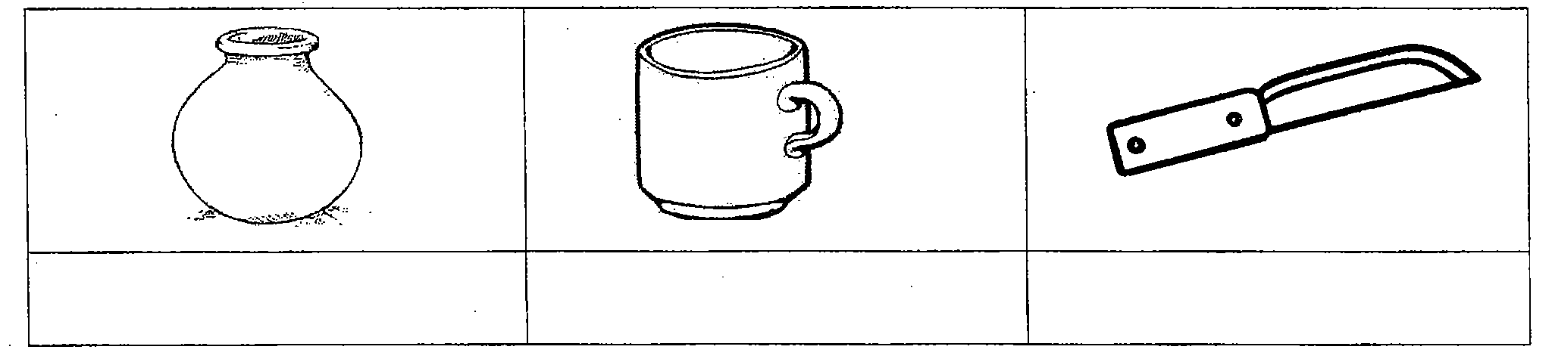

(b) Why do we need a knife at home?

______________________________________________________

1. **Match correctly.**

**People** **place of work**

Head teacher sickbay

Cooks classroom

Nurse office

Librarian kitchen

Teacher library

1. (a)Write two foods we eat at school.

(i) ___________________________________

(ii)___________________________________

(b) Write two important people who work in a school

(i)______________________________________ (ii)________________________________________

1. (a)How do children help their parents at home**?**
   1. __________________________________________
   2. __________________________________________

(b) Write two activities children can do in the field.

(i)_______________________________________________

(ii)________________________________________________

1. (a) Draw the building materials below.

|  |  |  |
| --- | --- | --- |
|  |  |  |
| Nails | Bricks | Iron sheets |

(b) Write two activities done by people in a community.

(i)____________________________________________________

(ii) ___________________________________________________