|  |  |
| --- | --- |
| **SECTION** | **MARKS** |
| **A** |  |
| **B** |  |
| **TOTAL** |  |

**TRINITY PRIMARY SCHOOL – BUKOTO**

**REVISION WORK**

**CLASS : P.3**

**LEARNING AREA : MATHEMATICS**

**Name: _________________________________**

**Date: ________________________________________________**

**SECTION A:**

* + - 1. **Subtract 3**

**- 3**

* + - 1. **Name the set.**

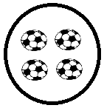**_____________________________________**

* + - 1. **What is the place value of 2 in 320?**
      2. **Draw the shape of a kite.**
      3. **Find the missing numbers.**

**0 , 3 , 6 , 9 , ________**

* + - 1. **Shade the fraction .**

|  |  |  |  |  |
| --- | --- | --- | --- | --- |
|  |  |  |  |  |

* + - 1. **Work out: T O**

**4 7**

**+ 1 8**

* + - 1. **Use a number line to subtract.**

**7 – 2 =**

**0 1 2 3 4 5 6 7 8**

* + - 1. **If 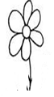represents 2 flowers. How many flowers are represented by?**
      2. **A pen cots shs. 300. What is the cost of 3 pens?**
      3. **Fill in the tens and ones.**

**________ tens _________ ones = 46**

* + - 1. **Tell the time.**

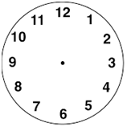

* + - 1. **Add: +**
      2. **Which pot holds more water?**

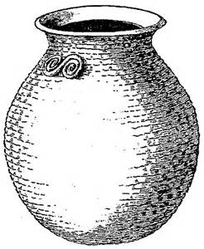 

**C D**

* + - 1. **Draw a set symbol to show A set of goats that fly.**
      2. **Find the missing number.**

**+ 5 = 11**

* + - 1. **A baby slept at 9 o’clock and woke up at 9 o’clock. For how long did the baby sleep?**
      2. **Share 24 mangoes equally among 3 girls. How many mangoes will each get?**
      3. **Find the perimeter of the square below.**

**5cm**

**5cm 5cm**

**5cm**

* + - 1. **Subtract -**

**SECTION B**

* + - 1. **Use the sets below to answer the questions.**

**A B**

 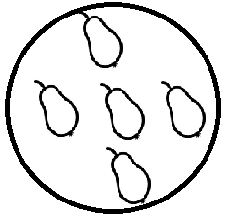

1. **Which set has more members?**
2. **Which set has 4 members?**
3. **How many more members are in set B than set A?**
   * + 1. **(a) Expand 24.**

**(b) Draw beads to represent 305 on the abacus below.**

**H T O**

* + - 1. **(a) Arrange these fractions starting with the smallest.**

$\frac{1}{4}$**, $\frac{1}{2}$, $\frac{1}{3}$**

**(b) Mother gave Tom a full cup of milk. Tom drunk $\frac{1}{2}$ of it. What fraction remained?**

* + - 1. **Study the shopping list below.**

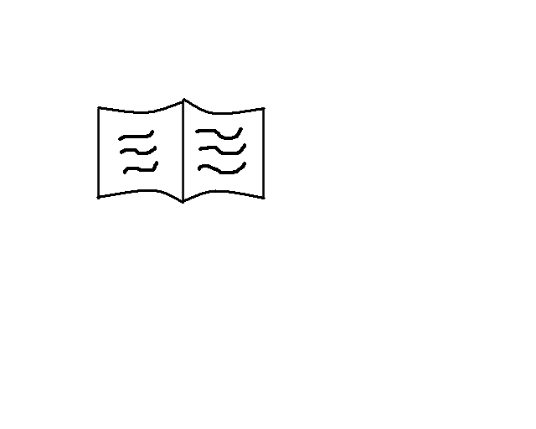 **a book shs 500**

** a pencil shs 200**

** an egg shs 400**

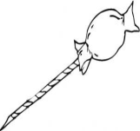 **a sweet shs 300**

1. **What is the cheapest item?**
2. **What is the total cost of a sweet and an egg?**
3. **If Fred had shs 900 and bought a book. How much money did he remain with?**
   * + 1. **Find the missing numbers.**

**÷ 2 = 4**

**X 3 = 15**

**- 1 = 10**

* + - 1. **(a) Write in figures: two hundred sixty three**

**(b) Which number has been expanded to give,**

**900 + 20 + 7 =**

* + - 1. **(a) Name these shapes.**

|  |  |
| --- | --- |
|  |  |
|  |  |

**(b) Draw these shapes.**

|  |  |
| --- | --- |
|  |  |
| **kite** | **cylinder** |

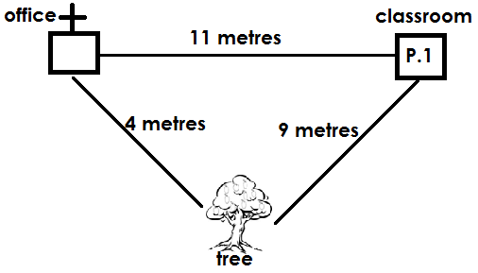

* + - * 1. **What is the distance from the office to the classroom?**
        2. **Which is the shortest distance?**
        3. **Add all the distances.**
      1. **(a) Work out: 5 1**

**- 9**

**(b) A cat has 4 legs. How many legs do 6 cats have?**

* + - 1. **Complete the table.**

|  |  |  |
| --- | --- | --- |
| **+** | **2** | **3** |
| **6** |  |  |
| **4** |  | **7** |
| **1** |  |  |

* + - 1. **Mayo is 17 years old. Brenda is 11 years.**
         1. **Who is older?**
         2. **Find their total age?**
      2. **Study the bar graph and answer the questions. Four pupils picked some mangoes.**
         1. **How many mangoes did Abdul pick?**
         2. **Who picked the highest number of mangoes?**
         3. **Olive picked the same number of mangoes as ___________**
         4. **Find the total number of mangoes picked by all the four pupils.**