**TRINITY PRIMARY SCHOOL- BUKOTO**

**REVISION WORK**

**CLASS: P.3**

**SUBJECT: RE**

**Name: …………………………………………....…..Stream: ……………….**

1. Name these places of worship.

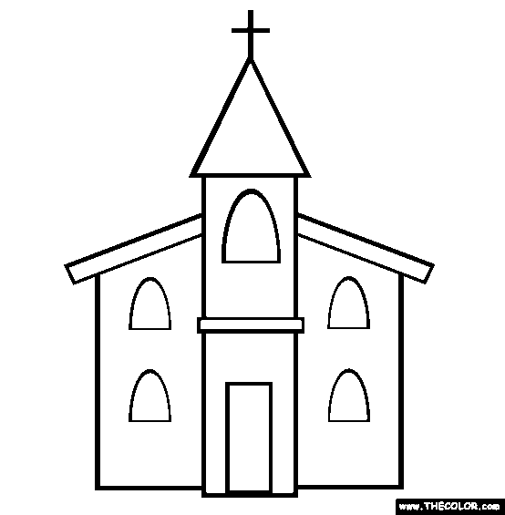 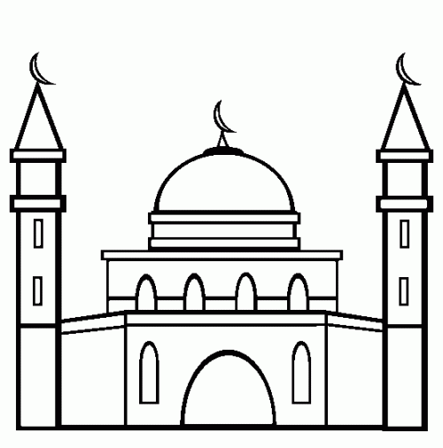

______________________ _________________________

1. (a) Mention any **three** examples of people who baptize people in churches.

(i)_____________________________ (ii)_______________________________

(iv)_____________________________

(b) In the space provide below, draw a priest baptizing a baby.

1. (a) Who died for our sins**? ____________________________________________**
2. State any **two** examples of sins

(i)____________________________________________________

(ii)____________________________________________________

1. What name is given to the holy book for________________________
2. **Match names to their meanings.**

Peter God is with us

Deborah rock

Emmanuel cheater

Isaac bee

Jacob laughter

1. Who was the father of all believers**?**

**________________________________________________________________**

1. In the space below, draw and shade Jesus on the cross
2. List any **three** gospel books.

(i)__________________(ii)___________________(iii)_____________________

1. Draw these things God created.

|  |  |  |
| --- | --- | --- |
| sun | lakes | rivers |
|  |  |  |
| birds | plants |  |
|  |  |  |

(b) How is the sun important to people.

___________________________________________________________________

1. Who was the wife of Adam**?**

**___________________________________________________________________**

1. Who climbed a sycamore tree to see Jesus**?**

**___________________________________________________________________**

1. **Match these correctly.**

Judas Iscariot baptized Jesus

Jesus the father of all believers

John the Baptist betrayed Jesus

Abraham died for our sins

1. God created us with senses. Mention the senses which these sense organs do.
2. nose _______________________________________________________
3. ear _________________________________________________________
4. skin _______________________________________________________
5. tongue ____________________________________________________
6. (a) Who is a Christian**?**

**___________________________________________________________________**

(b) Give **one** importance of a Bible to a Christian.

___________________________________________________________________

1. a) What are customs**?**

______________________________________________________________________

b) Give any **two** examples of traditional customs in our society.

i)__________________________________________________________________

ii) ______________________________________________________________

15. Mention any **two** groups of people who teach us customs.

i)_______________________________ ii) ________________________________

16. Name any **two** books in the New Testament.

(i)___________________________ (ii)____________________________

1. Draw and name any **two** animals which live in water.

|  |  |
| --- | --- |
|  |  |
|  |  |

1. Draw the following needs of a community.

|  |  |  |
| --- | --- | --- |
|  |  |  |
| clothing | shelter | food |

1. God created water for us, name any three uses of water to people.

(i)___________________________________________________________

(ii)___________________________________________________________

(iii)___________________________________________________________

1. Name any **two** commandments of God.

(i)_____________________________________________________________

(ii)_____________________________________________________________

**……………….END……………….**