**SECTION: A (40 MARKS)**

1. Name any one sense organ in man.

………………………………………………………………………………………………………………………………………

1. Mention any one method through which soil is formed.

………………………………………………………………………………………………………………………………………

1. How are canine teeth important to animals like dogs?

………………………………………………………………………………………………………………………………………

1. Write ORS in full.

………………………………………………………………………………………………………………………………………

Use the diagram below to answer question 5.

**X**

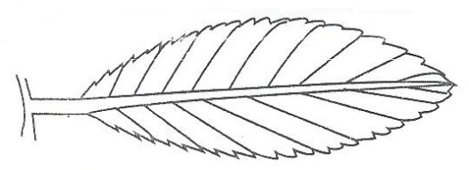

1. Name part marked X shown in the above diagram.

………………………………………………………………………………………………………………………………………

1. Mention one natural change in the environment.

………………………………………………………………………………………………………………………………………

1. How is a rain gauge useful to a farmer in Mbale district?

………………………………………………………………………………………………………………………………………

1. Why is it a good practice to wash our hands every after visiting the toilet?

………………………………………………………………………………………………………………………………………

1. Apart from boiling, mention any other way of making clean water safe for drinking.

………………………………………………………………………………………………………………………………………

1. Name the main use of a waste bin as found in your class rooms.

………………………………………………………………………………………………………………………………………

1. What are germs?

………………………………………………………………………………………………………………………………………

1. Name the component of air that supports life of living things like cows.

………………………………………………………………………………………………………………………………………

1. Identify any one form of accident that can take place in the classroom.

………………………………………………………………………………………………………………………………………

Below is an illustration to show different stages in the life cycle of an insect.

Eggs

Adult

**P**

1. Name the stage marked with letter P on the above life cycle.

………………………………………………………………………………………………………………………………………



………………………………………………………………………………………………………………………………………

1. State one way a P.4 child can prevent the spread of tooth decay.

………………………………………………………………………………………………………………………………………

1. Which body organ pumps blood to all parts of the body?

………………………………………………………………………………………………………………………………………

1. Identify the food value we get from eating fish.

………………………………………………………………………………………………………………………………………

1. 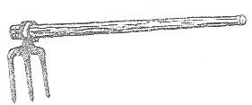How is the garden tool below useful to a farmer?

………………………………………………………………………………………………………………………………………

1. How is burning similar to rusting?

………………………………………………………………………………………………………………………………………

1. Where in the lungs does the exchange of gases take place?

………………………………………………………………………………………………………………………………………

1. Name the nearest clouds in the sky.

………………………………………………………………………………………………………………………………………

1. 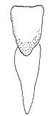Name the human tooth drawn below.

………………………………………………………………………………………………………………………………………

1. Give one reason why people eat food.

………………………………………………………………………………………………………………………………………

1. Which scientific term is used to mean the process in which plants make their own food called starch?

………………………………………………………………………………………………………………………………………

1. Define any one type of pollination.

………………………………………………………………………………………………………………………………………

1. Why is loam soil the best for crop growth?

………………………………………………………………………………………………………………………………………

1. Draw and name any one item used to keep our compound clean.
2. Why is a book called a non-living thing?

………………………………………………………………………………………………………………………………………

1. Which vector is well known for spreading diseases of the 4Fs potch?

………………………………………………………………………………………………………………………………………

1. How are the numerous ears important to a P.4 child in class?

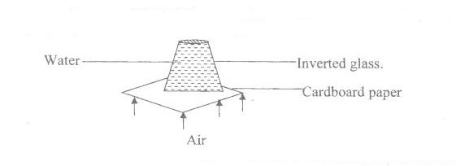………………………………………………………………………………………………………………………………………

1. Identify the property of air illustrated below.

………………………………………………………………………………………………………………………………………

1. Give a reason why it is good to harvest crops in dry seasons.

………………………………………………………………………………………………………………………………………

1. Name the instrument used to see germs.

………………………………………………………………………………………………………………………………………

1. Why do tomato farmers mulch their gardens?

………………………………………………………………………………………………………………………………………

1. Mention any one danger of living in dirty places.

………………………………………………………………………………………………………………………………………

1. Why is a goat called a living thing?

………………………………………………………………………………………………………………………………………

1. What causes goiter?

………………………………………………………………………………………………………………………………………

1. State any one value of swamps to people.

………………………………………………………………………………………………………………………………………

1. Which vector lays eggs in rotting matter?

………………………………………………………………………………………………………………………………………

SECTION B.

1. a) What is rehydration?

………………………………………………………………………………………………………………………………………

b) Write down any two signs of a dehydrated person.

i) …………………………………………………………………………………………………………………………………

ii) …………………………………………………………………………………………………………………………………

c) Identify any one cause of dehydration.

………………………………………………………………………………………………………………………………………

1. a) Mention the deficiency disease controlled by eating the following classes of food.
2. Proteins …………………………………………………………………………………………………………………………………
3. Carbohydrates …………………………………………………………………………………………………………………………………

b) Give two reasons why people eat food.

i) …………………………………………………………………………………………………………………………………

ii) …………………………………………………………………………………………………………………………………

1. a) What name is given to a person who has got an accident?

………………………………………………………………………………………………………………………………………

b) Give any reason why it is necessary to give first Aid to an accident victim.

i) …………………………………………………………………………………………………………………………………

ii) …………………………………………………………………………………………………………………………………

c) What name is given to a container used for keeping First Aid equipments?

………………………………………………………………………………………………………………………………………

1. The diagram below is a living house.

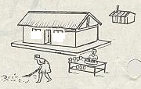**X**

**Y**

**X S**

1. Name the parts marked Y and R.
2. Y ……………………………………………………………………………………………………………………
3. R ……………………………………………………………………………………………………………………
4. Mention the function of parts marked X and S.
5. X …………………………………………………………………………………………………………………………
6. S …………………………………………………………………………………………………………………………
7. a) What are monocotyledonous seeds?

………………………………………………………………………………………………………………………………………

b) Write down two examples of dicotyledonous seeds.

1. ……………………………………………………………………………………………………………………………
2. ……………………………………………………………………………………………………………………………
3. Identify the type of germination undergone by the seeds mentioned in (b) above.

………………………………………………………………………………………………………………………………………

1. a) Weeding is the removal of unwanted plants in the garden. Give any two examples of unwanted plants in the garden.
2. …………………………………………………………………………………………………………………………………
3. …………………………………………………………………………………………………………………………………

b) Apart from removing weeds, state a reason why farmers weed their gardens?

………………………………………………………………………………………………………………………………………

1. Mention any one importance of weeds to man.

…………………………………………………………………………………………………………………………………

1. Use the diagram below to answer questions.

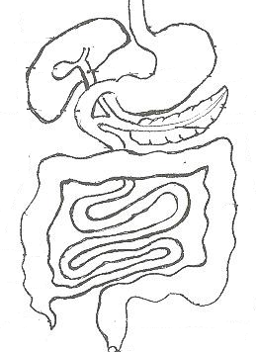

A Stomach

B

C

1. Name the parts marked with letter A – C.
2. A ………………………………………………………………………………………………………………………
3. B ………………………………………………………………………………………………………………………
4. C ………………………………………………………………………………………………………………………
5. State the function of the stomach.

…………………………………………………………………………………………………………………………………

1. Below is the process that takes place in the atmosphere.

K

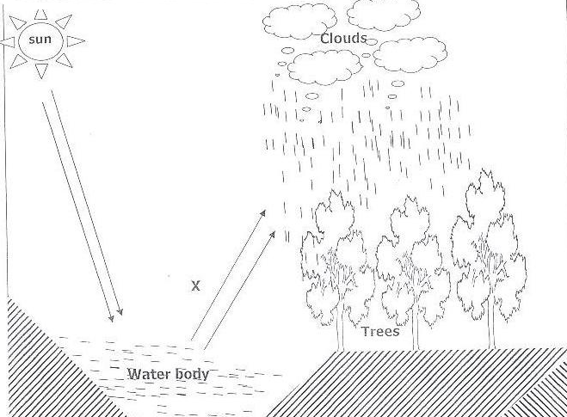

B

P

1. Name the process illustrated above.

…………………………………………………………………………………………………………………………………

1. State the process marked P and K.

i) P…………………………………………………………………………………………………………………………

ii) K ………………………………………………………………………………………………………………………

1. Give the importance of the above process to a crop farmer.

…………………………………………………………………………………………………………………………………

1. a) Name the vector that lays its eggs in stagnant water.

………………………………………………………………………………………………………………………………………

b) Write down any two health activities done to keep our school compound clean.

i) …………………………………………………………………………………………………………………………………

ii) …………………………………………………………………………………………………………………………………

c) Name any one diarrhoeal disease spread due to poor sanitation.

……………………………………………………………………………………………………………………………………….

1. Match the following items in A to those in B.

Heart smelling

Lungs breathing

Skin pumping blood

Nose feeling

1. Heart ……………………………………………………………………………………………………………………
2. Lungs ……………………………………………………………………………………………………………………
3. Skin ……………………………………………………………………………………………………………………
4. Nose ……………………………………………………………………………………………………………………
5. a) What is Oral hygiene?

…………………………………………………………………………………………………………………………………

b) Write down any one disease of the teeth.

…………………………………………………………………………………………………………………………………

1. State any two practices done to care for our teeth.
2. ……………………………………………………………………………………………………………………………
3. ……………………………………………………………………………………………………………………………
4. a) Write brief notes about the following:
5. mulching

…………………………………………………………………………………………………………………………………

1. thinking

…………………………………………………………………………………………………………………………………

1. weeding

…………………………………………………………………………………………………………………………………

1. Weeds

…………………………………………………………………………………………………………………………………

1. The pie-chart below shows composition of air. Use it to answer questions that follow.

R

P

Q

O

1. Name the gasses marked with letters O, P and R.
2. O …………………………………………………………………………………………………………………
3. P …………………………………………………………………………………………………………………
4. R …………………………………………………………………………………………………………………
5. Write down any one example of gases found in Q.

…………………………………………………………………………………………………………………………………

1. a) How do the following animals protect themselves?

i) A bee ………………………………………………………………………………………………………………………………………

ii) A dog

………………………………………………………………………………………………………………………………………

b) Give the young ones of the following animals.

i) Monkey

……………………………………………………………………………………………………………………………………

ii) Cow

………………………………………………………………………………………………………………………………………

1. a) What is leaf venation?

………………………………………………………………………………………………………………………………………

1. Mention the two types of leafs venation.
2. ….………………………………………………………………………………………………………………………………
3. …………………………………………………………………………………………………………………………………
4. State any one function of leaves to plants.

…………………………………………………………………………………………………………………………………