**NABBUNGA FOUNTAIN OF EDUCATION DAY AND BOARDING PRIMARY SCHOOL,**

**DEZ JUNIOR SCHOOL, ST. MARY’S IMMACULATE VILLA P/S, ST. THEREZA BWANDA P/S, ACT JUNIOR SCHOOL,**

**ST. ANDREWS MATALE HILL P/S, AND**

**ST. AGNES NSAMBYA PRIMARY SCHOOL**

**PRE-P.L.E JOINT EXAMINATION 2022**

# 

# SUBJECT : INTEGRATED SCIENCE

# DURATION : 2 HOURS 15 MINUTES

**EMIS NO.**

**PERSONAL NO.**

**Index No. :**

**Candidate’s Name : …...…………………………….…………………..............**

**Candidate’s Signature : …...…………………………………….………............**

**District Name : …..……………………..……………….……...................**

***DO NOT OPEN THIS BOOKLET UNTIL YOU ARE TOLD TO DO SO.***

**Read the following instructions carefully:**

**FOR EXAMINERS’**

**USE ONLY**

**Qn. No. MARKS EXRS’ IN.**

1 – 20

21 – 30

31 – 50

51 – 53

54 – 55

1. This paper has **two** sections: **A** and **B**.
2. Section **A** has 40 questions (40 marks)

Section **B** has 15 questions (60 marks)

1. Answer all questions. All questions to both Sections

**A** and **B** must be written in the spaces provided.

1. All answers must be written using a blue or black

ball-point pen or fountain pen.

1. Unnecessary changes of work may lead to **loss** of

marks. All diagrams must be drawn in pencil.

1. Any handwriting that cannot easily be read may

lead to **loss of marks.**

1. Do **not** fill anything in the boxes indicated:

**“For Examiners’ Use Only”**

**SECTION A:**

1. Which type of soil is the best for crop growing? ______________________________________________________
2. Name one exotic dairy breeds of cattle commonly kept in Uganda. ______________________________________________________
3. Under which group of living things do the lions belong? ______________________________________________________
4. How do the plants benefit from animals? ______________________________________________________
5. Which drug is got from fungi that is used to treat bacterial diseases? ______________________________________________________
6. Why is it advisable for pregnant mothers to eat food rich in proteins? ______________________________________________________
7. How is a physical change different from a chemical change? ______________________________________________________
8. Name one source of direction current electricity (D.C). ______________________________________________________

**The diagrams S and R show eggs of amphibians. Use them to answer questions that follow.**

**Embryos**

1. Which amphibians lay eggs drawn in diagram s? ______________________________________________________
2. How useful is the part labeled K to the embryos shown above? ______________________________________________________
3. Apart from using cubic units, name any other unit that can be used to measure volume. ______________________________________________________
4. Why is it very dangerous to set up apiary near a market? ______________________________________________________
5. What role does the government play in the immunization campaign? ______________________________________________________
6. Which apparatus do the tailors use to measure the size of one’s waist? ______________________________________________________
7. What element of primary health care checks on the population of a country? ______________________________________________________
8. A lever has its pivot between the load and the effort. Under which group of levers does it belong? ______________________________________________________

**The diagram below shows a life cycle of a housefly. Use it to answer questions 17 and 18.**

1. 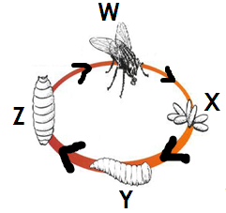Name one disease that can be spread the above insect to man. __________________________________________________________
2. How can the vector be controlled at stage marked W? __________________________________________________________
3. Which type of alcohol is poisonous to people? ______________________________________________________
4. Why is filtered water not good to be drunk before boiling it? ______________________________________________________
5. Name the blood cells that defend the body against germ infection. ______________________________________________________
6. How does paddock grazing control ticks in cattle management? ______________________________________________________
7. How is the uncontrolled cutting of trees affect climate of an area? ______________________________________________________
8. Name one primary sex characteristic in girls. ______________________________________________________
9. Which part of the fish helps it to detect vibration? ______________________________________________________
10. What name is given to the tubular structures that act as excretory osmoregulatory organ of some insects? ______________________________________________________
11. Why should the vulnerable people be given special feeding? ______________________________________________________
12. Name one practice done by people to protect themselves from getting infected with round worms. ______________________________________________________

**The diagram below sows a maize seed. Use it to answer questions that follow.**

1. 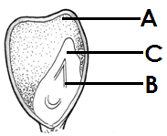How is part A similar to the cotyledon of a bean seed? ____________________________________
2. State one effect of pests on root crops. ____________________________________
3. Why is an ordinary thermometer not suitable for use to measure body temperature? ______________________________________________________
4. What role does the barometer play on a weather station? ______________________________________________________
5. State one use of essential drugs to the community. ______________________________________________________
6. Name one by-product of respiration. ______________________________________________________
7. How s the synovial fluid at the joint similar to the oil machines? ______________________________________________________
8. How is the web on the foot of a duck useful to the bird? ______________________________________________________
9. 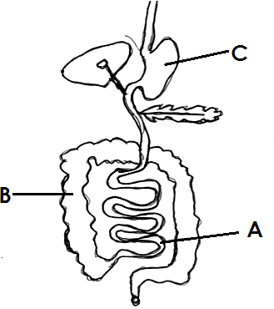Name part of the digestive system marked C. _________________________________
10. State one substance that is absorbed through B. __________________________________________________________________
11. Imagine you were a father why would you try very hard to avoid extended family. ______________________________________________________
12. Apart from producing progesterone hormone, state any other use of the ovary in man. ______________________________________________________

**SECTION B**

1. a) Name one foreign breed of rabbits kept in Uganda. ______________________________________________________

b) Why do some farmers in urban areas prefer keeping rabbits to other bigger animals like cattle? ______________________________________________________

c) State one factor you can consider when choosing a good rabbit to rear. ______________________________________________________

d) Which diseases of rabbits show the following signs; **rough far, diarrhea with blood**? ______________________________________________________

1. a) Which substances are responsible for chemical digestion in humans? ______________________________________________________

b) Name one organ of the digestive system which is not part of the alimentary canal. ______________________________________________________

c) How is the saliva in the mouth similar to the synovial fluid in function? ______________________________________________________

1. **A primary five class in Kakembe Primary School performed the experiment below. Study it and use it to answer questions that follow.**
2. 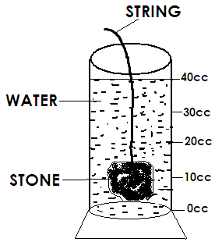Name the container that is holding the water. _________________________________
3. What was the level of the water when it had the stone inside? _________________________________
4. How much water was used in the experiment if the stone has a volume of 10cc? __________________________________________________________________
5. Why is the stone regarded as an irregular object? ____________________________________________________
6. a) Name one immunisable water borne disease that affects the skeletal system. ______________________________________________________

b) How does cholera cause death of the infected person? ______________________________________________________

c) Of what importance is the ORS during the treatments of cholera? ______________________________________________________

c) How does the putting of faeces in a latrine control water borne diseases? ______________________________________________________

1. a) Name one class of plants. ______________________________________________________

b) A P.6 class in Kyebambe P/S observed the following characteristics on a plant: net veined leaves, tap root system, woody stem. Under which group of flowering plants does this plant belong? ______________________________________________________

c) How does plant that use self dispersal disperse their seeds? ______________________________________________________

d) State one advantage of seed dispersal. ______________________________________________________

1. **The diagram below shows a health facility. Use it to answer the questions that follow.**

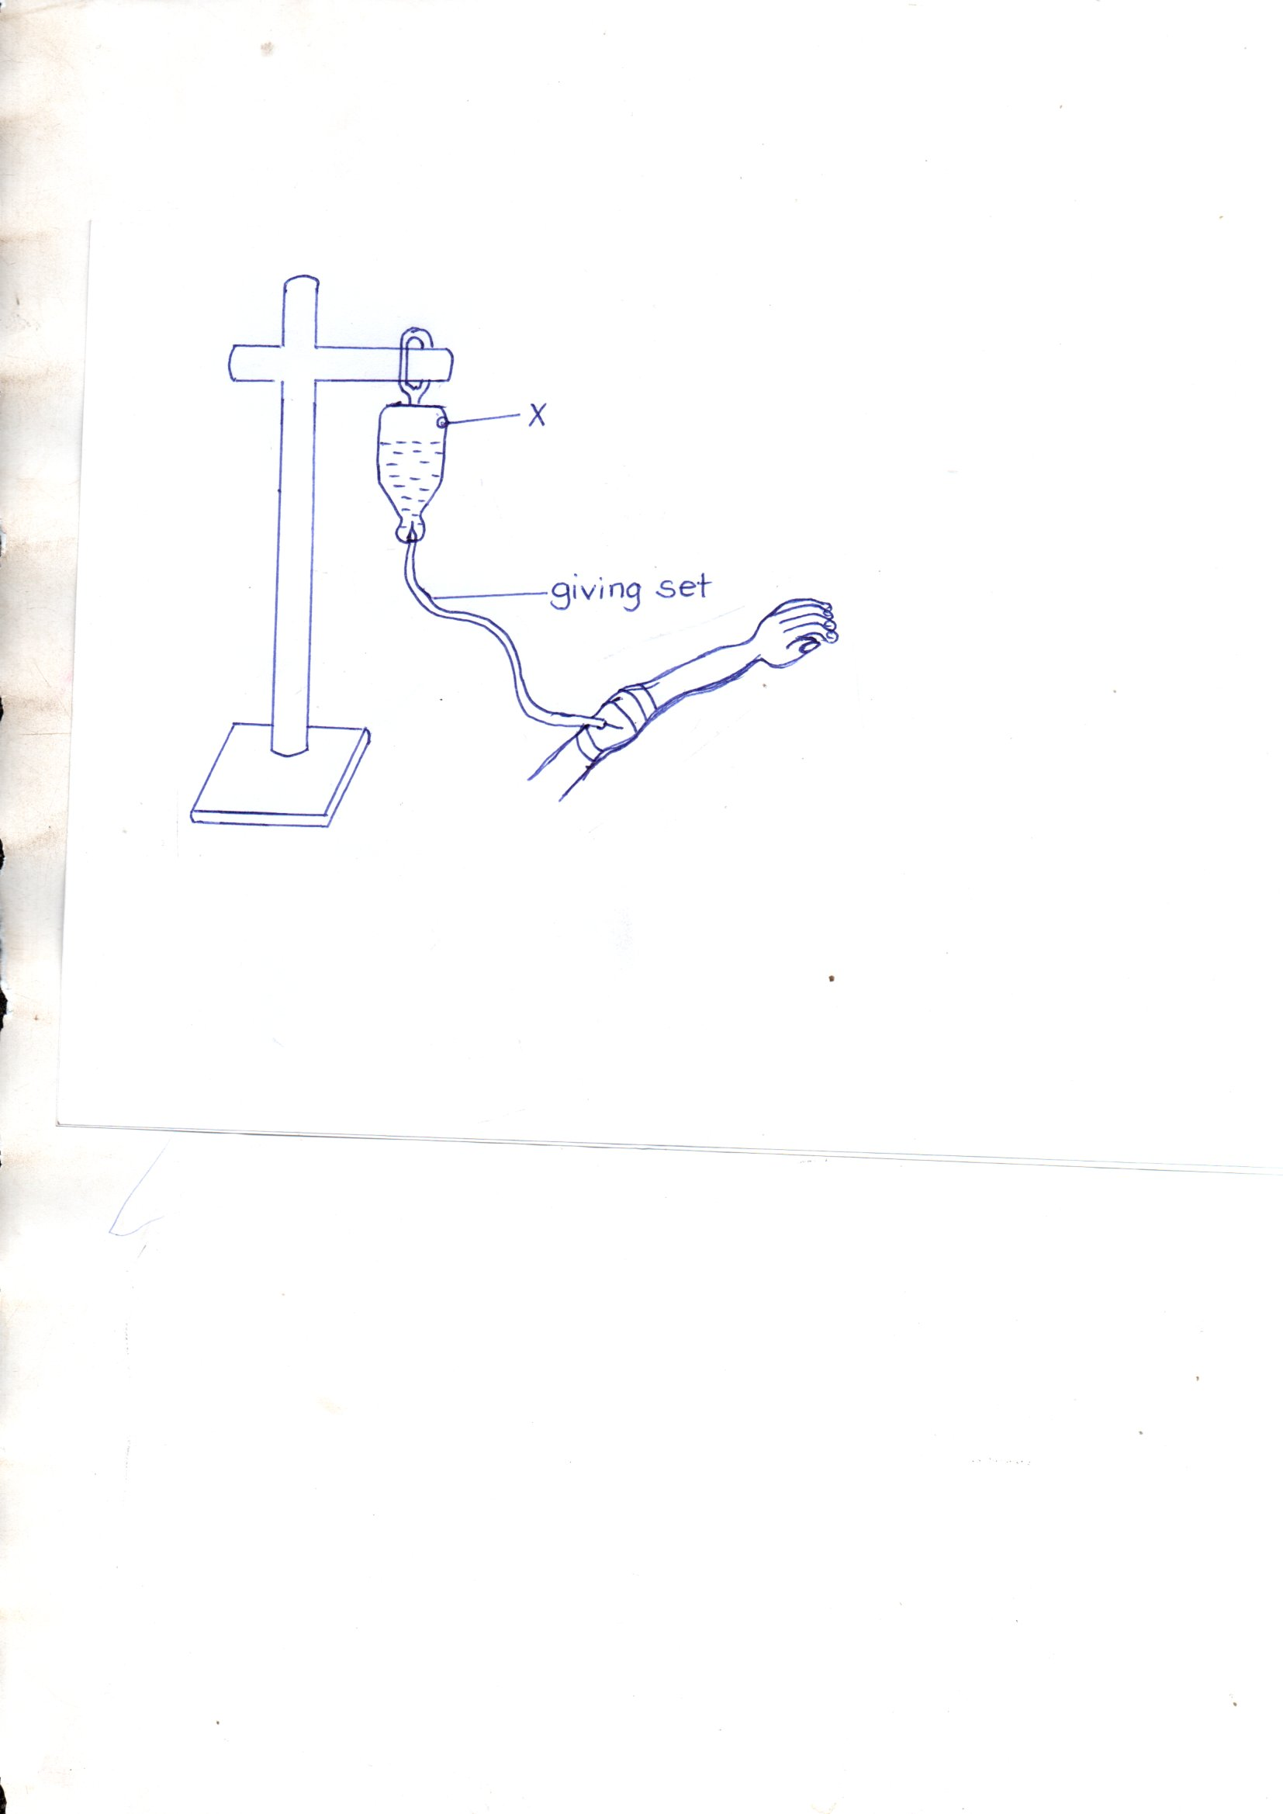

1. Give the use of the hole marked with letter X. ____________________________________________________
2. What general name is given to the health facility shown in the diagram above? ____________________________________________________
3. Why is Aspirin regarded as an essential drug? ____________________________________________________
4. State one reason for prescribing the drugs. ____________________________________________________
5. a) What is fever? ____________________________________________________________________________________________________________

b) Name one cause of fever. ______________________________________________________

c) Why should a convulsing person be put hard materials in the mouth? ______________________________________________________

d) State the first aid for fever. ______________________________________________________

1. a) State one natural non-living resource that is commonly used for agriculture. ______________________________________________________

b) Why should the government of Uganda encourage use of sustainable methods of harvesting resources? ______________________________________________________

c) State one the Rs recommended in waste management. ______________________________________________________

1. **The diagram shows part of the human skeleton.**
2. 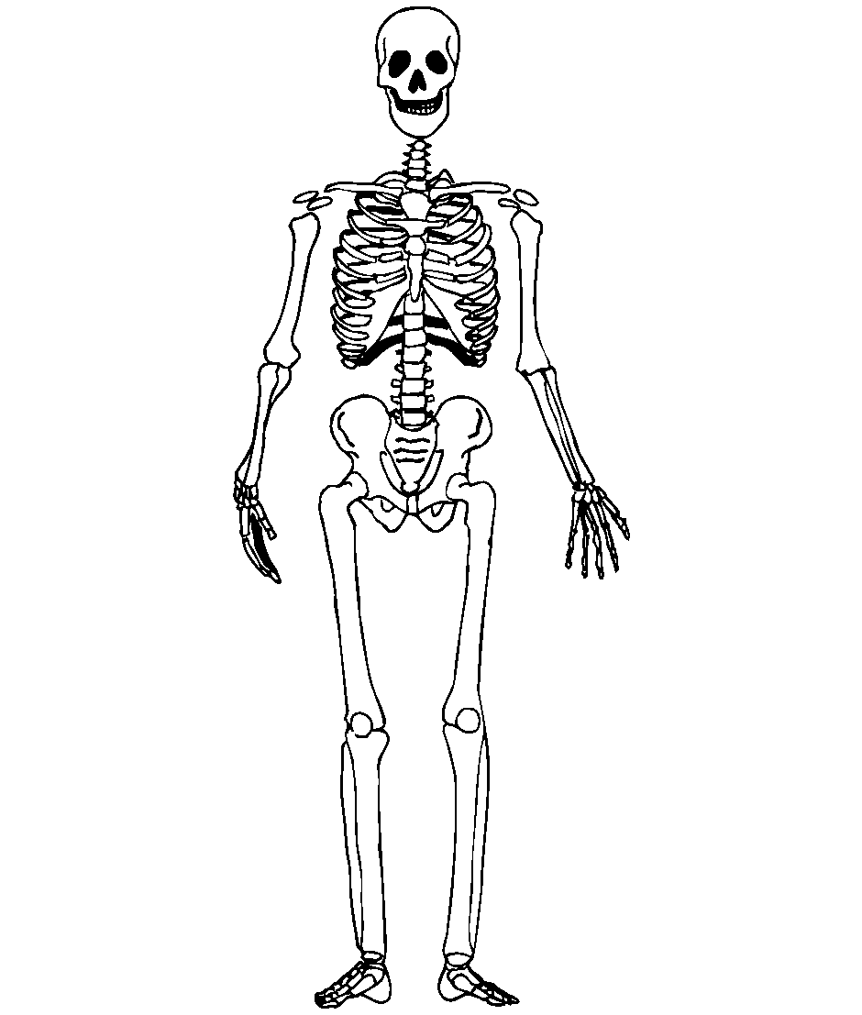Which part of the skeleton is shown in the diagram? _______________________________________
3. Name one body organ which is protected by the above part of the skeleton. _______________________________________
4. Which mineral should be given to a person who has had a fracture to help him heal faster? ____________________________________________________
5. Which type of cells are usually produced by the bone marrows? ____________________________________________________
6. a) In the space below, draw a garden tool used to dig in a stony ground.

b) State two ways of maintaining garden tools in a good working condition.

i. ____________________________________________________

ii. ____________________________________________________

c) State one danger that can result from the misuse of a garden tool. ______________________________________________________

1. **The diagram below shows sources of light.**

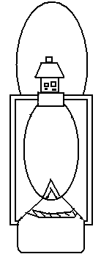

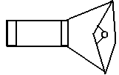

**A B C**

a) Which two sources can be grouped together? ______________________________________________________

b) Give a reason for your answer. ____________________________________________________________________________________________________________

c) How is the continuous of source C dangerous to human health? ______________________________________________________

d) State the source of energy used to produced light in B. ______________________________________________________

1. a) What is wind? ____________________________________________________________________________________________________________

b) How is the blowing of the wind important in rain distribution? ______________________________________________________

c) State one danger of wind in the environment. ______________________________________________________

d) How can we protect our homes from the dangers of wind? ______________________________________________________

1. a) What is a solution? ____________________________________________________________________________________________________________

b) Name one example of a solution. ______________________________________________________

c) Which solution is commonly used in the treatment of diarrhea diseases? ______________________________________________________

d) How can we identify a saturated solution? ______________________________________________________

1. a) What are warm blooded animals? ____________________________________________________________________________________________________________

b) State one group of vertebrates which is worm blooded. ______________________________________________________

c) How do the human beings help to maintain their body temperature during hot weather? ______________________________________________________

d) Of what importance is the fur on mammals’ bodies? ______________________________________________________

1. a) What is an electric circuit? ____________________________________________________________________________________________________________

b) State one cause of short circuit. ______________________________________________________

c) Mention one danger that can be used by electricity at home. ______________________________________________________

d) State one way we can protect ourselves from the dangers caused by electricity. ______________________________________________________

**\*\*\* GOD FEARING IS THE SOURCE OF WISDOM \*\*\***