**SECTION A: 40 MARKS**

Questions **1** to **40** carry **one mark** each

1. Name the form of energy that enables cyclists to avoid obstacles at night.

…………………………………………………………………………………………………….

2. Write down any **one** milk product you know.

……………………………………………………………………………..…………………….

3. Give any **one** cause of short circuit.

…………………………………………………………………………………………………….

The diagram below shows an equipment used on a poultry farm. Use

it to answer questions **4** and **5**.

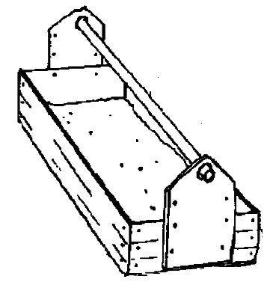

rotating handle

4. How useful is the equipment to a poultry farmer?

……………………………………………………………………………………………..…….

5. Why is the equipment made of rotating handle?

……………………………………………………………………………………..…………….

6. Mention any **one** factor considered when classifying living things.

…………………………………………………………………………………….…………….

7. Mention **one** danger of sharing drugs among patients.

…………………………………………………………………………………………….…….

8. How is the cause of polio similar to that of measles?

……………………………………………………………………………………….………….

…………………………………………………………………………………………………..

9. Give any **one** effect of food taboos to the community.

……….………………………………………………………………………………………….

10. Why are gaps left between rails during the construction of the

railway?

………………………………………………………………………………………………….

11. Why is cow called a ruminant animal?

………………………………………………………………………………………………….

12. State **one** importance of agro forestry.

………………………………………………………………………………………………….

13. State any **one** cause of eye defects.

.………………………………………………………………………………………………….

14. Which is the dangerous stage of a housefly?

……………………………………………………………………….………………………..

15. Mention any **one** proper way of maintaining good working condition

of the kidney.

………..……………………………………………………………………………..……….

16. How is a gizzard able to carry out the function of grinding food

during digestion?

………………………………………………………..……………………………………….

17. Give the importance of a stretcher in giving first aid.

……………………………………………………………………..………………………….

18. Mention one accident that can happen at school.

…………………………………………………………………..…………………………….

19. Name the gas used in fire extinguishers.

………….………………………………………………………………………………..…….

20. State the process by which heat moves through solids.

…………………………………………………………………………………..……………..

21. State **one** way how amphibians are useful in the environment

…………………………………………………………………………………………..…….

22. Why is it not advisable to put on a black coat on a very sunny day?

……………….……………………………………………..………………………………….

23. Mention **one** good health habit for the teeth.

………………………………………………………………..……………………………….

24. Give any **one** way of caring for people with special needs

………………………………………………………………………………………………….

Study the diagram of a maize grain below and use it to answer

question **25**.

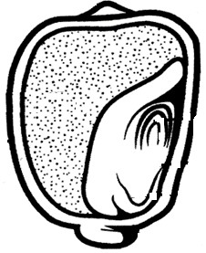

**M**

25. Give the function of part **M**.

………………………………………….……………………………………………………….

26. How do hairy bodies of a housefly able to carry germs that spread

disease?

……………………………………………………………………….……………………….

27. Why should young boys avoid drug abuse?

………………………………………………………………………………………………….

28. Mention **one** importance of ossicles during the process of hearing.

………………………………………………………………………………………………….

29. Give **one** way of controlling tape worm infestation in humans.

…………………………………………………………………………………….………….

30. Give **one** reason why young girls should avoid teenage pregnancy.

……………….………………………………………………………………..…………….

31. How does rural electrification conserve the environment?

……………………………………………………….……………………………………..….

32. State the unit for measuring rainfall.

…………………………..…………………………………………………………………..….

33. Give **one** reason why grease is applied in all moving parts of a

machine.

……………………………………………………………………………………………….….

34. Identify the type of change that takes place when fruits ripen.

………………………….……………………………………………………………………….

35. State **one** condition under which a mother may be stopped from

breast feeding the baby.

……………………..…………………………………………………………………………….

36. What is evaporation?

…………………………………………………………………………………….……………

…………………………………………………………………………………………….……

37. Mention the structure of a VIP latrine that traps and kills flies.

……………….….…………………………………………………………………………….

38. State the difference between pitch and volume in sound.

…………………………………………………………………………………………………

…………………………………………………………………………………………………

39. Give the function of valves in blood circulation.

……………………………..………………………………………………………………….

Study the picture of cow peas below and answer question **40**.

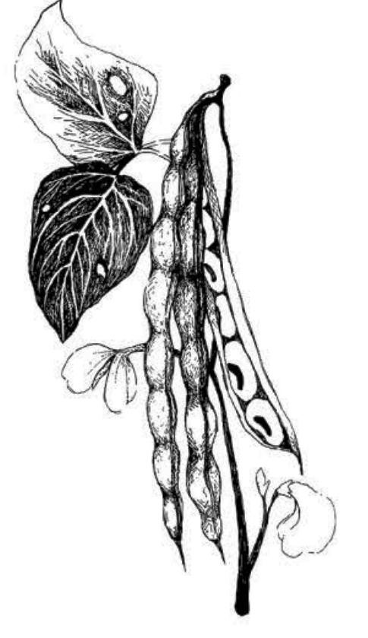

40. Which method of seed dispersal do cowpeas undergo?

……………..……………………………………………………………………..………….

**SECTION B: 60 MARKS**

Questions **41** to **55** carry four marks each.

41. (a) What are vertebrates?

……………………………………………………………………………………………….…

……………………………………………………………………………………………….…

(b) State any **two** types of vertebrates.

(i)………………………………………………………………………….……………………

(ii) ……………………………………………………………………………………………..

(c) Give any **one** characteristic of vertebrates

…………………………………………………………………………………….……………

42. (a) Write any **one** essential drug that can be taken to cure malaria.

…………………………………………………………………………………………….……

(b) Give any **two** characteristics of essential drugs.

(i) …………….……………………………………..…………………………………………

(ii) ……………………………………………………………………………………………..

(c) Why should medical drugs be well prescribed before they are

given to patients

………………….…………………………………………………………………………….…

……………………………………………………………………………………………..……

43. (a) Mention the programme which teaches pupils about HIV/AIDS in

schools.

……………………………………………………………………….…………………………

(b) Write any **two** messages passed onto the pupils during the

programme mentioned in (a) above.

…………….………………………………………………………………………………………

…………………………………………………………………………………..………………..

(c) Why does the above programme encourage pupils to abstain from

sex?

……………….…………………………………………………..……………………………….

44. (a) Name the set of teeth found in babies.

…………………………………………………………………….………………………………

(b) Which type of teeth is missing in the set you have mentioned in (a)

above?

………….…………………………………………………………………………………………

(c) Give a reason why babies should be given soft food.

………………………………………………………………………..………………………….

(d) State **one** way mothers can promote the strong growth of teeth in

their children.

…………………………………………………………………………………………………….

45. **The diagram below shows a method of finding volume. Use**

**it to answer the questions that follow.**

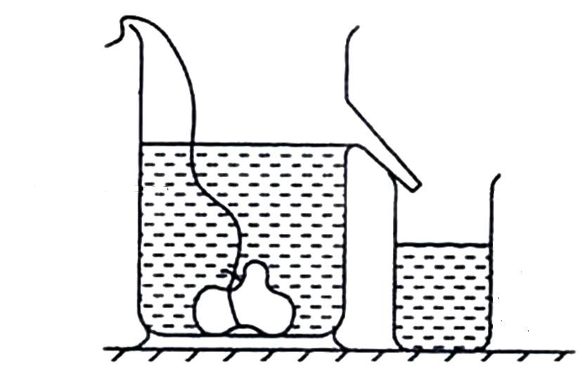

**S**

**Y**

**R**

1. Name the container marked **S**.

…………………………………………………………………………………………...…

1. Identify the type of object labeled **R**.

……………………………………………………………………………….………………

1. What does the water in container in **Y** equal to?

………………………..…………………………………………………….………………

1. Give a reason for your answer in (c) above.

…..………………………………………………………………………….………………

46. (a) What is an echo?

…………………………………………………………………………………………………

…………………………………………………………………………………………………

(b) In which one way are echoes dangerous to people?

……………..…………………………………………………………….……………………

(c) Kabanda was standing 16.5 metres away from his mother who

called him by hitting the drum. How long did it take Kabanda to hear

the drum?

………………………………………………………………………………………………

47. **Study the beaks of birds below and answer questions that follow.**

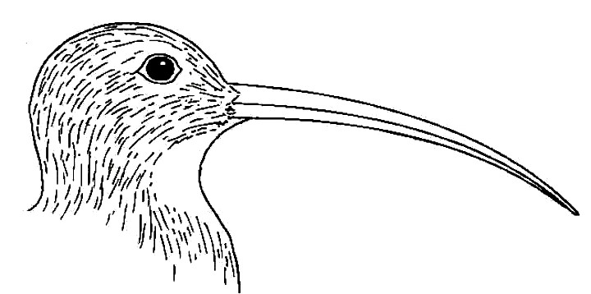 Beak **X** Beak **Y**

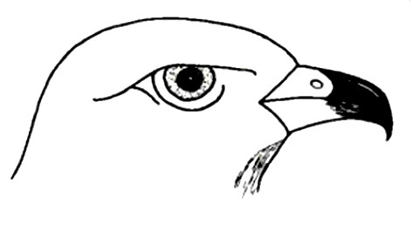

Sharp-hooked beak Long-slender beak

(a) How is each of the following beak adapted to its function?

(i)Beak **X**…………...………………………………………………………………………………………….…………………………………....................................................................

(ii)Beak **Y** ……………………………………………………………...……………………………………………………………………………………………………………………………………………...

(b) What type of food do birds with such beaks feed on?

Beak **X** …….…………………………………………………………………….…………

Beak **Y** …….………………………………………………………………………………

48. (a) State **one** way plants depend on animals.

…………………………………………………………….……………………………………

(b) How do animals depend on each other?

……………………………………………………………………………………….…………

(c) Give **one** way animals depend on plants.

……………………………………………………………………………………….………….

(d) Give **one** way land as a resource can be conserved.

……………..…………………………………………………………………………………… 49. Use the food chain below to answer the questions that follow.

|  |
| --- |
| **Bacteria** |

|  |
| --- |
| **lion** |

|  |
| --- |
| **millet** |

**rabbit**

(a) Identify the following organisms in the above food chain.

Producer ………………………………………………………………………………………

Primary consumer ………………………………………………………………….………

(b) What do the arrows represent in the above food chain?

…………………….………………………………………………………………………………

(c) What role do bacteria play in the food chain?

…………………………………………………………………..…………………………………

50. The picture below is of Mzee Zadde sharpening a knife. Use it to answer the questions that follow.

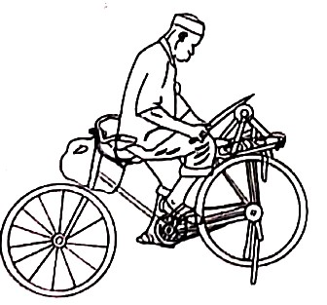

(a) Which force enables Mzee Zadde to sharpen the knife?

…….…………………………………………………………………………………………….

(b) Give **one** way Mzee Zadde can reduce on the force named in (a) above on the knife.

…………………………………………………………………………………………………….

(c) Find the work done by a man who pushed a wheelbarrow using force of 80kg through a distance of 9 metres.

51. How are the following practices important on the animal farm?

(i) Dipping ………………………………………………………………………….…

………………………………………………………………………………….. (ii) Deworming ………….…………………………………………………….……….

…………………………………………………………………………………… (iii)Dehorning ……...……………………………………………………………...…….

……………………………………………………………………………………………

(iv) Castration ………………………………………………………………….

……………………………………………………………………………………

52. Complete the table correctly

|  |  |  |
| --- | --- | --- |
| **Disease** | **Vaccine** | **Age** |
| …………………………. | BCG | At birth |
| Tetanus | …………………………. | At 3 months |
| Measles | Measles vaccine | ……………………. |
| Polio | ………………………. | At birth |

53. (a) State the end product of each of the following

(i) Proteins ………...………………………………………………………………….…

(ii) Carbohydrates ………...…………………………………………………….………

(iii) Fats …………….………………………………………………………….…………

(b) How is the liver important during the digestion of food in the human

body?

……………………………………………………………………………….………………….

54. (a) What is pollination?

………………………………………..…………………………………………….…………

…………………………………………………………………………………….…………..

(b) Mention any **two** characteristics of insect pollinated followers.

(i) …………………………..…………………………………………………………………...

(ii) ……………………………………………………………………………………..……….

(c) Give **one** plant which undergoes cross pollination.

………………………………………………………………………………………

55. The diagram below shows a simple circuit. Study it carefully and

use it to answer questions that follow.

M

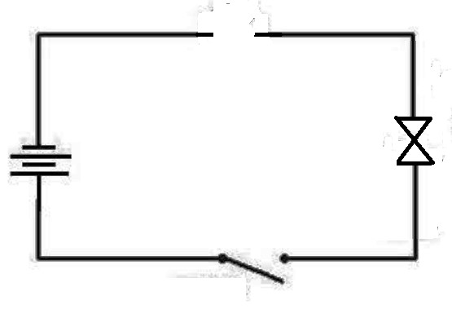

bulb

**T**

**M**

**B**

(a) Name the part marked **M**.

…………………………………………………………………………………………………….

(b) State the function of part marked **B**.

…………………………………………………………………………..………………………..

(c) What energy change takes place in an electric bulb when part marked

**T** is closed?

……………………………………………………………………..…..…………………………

(d) Use an arrow to show the flow of electrons in the diagram above.

**END**