TRINITY PRIMARY SCHOOL-BUKOTO
REVISION WORK
CLASS: P.3
SUBJECT: MATHEMATICS
Name: __________________________________ Stream: _________
SECTION A:
- What is a set?
_________________________________________________________________________
- Draw a set of 5 chairs

- Shade 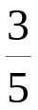

- Tell the time.
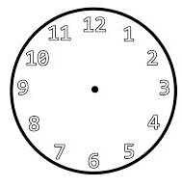___________________________________________
- Name this shape

_____________________________
- Count in twos.
2,4, ______, ______, 10, 12, ____

- Kabubu has 56 cows, Okurut has 34 cows. How many cows do they have altogether?

- Multiply.
6 X 3 = 4 x 9 =
1 3 2 8
x 6 x 5

- Share 26 mangoes between two children. How many will each get?

- Work out the following.
5 - = 3 9 ÷ = 9

- Name this shape.

________________________________________

- Write in words.
___________________________ __________________________
___________________________ __________________________

- Mulekwa had 32 bananas. 21 of them were bad. How many were good?

- Add 4 + 3 using a number line.

- Add: 332 + 471

- Write in words.
40________________________________ 9th ________________________
23rd ______________________________ 20th________________________

- Shade A only.
N A
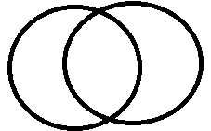

- Name the first day of the week.
________________________________________________________
- Work out.

+ 9 = 9

- Draw the symbols for the following
- Equal set __________________________

- Not equal__________________________

- Equivalent sets______________________

- Nonequivalent sets___________________

- Union sets_____________________________
- Jalia ate 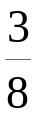 of his cake in the morning and  in the evening. What fraction of the cake did she eat altogether?

- Write shs. 900 in words.
______________________________________________________
- Complete
- - ____ hundreds _____ tens _____ ones

- In P3 class, there are 16 boys and 19 girls. How many pupils are in class altogether?

- A pen costs shs 300. How much money can I pay for 3 pens?

- Share 26 mangoes between two women. How many will each woman get?

