NABBUNGA FOUNTAIN OF EDUCATION DAY AND BOARDING PRIMARY SCHOOL,
VILLA ROAD P/S, KASAANA JUNIOR SCHOOL, AND MASTER CARE PRIMARY SCHOOL

PRE-P.L.E JOINT EXAMINATION 2022

SUBJECT : SOCIAL STUDIES AND R.E

DURATION : 2 HOURS 15 MINUTES

EMIS NO.
PERSONAL NO.
Index No. :

Candidate’s Name : …...…………………………….…………………..............
Candidate’s Signature : …...…………………………………….………............
District Name : …..……………………..……………….……...................
DO NOT OPEN THIS BOOKLET UNTIL YOU ARE TOLD TO DO SO.
Read the following instructions carefully:

FOR EXAMINERS’
USE ONLY
Qn. No. MARKS EXRS’ IN.
1 – 20
21 – 30
31 – 50
51 – 53
54 – 55

- This paper has two sections: A and B.

- Section A has 40 questions (40 marks)
Section B has 15 questions (60 marks)

- Answer all questions. All questions to both Sections
A and B must be written in the spaces provided.

- All answers must be written using a blue or black
ball-point pen or fountain pen.

- Unnecessary changes of work may lead to loss of
marks. All diagrams must be drawn in pencil.

- Any handwriting that cannot easily be read may
lead to loss of marks.

- Do not fill anything in the boxes indicated:
“For Examiners’ Use Only”

SECTION A:
1. Name the most swampy lake in Uganda. ___________________________________________________________________
2. What title was given to the king of Wanga kingdom? ___________________________________________________________________
3. Why should a community have by – laws? ___________________________________________________________________
4. Mention the element of a map that is used to show direction of places.
___________________________________________________________________
5. How does lightning affect people? ___________________________________________________________________
6. Give one reason why people keep pet animals. ___________________________________________________________________
7. How does a high population lead to industrial development in East Africa?
___________________________________________________________________
- Why does Uganda use English as its official language?
___________________________________________________________________
- Give any one way the traffic police tries to reduce motor accidents.
___________________________________________________________________
10. Which ministry is responsible for repairing and maintenance of ferry and ship?
___________________________________________________________________
11. State any one way in which children benefit from being members of the school choir.
___________________________________________________________________
12. Give any one disadvantage of using mobile phones for communication. ___________________________________________________________________
13. Which arm of government is responsible for providing social services to people?
___________________________________________________________________
14. Mention any one way parents promote education of their children at school.
___________________________________________________________________
15. State any one problem caused by smuggling of goods into the East African community member countries.
___________________________________________________________________
16. Why did the colonial government build roads in Uganda? ___________________________________________________________________
17. Give any one role of the LC1 secretary for defence. ___________________________________________________________________
18. What does the symbol below represent?

___________________________________________________________________
19. Name the king of Buganda who was exiled to London in 1953 by Sir Andrew Cohen.
___________________________________________________________________
20. What is barter trade? ___________________________________________________________________
21. Mention any one way people of Uganda can control drought. ___________________________________________________________________
22. State one way children can promote peace in a family. ___________________________________________________________________
23. Name the country that borders Rwanda to the south. ___________________________________________________________________
24. Mention any one factor that makes some people fail to get proper health service in Uganda.
___________________________________________________________________
25. Give any one factor that attracted the Bantu to settle within the lake regions of East Africa.
___________________________________________________________________
26. What does the black colour on the Uganda flag represent? ___________________________________________________________________
27. Why was Kabaka Daudi Chwa II unable to sign the 1900 Buganda agreement?
___________________________________________________________________
28. What word is used to refer to people who conduct population census?
___________________________________________________________________
29. Why are deserts cold at night and hot during day time? ___________________________________________________________________
30. How did Allidina Visram contribute to the economic development of Uganda?
___________________________________________________________________
31. Why should children respect elders in a community? ___________________________________________________________________
32. Why are the caravans helpful to the Arab traders in East Africa? ___________________________________________________________________

33. Mention the president of Tanzania who was one of the founder members of the East African Community.
___________________________________________________________________
34. Give any one way citizens contribute to the development of a country.
___________________________________________________________________
35. How are the Masai and Karimojong similar in terms of ethnicity? ___________________________________________________________________
For questions 36 – 40, answer either Christianity or Islam but not both.
36. Either: Which event marks the beginning of lent period in Christianity?
___________________________________________________________________
Or: Which event marks the end of Ramadhan in Islam? ___________________________________________________________________
37. Either: According to the Bible, who is referred to as the grandfather of all believers?
___________________________________________________________________
Or: According to the Qur’an, who is referred to as the grandfather of all believers?
___________________________________________________________________
38. Either:How did Stephen the first martyr in Christianity meet his death?
___________________________________________________________________
Or: How did Sumayah the first martyr in Islam meet her death? ___________________________________________________________________
39. Either: State any one way Adam and Eve caused suffering to the world.
___________________________________________________________________
Or: State any one way Adam and Hawa caused suffering to the world.
___________________________________________________________________
40. Either: Mention any one way Christians show respect to God during prayers.
___________________________________________________________________
Or: Mention any one way Muslims show respect to Allah during prayers.
___________________________________________________________________

SECTION B:
41.a) What is meant by the word election? ___________________________________________________________________
b) Mention any two examples of voting materials used during elections in Uganda.
i) _____________________________ ii) _______________________________
c) State any one method of voting used during elections in Uganda. ___________________________________________________________________
42.a) Name the ethnic group that migrated from the Cameroon highlands. ___________________________________________________________________
b) Give any two factors that caused the above named ethnic group to migrate from the Cameroon highlands.
i) ________________________________________________________________
ii) ________________________________________________________________
c) Mention any one negative result of the migration of the above named ethnic group in East Africa.
___________________________________________________________________
43.a) Mention any two types of forests in Uganda.
i) _____________________________ ii) _______________________________
b) State any one way forests control the effects of bad weather. ___________________________________________________________________
c) Give any one way people are affecting forests in Uganda. ___________________________________________________________________
44. Mukasa earns shs. 700,000/= a month and spends as follows.
Food | 150,000/=
Fees | 200,000/=
Rent | 180,000/=
Others | 100,000/=

a) What type of budget does Mukasa operate? ___________________________________________________________________
b) Calculate Mukasa’s expenditure.

_______________________________________________________________________
c) How much money does Mukasa save a month?

___________________________________________________________________
d) Give any one reason why people make budgets. ___________________________________________________________________
45.a) Name any two volcanic mountains found in Uganda.
i) ____________________________ ii) ________________________________
b) Give any one factor that affects human settlement on slopes of volcanic mountains.
___________________________________________________________________
c) What process led to the formation of volcanic mountains? ___________________________________________________________________
46. Study carefully the sketch map of Africa below and use it to answer the questions that follow.

- Name the islands marked A on the map above. ___________________________________________________________________
- Why are the islands marked A on the map above remembered in the colonial history of Bunyoro and Buganda kingdoms? ___________________________________________________________________
- Show with letter C the Tropic of Cancer on the sketch map above.
- Mention any one way in which the vegetation zone marked D is important to the people of this area. ___________________________________________________________________
47.a) What is population growth? ___________________________________________________________________
___________________________________________________________________
b) Mention any two factors that can lead to population growth in an area.
i) _______________________________ ii) _____________________________
c) How does population growth affect land? ___________________________________________________________________
48. Study the sketch map of East Africa below and answer the questions that follow.
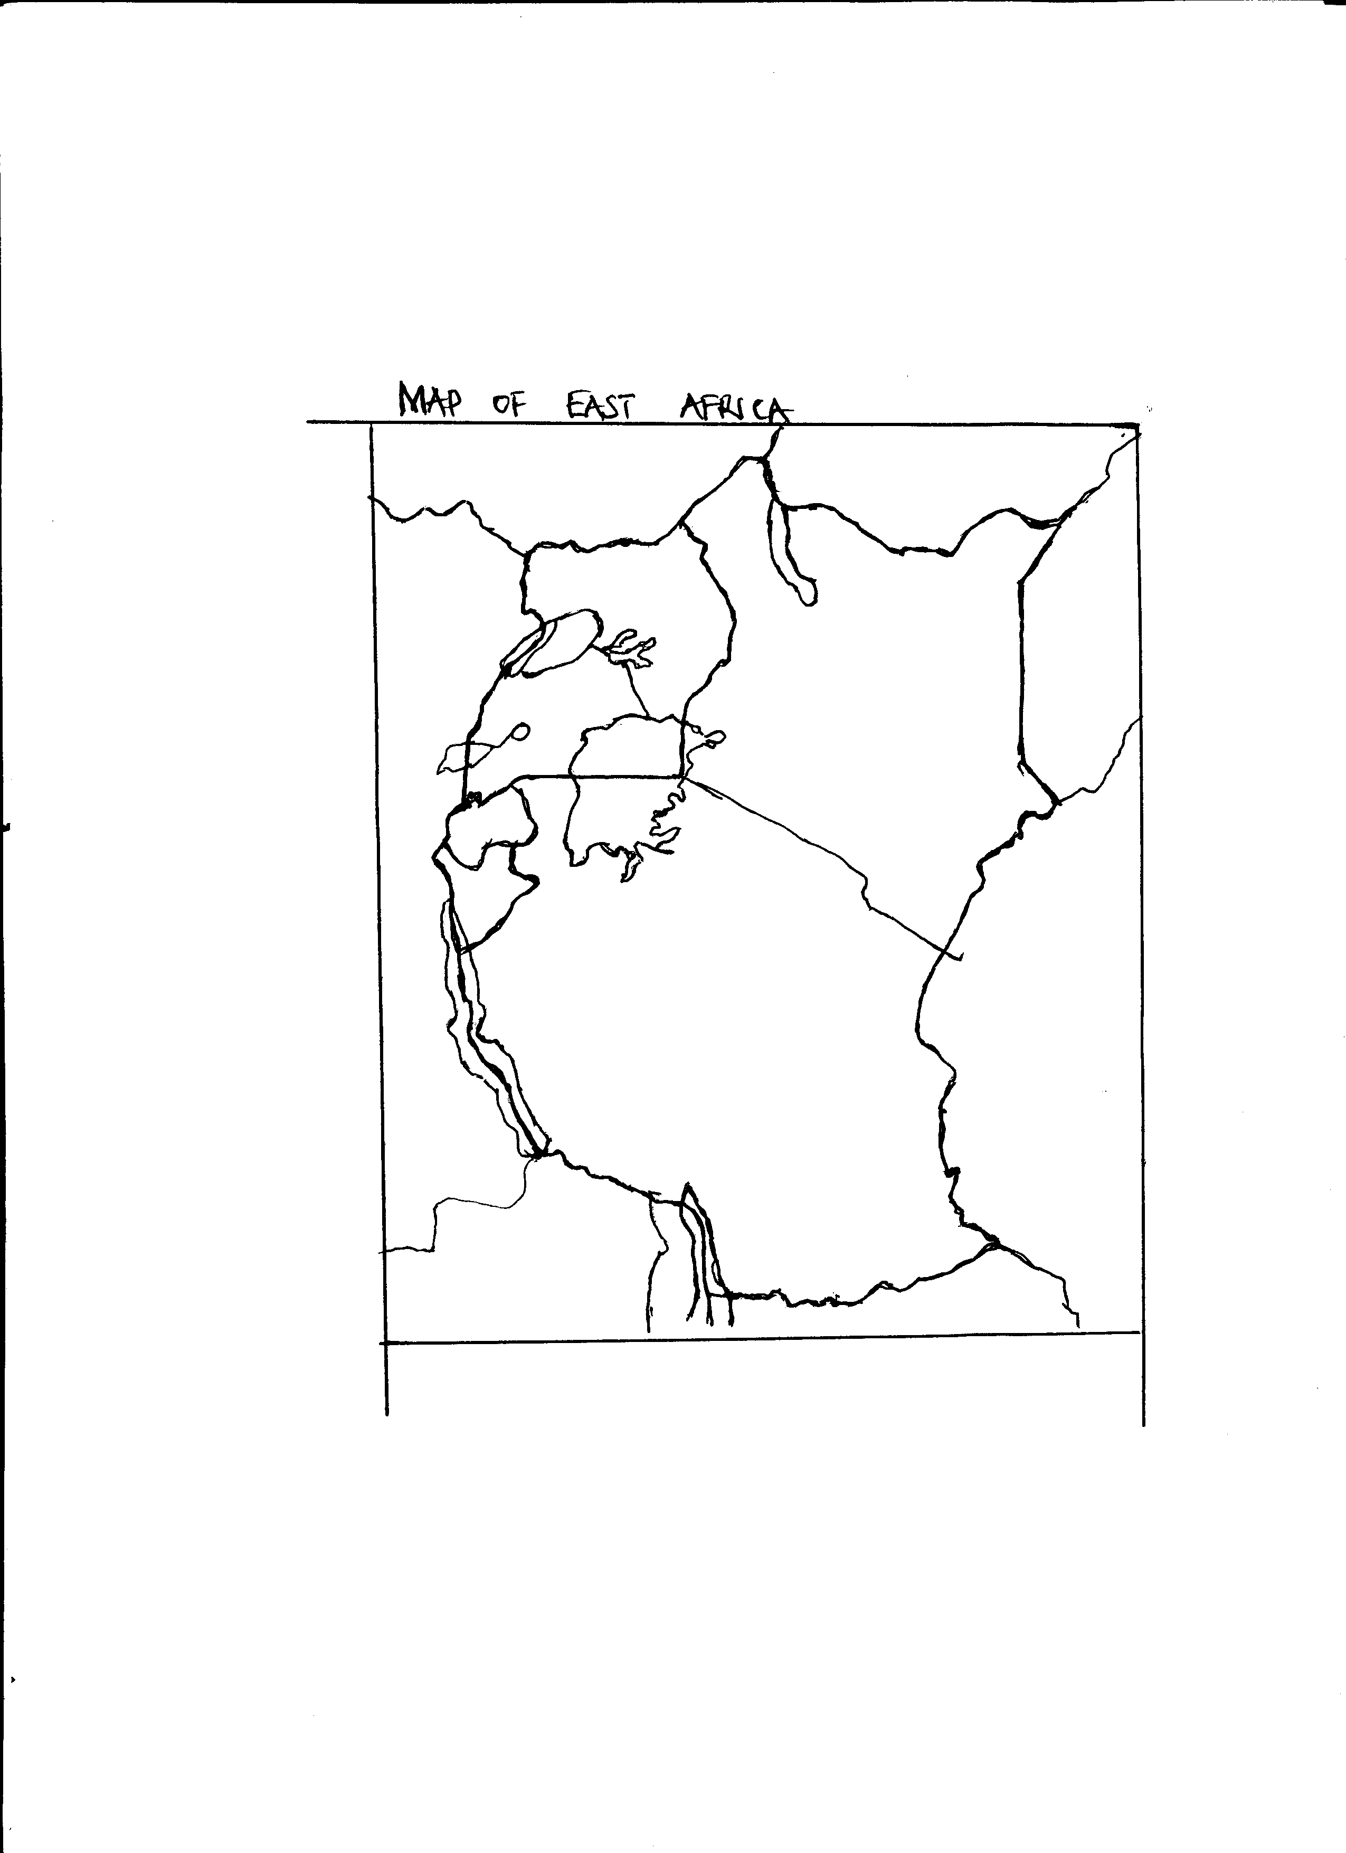
W
xxx

R

K

P

a) Name the sea port marked R. ___________________________________________________________________
b) Mention the rebellion that took place in the area marked xxxx. ___________________________________________________________________
c) What is the direction of country P from country K? ___________________________________________________________________
d) Use letter Y to show the smallest member country of the East African Community.
49.a) What name is given to a place where weather elements are recorded?
___________________________________________________________________
b) Mention the weather instrument used to record the weather elements below.
i) Air pressure _______________________________________________________
ii) Rain fall _________________________________________________________
c) In which one way do farmers benefit from the recorded weather information?
___________________________________________________________________
50.a) Give any two means of water transport used in Uganda.
i) ________________________________________________________________
ii) ________________________________________________________________
b) State any one factor that causes accidents on lakes in Uganda. ___________________________________________________________________
c) What safety wear is used by passengers crossing lakes to protect their lives?
___________________________________________________________________
For questions 51 – 55, answer either Christianity or Islam but not both.
51.a) Either: Give any one form of suffering Jesus faced on earth. ___________________________________________________________________
b) State any two ways Christians can share in the suffering of the sick people.
i) ________________________________________________________________
ii) ________________________________________________________________
c) What lesson do Christian learn from the suffering of Jesus? ___________________________________________________________________
Or: Give any one form of suffering Prophet Muhammad faced in Mecca.
___________________________________________________________________
b) State any two ways Muslims can share in the suffering of the sick people.
i) ________________________________________________________________
ii) ________________________________________________________________
c) What lesson do Muslims learn from the suffering Prophet Muhammad faced in Mecca?
___________________________________________________________________
52.a) Either: Name the last book of the Bible. ___________________________________________________________________
b) Give any three reasons why Christians should read the Holy Bible daily.
i) ________________________________________________________________
ii) ________________________________________________________________
iii) ________________________________________________________________
Or: Name the last chapter (Surah) in the holy Qur’an. ___________________________________________________________________
b) Give any three reasons why Muslims should read the Holy Qur’an.
i) ________________________________________________________________
ii) ________________________________________________________________
iii) ________________________________________________________________
53.a) Either: Apart from orphans, mention any other two needy groups of people that are helped by Christian voluntary organisations.
i) ________________________________________________________________
ii) ________________________________________________________________
b) In which one way do Christian voluntary organisation help orphans? ___________________________________________________________________
c) State any one challenge affecting Christian voluntary organisations.
___________________________________________________________________
Or: Apart from orphans, mention any other two needy groups of people that are helped by Islamic voluntary organisations.
i) ________________________________________________________________
ii) ________________________________________________________________
b) In which one way do Islamic voluntary organisations help orphans? ___________________________________________________________________
c) State any one challenge affecting Islamic voluntary organisation. ___________________________________________________________________
54. Either: Match correctly.
Jonah Led the Israelites out of Egypt
Moses Preached repentance to people of Nineveh
Elijah built the ark
Noah Prophet who went to heaven alive
___________________________________________________________________
___________________________________________________________________
___________________________________________________________________
___________________________________________________________________
Or: Match correctly:
Yunus led the ban Israel out of Egypt
Musa preached repentance to people
Prophet Muhammad built the ark
Nuhu performed miraj
___________________________________________________________________
___________________________________________________________________
___________________________________________________________________
___________________________________________________________________
55.a) Either: What title is given to the leader of all Anglicans in Uganda? ___________________________________________________________________
b) Apart from leading prayers, mention any other three roles of Christian religious leaders.
i) ________________________________________________________________
ii) ________________________________________________________________
iii) ________________________________________________________________
Or: What title is given to the leader of all Muslim leaders in Uganda?
___________________________________________________________________
b) Apart from leading prayers, mention any three roles of Muslim religious leaders.
i) ________________________________________________________________
ii) ________________________________________________________________
iii) ________________________________________________________________

***HARD WORK LEADS TO SUCCESS***

