NABBUNGA FOUNTAIN OF EDUCATION DAY AND BOARDING PRIMARY SCHOOL,
VILLA ROAD P/S, KASAANA JUNIOR SCHOOL, AND MASTER CARE PRIMARY SCHOOL

PRE-P.L.E JOINT EXAMINATION 2022

SUBJECT : INTEGRATED SCIENCE

DURATION : 2 HOURS 15 MINUTES

EMIS NO.
PERSONAL NO.
Index No. :

Candidate’s Name : …...…………………………….…………………..............
Candidate’s Signature : …...…………………………………….………............
District Name : …..……………………..……………….……...................
DO NOT OPEN THIS BOOKLET UNTIL YOU ARE TOLD TO DO SO.
Read the following instructions carefully:

- This paper has two sections: A and B.

FOR EXAMINERS’
USE ONLY
Qn. No. MARKS EXRS’ IN.
1 – 20
21 – 30
31 – 50
51 – 53
54 – 55

- Section A has 40 questions (40 marks)
Section B has 15 questions (60 marks)

- Answer all questions. All questions to both Sections
A and B must be written in the spaces provided.

- All answers must be written using a blue or black
ball-point pen or fountain pen.

- Unnecessary changes of work may lead to loss of
marks. All diagrams must be drawn in pencil.

- Any handwriting that cannot easily be read may
lead to loss of marks.

- Do not fill anything in the boxes indicated:
“For Examiners’ Use Only”
SECTION A:
1. Name one natural block in the food path. ___________________________________________________________
2. Which element of PHC is promoted by cutting fingernails short? ___________________________________________________________

The diagram below is of a bean seed. Study it carefully and answer the questions that follow.
A

3. What is the role of part marked A during seed germination?
___________________________________________________________
4. Name the component of blood which is destroyed by HIV/AIDs infection.
___________________________________________________________
5. How is the use of electricity environmentally friendly? ___________________________________________________________
6. A child was born with a gap between two incisor teeth. What name is given to the gap? ___________________________________________________________
7. Name one factor that may affect the pitch of sound produced by a guitar.
___________________________________________________________

The diagram below shows a VIP latrine. Use it to answer the questions that
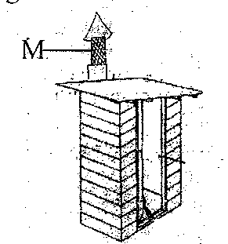

8. How does part marked M control diarrhoeal disease? ___________________________________________________________
9. What is the danger of the larva stage of butterflies to crops? ___________________________________________________________
10. Give one use of light from artificial sources. ___________________________________________________________
11. How do trees reduce transpiration during a dry season? ___________________________________________________________
12. State one role of mammalian skin. ___________________________________________________________
The diagram below shows a stone being thrown using catapult. Use it to answer question 13.

13. What type of energy is possessed by the rubber band before the stone is released?
___________________________________________________________
14. Why does a thermos flask have a tight stopper? ___________________________________________________________
15. Name the part of the human body where synovial fluid is found.
___________________________________________________________
16. Give one way a passion fruit benefits from a nearby mango tree. __________________________________________________________
17. State the type of energy stored by a dry cell. ___________________________________________________________
18. Name the vector which transmits bilharzia disease. ___________________________________________________________
19. What causes the bending of the light ray when it moves from one medium to another?
__________________________________________________________
20. N.P.K is one the artificial fertilizers. What does K stand for? __________________________________________________________
21. What happens to a patient who gets under dose? ___________________________________________________________
22. Name one problem farmers who are near forests face. ___________________________________________________________
23. What is the role of a chalaza in bird’s eggs? __________________________________________________________
24. Give one reason why sacks of beans in a store should be put on a raised stand.
___________________________________________________________
25. Why is AIDs the most feared disease in our community? ___________________________________________________________
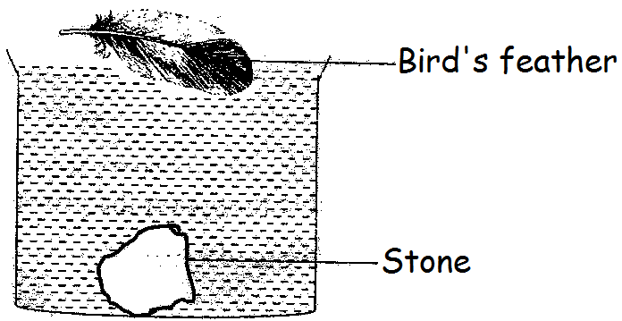
The diagram below shows a bird’s feather and a stone in a jug of water. Study and use them to answer question 26.

26. Why did the stone settle at the bottom while the feather remain on top of the water?
___________________________________________________________
___________________________________________________________
27. Give one reason why a barber uses alcohol. ___________________________________________________________
28. Which process in plants cannot take place without oxygen? ___________________________________________________________
29. Why does a class use the displacement method during their study? ___________________________________________________________
30. Why do plants require chlorophyll during photosynthesis?
___________________________________________________________
The diagram below shows two metallic ball rings. Study them and answer questions 32 and 33.

a) Before heating b) After heating
at room temperature
31. What does the experiment show about metals?
___________________________________________________________
32. Why did the metallic ball in B fail to pass through the ring? ___________________________________________________________
33. Name the substance which stops the action of hydrochloric acid on the chyme.
___________________________________________________________
34. Which body organ can be affected by sharing of clothes? ___________________________________________________________
35. Name the gas which increases around the tree when photosynthesis is taking place.
___________________________________________________________
36. Where in the alimentary canal does absorption of alcohol take place?
___________________________________________________________
37. Give one method a chameleon uses to get its prey. ___________________________________________________________
38. Why should the cooking place be raised from the ground? ___________________________________________________________
___________________________________________________________
39. Which mineral deficiency leads to deformed bones in human beings? ___________________________________________________________
40. Why does a 20 litre jerry can filled with water weigh less in water? ___________________________________________________________
___________________________________________________________

SECTION B:
41. The diagram below is of an invertebrate in the mollusk group. Study it and use it to answer questions that follow.

- Name the part marked W.
- W ____________________________________________________
- X ____________________________________________________
- State the function of the substance marked X to the above mollusk during movement. __________________________________________________________
- Mention the habitat for the above mollusk. ___________________________________________________________
42.a) What is seed dispersal in plants? ___________________________________________________________
___________________________________________________________
b) Apart from animals, name other two agents of seed dispersal.
i) _______________________________________________________
ii) _______________________________________________________
c) State one characteristic of seeds dispersed by animals. ___________________________________________________________
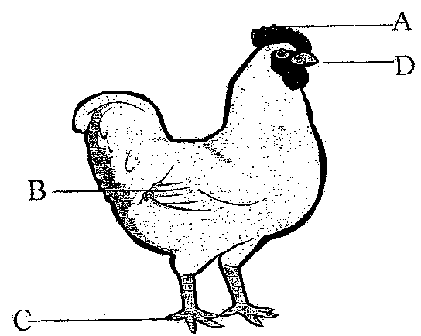
43. The diagram below is of a bird. Use it to answer the questions that follow.

a) Name the parts marked A and C.
A_________________________ C __________________________
b) State the function of part marked D. ___________________________________________________________
c) Which letter shows the part used for flying? ___________________________________________________________
44.a) State two dangers weeds cause to crops in a garden.
i) _______________________________________________________
ii) _______________________________________________________
b) Name one material that can be used for mulching. ___________________________________________________________
c) How do weeds affect the farmers economically? ___________________________________________________________
45.a) Name two groups of vertebrates with streamlined bodies.
i) ________________________ ii) ___________________________
b) Give the importance of streamlined ness of the body to any of the groups in (a) above.
___________________________________________________________
c) Apart from streamlined ness, give one other similarity between vertebrates in (a) above.
___________________________________________________________
46. a) Name two non – infectious diseases which affect the respiratory system.
i) _______________________________________________________
ii) _______________________________________________________
b) Why are diseases in (a) above said to be non-infectious? ___________________________________________________________
___________________________________________________________
c) State the best way of avoiding infectious diseases. ___________________________________________________________
47. Match correctly.
Anaemia bacaterium
Ringworm virus
Rinderpest iron
Anthrax fungus
- Anaemia _____________________________________________
- Ringworm_____________________________________________
- Rinderpest ___________________________________________
- Anthrax ______________________________________________
48. What is castration in the rearing of goats? ___________________________________________________________
___________________________________________________________
b) State one of the methods used in the castrating of goats. ___________________________________________________________
c) Give two benefits of castrating animals.
i) _______________________________________________________
ii) _______________________________________________________
49.a) Name two crops that require staking.
i) ________________________________________________________
ii) _______________________________________________________
b) Give one reason which necessitates the above crops to be staked.
___________________________________________________________
c) How does crop staking lead to good yield? ___________________________________________________________
50.a) Name the organ that removes urine from the body. ___________________________________________________________
b) To which body system does the organ named in (a) above belong? ___________________________________________________________
c) Give the mineral which if taken in excess affects the organ in (a) above.
___________________________________________________________
d) How is the urethra different from the ureter? ___________________________________________________________
___________________________________________________________
51.a) State one organism which produces by means of binary fission. ___________________________________________________________
b) Which instrument is used in seeing the above stated organism in (a) above?
___________________________________________________________
c) Mention one effect of the above organism to man. ___________________________________________________________
d) Why do these organisms mostly stay in fluids? ___________________________________________________________
52.a) What name is given to reflected sound? ___________________________________________________________
b) How are echoes important to;
i) sailors ___________________________________________________________
ii) bats ___________________________________________________________
c) Mention one way in which echoes are reduced in music recording studios.
___________________________________________________________
53.a) Name two diseases which affect the red blood cells.
i) _______________________________________________________
ii) ________________________________________________________
b) Apart from the red blood cell, state other one type of blood cell. ___________________________________________________________
c) Mention the blood cell whose proper functioning requires vitamin K. ___________________________________________________________
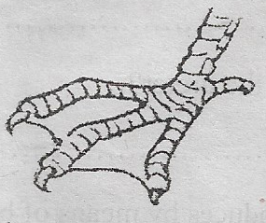
54. The diagram below is of a foot of a bird. Study it carefully and answer the questions that follow.

a) Name the habitat for the bird of this type of foot. ___________________________________________________________
b) Give two examples of birds with such a foot.
i) ______________________________________________________
ii) ______________________________________________________
c) State one characteristic of the above group of birds. ___________________________________________________________
55.a) State the way fungi differs from bacteria in their mode of reproduction.
___________________________________________________________
b) Give two examples of activities which cannot be carried out without fungi.
i) _______________________________________________________
ii) _______________________________________________________
c) Why should rooms handling storage of cereals be subjected to a lot of heat in the control of damage by fungi? __________________________________________________________

***HARD WORK LEADS TO SUCCESS***

