**ATLAS JUNIOR SCHOOL – LUGOBA NABWERU**

**MID TERM TWO ASSESSMENT 2024**

**SUBJECT : NUMBERS**

**AGE GROUP : 5 – 6 YEARS (TOP CLASS)**

**MY NAME IS : \_\_\_\_\_\_\_\_\_\_\_\_\_\_\_\_\_\_\_\_\_\_\_\_\_\_\_\_\_\_\_\_\_\_\_\_\_\_\_\_\_\_\_**

**MY SCHOOL IS : \_\_\_\_\_\_\_\_\_\_\_\_\_\_\_\_\_\_\_\_\_\_\_\_\_\_\_\_\_\_\_\_\_\_\_\_\_\_\_\_\_\_**

1. **Read and draw the pairs.**

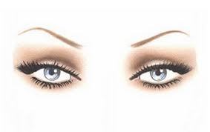

A pair of eyes

A pair of books\_\_\_\_\_\_\_\_\_\_\_\_\_\_\_\_\_\_\_\_

A pair of flowers \_\_\_\_\_\_\_\_\_\_\_\_\_\_\_\_\_\_\_\_

A pair of stones\_\_\_\_\_\_\_\_\_\_\_\_\_\_\_\_\_\_\_\_\_\_

A pair of baskets\_\_\_\_\_\_\_\_\_\_\_\_\_\_\_\_\_\_\_\_\_

A pair of tables\_\_\_\_\_\_\_\_\_\_\_\_\_\_\_\_\_\_\_\_\_\_

1. **Circle the correct word for the shape.**

sun star stick

rectangle roof ruler

cone circle comb

truck tree triangle

line lips lack

onion over oval

1. **Write numbers 0 – 20.**

0 , 1 , \_\_\_\_\_\_ , \_\_\_\_\_\_ , \_\_\_\_\_\_\_ , \_\_\_\_\_\_

\_\_\_\_\_\_\_ \_\_\_\_\_\_\_ \_\_\_\_\_\_\_ \_\_\_\_\_\_ \_\_\_\_\_\_\_

\_\_\_\_\_\_\_ \_\_\_\_\_\_\_ \_\_\_\_\_\_\_ \_\_\_\_\_\_ \_\_\_\_\_\_\_

\_\_\_\_\_\_\_ \_\_\_\_\_\_\_ \_\_\_\_\_\_\_ \_\_\_\_\_\_ \_\_\_\_\_\_\_

1. **Read and draw.**

four sticks \_\_\_\_\_\_\_\_\_\_\_\_\_\_\_\_\_\_\_

eleven balls \_\_\_\_\_\_\_\_\_\_\_\_\_\_\_\_\_\_

ten cups \_\_\_\_\_\_\_\_\_\_\_\_\_\_\_\_\_\_\_\_\_

fifteen sweets \_\_\_\_\_\_\_\_\_\_\_\_\_\_\_\_\_\_

thirteen apples \_\_\_\_\_\_\_\_\_\_\_\_\_\_\_\_\_

twelve spoons \_\_\_\_\_\_\_\_\_\_\_\_\_\_\_\_\_\_\_

1. **Compare and match.**

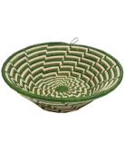

Description: Description: C:\Program Files\Microsoft Office\CLIPART\PUB60COR\NA01158_.WMFDescription: Description: C:\Program Files\Microsoft Office\CLIPART\PUB60COR\NA01158_.WMFDescription: Description: C:\Program Files\Microsoft Office\CLIPART\PUB60COR\NA01158_.WMFDescription: Description: C:\Program Files\Microsoft Office\CLIPART\PUB60COR\NA01158_.WMF

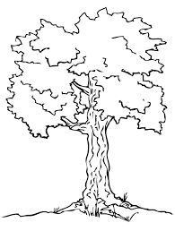

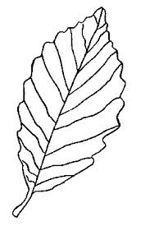

C:\Program Files\Microsoft Office\CLIPART\PUB60COR\FD00428_.WMFC:\Program Files\Microsoft Office\CLIPART\PUB60COR\FD00428_.WMFC:\Program Files\Microsoft Office\CLIPART\PUB60COR\FD00428_.WMFC:\Program Files\Microsoft Office\CLIPART\PUB60COR\FD00428_.WMFC:\Program Files\Microsoft Office\CLIPART\PUB60COR\FD00428_.WMFC:\Program Files\Microsoft Office\CLIPART\PUB60COR\FD00428_.WMFC:\Program Files\Microsoft Office\CLIPART\PUB60COR\FD00428_.WMFC:\Program Files\Microsoft Office\CLIPART\PUB60COR\FD00428_.WMF

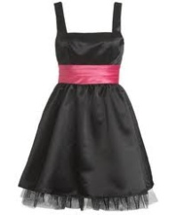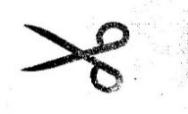

1. **Add and write the number.**

= 3triangles

=\_\_\_\_\_\_\_\_\_\_\_\_\_\_\_\_\_\_\_\_\_\_\_\_\_\_\_\_\_\_\_\_\_\_\_\_\_\_\_\_

=\_\_\_\_\_\_\_\_\_\_\_\_\_\_\_\_\_\_\_\_\_\_\_\_\_\_\_\_\_\_\_\_\_\_\_\_\_\_\_\_

=\_\_\_\_\_\_\_\_\_\_\_\_\_\_\_\_\_\_\_\_\_\_\_\_\_\_\_\_\_\_\_\_\_\_\_\_\_\_\_\_

=\_\_\_\_\_\_\_\_\_\_\_\_\_\_\_\_\_\_\_\_\_\_\_\_\_\_\_\_\_\_\_\_\_\_\_\_\_\_\_\_



+

+

+

+

+

+

=\_\_\_\_\_\_\_\_\_\_\_\_\_\_\_\_\_\_\_\_\_\_\_\_\_\_\_\_\_\_\_\_\_\_\_\_\_\_\_\_

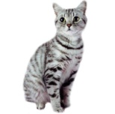

1. **Draw balls for the numbers.**



13 =

9 =

16=

10=

20=

15=

1. **Match and write.**

eight nine 9

twelve twenty \_\_\_\_\_\_\_

thirteen eight \_\_\_\_\_\_\_

twenty fifteen \_\_\_\_\_\_\_

nine twelve \_\_\_\_\_\_\_\_

fifteen thirteen \_\_\_\_\_\_\_\_

1. **Write the next number.**

1 2 3

14 15 \_\_\_\_\_

17 18 \_\_\_\_\_\_

10 11 \_\_\_\_\_\_\_

19 20 \_\_\_\_\_\_\_\_

24 25 \_\_\_\_\_\_\_\_

1. **Name the sets.**

 A set of books.

\_\_\_\_\_\_\_\_\_\_\_\_\_\_\_\_\_\_\_\_\_\_\_\_\_

****

 \_\_\_\_\_\_\_\_\_\_\_\_\_\_\_\_\_\_\_\_\_\_\_\_\_

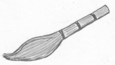

\_\_\_\_\_\_\_\_\_\_\_\_\_\_\_\_\_\_\_\_\_\_\_\_

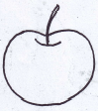

\_ \_\_\_\_\_\_\_\_\_\_\_\_\_\_\_\_\_\_\_

***Success***