**ATLAS JUNIOR SCHOOL – LUGOBA NABWERU**

**MID TERM TWO ASSESSMENT 2024**

**SUBJECT : NUMBERS**

**AGE GROUP : 4 – 5 YEARS (MIDDLE CLASS)**

**MY NAME IS : ___________________________________________**

**MY SCHOOL IS : __________________________________________**

1. **Match shape to a word.**

square

cone

star

circle

kite

1. **Name the pairs.**

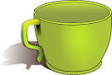

A pair of _________________

A pair of ____________________

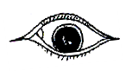

A pair of __________________

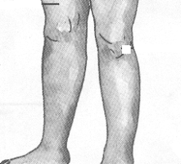

A pair of ______________________

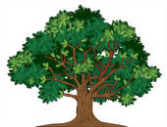

A pair of __________________

( cups , legs , balls , trees , eyes )

1. **Count and write.**



=­­­­­­­­­________

=_________

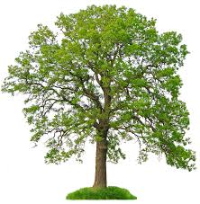

= ­­­­­­­_______________



=­­­­_____

= ­­­________

1. **Use long / short.**



________ ________

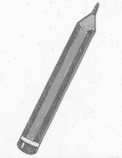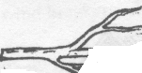

_________ _______

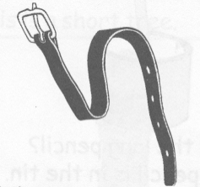

_______________

1. **Write the nest number.**

1________

3________

5________

7_________

9_________

11________

1. **Read and shade its colour.**

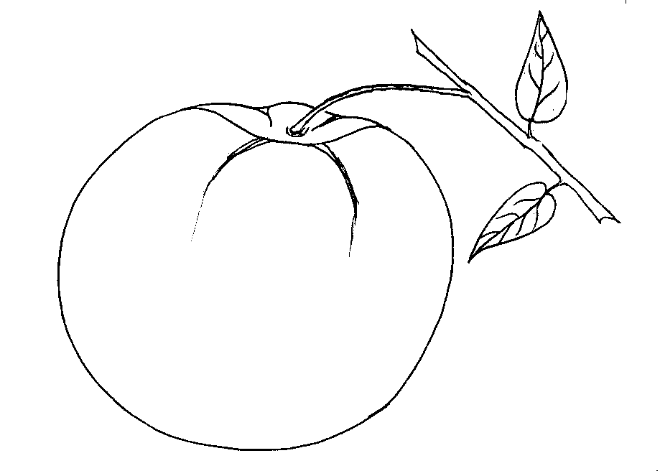yellow red

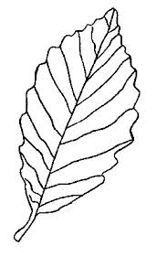D:\JULIANA\juliana\My Scans\My scans\My Scans 008.tif

blue green

1. **Write in figures.**

one ____1_____

six ________

three _______

two _________

ten ________

zero _______

eight _______

four ________

1. **Match to similar shapes.**

egg

zip

chalkboard

box

ball

1. **Write numbers 1 – 10**

___1___ ______ ______ ______ _____

_______ ______ ______ ______ _____

***Success***