**ATLAS JUNIOR SCHOOL – LUGOBA NABWERU**

**MID TERM TWO ASSESSMENT 2024**

**SUBJECT : NUMBERS**

**AGE GROUP : 3 – 4 YEARS (BABY CLASS)**

**MY NAME IS : ___________________________________________**

1. **Draw and write.**

|  |  |
| --- | --- |
|  | oval |
|  |  |
|  | kite |
|  |  |

1. **Match to similar shapes.**



untitledghjk.png



1. **Match correctly.**

[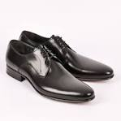](http://www.google.co.ug/imgres?imgurl=http://www.thedynamicdesigngroup.com/wp-content/uploads/2013/02/Black-Derby-Shoes-466P.jpg&imgrefurl=http://www.thedynamicdesigngroup.com/are-you-catering-to-your-customers-buying-behaviors/black-derby-shoes-466p/&usg=__Cd5b4NGDiOzq_o-SmjQCllBXEGI=&h=1000&w=1000&sz=121&hl=en&start=17&zoom=1&tbnid=ig6CitrR1qEF9M:&tbnh=149&tbnw=149&ei=z3x-UeP3O6ez4ATytYAg&prev=/search?q=shoes&hl=en-UG&gbv=2&tbm=isch&itbs=1&sa=X&ved=0CEoQrQMwEA)





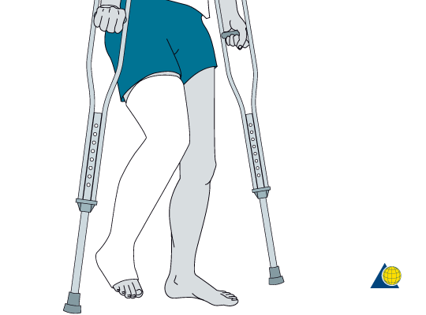

1. **Copy numbers.**

|  |  |  |  |  |  |
| --- | --- | --- | --- | --- | --- |
| 0 | 1 | 2 | 3 | 4 | 5 |
|  |  |  |  |  |  |

1. **Circle the odd man out.**

8 0 0

7 5 5

4 6 6

1. **Tell the numbers.**

2 4 1 5 3

***Good luck***