**LE BON BERGER NURSERY AND PRIMARY SCHOOL**

**PRIMARY ONE ENGLISH BEGINNING OF TERM TWO 2022-2023**

**NAME ______________________________________ stream______**

**1) Dictation**

______________________________

______________________________

______________________________

______________________________

______________________________

**2. What is your name?**

_____________________________________________

**3. Fill in the missing letters.**

i) a ______ c______ e _______g ____ h _____

ii) A _____ I _____ 0______ **5 . Copy and write**

I). SCHOOL. DOOR , ZEBRA BOX

_________ _____________ ____________ ____________

ii). book, Pencil. table. window

____________ __________ ___________ ____________

**6. Match these correctly.**

A b

D. f

B. a

E. d

F. e

**7. Name these pictures**

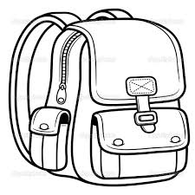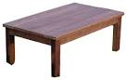

**___________________ ______________________**



**_______________________ _________________________**

**(book, table, chair, bag)**

**8. Write in small letters.**

A B C D E F

_____ ____ ____ ____ ____ ______

**4. Read and draw**

|  |  |  |  |  |
| --- | --- | --- | --- | --- |
|  |  |  |  |  |
| Chair | ball | pencil | book | house |

END