**PRIMARY ONE EXAMS**

**RELIGIOUS EDUCATION MID TERM THREE 2024**

***Time Allowed: 2 Hours***

Name: ………………………………………………………………………………

1. Give **three** examples of domestic animals God created.
2. ____________________________________________________
3. ____________________________________________________
4. ____________________________________________________
5. Give the meaning of the name Peter. _____________________________________________
6. Write your religious name.

__________________________________________________________

1. In which city was Jesus born?

___________________________________________________________

1. Parents are ____________________ to us. (friends, gifts)
2. Write **two** Christian names for girls.
3. ___________________________________________________
4. ___________________________________________________
5. How many apostles did Jesus have?

___________________________________________________________

1. Name these things used during baptism.

|  |  |  |  |
| --- | --- | --- | --- |
|  |  |  |  |
|  |  |  |  |

1. Give any **two** miracles Jesus performed.
2. ___________________________________________________
3. ___________________________________________________
4. Write **two** books in the Bible.
5. ____________________________________________________
6. ____________________________________________________
7. __________________ is a way of talking to God.
8. Tick the ways of showing respect to elders.

* Greeting them.
* Quarrelling with them.
* Obeying them.
* Thanking them.

1. Draw these family members.

|  |  |  |  |
| --- | --- | --- | --- |
| **father** | **mother** | **baby** | **sister** |
|  |  |  |  |

1. In which river was Jesus baptized from?

___________________________________________________________

1. Why did God create man?

______________________________________________________________________________________________________________________

1. Name the holy book for;
2. Christians : _______________________________
3. muslims : _______________________________
4. Who was the earthly father of Jesus?

__________________________________________________________

1. Name these things God created.

|  |  |  |
| --- | --- | --- |
|  |  |  |
|  |  |  |

1. Write any **two** needs of people.
2. ___________________________________________________
3. ___________________________________________________
4. Who calls muslims for prayers?

__________________________________________________________

1. Jesus Christ loved people by _____________________ for them. (fighting, praying )
2. How do these people talk to God?

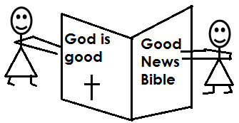

By ______________________________________________________

1. Muslims pray ________________ times a day.
2. Match these sense organ to the their senses

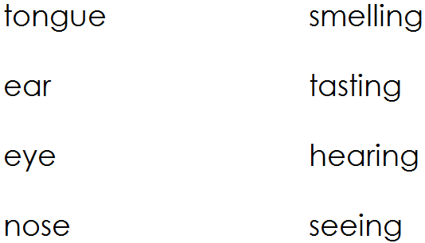

1. Which body part is used for reading the Bible?

__________________________________________________________

1. Most Christians go to _________________ on Sundays.
2. Draw these places of worship.

|  |  |
| --- | --- |
| **church** | **mosque** |
|  |  |

1. Give **two** things found in church.
2. ___________________________________________________
3. ___________________________________________________

**THE END**