**RAAYAT ISLAMIC NUR & PRIMARY SCHOOL**

**MID-TERM ONE EXAMINATION, 2024**

**READING – P.1**

**TIME: 2HRS 15 MINS2023**

CLASS P.1 ENGLISH JUNIOR SCHOOL

AND DAYCARE CENTRE

MID TERM ONE EXAMINATION 2023

CLASS P.1 ENGLISH

**Name: _________________________________________________**

**SECTION A**

**1. Read these sounds.**

**a ck s t i**

**2. Match sound to picture.**



 **P**

**e**

**a**

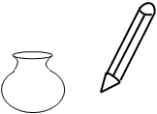

**t**

**3. Sound and read.**

**c-a-t t-i-n p-i-ck**

**m-a-t t-a-p**

**4. Underline words of sound “a”**

**She has a bag.**

**I can see an axe**

**Look at that man.**

**Dad is going to the mosque.**

**5. Join and form words.**

**p-i-ck pick**

**d-u-ck _____________________**

**p-a-ck _____________________**

**s-a-ck _____________________**

**e-gg _____________________**

**6. Read and draw.**

|  |  |  |  |
| --- | --- | --- | --- |
|  |  |  |  |
| **bag** | **sun** | **mat** | **cat** |

**7. Circle words with sound “ir”**

**shirt dress third**

**got girl tree**

**first burn bird**

**8. Fill in the missing sound.**

**c___t t___n b___d**

**9. Read and draw.**

**I have two eyes. He has a ball.**

**This is an apple**

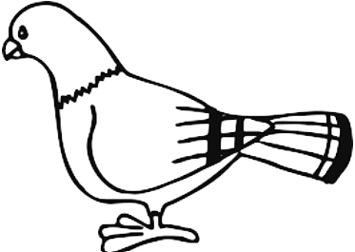**10. Make sentences using: It is a ______________**

**__________________________________________**



 **____________________________________________**

**____________________________________________**

**_____________________________________________**

**11. Sound and draw.**

t

b

a

f

s

**12. Shade these family members.**

C:\Users\jarah\Desktop\pictures\VJS\PICTURES\english pictures\Animals\family.tif