**Name: ……………………………………….………… Date: ………………….….**

**MATHEMATICS**

**1. Study the price list below and answer the questions below.**

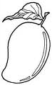

an egg an apple a mango

Shs. 400 Shs. 800 Shs. 500

a) What is the cost of a mango?

__________________________________________________________________

b) What is the most expensive items?

___________________________________________________________________

c) What is the cost of an apple and a mango?

___________________________________________________________________

d) How much will Priscilla pay for all the items?

___________________________________________________________________

e) Find the cheapest item on the list.

___________________________________________________________________

**2. Study the picture below and answer the questions.**

**_ _ _ _ _**

**Alex Bob Emma Tom**

1. Who is in **the first** position?

___________________________________________________________________

2. Who is **the third**?

___________________________________________________________________

3. How many pupils are running?

___________________________________________________________________

4. Who is **the last**?

___________________________________________________________________

5. Write **9th** in words.

____________________________________________________________________

**General Knowledge**

State atleast**one** indoor game you know.

............................................................................................................................

**ENGLISH**

**1. Read and draw.**

a) Here is a policeman b) This is an Imam

c) There is a soldier

**2. Arrange in ABC order.**

a) soldier, child, Imam, teacher

........................................................................................................................

b) Parent, woman, mosque, army

........................................................................................................................

**3. Write any five nouns.**

i) ............................................ ii) ...........................................

iii) .......................................... iv) ..........................................

v) ..........................................

**General Knowledge**

Why is important for a P.2 child to attend all physical education lessons?

............................................................................................................................

**LITERACY ONE**

1. **Answer correctly.**

a) What is your name?

____________________________________________________________________

b) What is your father’s name?

____________________________________________________________________

c) What is your mother’s name?

____________________________________________________________________

d) Write your school name.

____________________________________________________________________

2. **Make sentences using the words below.**

a) son: _______________________________________________________________

b) sun: _______________________________________________________________

c) hear: ______________________________________________________________

d) here: ______________________________________________________________

3. **Write words with these sounds**.

a) ai: _______________________ (b) sh: ______________________

c) ch: _______________________ (d) sp: ______________________

**LITERACY TWO**

1. Which animal guards our home?

............................................................................................................................

2. Name the people who provide basic needs to family members.

............................................................................................................................

3. Suggest **any three** people at school who promote peace and security.

i) .............................................................

ii) ...........................................................

iii) ............................................................

4. Who heads a school?

............................................................................................................................

5. How do children promote peace and security at school and home?

............................................................................................................................

**General Knowledge**

What is the use of a school bag?

............................................................................................................................

|  |  |  |
| --- | --- | --- |
| **Comment:** |  | |
| **Name of Parent** |  | **Sign:** |
| **Date** |  | **Contact:** |

**Name: ……………………………………….………… Date: ………………….….**

**MATHEMATICS**

**1. Define the following terms.**

a) A set _____________________________________________________________

__________________________________________________________________

b) Money _____________________________________________________________

____________________________________________________________________

c) A fraction __________________________________________________________

____________________________________________________________________

d) An empty set ______________________________________________________

____________________________________________________________________

e) Length _____________________________________________________________

__________________________________________________________________

f) capacity ___________________________________________________________

____________________________________________________________________

g) weight _____________________________________________________________

__________________________________________________________________

h) Elements ___________________________________________________________

____________________________________________________________________

i) Intersection_________________________________________________________

____________________________________________________________________

**General knowledge**

Draw a symbol of an empty set.

_________________________________________________________________

**ENGLISH**

**Answer questions using the words in brackets.**

1. What do you like? (greeting)

............................................................................................................................

2. What do you like? (forgiving)

............................................................................................................................

3. What do you like? (helping)

............................................................................................................................

4. What do you like? (obeying elders)

............................................................................................................................

5. What do you like? (playing with friends)

............................................................................................................................

6. What do you like? (thanking people)

............................................................................................................................

7. Do you like praying? (Yes)

............................................................................................................................

8. Do you like stealing? (No)

............................................................................................................................

9. Do you like sharing? (Yes)

............................................................................................................................

10. Do you like playing? (No)

............................................................................................................................

**General knowledge**

Mention **one** form of discipline expected of a Kings pupil.

..........................................................................................................................

**LITERACY ONE**

**1. Fill in the missing letters.**

a) d..........nce b) d........ct........r

c) wro...........e d) n........rse

**2. Join the words.**

im .......................................

earing ........................................

sw eep .........................................

ing ..........................................

eet ...........................................

eat ...........................................

**3.** Why do we give first aid?

i) ........................................................................................................................

ii) ........................................................................................................................

**4. Choose the correct word from the box and complete correctly.**

|  |
| --- |
| **carpenter, cobbler, pilot, secretary, cyclist, priest** |

a) A ...................................... types letters.

b) A ......................................flies an aeroplane.

c) A ......................................makes furniture.

d) A ......................................leads prayers in church.

e) A ......................................rides a bicycle.

d) A ......................................makes and repairs shoes.

**General knowledge**

Mention atleast**five** of your class rules.

i) ........................................................................................................................

ii) ........................................................................................................................

iii) ......................................................................................................................

iv) ......................................................................................................................

v) ......................................................................................................................

**L LITERACY TWO**

1. Who heads a local council one?

............................................................................................................................

2. Name **any four** places which need security guards to keep peace and security.

i) .................................................. ii) ...............................................

iii) ................................................. iv) ..............................................

4. **Match correctly.**

Head teacher diocese

Lawyers and judges kingdom

Priest and Pastor country

President school

King court

Bishop church

5. Who is the Headteacher or your school?

............................................................................................................................

**General knowledge**

Mention the days of the week when you wear sports shoes.

..........................................................................................................................

|  |  |  |
| --- | --- | --- |
| **Comment:** |  | |
| **Name of Parent** |  | **Sign:** |
| **Date** |  | **Contact:** |

**Name: ……………………………………….………… Date: ………………….….**

**MATHEMATICS**

**1. Divide/ share**

a) 6 $÷$ 2 = _______ b) 3 21

c) Share **20** guns among four security men.

How many guns will each security man get?

__________________________________________________________

d) Share **18** sweets by **3** boys. How many sweets did each get?

__________________________________________________________

2. **Read and answer.**

a) Dorah weighs **24kg**. Tendo weighs **18kg**.

i) Who is lighter?

__________________________________________________________

ii) Who is heavier?

__________________________________________________________

iii) What is their total weight?

___________________________________________________________

iv) How many more kilograms does Dorah weigh than Tendo?

____________________________________________________________

**General knowledge**

A sac of feathers weighs **15kg**. A box of sugar weighs **15kg**. Which one is heavier?

____________________________________________________________________

**ENGLISH**

**Use ‘is’, ‘are’ or ‘am’, to complete the sentences.**

1. The police man ..................................... holding a gun.

2. The children .......................................... sharing mangoes.

3. We ...............................................helping our parents.

4. They ............................................praying to God.

5. The boys ....................................... greeting visitors.

6. I ............................... cooking food for my friend.

7. He ......................... buying a gift.

8. Bbosa and Viola ..................................... good children.

9. Cissy .................................. very happy.

**General knowledge**

Write down the your schools mission.

………………………………………………………………………………………………..

|  |  |  |
| --- | --- | --- |
| **Comment:** |  | |
| **Name of Parent** |  | **Sign:** |
| **Date** |  | **Contact:** |

**LITERACY ONE**

1. Join the words from phonetic slide.

sw t 1. ...........................................

t d 2. ...........................................

r k 3. ...........................................

w ea t 4. ............................................

t m 5. ............................................

l d 6. ............................................

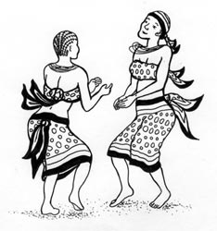2. Make sentences using the pictures below.

a) .......................................................................................

b) .......................................................................................



c) .......................................................................................

d) ......................................................................................

3. Write down words with sound “ght”

i) ................................................. ii) ..............................................

iii) .............................................. iv) ............................................

4. Underline words with sound ‘c’ in the sentences below.

a) My uncle has come.

b) The door is crossed.

c) A young cow is a calf.

**General knowledge**

Why is it important to ask for permission before getting out of class?

............................................................................................................................

**LITERACY TWO**

1. Who is a child?

............................................................................................................................

............................................................................................................................

2. Give **any two** roles of children at home.

i) .........................................................................................................................

ii) ........................................................................................................................

3. List down **any two** examples of children’s needs.

i) .........................................................................................................................

ii) ........................................................................................................................

4. Why do children need rights?

............................................................................................................................

5. Identify **any three** examples of children’s rights you know.

i) .........................................................................................................................

ii) ........................................................................................................................

iii) .......................................................................................................................

6. What were Adam and Eve eating in the Garden of Eden?

............................................................................................................................

**General knowledge**

How useful is a timetable in class?

............................................................................................................................

|  |  |  |
| --- | --- | --- |
| **Comment:** |  | |
| **Name of Parent** |  | **Sign:** |
| **Date** |  | **Contact:** |

**Name: ……………………………………….………… Stream: ………………….….**

**MATHEMATICS**

1. Study the graph below and answer the questions.

|  |  |  |  |  |
| --- | --- | --- | --- | --- |
| C:\Users\Secretary\Documents\OTHERS\new images\Food\mango.jpg  C:\Users\Secretary\Documents\OTHERS\new images\Food\mango.jpg | C:\Users\Secretary\Documents\OTHERS\new images\Food\mango.jpgC:\Users\Secretary\Documents\OTHERS\new images\Food\mango.jpgC:\Users\Secretary\Documents\OTHERS\new images\Food\mango.jpgC:\Users\Secretary\Documents\OTHERS\new images\Food\mango.jpg | C:\Users\Secretary\Documents\OTHERS\new images\Food\mango.jpg | C:\Users\Secretary\Documents\OTHERS\new images\Food\mango.jpgC:\Users\Secretary\Documents\OTHERS\new images\Food\mango.jpgC:\Users\Secretary\Documents\OTHERS\new images\Food\mango.jpg | C:\Users\Secretary\Documents\OTHERS\new images\Food\mango.jpgC:\Users\Secretary\Documents\OTHERS\new images\Food\mango.jpg |
| Joan | Kato | Paul | Sam | Tina |

a) How many children picked the mangoes?

_________________________________________________________________

b) Who got the biggest number of mangoes?

_________________________________________________________________

c) How many mangoes did Sam and Joan get?

_________________________________________________________________

d) Who got the least number of mangoes?

_________________________________________________________________

e) How many mangoes did they get altogether?

____________________________________________________________________

**2. Fill in the missing letters.**

a) J ____nuary b) Aug_____st

c) Sept______mber d) Febr_____ary

**General knowledge**

Which domestic work do you always do at your home?

___________________________________________________________________

**ENGLISH**

**Use “Yes, it is” or “No, it is not”.**

1. Is it good to share with others?

...........................................................................................................................

2. Is it good to help others?

...........................................................................................................................

3. Is it good to fight one another?

...........................................................................................................................

4. Is it good to pray for others?

...........................................................................................................................

**Make sentences from the table.**

|  |  |  |
| --- | --- | --- |
| It is had to  It is good to | love  greet  abuse  fight  share | others.  with others. |

i) ........................................................................................................................

ii) ........................................................................................................................

iii) .......................................................................................................................

iv) .......................................................................................................................

v) .......................................................................................................................

**General knowledge**

What is a verb?

............................................................................................................................

**LITERACY ONE**

1. Name **three** things used to keep peace and security.

i) .................................................. ii) ..........................................

iii) ................................................

**2. Fill in the missing letters.**

a) s.........lt.........ng b) s........nd.......ying

c) sm..........k........ng d) f......... .........d

**3. Join the sounds to form words.**

en ......................................

ere ......................................

wh ole ......................................

y ......................................

eel ......................................

o ......................................

**4. Re – arrange the jumbled sentences.**

a) family Parents needs provide.

............................................................................................................................

b) law Police and keeps order.

............................................................................................................................

c) peace keep Parents security and.

............................................................................................................................

**General knowledge**

Write **five** words with sound ‘ght’

i) ......................................... ii) .....................................

iii) ....................................... iv) .................................. v) ..........................

**LITERACY TWO**

1. Draw these things used to keep peace and security.

|  |  |  |  |
| --- | --- | --- | --- |
|  |  |  |  |
| dog | stick | spear | baton |

2. Identify **any one** example of child abuse.

............................................................................................................................

3. Suggest **any two** examples of bad people in your community.

i) ................................................ ii) .........................................  
4. Mention **two** subjects you learn at school.

i) ...................................................... ii) ...................................................

**General knowledge**

How many days are in the month of October?

____________________________________________________________________

|  |  |  |
| --- | --- | --- |
| **Comment:** |  | |
| **Name of Parent** |  | **Sign:** |
| **Date** |  | **Contact:** |

**Name: ……………………………………….………… Date: ………………….….**

**MATHEMATICS**

**1. Write the next number in the sequence.**

12, 14, 16, _________, _______

2. Given that **K** = 1, 3, 4, 5, 6 and **M** = 1, 3, 5, 7, 9 .

a) Show the members of set **K** and **M**

**K M**

b) Write down the members of set **K $∪$ M**.

______________________________________________________________

c) How many members are in set **K M**?

______________________________________________________________

3. Write the place value of **4** in **6435**.

______________________________________________________________   
4. Write **nine hundred ninety nine** in figures.

______________________________________________________________

**General knowledge**

What time is **15** minutes before **15** minutes past **7**?

________________________________________________________________________

**ENGLISH**

**Fill in the missing letters.**

1. h......... ...........vy 2. f..........ght 3. tou.........h

**Arrange in ABC order.**

4. late, burn, rest

...........................................................................................................................

5. heavy, fetch, sweep

...........................................................................................................................

6. mop, clean, work

...........................................................................................................................

**LITERACY ONE**

1. Write words with these syllables.

di ............................................... ce ............................................

mu ............................................ kn .............................................

ro .............................................. ph ............................................

2. Name the parts of a plant below.

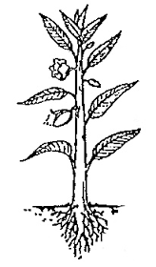

................ a

................. b c ..................................

d ....................................

e....................................

3. Write three basic needs of people.

i) ..................................................... ii) ............................................

iii) ....................................................

**LITERACY TWO**

1. ...................................................... is where people are free from work.

2. Identify **any two** places where people go for recreation.

i) .................................................. ii) ..................................................

3. Give **any one** activity done in the Mosque.

............................................................................................................................

4. Mention **any two** reasons why people work.

i) .........................................................................................................................

ii) ........................................................................................................................

5. Which activities do you do at school in your free time?

............................................................................................................................

6. Write **any two** types of work people do.

i) .........................................................................................................................

ii) ........................................................................................................................

7. Name **any three** religious leaders you know.

i) ....................................................... ii)......................................................

ii).......................................................

|  |  |  |
| --- | --- | --- |
| **Comment:** |  | |
| **Name of Parent** |  | **Sign:** |
| **Date** |  | **Contact:** |

**Name: ……………………………………….………… Date: ………………….….**

**MATHEMATICS**

**1. Match the sets.**

4

5

3

2. Form new sets (sub sets)

 ________________________

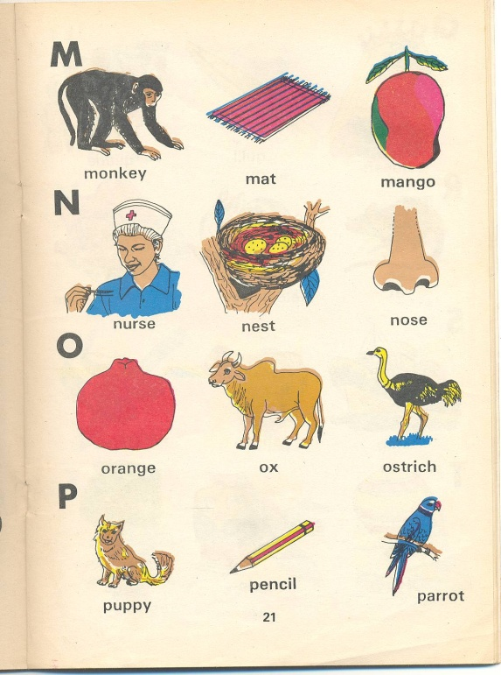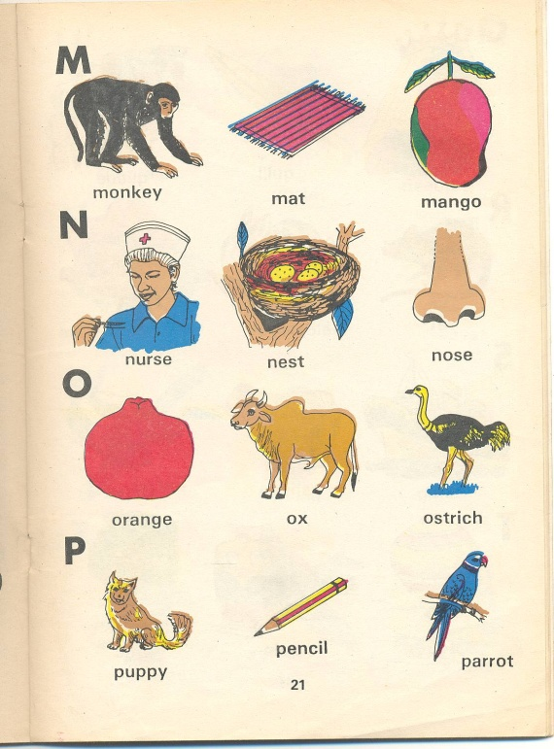

 ________________________

3.a) What number is shown on the abacus?

H T O

= _______

b) Show **205** on the abacus.

H T O

4. Write 33 in words.

__________________________________________________________________

**General knowledge**

To multiply by me, here is what you can do. First multiply by 10, then multiply by 2 what am I?

**ENGLISH**

**Re – arrange words correctly.**

1. ndarcale ...................................... 2. bernum ...................................

3. terquar ......................................

**Fill in the missing letters.**

4. ye...........r 5. da.........ly 6. we...........k

**Circle the correct words.**

7. calendar calender celender

8. nuber namber number

**LITERACY ONE**

1. Complete the guided composition.

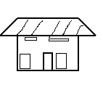

P.1

ppo

P.2

P.4

Alvin and Jayden go to KingsP.1P2P3 ........................................

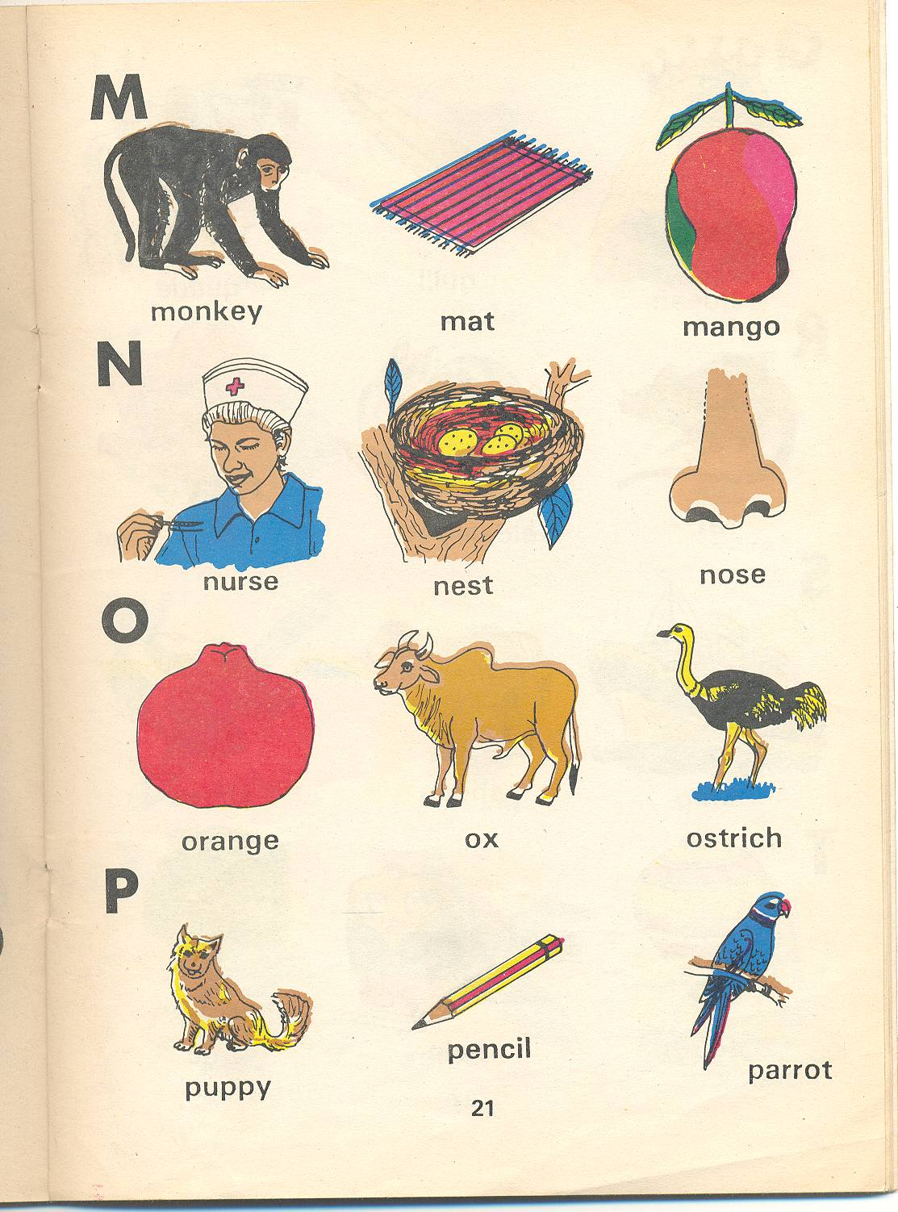

They carry ..................... and ......................... in their bags.

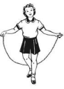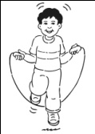

After classes Alvin plays with his ........................ and Jayden

stays in class and sweeps it with a ..............................

Teacher likes Jaden very much because she is a hardworking girl.

**LITERACY TWO**

1. What is your hobby?

............................................................................................................................

2. Outline **any two** common games people do in their free time.

i) ........................................................ ii).................................................

3. Name the two holy books religious leaders read in their leisure time.

i) ....................................................... ii) .............................................

4. Identify **any one** game/ activities done at school.

......................................................................................................................

5. Who leads prayers in the Mosque?

......................................................................................................................

**Name: ……………………………………….………… Date: ………………….….**

**MATHEMATICS**

**1. What is the time?**

11 12 1

10 2

9 3

8 4

7 6 5

___________________________________________

**2. Name the shape below.**

__________________________

3. One book costs Sh. 300. How much will I pay for 3 books?

___________________________________________________________________

4. A mother shared **35** oranges equally among her **5** children. How many oranges did each get?

____________________________________________________________________

5. Subtract: 6. Multiply:

2 7 5 2 5

**–** 1 5 8 **x** 3

____________ __________

**ENGLISH**

**Match number positions to their words.**

1st seventh

2nd fourth

3rd ninth

4th first

5th seventeenth

6th second

7th third

17th tenth

9th fifth

10th sixth

**LITERACY ONE**

**1. Write these words correctly.**

a) sehou ........................ b) loudc .................................

c) ndrou ......................... d) semou ...............................

**2. Re – arrange the jumbled words to form correct sentences.**

a) of proud daughter I am my.

..........................................................................................................................

b) insect A is bad louse a.

..........................................................................................................................c) groundnuts brought Tinah.

..........................................................................................................................d) outside Who the is class?

..........................................................................................................................e) help the children friend their.

..........................................................................................................................

**LITERACY TWO**

1. How do we call a person who plays music at the ceremony?

.........................................................................................................................

2. Suggest **any one** bad game you know. .........................................................................................................................

3. Give **any one** ceremony done at school.

.........................................................................................................................

4. Which kind of ceremony is done at church?

.........................................................................................................................

5. What are ceremonies?

.........................................................................................................................

6. Mention **two** people who start a family.

i) .......................................................... ii) ........................................................

7. What did Jesus do at the wedding at Cana?

............................................................................................................................

**Name: ……………………………………….………… Stream: ………………….….**

**MATHEMATICS**

Ivan (1st)

Fred (2nd)

Paul (3rd)

John (4th)

Bob (5th)

Dan (6th)

Mark (7th)

Otim (8th)

1. Who is on the 3rd step?

___________________________________________________________________

2. Name the 7th and 8th child.

__________________________________________________________________

3. How many pupils are climbing the steps?

__________________________________________________________________

4. On which step is Dan?

__________________________________________________________________

5. Write in words.

i) 1st _______________________ ii) 9th _______________________

6. Write the value of the following.

a) 5 hundreds ___________________b) 6 tens ______________________

**General knowledge**

A boy closed one of his eyes and saw 2 cats in the compound.

How many cats did he see when he opened the second eye?

------------------------------------------------------------------------------------------------

**ENGLISH**

**Fill in the correct word.**

1. An insect is flying .........................................a flower.

2. Hindu is sitting .........................................a chair.

3. The doll is .........................................the bed.

4. Maria is going ....................................... school.

**Write the days of the week in full.**

5. Sun. ......................................... 6. Mon. .......................................

7. Tue. .......................................... 8. Wed. ......................................

9. Thur. .......................................... 10. Fri. .......................................

**General knowledge.**

How many consonant letters are in the English alphabet?

__________________________________________________________________

**LITERACY ONE**

**Read the story and answer the questions in full sentences.**

**CHILD ABUSE**

Child abuse is when a child is denied his or her rights. A child is someone below eighteen years. Some of the causes of child abuse are poverty, alcoholism, broken family, insecurity and others.

Children can be abused by beating, burning, labouring, defiling, kidnapping etc. Children should be protected to live a happy life.

**By Brenda**

**Questions:**

1. What is child abuse?

.........................................................................................................................

2. Who is a child?

.........................................................................................................................

3. Give **two** causes of child abuse.

i) ..................................................... ii) ......................................................

4. What is the title of the story?

.........................................................................................................................

5. Write words with these sounds.

i) ou ................................................ ii) ck .............................................

iii) bra ............................................. iv) kn ............................................

**LITERACY TWO**

1. Name the recreation activities done at the play ground.

.........................................................................................................................

2. What are cultural festivals?

.........................................................................................................................

3. Match correctly.

Baganda Rutooro

Basoga Lugisu

Batooro Runyankole

Banyankole Luganda

Bagisu Lusoga

**General knowledge**

What is the name of the area where your home is?

____________________________________________________________________

|  |  |  |
| --- | --- | --- |
| **Comment:** |  | |
| **Name of Parent** |  | **Sign:** |
| **Date** |  | **Contact:** |

**LITERACY ONE**

1. ............................................. is a system showing days, weeks and months of a year.

2. How many days make a week?

.........................................................................................................................

3. What is the first day of the week?

.........................................................................................................................

4. List three days of the week.

i) ..................................................... ii) ............................................

iii) ....................................................

5. Name the last month of the year.

.........................................................................................................................

6. How many months are in a year?

.........................................................................................................................

7. How many days has February?

.........................................................................................................................

8. Give **three** months which have 31 days.

i) ..................................................... ii) ...........................................

iii) ....................................................

**LITERACY TWO**

1. ............................................. are things made using hands from local materials.

2. Name **any two** things made by machines in the factories.

i) ..................................................... ii) ..............................................

3. Mention **any two** things in the sitting room made by people using hands.

i) .......................................................... ii) .................................................

4. Name **any two** examples of furniture.

i) ............................................................ ii) ...................................................

5. How do we call a person who makes things out of wood?

..........................................................................................................................