THE TUBBIES SCHOOL

**END OF TERM II EXAMINATION, 2024**

**CLASS: P.2**

# SUBJECT: READING AND WRITING

# DURATION: 2 HOURS 15 MINUTES

# 

**Name …………………………………………………………………..**

**SECTION A**

**1. Listen and write:**

a) ________________________b) _______________________

c) ___________________________________________________

**2. Write the given words correctly. ( 1 mark)**

a) neves: ______________________

b) erweh_______________________

c) recilc________________________

d) onsop________________________

**3. Write a correct blend for each of these pictures. (1 mark)**

|  |  |
| --- | --- |
| C:\Users\KJS\AppData\Local\Microsoft\Windows\INetCache\Content.MSO\F88C1654.tmp | C:\Users\KJS\AppData\Local\Microsoft\Windows\INetCache\Content.MSO\DAFA5382.tmp |
|  |  |
| Broom for cleaning on a white background 2281517 Vector Art at Vecteezy | C:\Users\KJS\AppData\Local\Microsoft\Windows\INetCache\Content.MSO\597161.tmp |
|  |  |

**4 Write a correct word for each of the given sounds/spellings.**

a) ai________________________c)sk______________________

b) sp______________________d)ay________________________

e) st_________________________

**5. Underline the long vowel sound and write a word with the sound. (1 mark)**

a) teeth b) toad

b) bruise d) team

**6. Rearrange the sentences to form a good story..**

I take my break fast

First, I pray.

When I wake up in the morning

Last I put on my uniform and go to school.

Next I wash my face.

a)When I wake up in the morning,

b)_________________________________________________

c)_________________________________________________

d)_________________________________________________

e)__________________________________________________

**7. Circle the word that has a different vowel sound.**

a) beat, meat, boat, heat

b) pail, peel, pain, paint.

c) ball, small, mall, warm.

d) doctor, director, fork, monitor.

**8. Copy the letters correctly.**

(a) **Ss** **Ss** **Ss**

(b) snail small smooth

A snail moves slowly



**9. Use the correct word from the brackets to fill the gaps.**

a) The lorry is climbing a __________________. (heel, hill)

b) She likes ______________ more than fish. (meat, meet)

c) Mother has gone to___________ a loaf of bread. ( by, buy)

d) We don’t _______________ the correct answer. (no, know)

**10. Cross out a letter at a time. What word do you have?**

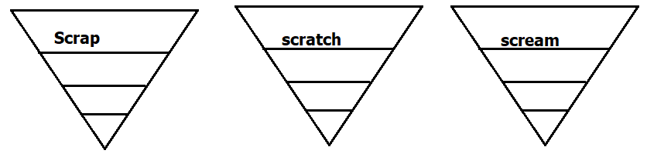

**11. Use the given words to write correct sentences.**

a) why

____________________________________________________

b) some

____________________________________________________

c) where

____________________________________________________

d) and

____________________________________________________

**12. Complete the riddles correctly.**

a) I am an animal. I can bark and sniff. My work is to guard people’s homes. Who am I ?

____________________________________________________

b) I can jump. I can croak. I stay in water. Who am I?

____________________________________________________

c) I am long. I have small houses on me. people sit in me and move on rails. who I am I ?

____________________________________________________

**13. Match and write a bigger word.**

a) police oil.___________________________

b) work work._________________________

c) cooking man._________________________

d) holiday shop__________________________

**14. Write the correct sentences about the pictures.**

a)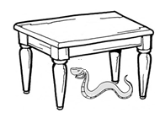___________________________________________________

b) 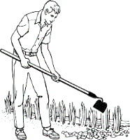

____________________________________________________

c) 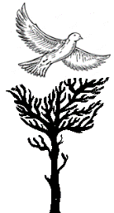_______________________________________________

**15. Soma okube**

a) Mukasa asoma ekitabo

b) Laba kkapa ennene

**16. Match the words that sound the same.**

won wear

I one

are eye

where a

**17. Match, join and make words.**

wi cks___________________

pla st___________________

bru ng___________________

ne nt____________________

sto sh_____________________

**18. Write a word for each blend.**

|  |  |  |  |  |
| --- | --- | --- | --- | --- |
| spr | scr | str | spl | thr |
|  |  |  |  |  |

**19. Write the sounds in these words.**

a) foot b) strip

|  |  |  |
| --- | --- | --- |
|  |  |  |

|  |  |  |  |  |
| --- | --- | --- | --- | --- |
|  |  |  |  |  |

c) smatch.

|  |  |  |
| --- | --- | --- |
|  |  |  |

**20. Read the story and answer the questions in full sentences.**

**Bart the dog.**

Bart the dog likes to bark. He barks in the car. He barks in the dark. He barks at the market. He barks at the park. Bart’s bark causes alarm but don’t start to run. He will not harm you. His bark is big, but he does

not bite.

**Questions.**

a) What is the title of the story?

____________________________________________________

b) Write words that have –ar- in the story.

a)______________________________ b)___________________________________

c) What does Bart’s bark cause?

____________________________________________________

d) What does Bart the dog like?

____________________________________________________