**ATLAS JUNIOR SCHOOL – LUGOBA NABWERU**

**MID TERM TWO ASSESSMENT 2024**

**SUBJECT : READING**

**AGE GROUP : 3 – 4 YEARS (BABY CLASS)**

**MY NAME IS : ___________________________________________**

1. **Match to a sound it makes.**



moo

[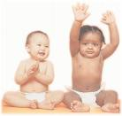](http://images.google.co.ug/imgres?imgurl=http://www.cgh.org/images/babies.gif&imgrefurl=http://www.cgh.org/PatientEmailCGH.html&start=5&h=640&w=673&sz=175&tbnid=5HKiwCyjpcTM1M:&tbnh=131&tbnw=138&hl=en&prev=/images?q=babies&gbv=1&svnum=10&hl=en&ie=UTF-8&oe=ISO-8859-1)

sss

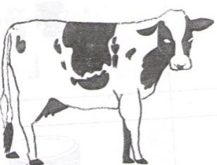

aaa

1. **Draw and write.**

|  |  |
| --- | --- |
|  | **s** |
|  |  |

1. **Match to a sound.**

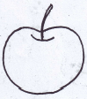

n

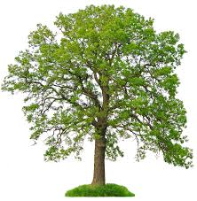

s



a

pillar examination 007

t

1. **Copy sound.**

|  |  |  |  |  |
| --- | --- | --- | --- | --- |
| a | t | i | p | n |
|  |  |  |  |  |

1. **Tell a sound.**

s a

t i

p n