GREENHILL ACADEMY

PRIMARY THREE
RELIGIOUS EDUCATION
LESSON NOTES
FOR
TERM 11(2016)

COMPILED BY;
- ALEX MUTOTO
- ROBERTSON WANZU
- BETTY AKELLO
- ISAAC BUYUNGO
- FLORENCE NAMAGEMBE
WEEK:2
Lesson 1
JESUS GIVES US THE HOLY SPIRIT
Read;
John 4:15-18
- Jesus promised us the Holy Spirit.
- The Holy Spirit is the helper Jesus promised to his disciples.

- Why did Jesus promise the Holy Spirit to the disciples?
- To guide them.
- To comfort them.
- To give them power.
- To teach them.

- The Holy Spirit came upon Jesus’ disciples on Pentecost day.

Exercise
- Who said,’’ behold I send you a helper.’’
- Which helper was promised?
- Give two reasons why Jesus gave us the Holy Spirit.
- On which day did the Holy Spirit come on the apostles?

Lesson 2
Events that happened on Pentecost day
Read:
Act 2;1-4
- There was a loud voice from heaven.
- The Holy Spirit came upon the disciples in form of flames of fire.
- They started speaking different tongues or languages.
- Peter started preaching.

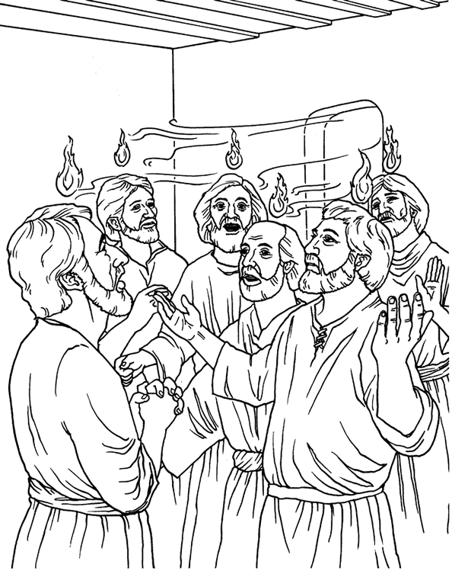

Exercise
- In which form did the Holy Spirit come on the disciples?
- Name any event that happened on the Pentecost day.
- Who preached on the Pentecost day?
- Draw, frame and color the Holy Spirit coming upon the disciples.

WEEK:3
Lesson 1
How the holy spirit helped the early Christian
Read;
Acts3:38-47
- Ways how the Holy Spirit helped the apostles.
- To preach the word of God.
- To live and share things together.
- To perform miracles.
- To endure hardships
- To speak to leaders without fear.

- How the Holy Spirit helps us today.
- To know what is right and wrong.
- Gives us hope in times of trouble.
- Protects us from sin and Satan.
- Guides us in prayer and worship.
- To endure hardships.

Exercise
- State two ways how the Holy Spirit helped the first Christians.
- How does the Holy Spirit help the Christians today?

Lesson 2
Gifts of the Holy Spirit and how to use them
Read;
1corinthans 12:1-11
- There are nine gifts of the holy spirit namely;
- Wisdom
- Knowledge
- Faith
- Healing
- Working miracles
- Prophesy
- Speaking new tongues
- Interpreting tongues
- Knowing a person with an evil spirit( discernment )

- Activities we do together when guided by the holy spirit:
- Reading the Bible.
- Praying together
- Sharing experiences
- Sharing meals
- Selling possession to help one another.

Exercise
- Identify any four gifts of the Holy Spirit.
- Which gift would you desire to have?
- Apart from the above, name any other two gifts that God gave us.

Lesson 2
THE WORSHIPPING COMMUNITY
- What is worship?
Worship is a way of praying and showing respect to God.
- Ways of worshipping God
Read;
Psalms 150:1-6
- Offering to God.
- Reading the bible.
- Singing hymns /religious songs.
- Dancing
- Waving hands
- Playing musical instruments.
- Clapping
- Jumping


Exercise
- What is worship?
- Give three ways of worshipping God.
- Draw people worshipping God.

WEEK:5

Lesson 1
Read;
Psalms 100: 1-5
- Why should Christians worship God?
Christians worship God because;
- God saved us from sins
- He is our creator
- God is greater than all gods and people
- He is the kings of kings
- He will judge all the people with justice
- He gives us life, food, clothes and other needs
- He rules over all the people of the world

- Examples of people who worshiped God are;
- Jacob
- Isaac
- King David
- King Solomon
- Daniel

Exercise
- Identify any two people in the Bible who worshipped God.
- Give three reasons why we worship God.

Lesson 2
PRAYING TO GOD
Read;
Matt6;5-8

- What is prayer?
Prayer is a way of talking to God
- What should a Christian do before praying?
- Repenting(ask God for forgiveness)
- Forgive those who anger him /her.
- Humble himself/her self.
- Turn his /her mind towards God.
- Kneel down when praying

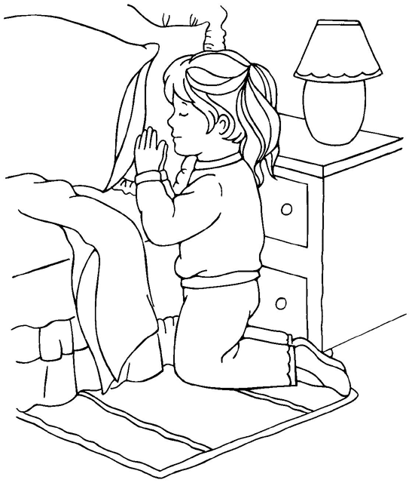

- Reasons why people pray to God
- To ask for forgiveness.
- People ask for protection.
- People pray to get blessings.
- To thank God for what he has done for them.
- People pray to get daily needs ;like food, clothes, shelter etc

- When do we pray?
- Before a meal
- Before sleeping.
- After bed
- When in troubles
- When going for a journey etc.

Exercise
- What is prayer?
- Write two things a Christian should do before praying.
- Give two reasons why people pray.
- Draw yourself praying.

WEEK:6
Lesson 1

Personal prayers
Read;
Matt7;7 -11
1. What is a personal prayer?
A personal prayer is a prayer said alone / individually.

2. Types of personal prayers
- Personal thanks-giving prayer
Is prayer said to thank God for something he has done e.g. healing.
- Confession prayer
Is a prayer said to ask God to forgiveness.
- Petition prayer
Is prayer said to ask for daily needs e.g. healing, food, shelter etc.
- Intercession prayer;
Is a prayer where one prayers for others.

Exercise
- Define a personal prayer.
- Name two types of personal prayers.
- Which type of prayer is said to ask for forgiveness?

Lesson 2
- People who need to be prayed for;

- children
- teachers
- the sick
- the prisoners
- the mad
- the leaders
- the war victims
- parents
- the dumb and deaf

- Places where we can pray from:
-You can pray from anywhere in case you feel to pray.
-You can pray from these places:
- Form the church
- Classroom
- Bed room
- In a vehicle
- On the mountain or hill

- Examples of people who prayed God and were answered:

- Abraham
- Jacob
- Jesus
- King David
- Daniel
- Samson
- Ruth
- Simon Peter
- Jeremiah etc

Exercise
- Name three groups of people who should be prayed for.
- Apart from a church, where else can a Christian pray from?
- What do you know about these people in the Bible?
- Samson
- Daniel

WEEK:7
Lesson 1
THE LORD’S PRAYER
Read;
Matthew 6:9-14
- What is the Lord’s Prayer?
This is the prayer Jesus taught his apostles.
NB. Recite the Lord’s Prayer.

- Requests are made in the Lord’s Prayer
- God’s kingdom to come.
- God’s will to be done.
- To give us our daily food. (bread)
- To forgive our trespasses.
- Not to lead us into temptations.
- To deliver us from evil.

- What lessons do you learn from the Lord’s Prayer?
- To glorify/ praise God.
- To ask for God’s kingdom to come.
- To ask God for deliverance in case of trouble.

Exercise
- Which prayer did Jesus teach his apostles?
- Identify any two requests made in the Lord’s Prayer.
- Why do you think Jesus taught his disciples this prayer?

Lesson 2
THE TEACHINGS OF JESUS
Read;
Matt 5:43-48
- Jesus teaches us Christian values.
- What are values?
Values are beliefs about what is right and wrong.

- Example of Christian values.
- Being honest/ faithful.
- Being responsible.
- Helping others.
- Respecting elders.
- Loving one another.
- Forgiving one another.

- How Jesus helped others.
- He healed the sick.
- Jesus fed the hungry.
- He raised the dead.
- He healed the deaf and the dumb.
- He healed the blind. etc

Exercise
- Name any two Christian values.
- Mention any two needy groups of people.
- Identify four ways you can help the needy.

WEEK:8
Lesson 1
Parables taught by Jesus
- What is a parable?
A parable is a short story with hidden meaning.

- Examples of parables used by Jesus.
- The parable of the sower (Mark 4:1-9)
- Parable of the lost son prodigal son (Luke15:11-31)
- Parable of the Good Samaritan (Luke 10:25-37)
- Parable of the ten virgins(Matt25:1-13)
- Parable of the lost coin(Luke15:8-10)
- Parable of the lost sheep(Luke15:1-7)
- Parable of the talents (Matt25:1-13)
- Parable of the tenants(Luke20:9-16) etc

- Jesus used parables because;
- He didn’t want others to know what he was saying.
- For the disciples to understand well.
- To fulfill what was said about him.

Exercise
- Define a parable.
- Name any two parables in the Bible.
- Why did Jesus use parables in his teachings?

Lesson 2
God given abilities (talents)
Read;
Matt25:1-13
- What is a talent?
A talent is a gift from God.
-Talents are not learnt but natural.

- Examples of talents:
- singing
- dancing
- drama
- painting
- drawing
- Playing games and sports.
- Good public speaking.

- How to use your talent(s) well:
- Never be proud.
- Use it to help others.
- Use it to glorify God.
- Do not hide your talent.
- Use your talent to make it perfect.
- Use it to earn a living.

Exercise
- What is a talent?
- Name any two talents God gave us?
- What is your talent?
- How can one misuse his/her talent?

WEEK: 9
Lesson 1
Read;
John3 :16
Characteristics of God found in Jesus
- Children adopt some characteristics from their parents.
- Jesus also had characteristics from God, his father.
- These were;
- Love
- Kindness
- Holiness 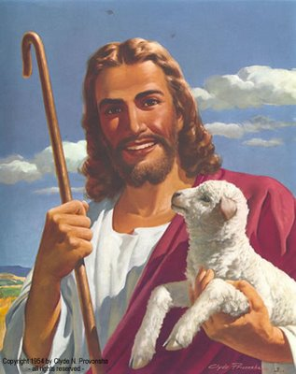
- Devine power
- Being eternal
- Knowing people’s thoughts.
- Knowing the past, the present and the future.

Exercise
- Identify any two things which showed that Jesus was a son of God.
- Name the three persons in the Trinity.
- Why did God send his son on earth?

THE END

