PRIMARY THREE
RELIGIOUS EDUCATION
LESSON NOTES
FOR
TERM 1

WEEK1: Lesson 1

THEME 1: CHRISTIANS GROW IN JESUS

TRADITIONS/ CUSTOMS

1. What are customs?
Customs are traditional practices in a society.

2. Examples of traditional customs in our society
- Greeting.
- Naming twins.
- Bowing down before kings.
- Paying bride price.
- Having last funeral rites.
- Dressing
- Welcoming visitors at home.

3. People who teach us customs include:
- Parents
- Teachers
- Pastors
- Elders
- Grand parents

Activity
- What term is used to mean the traditional practices of a society?
- Name two traditions among the Baganda
- Draw and colour yourself performing any one custom at home.

WEEK1: Lesson 2
Importance of customs in our society

(a)Greeting;
- Creates friendship
- Sign of respect
- Makes people feel happy.

(b) Paying bride price/wealth;
- Sign of thanks you to the girl’s family.
- Sign of responsibility.
- To stabilize marriage.

(c) Naming children;
- For identification
- Creates unity among clan members.

(d) Welcoming visitors;
  - To show respect.
  - To create friendship.

(e) Mourning for the dead;
- Way of showing sorrow.
- Sign of love for the dead.

Activity
- Name any two customs at school.
- Why we greet one another?
- What do you do when you receive a visitor?

WEEK2: Lesson 1
Customs in the Christian family
1. Christian customs help to unite us in God’s family

2. Examples of Christian customs;
- Attending church services.
- Baptism (John 1:29-34)
- Confirmation
- Holy marriage
- Fasting during lent period.
- Praying for the sick.
- Praying before a meal.
- Paying tithes and offertories.

3. What is the importance of baptism in Christian family?
- To wash away the original sin.
- To bring us into God’s family.

Activity
- Name any two Christian customs.
- Which custom helps a man and woman to be husband and wife?
- Why do we pay tithes and offertories?
- Draw, name and colour any one Christian custom.

WEEK2: Lesson 2

Other customs we meet

1. Each society has its own customs e.g.
The Baganda bow down before their Kabaka

2. Why should we respect other people’s customs?
- To fit in every society.
- To live happily with other people.
- To learn the behavior of other people.

TOPICAL TEST

- What are customs?
- Give two examples of customs in your society
- Why do Baganda women and girls kneel while greeting?
- Mention any two Christian customs?
- Of what importance is baptism to a Christian?
- In which place did Jesus attend the wedding ceremony?

WEEK3: Lesson 1
LEADERSHIP
Read;
Eph 4:11-13
Mark9:33-35

1. What is leadership?
Leadership is a position of guiding or managing others

2. Who is a leader?
-A person given a responsibility of guiding others.
-A leader is a person who guides or manages others.

3. Examples of leaders include:

- president
- A head teacher
- Classteachers
- Head prefect
- Class prefects
- Pastors
- Bishops
- Kings

4. Qualities of a good leader
1 Tim3:1-7
- Should lead by example.
- Should be a good listener.
- Should make good decisions.
- Should be kind
- Should not be God-fearing.
- Should be patient.

Activity
1. Who is a leader?
2. Give any two characteristics of a good leader.
3. Who heads a church?

WEEK3: Lesson 2
Levels of leadership in our society
- At different levels and places, we have different leaders

These include:
(a)At family level;
- Father
- Mother

(b)At school level;
- Head teacher
- Deputy head teachers
- Heads of department
- Class teachers
- Prefects etc

(c)At church level;
Read;
Eph 4:11-13
- Bishops
- priests
- Reverends
- Pastors
- Deacons and ushers

(d)At community level;
- L C 3 Chairperson at the sub-county level
- L C 2 Chairperson at the parish level
- L C 1 chairperson at the village level

(e)At clan level
- Clan head
- Lineage head
- Family heads

Activity
Mention any two leaders at school.
Who heads a family?

WEEK4: Lesson 1
1. Examples of leaders in the Old Testament

- Abraham
- Moses
- Joshua
- Samuel
- Ruth
- Kings like David, Solomon etc

A). ABRAHAM AS A LEADER
Gen 12:1-5
Gen22
- Abraham’s wife was Sarah.
- They lived in a country called Haran (Ur).
- God told Abraham to leave his homeland and go to another land.
- Canaan was the new land God promised Abraham.
- Isaac was the son God gave to Abraham and Sarah.
- God asked Abraham to sacrifice his only son, Isaac.
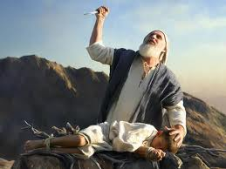
- When Abraham obeyed, God made him the grandfather of all nations.

Activity
- Who was the wife of Abraham?
- Which land was promised to Isaac?
- Why did God ask Abraham to sacrifice his son?

WEEK4: Lesson 2
b).MOSES AS A LEADER OF GOD
Exodus 3
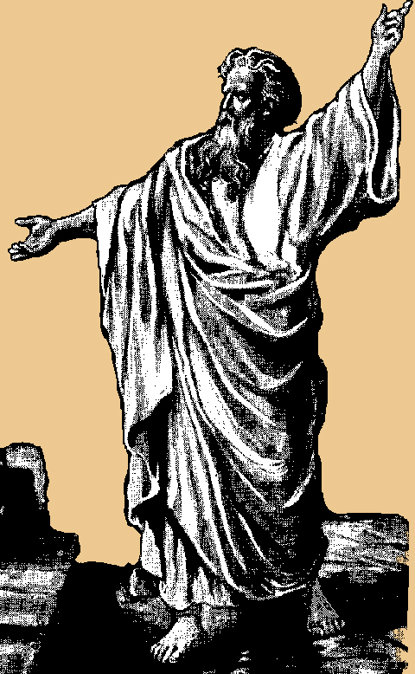
Moses
- Moses was a shepherd before he became a leader.
- God first appeared to Moses on Mt Sinai in form of a burning bush.
- Moses was told lead the Israelites from Egypt to the Promised Land.
- He led the Israelites out of Egypt across the Red sea.
- Moses died on the way because he disobeyed God.
- He was buried on Mt Nebo.

Activity
- Who led the Israelites out of Egypt?
- Name the water body which was crossed by the Israelites from Egypt.
- In which form did God first appear to Moses?
- Why didn’t Moses reach the Promised Land?

WEEK5: Lesson 1
JOSHUA AS A LEADER OF GOD
Joshua1:1-3
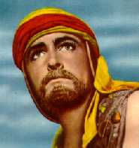
- Joshua succeeded Moses.
- He led the Israelites across River Jordan to the Promised Land.
- The Promised Land was called Canaan.
4. Qualities of leaders in the Old Testament
- They were God-fearing.
- They were obedient
- They were faithful.
- They wear brave.

Activity
- Who lead the Israelites to the Promised Land?
- Name the river which was crossed by the Israelites to the Promised Land.
3. What was the name of the Promised Land?
4. Give any two qualities of leaders in the Bible.

WEEK5: Lesson 2
JESUS AS A LEADER
Read;
Mark10:13-15
John2:13-16
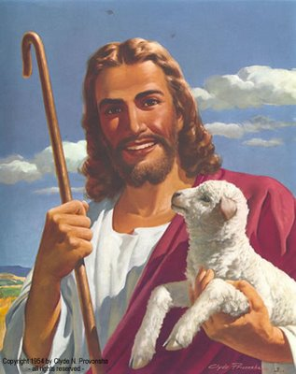
1. How was Jesus Christ a good leader?
- Jesus was a servant of all people.
- Jesus treated all people fairly.
- He was humble.
- He was loving and caring.
- He was obedient to the law.
- He was God fearing.

Activity
- Give two ways in which Jesus was a good leader.
- What lesson do we learn from Jesus?
- Mention any two qualities of a bad leader.
- Draw and show Jesus with the little children

WEEK6: Lesson 1
MESSENGERS OF GOD

How God speak to us
Isaiah6:1-10
1Sam13:1-21
1. Mention the ways how God speaks to us

- Through reading the Bible
- Using prophets, priests, pastors etc
- Through dreams
- Through visions

2. Who is a prophet?
A prophet is a messenger of God.

3. Examples of prophets in the Bible

- John the Baptist
- Isaiah
- Jeremiah
- Elijah
- Noah
- Joel
- Moses
- Amos
- Micah
- Ezekiel

4. Qualities of people chooses to be his messengers
- They are faithful
- They are trustworthy
- They are obedient
- They are not proud
- They humble

Activity
- List any two way how God can speaks to us.
- Who is a prophet?
- Mention any three prophets in the Bible.

WEEK6: Lesson 2
NOAH AS A MESSENGER
Gen 6:1-8
- God told Noah to build the big boat called the Ark.
- The Ark saved Noah, his family and other creatures from the flood.
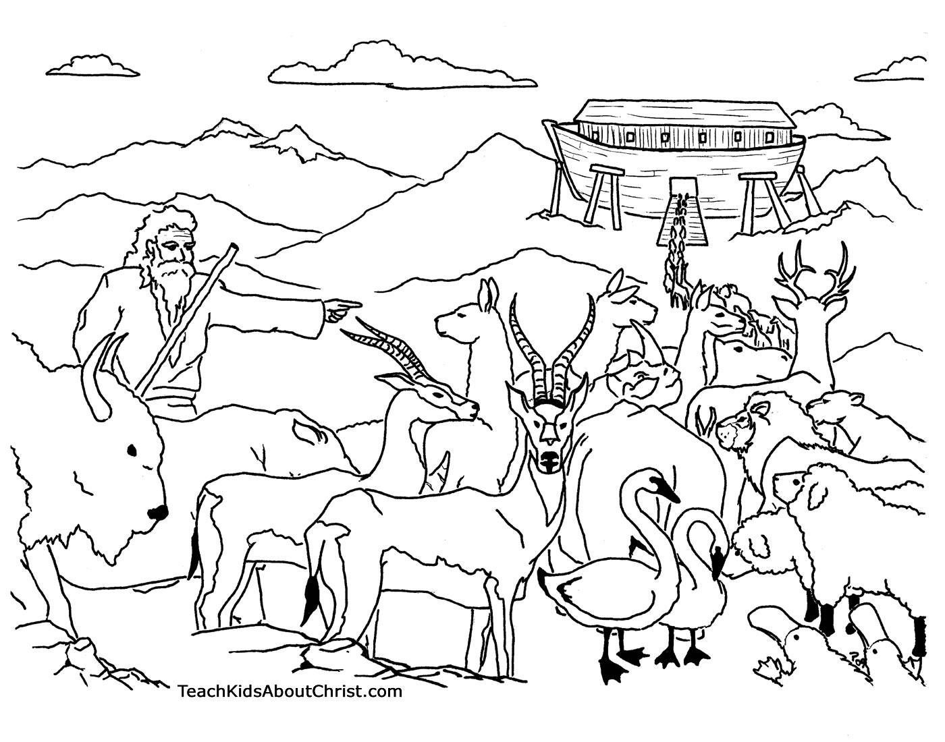
- It flooded for 40 days and nights
- The names of Noah’s sons were:
  - Shem
  - Ham
  - Japheth
- Noah’s ark rested on Mountain Ararat.
Activity
- Who built the ark?
- For how long was the flood in Noah’s time?
- On which mountain did the Ark rest?

WEEK7: Lesson 1
Angels as God’s messenger
Read:
Luke1:26-38
1. Who are angels?
Angels are heavenly messengers of God.

2. Angel Gabriel brought the message to Mary about the birth of Jesus Christ.
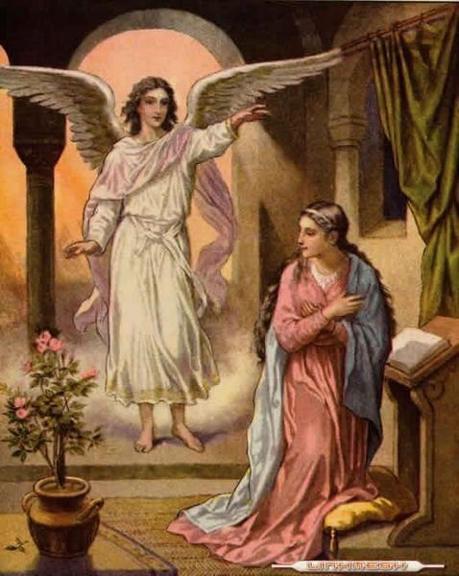

Activity
- How is an angel different from a prophet?
- Which angel brought the good news to Mary?
- What do we learn from virgin Mary?

WEEK7: Lesson 2
Messages about Jesus from God’s messengers

(a)Prophet Isaiah (Isa 53)
  - He talked about the coming of Jesus.
  - He said that Jesus would suffer on behalf of Christian.
  - That Jesus would be beaten, wounded and killed.

(b) Prophet Micah (Micah 5:2)
He said that Jesus would be born in the town called Bethlehem.

(c) Prophet Zechariah (Zech 9:9)
- He also said that Jesus would go to Jerusalem on a donkey. ( a colt)

(d) John the Baptist
- He was the last prophet in the Bible
- He prepare for the coming of Jesus Christ.
- He baptized Jesus at River Jordan.

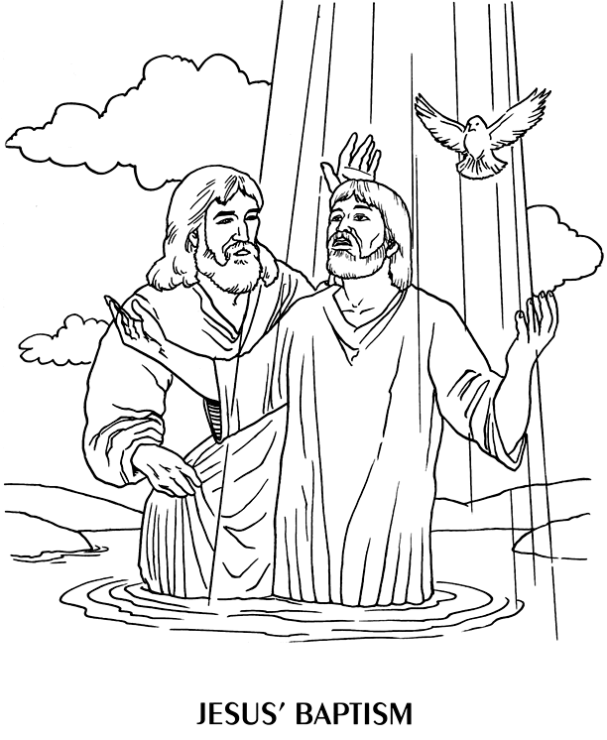

Activity
- Which prophet said that Jesus would beat and killed?
- In which town was Jesus born?
- Who baptized Jesus?
- Name the river where Jesus was baptized.

WEEK:8 Lesson 1
SORROW AND JOY IN LIFE

LENT
Read;
Matt6:16-18
1. What is lent?
Lent is the fasting period for Christians.
2. Lent period lasts for forty (40) days.
3. Christians begin their lent on Ash Wednesday.
4. Reasons why Christians fast
- To repent of their sins
- To strengthen their faith
- To get blessings
5. What should a Christian do during lent?
- Repenting his/her sins
- Forgiving others
- Praying to God
- Reading the Bible

Activity
- What do we call the fasting period for Christians?
- When do Christians begin fasting?
3. Mention any three things a Christian should not do during lent.
4. Why do Christians fast?

WEEK:8 Lesson 2
Jesus’ stay in the wilderness
Read;
Luke 4:1-12
1. Jesus was in the wilderness for 40 days and nights.
2. He was fasting and praying.
3. He was tempted by devil or Satan.
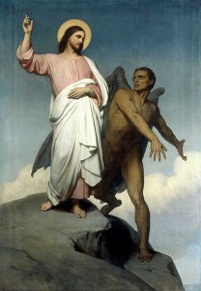
Temptations given to Jesus
- To turn the rock (stone) into bread.
- To bow down and worship the devil.
- To fall down from the highest point of the temple.

Activity
- For how long was Jesus in the wilderness?
- Who tempted Jesus?
- Mention any one temptation given to Jesus.
- What should we do when we are tempted?

WEEK: 9 Lesson 1
THE HOLY WEEK
Read;
Mark 14 & 15
1. What was known as the Holy week?
It was the week in which Jesus died for our sins.

2. What happened during the Holy Week?

a)Palm Sunday (John 12:9-19)
Jesus entered Jerusalem riding a donkey.
b)Holy Thursday
Jesus had the last supper with his apostles.
c) Good Friday
Jesus was crucified/nailed on the cross.
d) Easter Sunday
Jesus resurrected or rose from the dead.

Activity
Match the following correctly.
A B
Palm Sunday -Jesus rose from the dead.
Good Friday -Jesus entered Jerusalem on a donkey.
Easter Sunday -Jesus had his last supper.
Holy Thursday -Jesus was crucified.

WEEK:9 Lesson 2
THE LAST SUPPER
Read;
Luke 22:14-23
1. What was the Last Supper?
This was the last meal Jesus had with his apostles.
2. Jesus had the last supper on the Holy Thursday.
3. They used bread and wine during the Last Supper.
4. The bread represented the body of Jesus Christ.
5. The wine represented the blood of Jesus Christ.
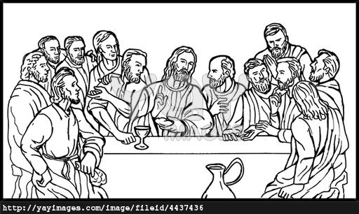
- Christians today celebrate the Lord’s Supper through the Holy Communion or Holy Eucharist.

Activity
On which did Jesus have his Last supper?
Name the two things that were used during the Last supper?
What do the following represent during Holy Communion?
- the bread
- the wine

WEEK:10 Lesson 1
JESUS’ CRUCIFIXION AND DEATH
Read;
Matthew 27; 32-53
Luke 22:14-9-23 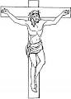
1. Judas Iscariot betrayed Jesus while Simon Peter denied him 3 times.
2. Jesus was crucified on Good Friday.
3. He was crucified on the cross at a place called Golgotha.

4. What happened at Jesus’ death on the cross?
- There was total darkness (an eclipse) from noon.
- The temple curtain tore into two pieces.
- There was an earth quake.
- The graves opened.
- The holy people rose up.

5. Joseph of Arimathea buried the body of Jesus.

Activity
- On which day was Jesus crucified?
- Name the apostle who betrayed Jesus Christ.
- Why is Joseph of Arimathea remembered in the Bible?
- Identify any one event which happened at Jesus’ death?

WEEK: 10 Lesson 2
JESUS’ RESURRECTION
Read;
Luke 24:1-12
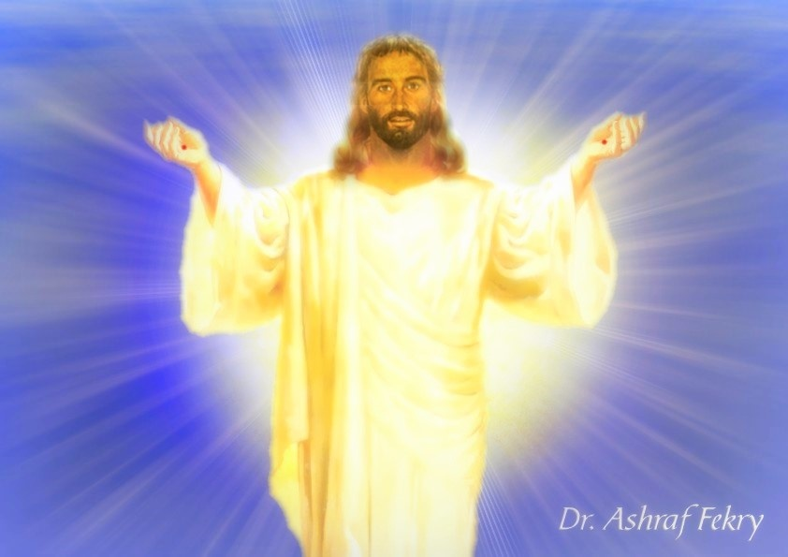
1. Jesus rose from the dead on Easter Sunday.
2. He re-appeared to Mary and the apostles.
3. Thomas doubted the resurrection of Jesus Christ.
4. Jesus went to heaven on Ascension Day.
5. Why Jesus’ death and resurrection is important to us?
- Our sins were forgiven.
- Christians got power over Satan, sin and death.
- Christians have hope for life after death (eternal life).

Activity
- Why is Easter Sunday important to Christians?
- What showed that Jesus had resurrected?
- Name the apostle who doubted Jesus’ resurrection.
- On which day did Jesus return to heaven.

THE END

GREENHILL ACADEMY

PRIMARY THREE
RELIGIOUS EDUCATION
LESSON NOTES
FOR
TERM 11

WEEK:2
Lesson 1
JESUS GIVES US THE HOLY SPIRIT
Read;
John 4:15-18
- Jesus promised us the Holy Spirit.
- The Holy Spirit is the helper Jesus promised to his disciples.

- Why did Jesus promise the Holy Spirit to the disciples?
- To guide them.
- To comfort them.
- To give them power.
- To teach them.

- The Holy Spirit came upon Jesus’ disciples on Pentecost day.

Exercise
- Who said,’’ behold I send you a helper.’’
- Which helper was promised?
- Give two reasons why Jesus gave us the Holy Spirit.
- On which day did the Holy Spirit come on the apostles?

Lesson 2
Events that happened on Pentecost day
Read:
Act 2;1-4
- There was a loud voice from heaven.
- The Holy Spirit came upon the disciples in form of flames of fire.
- They started speaking different tongues or languages.
- Peter started preaching.

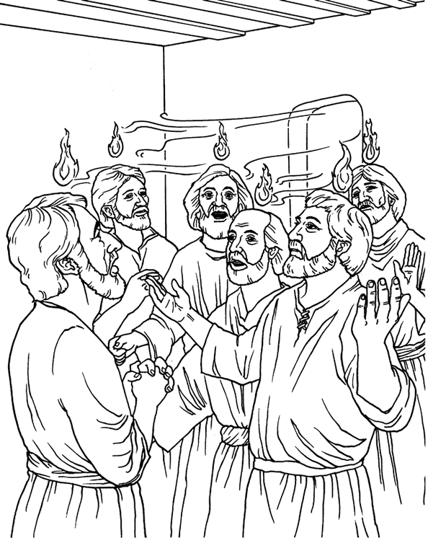

Exercise
- In which form did the Holy Spirit come on the disciples?
- Name any event that happened on the Pentecost day.
- Who preached on the Pentecost day?
- Draw, frame and color the Holy Spirit coming upon the disciples.

WEEK:3
Lesson 1
How the holy spirit helped the early Christian
Read;
Acts3:38-47
- Ways how the Holy Spirit helped the apostles.
- To preach the word of God.
- To live and share things together.
- To perform miracles.
- To endure hardships
- To speak to leaders without fear.

- How the Holy Spirit helps us today.
- To know what is right and wrong.
- Gives us hope in times of trouble.
- Protects us from sin and Satan.
- Guides us in prayer and worship.
- To endure hardships.

Exercise
- State two ways how the Holy Spirit helped the first Christians.
- How does the Holy Spirit help the Christians today?

Lesson 2
Gifts of the Holy Spirit and how to use them
Read;
1corinthans 12:1-11
- There are nine gifts of the holy spirit namely;
- Wisdom
- Knowledge
- Faith
- Healing
- Working miracles
- Prophesy
- Speaking new tongues
- Interpreting tongues
- Knowing a person with an evil spirit( discernment )

- Activities we do together when guided by the holy spirit:
- Reading the Bible.
- Praying together
- Sharing experiences
- Sharing meals
- Selling possession to help one another.

Exercise
- Identify any four gifts of the Holy Spirit.
- Which gift would you desire to have?
- Apart from the above, name any other two gifts that God gave us.

Lesson 2
THE WORSHIPPING COMMUNITY
- What is worship?
Worship is a way of praying and showing respect to God.
- Ways of worshipping God
Read;
Psalms 150:1-6
- Offering to God.
- Reading the bible.
- Singing hymns /religious songs.
- Dancing
- Waving hands
- Playing musical instruments.
- Clapping
- Jumping
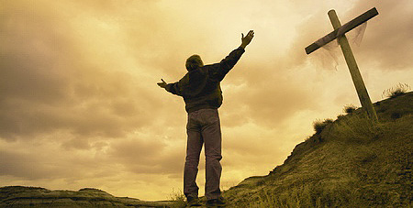

Exercise
- What is worship?
- Give three ways of worshipping God.
- Draw people worshipping God.

WEEK:5

Lesson 1
Read;
Psalms 100: 1-5
- Why should Christians worship God?
Christians worship God because;
- God saved us from sins
- He is our creator
- God is greater than all gods and people
- He is the kings of kings
- He will judge all the people with justice
- He gives us life, food, clothes and other needs
- He rules over all the people of the world

- Examples of people who worshiped God are;
- Jacob
- Isaac
- King David
- King Solomon
- Daniel

Exercise
- Identify any two people in the Bible who worshipped God.
- Give three reasons why we worship God.

Lesson 2
PRAYING TO GOD
Read;
Matt6;5-8

- What is prayer?
Prayer is a way of talking to God
- What should a Christian do before praying?
- Repenting(ask God for forgiveness)
- Forgive those who anger him /her.
- Humble himself/her self.
- Turn his /her mind towards God.
- Kneel down when praying

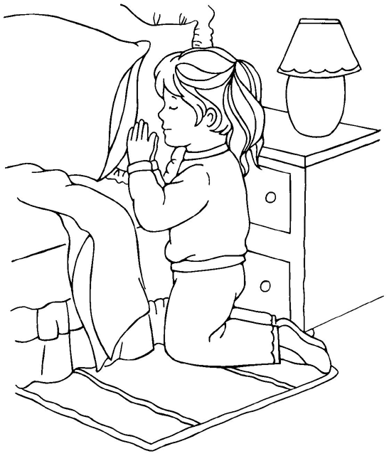

- Reasons why people pray to God
- To ask for forgiveness.
- People ask for protection.
- People pray to get blessings.
- To thank God for what he has done for them.
- People pray to get daily needs ;like food, clothes, shelter etc

- When do we pray?
- Before a meal
- Before sleeping.
- After bed
- When in troubles
- When going for a journey etc.

Exercise
- What is prayer?
- Write two things a Christian should do before praying.
- Give two reasons why people pray.
- Draw yourself praying.

WEEK:6
Lesson 1

Personal prayers
Read;
Matt7;7 -11
1. What is a personal prayer?
A personal prayer is a prayer said alone / individually.

2. Types of personal prayers
- Personal thanks-giving prayer
Is prayer said to thank God for something he has done e.g. healing.
- Confession prayer
Is a prayer said to ask God to forgiveness.
- Petition prayer
Is prayer said to ask for daily needs e.g. healing, food, shelter etc.
- Intercession prayer;
Is a prayer where one prayers for others.

Exercise
- Define a personal prayer.
- Name two types of personal prayers.
- Which type of prayer is said to ask for forgiveness?

Lesson 2
- People who need to be prayed for;

- children
- teachers
- the sick
- the prisoners
- the mad
- the leaders
- the war victims
- parents
- the dumb and deaf

- Places where we can pray from:
-You can pray from anywhere in case you feel to pray.
-You can pray from these places:
- Form the church
- Classroom
- Bed room
- In a vehicle
- On the mountain or hill

- Examples of people who prayed God and were answered:

- Abraham
- Jacob
- Jesus
- King David
- Daniel
- Samson
- Ruth
- Simon Peter
- Jeremiah etc

Exercise
- Name three groups of people who should be prayed for.
- Apart from a church, where else can a Christian pray from?
- What do you know about these people in the Bible?
- Samson
- Daniel

WEEK:7
Lesson 1
THE LORD’S PRAYER
Read;
Matthew 6:9-14
- What is the Lord’s Prayer?
This is the prayer Jesus taught his apostles.
NB. Recite the Lord’s Prayer.

- Requests are made in the Lord’s Prayer
- God’s kingdom to come.
- God’s will to be done.
- To give us our daily food. (bread)
- To forgive our trespasses.
- Not to lead us into temptations.
- To deliver us from evil.

- What lessons do you learn from the Lord’s Prayer?
- To glorify/ praise God.
- To ask for God’s kingdom to come.
- To ask God for deliverance in case of trouble.

Exercise
- Which prayer did Jesus teach his apostles?
- Identify any two requests made in the Lord’s Prayer.
- Why do you think Jesus taught his disciples this prayer?

Lesson 2
THE TEACHINGS OF JESUS
Read;
Matt 5:43-48
- Jesus teaches us Christian values.
- What are values?
Values are beliefs about what is right and wrong.

- Example of Christian values.
- Being honest/ faithful.
- Being responsible.
- Helping others.
- Respecting elders.
- Loving one another.
- Forgiving one another.

- How Jesus helped others.
- He healed the sick.
- Jesus fed the hungry.
- He raised the dead.
- He healed the deaf and the dumb.
- He healed the blind. etc

Exercise
- Name any two Christian values.
- Mention any two needy groups of people.
- Identify four ways you can help the needy.

WEEK:8
Lesson 1
Parables taught by Jesus
- What is a parable?
A parable is a short story with hidden meaning.

- Examples of parables used by Jesus.
- The parable of the sower (Mark 4:1-9)
- Parable of the lost son prodigal son (Luke15:11-31)
- Parable of the Good Samaritan (Luke 10:25-37)
- Parable of the ten virgins(Matt25:1-13)
- Parable of the lost coin(Luke15:8-10)
- Parable of the lost sheep(Luke15:1-7)
- Parable of the talents (Matt25:1-13)
- Parable of the tenants(Luke20:9-16) etc

- Jesus used parables because;
- He didn’t want others to know what he was saying.
- For the disciples to understand well.
- To fulfill what was said about him.

Exercise
- Define a parable.
- Name any two parables in the Bible.
- Why did Jesus use parables in his teachings?

Lesson 2
God given abilities (talents)
Read;
Matt25:1-13
- What is a talent?
A talent is a gift from God.
-Talents are not learnt but natural.

- Examples of talents:
- singing
- dancing
- drama
- painting
- drawing
- Playing games and sports.
- Good public speaking.

- How to use your talent(s) well:
- Never be proud.
- Use it to help others.
- Use it to glorify God.
- Do not hide your talent.
- Use your talent to make it perfect.
- Use it to earn a living.

Exercise
- What is a talent?
- Name any two talents God gave us?
- What is your talent?
- How can one misuse his/her talent?

WEEK: 9
Lesson 1
Read;
John3 :16
Characteristics of God found in Jesus
- Children adopt some characteristics from their parents.
- Jesus also had characteristics from God, his father.
- These were;
- Love
- Kindness
- Holiness
- Devine power
- Being eternal
- Knowing people’s thoughts.
- Knowing the past, the present and the future.

Exercise
- Identify any two things which showed that Jesus was a son of God.
- Name the three persons in the Trinity.
- Why did God send his son on earth?

THE END

PRIMARY THREE
RELIGIOUS EDUCATION
LESSON NOTES
FOR
TERM 111

WEEK1: Lesson 1
FORGIVENESS AND ACCEPTANCE
- What is forgiveness?
Forgiveness means stopping being angry with some body for something he/she has done wrong.
2. If you want somebody to stop being angry with you, say, “please forgive me” or “please, am sorry.”
3. Traditional ways of encouraging forgiveness
- Paying a fine i.e. a cock, goat etc.
- Sharing a meal.
- Saying sorry to a person wronged.
- Using another person (mediator) to reconcile the two people friends again.
- Re-accepting the offender into the family.
4. Draw, name and colour any one traditional way of encouraging forgiveness

WEEK1: Lesson 2
1. Reasons why we need to forgive
We need to forgive others because:
- God also forgives us
- Everybody makes mistakes
- Forgiveness helps us to live and work together happily
- Forgiveness prevents bad out comes like hatred, fighting etc.
- It serves as a lesson to the person forgiven to also forgive others who wrong him/her.
- Jesus showed us an example when he forgave those who hated him.

2. Examples of people who forgave one another in the Bible
- Jacob and Esau(Genesis33:1-11)
- Joseph and his brothers(Genesis45:1-5)
- King Darius and Daniel(Daniel 6:13-23)
- The prodigal son and his father(Luke 15:11-31)

WEEK2: Lesson 1
Resolving misunderstanding without violence
1. To resolve means to find a solution or an answer to a problem.
2. The word violence means an act of using physical force e.g. fighting.
3. How Jesus teaches about resolving misunderstanding without violence
(Matthew 18:15-16)
Steps:
- Solve it in private with a person who has wronged you.
- If the person does not listen, take/call other two people.
- If he/she does not listen to the two, take it to the church (group).
- If he/she does not listen to the church (group) take the case to LC or court.

WEEK2: Lesson 2
1. Causes of misunderstandings/violence
- Physical differences e.g. height, colour and body shape.
- Religious differences e.g. some are Catholics, Protestants, Pentecostals etc.
- Cultural differences e.g. Buganda, Acholi, Karamajong.
- Racial differences e.g. the black and white.
- Home differences e.g. the rich and the poor.
- Differences in education.
2. We are all God’s children regardless of our differences.
3. We should accept and be tolerant to other peoples’ differences to live peacefully.

4. Ways of accepting and tolerating other peoples’ differences
- Loving and caring for one another.
- Over looking our differences
- Praying together
- Sharing time of sorrow and joy
- Knowing that we are all God’s children

WEEK3: Lesson 1
TOPICAL TEST
- What should you do after annoying a friend?
- Name any two traditional ways of encouraging forgiveness.
- Give two reasons why we should forgive others.
- What lesson do we learn from the parable of the lost son?
- Name one group of people who forgave one another.
- Mention any two differences that exist among people.
- Which prophet was thrown in the lion’s den?

WEEK3: Lesson 2
TREATING OTHERS FAIRLY
1. Being fair means treating each person equally.
2. Unfairness is the opposite of fairness.

- Common examples of fair behaviour
  - Marking all pupils’ books and awarding right marks.
  - Allowing all family members to have meals.
  - Buying clothes to all children in a family.
  - Punishing all late comers at school.

4. Common examples of unfairness
- Marking some pupil’s books and leaving others unmarked.
- Punishing some late comers and leaving others unpunished.
- Forcing an adult to follow a certain religion.
- Buying clothes for children and leaving others.
- Giving food to some children and starving others.

WEEK4: Lesson 1
- Results of fair behavior.
  - Bring happiness to people.
  - It pleases God.
  - It solves mis-understandings.
  - It brings God’s blessing.
  - It brings unity among people in the family.
2. Results of unfair behavior
- Fighting
- Hatred
- Unhappiness
- Quarreling
- Revenge
- Annoying God
- Curses
- Spread of diseases among the people

WEEK4: Lesson 2
1. Reasons why some people behave unfairly
- Too much love for money.
- Failure to obey God’s commandments.
- Need to please one person/group of people.
- Failure to know the right way of doing things.
- Too much love for success.
- Failure to listen to advice.
- Need to revenge.
- Failure to follow the rules and laws.

2. Ways how you can act fairly
- Doing what you wish others to do for you.
- Being God fearing.
- Doing things according to the set rules or laws.
- Doing good to those who have wronged you.
- Reporting unfair people to authorities.
- Pray to God to help you act fairly.
- Pray to God to change unfair people into fair ones.
3. Draw and colour yourself acting fairly.

WEEK5: Lesson 1
How John the Baptist teaches us to be fair
(Luke 3:10-13)
John the Baptist teaches us the following:
- To share with others.
- Not to collect money (tax) more than what the Law requires.
- Not to take away ones money by force.
- To be contented of our pay.

WEEK5: Lesson 2
Cheating
1. What is cheating?
It means to take away something from somebody dishonestly or unfairly.

2. Forms of cheating
- Not giving back balance/change to your parents after buying something.
- Getting answers from a book, paper or friend in exams.
- Exchanging a bad pencil or pen with another person without his/ her knowledge.
- Exchanging cards in a play.
- Embezzling company/church funds.
- Diverting school fees to buying personal needs.

WEEK6: Lesson 1
Examples of people who cheated in the Bible
a)Jacob ;
- Cheated his brother, Esau’s blessing .(Genesis27:1-33)
- He also cheated his uncle, Laban’s flock.(Genesis3:31-43)
b)Judas Iscariot;
- He used to cheat church funds (John12:1-6)
- He was bribed for 30 silver pieces to betray Jesus.(Matthew26:14-16)
c) The sons of priest Eli:
- Used to cheat God’s offerings.(1Samuel2:12-17}

WEEK6: Lesson 2
1. Reasons why cheating is bad
- It is against God’s commandments.
- It stops some people from being successful.
- People do not trust a cheat.
- Cheating is punishable
- It leads to curses
- It stops God’s blessing i.e. God does not bless a cheat
- Cheats will not go to heaven

2. Ways how you can avoid cheating
- Following God’s commandments.
- Avoid being money greed.
- Respect rules and laws of an area or place.
- Report cheats to police, teachers or parents.
- Work hard for success.

WEEK7:Lesson1
TOPICAL TEST
- Mention two examples of unfair behaviour.
- Give two reasons why some people behave unfairly.
- How does John the Baptist teach us about fairness in Luke 3:10-13
- What is cheating?
- Identify two forms of cheating.
- Who cheated his brother’s blessing in the book of Genesis?
- Give two reasons why some people cheat.
- Give two reasons why cheating is a bad act.
- What can you do to a person who cheats an examination?

WEEK7: Lesson 2
JESUS BRINGS JOY
Old prophesies about Jesus
The following were fore told about Jesus’ birth and were true:
- That Jesus was to be born by a virgin woman.( Isaiah7:14)
- That Jesus would be born in a small town called Bethlehem.(Micah5:2)
- That he would be born in the lineage of King David.(Luke2:4)
- That Jesus would be a saviour for all people.

Preparation for Christmas
1. Jesus was born on the first Christmas.
2. Christians celebrate the birth of Jesus Christ on 25th December every year.
3. What things do Christians do during Christmas celebrations?
- Repenting their sin
- Buying new clothes and shoes.
- Cleaning the compound.
- Sending Christmas cards to friends and relatives.
- Praying together in churches.
- Singing Christmas carols.
4. Draw and colour baby Jesus in a manger.

WEEK8: Lesson 1
1. Ways how we can share Christmas joy with others
- By reading the bible together.
- Praying together.
- Singing Christmas songs / carols.
- Listening to Christmas carols.
- Exchanging gifts.
- Eating and drinking together.

2. Draw and colour yourself and your family celebrating a Christmas day.

WEEK8: Lesson 2
Meaning of different names
a) Jesus; The savour
b)Emmanuel: God is with us
C) Peter: A rock
d))Abraham: Father of many nations
e)Sarah; Mother of many nations
f)Jacob: A liar or a cheat
TOPICAL TEST
- On which day do Christians celebrate the birth of Jesus Christ?
- In which town was Jesus Christ born?
- Name three things you do during Christmas season.
- Why Jesus was called the saviour?
- Who was Jesus’ mother?
6, Give two ways in which Jesus fulfilled what was said about him by the old prophets?
“Merry X-mass”
THE END

