|  |  |
| --- | --- |
| **SECTION** | **MARKS** |
| **A** |  |
| **B** |  |
| **TOTAL** |  |

**TRINITY PRIMARY SCHOOL – BUKOTO**

**REVISION WORK**

**CLASS : P.4**

**LEARNING AREA : MATHEMATICS**

**Name: ________________________________ Stream:________**

**Date: __________________________________________________**

**SECTION A**

1. **Add: 3 + 2 + 4 =**
2. **Find the next number in the sequence.**

**0, 5, 10, 15, ______, ______**

1. **Use a number line to work out.**

**2 X 3 =**

**0 1 2 3 4 5 6 7 8 9**

1. **Shade AuB on the venn diagram.**

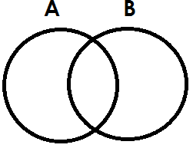

1. **Express xv in Hindu Arabic numerals.**
2. **Write the unshared fraction.**

|  |  |  |  |  |
| --- | --- | --- | --- | --- |
|  |  |  |  |  |

1. **If represents 4 cylinders. How many cylinders are represented by?**
2. **Name this shape.**

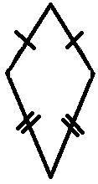

1. **Multiply 2 4**

**X 2**

1. **Work out: shs 7 0 0**

**-shs 2 5 0**

1. **Write 940 in words.**
2. **Name this set.**

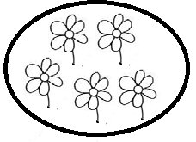**A set of ____________________________**

1. **Mary ate $\frac{2}{10}$ of the cake in the morning and $\frac{4}{10}$ in the afternoon. What fraction did she eat altogether?**
2. **How many days are in a fort night?**
3. **Work out: H T O**

**4 2 3**

**+ 1 7**

1. **Find the perimeter of the triangle below.**

**6cm 5cm**

**9cm**

1. **Simplify the like terms.**

**m + m + m = _________**

1. **Find the value 7 in 271.**
2. **Use “greater than” or “less than” to compare the fractions.**

$\frac{1}{2}$**is _____________________ than $\frac{1}{4}$**

1. **Which number comes just before 29?**

**SECTION B**

1. **(a) Expand 19.**

**(b) Which number is shown on the abacus?**

**H T O**

**(c) Find the place value of 6 in 604.**

1. **(a) Add: m cm**

**4 20**

**+3 10**

**(b) Calculate the area of the rectangle below.**

**4cm**

**6cm**

1. **Use the venn diagram to answer the questions.**

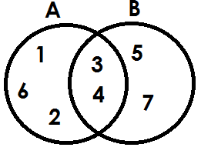

1. **List the members of;**
2. **Set A**
3. **Set AnB**
4. **Set AuB**
5. **How many members are in set B?**
6. **Complete the magic square below.**

|  |  |  |
| --- | --- | --- |
| **c** | **d** | **5** |
| **b** | **4** | **6** |
| **3** | **a** | **1** |

1. **(a) Add $\frac{2}{11}$ + $\frac{4}{11}$ + $\frac{1}{11}$**

**(b) Namugga ate $\frac{1}{4}$ of a chapatti. What fraction remained?**

1. **The containers A and B have water. Use the containers A and B to answer the questions correctly.**

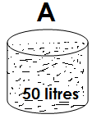 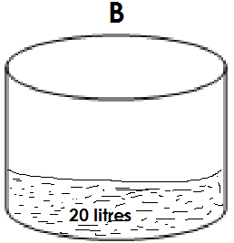

1. **Which container is bigger?**
2. **Which container has more water?**
3. **If all water in container A is poured in container B, how many litres of water will be in container B?**
4. **(a) How many triangles can you see?**

**(b) Draw these shapes.**

|  |  |
| --- | --- |
|  |  |
| **trapezium** | **cone** |

1. **The table below shows the price list in Mr. Barigye’s shop. Use it to answer the questions.**

|  |  |
| --- | --- |
| **Item** | **Price** |
| **A book**  **A pencil**  **An egg**  **A bar of soap**  **A kg of rice**  **a pen** | **Shs 700**  **Shs 200**  **Shs 400**  **Shs 800**  **Shs 1000**  **Shs 500** |

1. **How much is the cost of a book and a pencil?**
2. **How much is the cheapest item?**
3. **Find the total cost of a pen, a book and a bar of soap altogether?**
4. **(a) What time is sown on the clock face?**

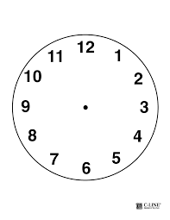

**It is _____________________**

1. **A teacher started teaching at 8 o’clock and stopped at 10 o’clock. How long did he spend teaching?**
2. **Change 2 hours to minutes.**
3. **(a) Find the missing number.**
4. **- 6 = 4**
5. **+ 8 = 15**

**(b) Tom is 6 years old. Paul is 9 years old. Find their total age.**

1. **(a) Share 36 bananas equally among Ritah and Luke. How many bananas does each get?**

**(b) Kato has 29 pens. Musa has 32 pens,**

**(i) How many pens do they have altogether?**

**(ii) How many more pens does Musa have than Kato?**

1. **The graph below shows the number of cars counted by Juma on Saturday.**
2. **How many white cars did he count?**
3. **Which colour has the least number of cars?**
4. **Find the total number of cars that Juma counted in Saturday.**