**Name: ……………………………………….………… Date: ………………….…......**

**MATHEMATICS**

1.a) Calculate the area of the triangle below.

7cm

10cm

8cm

b) Work out the perimeter of the triangle above.

2. How many degrees are between the Northern direction and the Western direction clockwise?

N

W E

S

3. Using a ruler and a pencil, draw a line segment of 8.3cm.

**General knowledge**

Mention **three** examples of 3 – dimensional figures.

|  |  |  |
| --- | --- | --- |
| **Comment:** |  | |
| **Name of Parent** |  | **Sign:** |
| **Date** |  | **Contact:** |

**Name: ……………………………………….………… Date: ………………….…......**

**ENGLISH**

**Re – write the following sentences using “any”**

1. James has some milk.

………………………………………………………………………………………………….

1. We have some salt.

…………………………………………………………………………………………………..

1. There is some juice in that store.

…………………………………………………………………………………………………..

1. He has bought some bicycles.

……………………………………………………………………………………………………

1. Jett has some soap in his shop.

…………………………………………………………………………………………………..

1. We saw some items in the stalls.

……………………………………………………………………………………………………

**Re – write the following sentences using: ‘some’**

1. I do not have any money for shopping.

………………………………………………………………………………………………….

1. There weren’t any biscuits in the market.

……………………………………………………………………………………………………….

1. She doesn’t have any new dresses to sell.

………………………………………………………………………………………………………

1. The trader doesn’t have any paraffin to sell.

……………………………………………………………………………………………………..

1. There isn’t any money at the moment.

………………………………………………………………………………………………………

1. Ramathan did not buy any food.

………………………………………………………………………………………………………

**General knowledge**

15. Write down any two tongue twisters you know.

………………………………………………………………………………………………………..

………………………………………………………………………………………………………..

|  |  |  |
| --- | --- | --- |
| **Comment:** |  | |
| **Name of Parent** |  | **Sign:** |
| **Date** |  | **Contact:** |

**Name: ……………………………………….………… Date: ………………….…......**

**SCIENCE**

1. Name **one** childhood immunisable disease that affects lungs.

…………………………………………………………………………………………………………

1. Which state of matter does not have a definite shape?

…………………………………………………………………………………………………………………..

1. What is cohesion?

……………………………………………………………………………………………………………

1. Name **one** type of soil

…………………………………………………………………………………………….

1. Which class of food helps in proper body growth?

……………………………………………………………………………………………………

1. Name **one** exotic breed of chicken.

…………………………………………………………………………………………………..

1. State the importance of the Child Health card to parents.

………………………………………………………………………………….

1. What general name is given to the seeds given to poultry?

………………………………………………………………………………………………

1. Which organ removes carbondioxide from the body?

………………………………………………………………………………………………

1. State **one** way of promoting personal hygiene.

………………………………………………………………………………………………..

1. Name **one** root crop pest.

………………………………………………………………………………………………..

12. The diagram below is of a flowering plant and use it to answer the questions that follow.

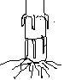**P** **T**

**Q**

**M**

a) Name the parts marked;

i) **T …………………………………………..** ii) **Q …………………………………**

b) Give the function of part marked;

i) **P ………………………………………………………..**

ii) **M ………………………………………………………………………..**

**General knowledge**

What is the end product in the digestion of proteins?

…………………………………………………………………………………………………………..

**Name: ……………………………………….………… Date: ………………….…......**

**S.S.T**

1a) Who is **a collaborator**?

………………………………………………………………………………………………….

b) Write down the collaborators who helped the British to extend colonial rule to:-

(i) Eastern Uganda …………………………………………………………………………

(ii) Western Uganda ………………………………………………………………………..

2. How did the signing of 1894 treaty affect Uganda?

……………………………………………………………………………………………………..

3. Mention the signatories of the 1900 Buganda agreement on behalf of:

(i) Buganda Kingdom ……………………………………………………………………..

(ii) British colonial government ………………………………………………………………..

4. Suggest **any two** reasons why IBEACO withdrew from Uganda.

……………………………………………………………………………………………………………..

5. Why didn’t KabakaDaudiChwa sign the 1900 Buganda agreement?

………………………………………………………………………………………………………………

6. Write down **any two** terms of the 1900 Buganda agreement.

………………………………………………………………………………………………

………………………………………………………………………………………..

7. State **any two** effects of the 1900 Buganda agreement.

……………………………………………………………………………………….

…………………………………………………………………………………………

**General knowledge**

In which country was democracy first introduced?

……………………………………………………………………………………………………………………………

|  |  |  |
| --- | --- | --- |
| **Comment:** |  | |
| **Name of Parent** |  | **Sign:** |
| **Date** |  | **Contact:** |

**Name: ……………………………………….………… Date: ………………….…......**

**MATHEMATICS**

1. Use the sketch below and draw the accurate diagram.

**Z**

**X**5cm **Y**

2. A taxi was travelling at 80km/hr to cover a distance of 160km. Calculate the time taken to cover the distance.

3. Add:

HRS MIN

2 30

**+** 1 40

_____________

|  |  |  |
| --- | --- | --- |
| **Comment:** |  | |
| **Name of Parent** |  | **Sign:** |
| **Date** |  | **Contact:** |

**Name: ……………………………………….………… Date: ………………….…......**

**ENGLISH**

**Use the correct form of the words given in the brackets.**

1. We usually do the ............ of term exams whenever we report back to school. (begin)

2. What a .................day it was yesterday. (sun)

3. Tom was .................received when he went to spend the holidays with his uncle. (happy)

4. ................ daily participation in the work helped them to do the exercise easily. (they)

5. The .................he gave me was not clear at all. (explain)

6. I did the work ................., so nobody helped me. (self)

7. All the letters were .................in black in. (write)

8. He was the .................during the sports competition. (twelve)

9. Several .................were moving in the farm yard. (ox)

10. One should always tell the .................if one wants to be respected. (true)

**General knowledge**

11. Complete the word puzzle correctly using the given clues.

|  |  |  |  |  |  |  |  |  |  |  |
| --- | --- | --- | --- | --- | --- | --- | --- | --- | --- | --- |
| 1 |  |  | 2 |  |  |  |  |  |  | 3 |
|  |  |  |  |  |  |  |  |  |  |  |
| 4 |  |  |  |  |  |  |  |  |  |  |
|  |  |  |  |  |  |  |  |  |  |  |
|  |  |  | 5 |  |  |  |  |  |  |  |
|  |  |  |  |  |  |  |  |  |  |  |
|  |  |  |  |  |  |  |  |  |  |  |
|  |  |  | 6 |  |  |  |  |  |  |  |

**Across**

2 – Actors and actress wear them (8)

4 – A boy who takes part in a play (5)

5 – To say a poem without reading it (6)

6 – We do this when the drums sound (5)

**Down**

1 – Acting of plays is called (5)

2 – A group of singers (5)

3 - A plat form where songs, plays and dances

take place (5)

|  |  |  |
| --- | --- | --- |
| **Comment:** |  | |
| **Name of Parent** |  | **Sign:** |
| **Date** |  | **Contact:** |

**Name: ……………………………………….………… Date: ………………….…......**

**SCIENCE**

1. Name the force which opposes motion between two surfaces.

………………………………………………………………………………………………

1. How do we call the finger – like structures found in the ileum?

……………………………………………………………………………………………………….

1. State **one** natural source of heat in the environment.

………………………………………………………………………………………………………….

1. Name the first set of teeth in man.

………………………………………………………………………………………………………..

1. Which form of energy is possessed by a passenger in a moving bus?

………………………………………………………………………………………

1. Give **one** way food gets contaminated.

……………………………………………………………………………………………………….

1. State **one** way poultry keeping help in the control of deficiency diseases.

………………………………………………………………………………………………………….

1. Why do bees collectpropolis?

……………………………………………………………………………………………………….

1. Why are wasps regarded as social insects?

………………………………………………………………………………………………………..

1. How are root hairs important to a plant?

………………………………………………………………………………………………………..

1. Define the term capon.

…………………………………………………………………………………………………………..

1. List down **four** qualities of a clean home.

………………………………………………… ……………………………………………………

………………………………………………… …………………………………………………….

**General Knowledge**

How is transfer of heat by radiation useful to a dobby?

…………………………………………………………………………………………………………………….

|  |  |  |
| --- | --- | --- |
| **Comment:** |  | |
| **Name of Parent** |  | **Sign:** |
| **Date** |  | **Contact:** |

**Name: ……………………………………….………… Date: ………………….…......**

**S.S.T**

1. Define **indirect rule** as used by the British in Uganda.

………………………………………………………………………………………………………….

2. Name **any** tax which was introduced by the 1900 Buganda Agreement.

………………………………………………………………………………………………..

3. State **any two** results of the 1900 Buganda agreement.

…………………………………………………………………………………………………

……………………………………………………………………………………………….

4. How did the 1900 Buganda agreement affect the size of Buganda positively?

………………………………………………………………………………………………..

5. State the reason why KabakaDaudiChwa did not sign the 1900 Buganda agreement.

……………………………………………………………………………………………………….

6. Who signed the Buganda agreement on behalf of:-

(i) Buganda Kingdom ………………………………………………………………………….

(ii) British government ……………………………………………………………………………

7. Which colonial agent helped the British to extend colonial rule to the eastern part of Uganda?

……………………………………………………………………………………………………….

8. Name **any two** ways how the British extended colonial rule in Uganda.

…………………………………………………………………………….

…………………………………………………………………………………….

9. State **two** reasons why the British used Indirect rule in Uganda.

………………………………………………………………………………………

……………………………………………………………………………………….

10. State **any two** disadvantages of Indirect rule in Uganda.

………………………………………………………………………………….

………………………………………………………………………………….

**General Knowledge**

Name the German who invented the first car in the world.

…………………………………………………………………………………………………….

|  |  |  |
| --- | --- | --- |
| **Comment:** |  | |
| **Name of Parent** |  | **Sign:** |
| **Date** |  | **Contact:** |

**Name: ……………………………………….………… Date: ………………….…......**

**MATHEMATICS**

1. Given the data below;

50, 25, 50, 10, 40, 50, 20

Use the data above to find the;

1. mode
2. modal frequency
3. mean
4. median

1. range

**General knowledge**

How useful is the media to schools in Uganda?

……………………………………………………………………….

|  |  |  |
| --- | --- | --- |
| **Comment:** |  | |
| **Name of Parent** |  | **Sign:** |
| **Date** |  | **Contact:** |

**Name: ……………………………………….………… Date: ………………….…......**

**ENGLISH**

**Use these words in sentences to show that you understand their meaning.**

1. peace

…………………………………………………………………………………………………..

2. piece

………………………………………………………………………………………………….

3. court

………………………………………………………………………………………………….

4. coat

………………………………………………………………………………………………………

5. cell

……………………………………………………………………………………………………

6. sell

…………………………………………………………………………………………………..

7. police

…………………………………………………………………………………………………….

8. policy

……………………………………………………………………………………………………..

9. steal

……………………………………………………………………………………………………

10. still

………………………………………………………………………………………………………

**General knowledge**

In only one stanza of five verses, write a rhyme about, ‘the naughty dog”

|  |  |  |
| --- | --- | --- |
| **Comment:** |  | |
| **Name of Parent** |  | **Sign:** |
| **Date** |  | **Contact:** |

**Name: ……………………………………….………… Date: ………………….…......**

**SCIENCE**

1. Identify **one** vice in poultry.

……………………………………………………………………………………………

1. Name the mineral that hardens the egg shell.

…………………………………………………………………………………………….

1. What is piggery?

…………………………………………………………………………………………………

1. Give **one** value of goats to people?

…………………………………………………………………………………………….

1. Which deficiency disease is called due to lack of Vitamin **D**?

…………………………………………………………………………………

1. What is crop rotation?

……………………………………………………………………………………………………..

1. Name **one** disease of cassava

……………………………………………………………………………………………………….

1. Mention **one** use of a vacuum flask at home.

………………………………………………………………………………………………………

1. Name the type of air used for putting out fire.

………………………………………………………………………………………………………..

1. Why is the handle of the iron box made of wood or plastic?

………………………………………………………………………………………………………..

1. What is the importance of cilia found in the human nose?

………………………………………………………………………………………………………..

12.a) What is self pollination?

……………………………………………………………………………………………………………..

b) State the work played by bees during pollination.

…………………………………………………………………………………………………….

c) What will happen to the plant if pollination doesn’t take place?

………………………………………………………………………………………………………..

d) State **one** characteristic of insect pollinated flowers.

………………………………………………………………………………………………………………

**General knowledge**

Musa eats un washed mangoes that contain germs, which substance helps him to overcome diseases that is produced in the stomach?

………………………………………………………………………………………………………………………

|  |  |  |
| --- | --- | --- |
| **Comment:** |  | |
| **Name of Parent** |  | **Sign:** |
| **Date** |  | **Contact:** |

**Name: ……………………………………….………… Date: ………………….…......**

**S.ST**

1. Which political event took place in Uganda in 1894?

………………………………………………………………………………………………….

1. Why is Sir Hesketh Bell remembered in the history of Uganda? (Give two reasons)

……………………………………………………………………………………….

…………………………………………………………………………………………

1. Why didn’t Kabaka Daudi Chwa fail to sign the 1900 Buganda agreement?

……………………………………………………………………………………………………

1. Name the three terms of the 1900 Buganda agreement.

…………………………………………………………………….

…………………………………………………………………….

…………………………………………………………………….

1. On which Islands did Kabaka Mwanga and Omukama Kabalega exiled?

……………………………………………………………………….

1. List down **four** negative effects of colonialism.

……………………………………………………………………….

…………………………………………………………………………

……………………………………………………………………………

……………………………………………………………………………

1. How did the fixing of boundaries in Uganda affect the people who live near the border?

………………………………………………………………………………………………..

**General knowledge**

When did the world experience the eclips of the sun?

………………………………………………………………………………………………………………………….

|  |  |  |
| --- | --- | --- |
| **Comment:** |  | |
| **Name of Parent** |  | **Sign:** |
| **Date** |  | **Contact:** |

**Name: ……………………………………….………… Date: ………………….…......**

**MATHEMATICS**

1. Complete the shopping bill.

|  |  |  |  |
| --- | --- | --- | --- |
| Item | Quantity | Unit cost | Amount |
| Sugar  Salt  Meat  Cooking oil | 2kg  _____kg  3kg  ____ litres | Shs. 4000  Shs. 2000  Shs. _______  Shs. 1,200 | Shs. ________  Shs. 6000  Shs. 2400 |
| Total Expenditure | | | Shs. _______ |

b) If Amos remained with Shs. 5000, how much money did he have at the beginning?

2. If 2 bunches of bananas cost Shs. 6000, how much money will I pay for only **3** bunches?

**General knowledge**

If a cat and a half eat a rat and a half in a day and a half. How long will it take 100 cats to eat 100 rats?

|  |  |  |
| --- | --- | --- |
| **Comment:** |  | |
| **Name of Parent** |  | **Sign:** |
| **Date** |  | **Contact:** |

**Name: ……………………………………….………… Date: ………………….…......**

**ENGLISH**

**Complete the following sentences using “has” or “have”**

1. The robbers ................... given the statement to the police.

2. Sarah ................... reported the case to the criminal investigation department

3. The wetness ................... given their statements about the murder case.

4. The police ................... recovered three guns and a pistol.

5. The magistrate ................... sentenced Arinaitwe to life imprisonment.

6. The army commander ................... arrested the rebel leader.

7. Her step mother ................... been summoned by the high court.

8. Katumba and his wife ................... been accused of child abuse.

9. The complainant ................... filed a case against Okumu.

10. The refugees ................... been given blankets and food by the Red cross.

**General knowledge**

11. Write down

i) your first name

………………………………………………………..

ii) your mother’s maiden name

………………………………………………………………………….

1. How many members of parliament went to attend Uganda North American (UNA) conference this year?

………………………………………………………………………………………………………..

|  |  |  |
| --- | --- | --- |
| **Comment:** |  | |
| **Name of Parent** |  | **Sign:** |
| **Date** |  | **Contact:** |

**Name: ……………………………………….………… Date: ………………….…......**

**SCIENCE**

1. Name the vitamin we get when we eat fruits.

……………………………………………………………………………………….

1. Why is a male anopheles mosquito not able to spread malaria?

……………………………………………………………………………………………

1. Draw a diagram to show epigeal germination.

…………………………………………………………………………………………..

1. How is a health parade useful to pupils at school?

…………………………………………………………………………………………………..

1. How does mass differ from weight in the way they are measured?

…………………………………………………………………………………………….

1. What is humidity?

……………………………………………………………………………………………….

1. What is the cause of kwashiorkor in children?

……………………………………………………………………………………………………

1. Give the role of a queen excluder in a bee hive?

……………………………………………………………………………………………………….

1. What can a poultry farmer do in order to improve the quality of local breeds of chicken?

…………………………………………………………………………………………………………

1. Why do plants shed off their leaves during a dry season?

……………………………………………………………………………………………………………

1. Name the method used to find the volume of irregular objects.

…………………………………………………………………………………………………………..

1. In four sentences, explain the steps involved in the germination of a seed into a seedling.

……………………………………………………………………………………………………

……………………………………………………………………………………………………

……………………………………………………………………………………………………

……………………………………………………………………………………………………

**General knowledge**

Which of the following is an odd man out?

* Typhoid, Tuberculosis, Cholera, Diphtheria, Tetanus, Plague, Influenza

|  |  |  |
| --- | --- | --- |
| **Comment:** |  | |
| **Name of Parent** |  | **Sign:** |
| **Date** |  | **Contact:** |

**Name: ……………………………………….………… Date: ………………….…......**

**S.S.T**

1. Define **Patriotism**.

…………………………………………………………………………………………………….

2a) What is indirect rule?

………………………………………………………………………………………………………………….

b) Mention **any two** reasons why the British used indirect rule.

………………………………………………………………………………………………….

……………………………………………………………………………………………………..

c) Name **any one** African who collaborated with the British in Uganda.

………………………………………………………………………………………………..

3a) Identify **any two** examples of Natural vegetation in Uganda.

……………………………………………………………………………………………..

………………………………………………………………………………………………..

b) Why are the Equatorial rain forests ever green throughout the year?

………………………………………………………………………………………………….

c) Which type of wood is got from natural forests?

………………………………………………………………………………………

4a) Who was the founder of Bunyoro Kingdom?

……………………………………………………………………………………..

b) State **any two** reasons why the Chwezi are still remembered in the history of Uganda.

……………………………………………………………………………………………………

……………………………………………………………………………………………………

c) What was the final cause of the collapse of Bunyoro-Kitara Empire?

…………………………………………………………………………………………………………

**General knowledge**

What title was given to the head of Government of Uganda between 1962 – 1966?

………………………………………………………………………………………………………………………..

**Name: ……………………………………….………… Date: ………………….…......**

**MATHEMATICS**

1. Find the area of the shaded part of the following shapes.

9m

i) ii)

**4m 7m**

3m 6m

**6m**

**7m**

iii)

8m 9m

3m 4m

**General knowledge**

Two pupils were asked to fill a 20 litrejerrycan each. One pupil used $\frac{1}{2}$ litre cup and another used 1 litre caup. How many more cups of water will the first pupil use than the second pupil?

**Name: ……………………………………….………… Date: ………………….…......**

**ENGLISH**

**Use the correct form of the words given in the brackets to complete the sentences.**

1. The cashier blamed me for .......................thecheque book. (dirty)

2. Musa’s uncle is an .......................instanbic bank.

3. This is the .......................cheque I have ever written. (twelve)

4. He goes to the bank .......................every month. (one)

5. A good bank usually gives .......................to its customers. (lend)

6. The woman in a white suit is the bank ....................... (manage)

7. The .......................stamped the deposit slip after counting the money.

8. Their aunt opened up a .......................account in Bank of Baroda. (save)

9. Our class teacher ....................some money from his account last month. (without)

**Re – write the sentences giving one word for the underlined group of words.**

10. The **place where people keep their money** is always closed at 5:00pm.

………………………………………………………………………………………………………………..

1. There was a long **line of people** at the bank.

………………………………………………………………………

1. The **person who receives and gives money in the bank** was kind to me.

……………………………………………………………………………………………………………………….

**General knowledge**

At what time did the match between Uganda Cranes and Comoros played on Sunday 4th September, 2016 start?

|  |  |  |
| --- | --- | --- |
| **Comment:** |  | |
| **Name of Parent** |  | **Sign:** |
| **Date** |  | **Contact:** |

**Name: ……………………………………….………… Date: ………………….…......**

**SCIENCE**

1. Which type of feathers do chicks have at the time they hatch?

…………………………………………………………………………………………………..

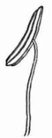2. Write down the scientific name given to the part of a flower below.

**B**

…………………………………………………………….

1. What is the function of part **B**?

…………………………………………………………………………………………………….

1. State the function of enzymes during digestion.

………………………………………………………………………………………………………

1. Which type of clouds bear droplets of rain?

………………………………………………………………………………………………………………

1. Why is a bean seeds regarded as a legume?

………………………………………………………………………………………………………….

1. Mention **one** element of a good living house.

………………………………………………………………………………………………………

1. Write down **one** example of exotic breed of poultry kept in Uganda.

……………………………………………………………………………………………………..

1. Why do poultry keepers cut short the upper part of a hen’s beak?

……………………………………………………………………………………………………….

1. Write **one** word used to mean a plant response towards stimuli.

…………………………………………………………………………………………………………..

1. Draw and name the tooth used to tear through food.

…………………………………………………………………………………………………………

12.a) Using a pencil and a ruler, draw a diagram of a fish and indicate the following parts.

i) Lateral line

ii) Anal fin

b) Give the work of the following parts of a fish.

i) Nostril ………………………………………………………………………………………

ii) Dorsal fin …………………………………………………………………………………………….

**Name: ……………………………………….………… Date: ………………….…......**

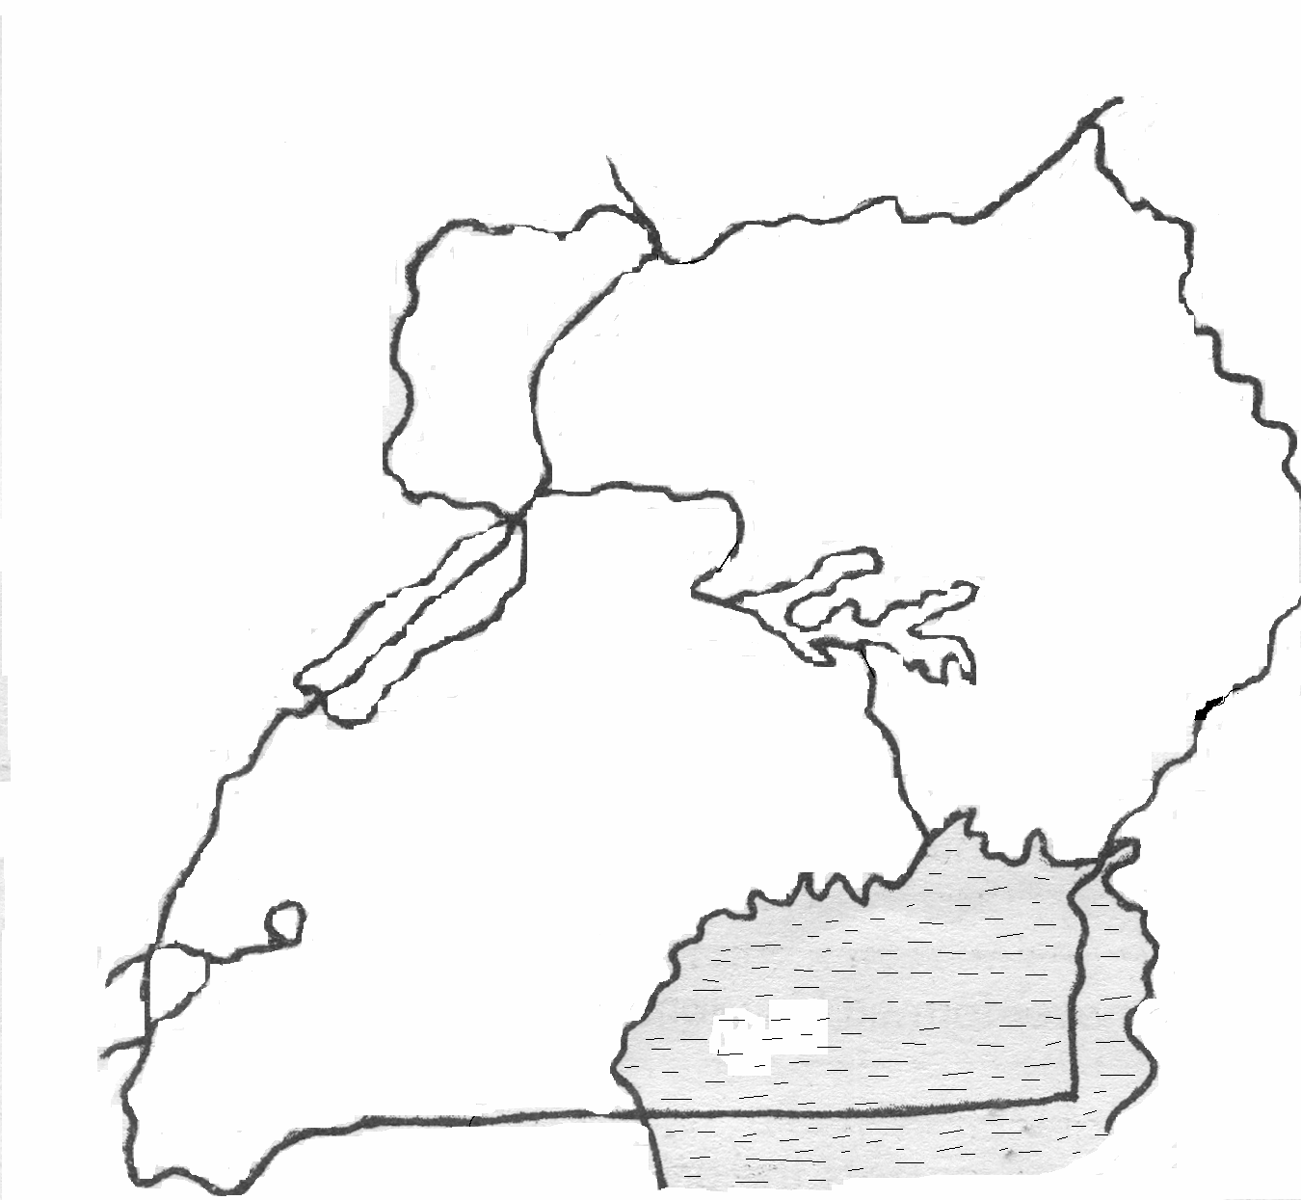**S.ST**

1.a) Name the water way marked with

letter ‘**K’**.

………………………………………………………………….

b) Which part of the Nile is marked “**P**”?

R …………………………………………………………………

**P** c) Name the game park found in the shaded area.

……………………………………………………………………

**K** d) Which mineral has been discovered in the

lake marked ‘**R’**?

…………………………………………………

2a) State **two** reasons why Europeans colonized Uganda.

………………………………………………………………………………………………

……………………………………………………………………………………………..

b) State **any two** economic contributions of colonialists in Uganda.

……………………………………………………………………………………………..

………………………………………………………………………………………………

3a) Who were the founders of Bunyoro-Kitara empire?

……………………………………………………………………………………………..

b) Give **any one** cause of the decline of Bunyoro-KitaraEmpire.

……………………………………………………………………………………………..

c) State **any two** economic contributions of the Bachwezi in Uganda.

……………………………………………………………………………………………………

……………………………………………………………………………………………………

4a) What does the term **wildlife** mean?

………………………………………………………………………………………….

b) Mention the **two** types of wildlife.

……………………………………………………………………………………………………………..

……………………………………………………………………………………………………………..

c) Mention **any one** problem faced by wild life.

……………………………………………………………………………………………………………….

|  |  |  |
| --- | --- | --- |
| **Comment:** |  | |
| **Name of Parent** |  | **Sign:** |
| **Date** |  | **Contact:** |

**Name: ……………………………………….………… Date: ………………….…......**

**MATHEMATICS**

1. Convert 18kg to gm

2. Add: kg gm

9 300

+ 4 400

__________

1. The volume of an object is 2000cc. Calculate its capacity.

4. Find the volume and capacity of the box below.

2m

7m

10m

**General knowledge**

Every day, It takes MrsOkulu4¼ hours to prepare an egg. One day, 2 friends joined her for breakfast. How long did it take her to prepare 3 eggs?

**Name: ……………………………………….………… Date: ………………….…......**

**ENGLISH**

**Re – write the following sentences beginning; Neither.........nor.........**

1. The cashier did not see the money. The auditor did not see the money.

…………………………………………………………………………………………………………..

1. Our aunt did not withdraw the money. Our uncle did not withdraw the money.

……………………………………………………………………………………………………………….

1. The cook did not receive her salary. The gate keeper did not receive her salary.

……………………………………………………………………………………………………………..

1. The coin was not genuine. The note was not genuine.

………………………………………………………………………………………………………………

1. You don’t know the balance. I don’t know the balance..

…………………………………………………………………………………………………………………….

1. My mother does not work in the bank. My father does not work in the bank.

………………………………………………………………………………………………………………….

**Re – write the following sentences using: ........neither.........nor............**

1. We shall not approve the loan. We shall not sign the cheque.

…………………………………………………………………………………………………………………

1. The manager will not attend the conference. The treasurer will not attend the conference.

…………………………………………………………………………………………………………………………………………………………………………….

1. I am not the teller. I am not the accountant.

……………………………………………………………………………………………..

1. Juma doesn’t go to the post office. Juma doesn’t go to the bank..

…………………………………………………………………………………………………………………….

1. The cashier did not come early. The bank manager did not come early.

……………………………………………………………………………………………………………………

1. The cheque is not mine. The cheque is not hers.

…………………………………………………………………………………………………………………

**General knowledge**

Which part of the computer has the same function as a primary five pupil’s box file?

…………………………………………………………………………………………………………………….

|  |  |  |
| --- | --- | --- |
| **Comment:** |  | |
| **Name of Parent** |  | **Sign:** |
| **Date** |  | **Contact:** |

**Name: ……………………………………….………… Date: ………………….…......**

**SCIENCE**

1. Give one practice that may control the spread of cholera at home.

………………………………………………………………………………………………………

1. State one reason why weak plants climb others.

………………………………………………………………………………………….

1. State the type of energy possessed by a falling mango fruit before reaching the ground.

……………………………………………………………………………………..

1. Name one sense organ.

………………………………………………………………………………………………

1. How does a rat differ from a cockroach in the way they breathe?

……………………………………………………………………………………………….

1. Give **one** way in which soil is important to plants.

……………………………………………………………………………………………..

1. Why is a wet piece of cloth put on the body of a person with fever?

………………………………………………………………………………………………..

1. Give one way in which crops benefit from trees.

……………………………………………………………………………………………………

1. Give one example of a leguminous crop.

…………………………………………………………………………………………………………

1. Which human sense organ is attacked by trachoma?

……………………………………………………………………………….

1. Identify **one** common food that can be peeled, dried and ground before it is prepared for food.

……………………………………………………………………………………………………

1. Identify **two** advantages of breasting feeding to a baby.

……………………………………………………………………………………

…………………………………………………………………………………………

|  |  |  |
| --- | --- | --- |
| **Comment:** |  | |
| **Name of Parent** |  | **Sign:** |
| **Date** |  | **Contact:** |

**Name: ……………………………………….………… Date: ………………….…......**

**S.S.T**

1. Why is I.K Musaazi remembered in the history of Uganda?

……………………………………………………………………………………….

1. Name the first political party to be formed in Uganda.

………………………………………………………………………………………..

1. Name the first three Africans appointed to the Legco in 1945.

………………………………………………………………..

………………………………………………………………….

…………………………………………………………………

1. State **any two** reasons why Ugandans wanted to be represented to the Legco

………………………………………………………………………………………………….

…………………………………………………………………………………………………..

1. Why is Sir Robert ThoneCoryndon remembered in the history of Uganda?

……………………………………………………………………………………………………….

1. What political event took place in Uganda in 1962?

………………………………………………………………………………………………….

1. How did the U.P.C party to win the 1962 elections?

……………………………………………………………………………………………………………..

1. Who was the first chief minister of Uganda?

………………………………………………………………………………………………………

|  |  |  |
| --- | --- | --- |
| **Comment:** |  | |
| **Name of Parent** |  | **Sign:** |
| **Date** |  | **Contact:** |

**Name: ……………………………………….………… Date: ………………….…......**

**MATHEMATICS**

1. Add -3 + +6

2. Work out these;

i) 7 – +3 ii) -8 – -3

iii) -6 + -4

3. Subtract using a number line.

1. 6 – 3 =

ii) 9 – 4 =

**General knowledge**

Mention **2** reasons as to why 0 is greater than **-**100.

………………………………………………………………………….

……………………………………………………………………………

|  |  |  |
| --- | --- | --- |
| **Comment:** |  | |
| **Name of Parent** |  | **Sign:** |
| **Date** |  | **Contact:** |

**Name: ……………………………………….………… Date: ………………….…......**

**ENGLISH**

**Read the story and answer the questions in full sentences.**

**MY LAST TIME AT THE BANK**

My first time at the bank was at the beginning of first term. I was in Primary five. Barely ten years of years, my father filled the school bank pay – in – slips and told me to go and deposit my school fees in Cente plus Rural Development Bank in Ndeeba town.

When I reached the bank, I went to the customer care desk to make inquiries about the banking procedure. The lady at the customer care desk, therefore advised me to join the queue. I did as she had told me. However, the queue could hardly move. It was like a fleet of vehicles stuck in the traffic jam.

After standing for an hour in the **queue**, I finally succeeded in getting to the counter where the cashier was. She received my school bank pay – in – slip, checked, signed and stamped them. After a short time, the cashier called out my name and handled to me the parent’s copy and the school copy. She remained with the bank copy, waved and said good bye to me.

I kept the two copies of the school bank pay – in – slip in my school bag and went to school. Immediately I reached school, I gave the school copy to the bursar. She then made a receipt and a clearance card to me.

**Questions:**

1. Where did the writer go according to the story?

……………………………………………………………………………………………………..

1. Why was the writer sent to the bank?

……………………………………………………………………………………………………….

1. In which district is the bank located?

………………………………………………………………………………………………………..

1. For how long did the writer stand in the bank?

………………………………………………………………………………………………………….

1. What did the writer carry with her to the bank?

………………………………………………………………………………………………………………

1. How old was the writer?

…………………………………………………………………………………………………………..

1. When did the writer go to the bank?

…………………………………………………………………………………………………………………

8. Who filled the bank pay – in – slip?

……………………………………………………………………………………

1. According to the story, in which class was the writer?

………………………………………………………………………………………………………..

1. Give another word or group of words with the same meaning as **queue**.

…………………………………………………………………………………………………..

**Name: ……………………………………….………… Date: ………………….…......**

**SCIENCE**

1. Why is de-beaking important in poultry?

……………………………………………………………………………………………………

1. What type of mash is given to layers below four weeks?

…………………………………………………………………………………………..

1. Who was the first scientist to discover blood circulation?

………………………………………………………………………………………………..

1. Of what importance are the antennae to an insect?

………………………………………………………………………………….

1. Identify the type of organisms which cause malaria in human beings.

………………………………………………………………………………………………………..

1. Why do bees visit flowers?

……………………………………………………………………………………….

1. State the importance of lungs in the body.

……………………………………………………………………………………………….

8. If the mass of the block below is 120g. Find its density.

3cm

4cm

5cm

1. What name is given to a young frog

………………………………………………………………………………………

10. Name the garden tool below.

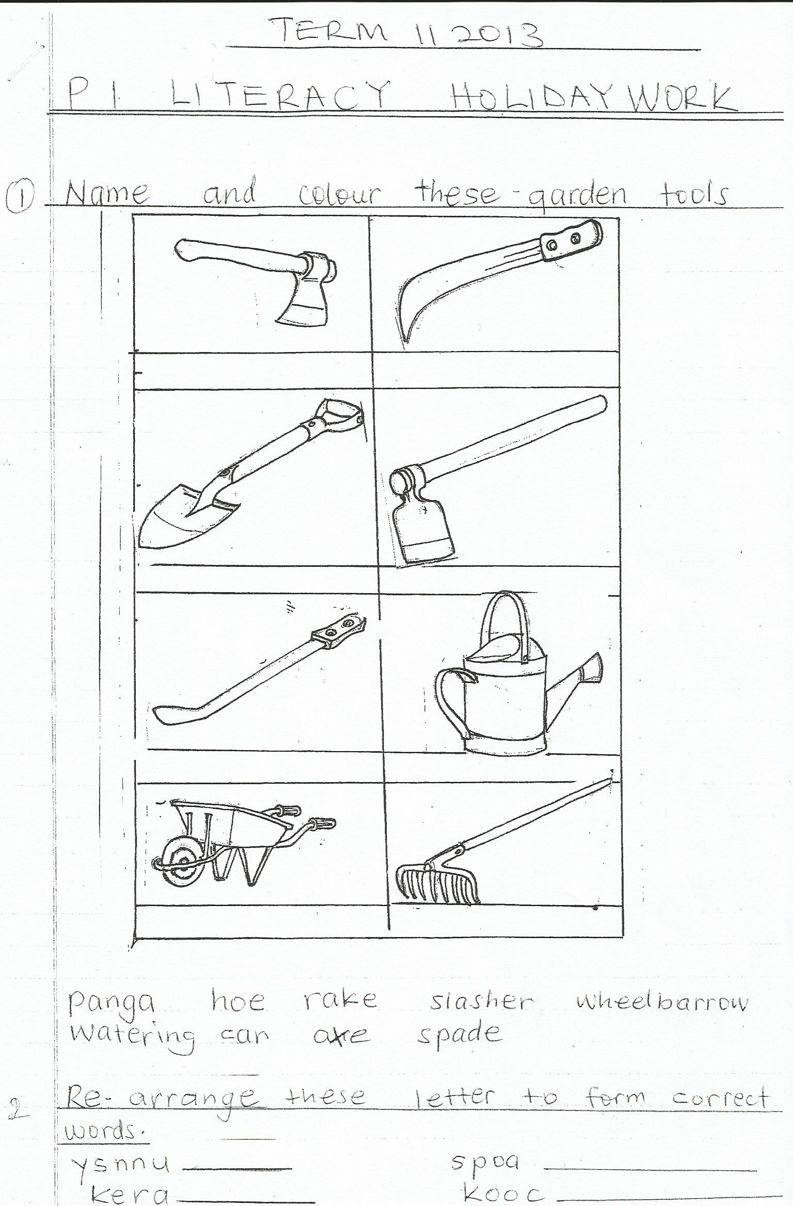

**General knowledge**

In Kinyamaseke, Bwambale’ssow gave birth to 10 piglets among which there was a very small piglet. What scientific name do we give to such a small piglet in the litter?

**Name: ……………………………………….………… Date: ………………….…......**

**S.S.T**

1a) Which bird is used for Uganda’s national Emblem?

………………………………………………………………………………………………..

b) Why was the above named bird chosen as the Emblem of Uganda?

………………………………………………………………………………

c) Why does the above named bird stand on one leg?

…………………………………………………………………………………….

2a. How do the people of Uganda respect the national flag?

……………………………………………………………………………

b. Why is the Uganda national team given a national flag?

…………………………………………………………………………………………………………

1. Which British governor exiled KabakaMutesa II to London?

………………………………………………………………………………………………….

1. Which title was given to the British representatives in Uganda from 1905?

………………………………………………………………………………………………………………..

4. Which political events happened in Uganda in the following years:-

(i) 1921 …………………………………. (ii) 1945 ……………………………….

(iii) 1952 …………………………………. (iv) 1953 …………………………………..

**General knowledge**

What is the name of the Goal keeper of the Uganda National Football team?

………………………………………………………………………………………………….

|  |  |  |
| --- | --- | --- |
| **Comment:** |  | |
| **Name of Parent** |  | **Sign:** |
| **Date** |  | **Contact:** |

**Name: ……………………………………….………… Date: ………………….…......**

**MATHEMATICS**

1. Given that a = 6, b = 8 and c = 4.

Find:

1. a + b + c
2. abc
3. ac – b

$\frac{bc}{c}$

$\frac{bb}{b}$

|  |  |  |
| --- | --- | --- |
| **Comment:** |  | |
| **Name of Parent** |  | **Sign:** |
| **Date** |  | **Contact:** |

**Name: ……………………………………….………… Date: ………………….…......**

**ENGLISH**

**Below is a dialogue between Kasirye and Kamukamu. What Kasirye said is given below. Complete it by filling in the blank spaces what you think Kamukamu said.**

Kasirye : Hello, Kamukamu, what have you been doing in your class?

Kamukamu : .........................................................................................................

Kasirye : Having a meeting! What was the meeting about?

Kamukamu : .........................................................................................................

Kasirye : Starting a school news paper! What kind of news are you going to write?

Kamukamu : .........................................................................................................

Kasirye : Local and foreign news! Who were chosen to be the chief editor and

Journalists?

Kamukamu : .........................................................................................................

Kasirye : Biko, Twine and Maggie! Why were they chosen?

Kamukamu : .........................................................................................................

Kasirye : For being good at English! For being good at English! Which articles are

you going to write?

Kamukamu : .........................................................................................................

Kasirye : About sports, education and politics! Who will draw the cartoons?

Kamukamu : .........................................................................................................

Kasirye : Collin! Is he good at drawing cartoons?

Kamukamu : .........................................................................................................

Kasirye : Indeed he deserved it. I wish you success.

Kamukamu : .........................................................................................................

Kasirye : Good bye, Kamukamu.

Kamukamu : .........................................................................................................

**General knowledge**

He was not made and born. He lives everywhere. Who is He?

…………………………………………………………………………………………………………

|  |  |  |
| --- | --- | --- |
| **Comment:** |  | |
| **Name of Parent** |  | **Sign:** |
| **Date** |  | **Contact:** |

**Name: ……………………………………….………… Date: ………………….…......**

**MATHEMATICS**

1.a) The volume of the cuboid is **120m3**, calculate the value of **h**.

h

2m

6m

b) How many litres can the above box hold?

1. Solve for $f$ if $\frac{2f}{3}$ = 4
2. Simplify: 2b + m – b + 6m

|  |  |  |
| --- | --- | --- |
| **Comment:** |  | |
| **Name of Parent** |  | **Sign:** |
| **Date** |  | **Contact:** |