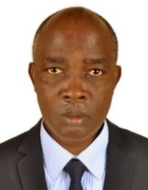UGANDA NATIONAL EXAMINATION BOARD

PRIMARY LEAVING EXAMINATION

Dr. Bbosa Science

Nurture your dreams

d

digitalteachrs.co.ug

**Science 1993**

Time allowed: 2hours 15 minutes

|  |  |  |  |  |  |  |  |  |
| --- | --- | --- | --- | --- | --- | --- | --- | --- |
|  |  |  |  |  |  |  |  |  |

Index No:

Candidate’s Name……………………………………………………………………………………..

Candidate’s signature…………………………………………………………………………………..

District Name…………………………………………………………………………………………………

|  |  |  |
| --- | --- | --- |
| **FOR EXAMINERS**  **USE ONLY** | | |
| **Qn. No** | **MARKS** | **EXR’S NO.** |
| **1-10** |  |  |
| **11-20** |  |  |
| **21-30** |  |  |
| **31-40** |  |  |
| **51** |  |  |
| **52** |  |  |
| **53** |  |  |
| **54** |  |  |
| **55** |  |  |
| **Total** |  |  |

Read the following instructions carefully

1. This paper has two sections **A** and **B.** Section **A** has 50 questions and section **B** has 5 questions. The paper has 15 pages following altogether.
2. Answer all questions. All answers to both sections A and B must be **written** in the spaces provided.
3. All answers must be written using a blue or black ball-point pen or ink. **Any** work written in pencil other than graphs, pictures and diagrams will **not** be marked.
4. Unnecessary change of work may lead to loss of marks.
5. Any handwriting that cannot easily be read may lead to loss to marks.
6. Do not fill anything in the boxes indicated:
7. “For examiners’. Use only and inside the question paper

©1993 Uganda National Examination board

1. Jane put a bottle of soda in a bucket of ice. Two hours later, she found that the soda was frozen and the bottle broken. Why did the bottle break?

…………………………………………………………………………………………………………………………………………………..

1. What is the role of brightly colored petals in pollination?

……………………………………………………………………………………………………………………………………………………

1. State one reason why loam soil is better than sandy soil for crop growing.

…………………………………………………………………………………………………………………………………………………..

Use the drawing below to answer questions 4 to 8

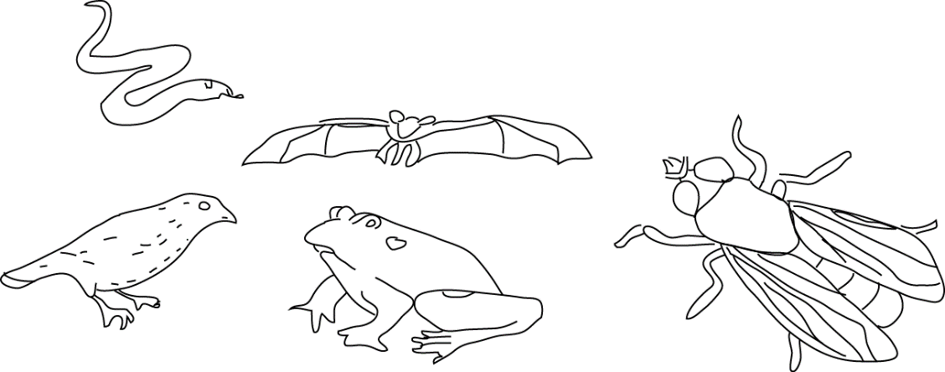

1. Which animal lay eggs?

……………………………………………………………………………………………………………………………………………………..

1. Which of these animals are cold blooded?

……………………………………………………………………………………………………………………………………………………..

1. Which of these animals has no back bone?

……………………………………………………………………………………………………………………………………………………..

1. Which these animals can fly?

……………………………………………………………………………………………………………………………………………………..

1. Which of these animals is a mammal?

…………………………………………………………………………………………………………………………………………………

1. Why would an egg from a layer not hatch into a chick after it has incubated for 21 days?

……………………………………………………………………………………………………………………………………………………..

1. The chameleon is a slow-moving animal. State one way by which it protects itself.

……………………………………………………………………………………………………………………………………………………

1. Why is milk the best food for a baby less than one year old?

……………………………………………………………………………………………………………………………………………………

1. Why should left-over food be properly covered?

……………………………………………………………………………………………………………………………………………………..

1. What causes malaria?

……………………………………………………………………………………………………………………………………………………

The diagram below shows a setup of an experiment and its results. Use it to answer questions 14 and 15

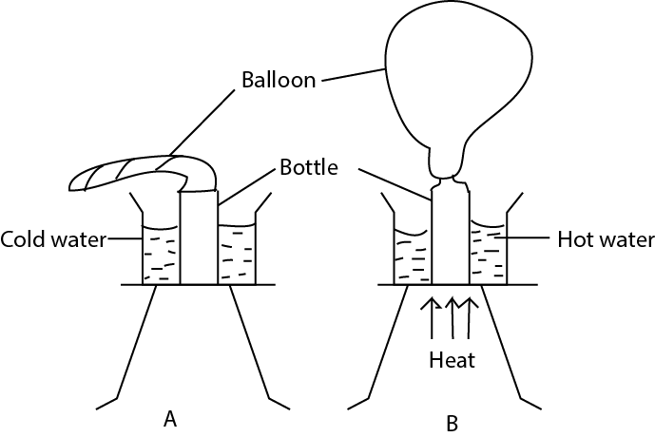

1. Why does a bulb swell out as shown in B?

……………………………………………………………………………………………………………………………………………………

1. Suggest what you think the experiment is intended to show?

……………………………………………………………………………………………………………………………………………………

1. Why are people encouraged to drink boiled water?

…………………………………………………………………………………………………………………………………………………….

1. Why must fruits and vegetables be included in our diet?

……………………………………………………………………………………………………………………………………………………

1. Why does a pregnant mother need food rich in protein?

…………………………………………………………………………………………………………………………………………………..

1. Why should finger nails be cut short?

…………………………………………………………………………………………………………………………………………………….

1. Why a maize grain is considered a fruit?

……………………………………………………………………………………………………………………………………………………

Use the drawing below to answer questions 21 and 22

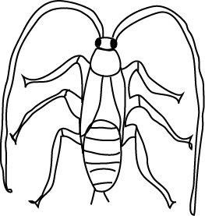

1. What stage in the life cycle of a cockroach is shown in the diagram?

……………………………………………………………………………………………………………………………………………………

1. Give a reason answer in question 21.

……………………………………………………………………………………………………………………………………………………

1. How does a cassava plant obtain its food when its leaves have fallen off?

……………………………………………………………………………………………………………………………………………………

1. Why does a piece of stone placed into water sink?

…………………………………………………………………………………………………………………………………………………….

The diagram below shows a metallic rod made of two different metal X and Y bound together as shown in A. when heated, the rod bends as shown in B. use the diagram to answer questions 25 and 26.

X

Y

Y

X

A

B

1. Which of the metal expands faster, X or Y?

……………………………………………………………………………………………………………………………………………………

1. Give a reason for your answer in 25.

……………………………………………………………………………………………………………………………………………………

1. What is the function of a dry cell?

………………………………………………………………………………………………………………………………………………….

1. Why does a wet cloth spread on a line inside a house dry?

………………………………………………………………………………………………………………………………………………….

1. What is a compound fracture?

……………………………………………………………………………………………………………………………………………………

1. What First Aid should be given to a person with a compound fracture on the arm?

…………………………………………………………………………………………………………………………………………………..

1. Why must one avoid being near a person who is smoking?

…………………………………………………………………………………………………………………………………………………..

1. Of what use is a ventilator of a house?

……………………………………………………………………………………………………………………………………………………

1. What do you understand by “drug dependence”

……………………………………………………………………………………………………………………………………………………..

1. What vector (animal) carries bubonic plaque germs?

……………………………………………………………………………………………………………………………………………………..

1. Why should a pit latrine be smocked from time to time?

……………………………………………………………………………………………………………………………………………………..

1. Bbosa shares his house with goats. State the disadvantage of this practice.

……………………………………………………………………………………………………………………………………………………..

1. Some charcoal is burnt in a container as shown in the diagram below. The container and its contents were weighed before and after. There was no change in the weight. Why was there no change?

Heat

Charcoal

Test tube

Air

Air- tight cover cover

……………………………………………………………………………………………………………………………………………………

1. State one cause of fainting.

……………………………………………………………………………………………………………………………………………………

1. A ray of light meets the surface of the mirror as shown in the diagram below. Draw a reflected ray. (Use of a compass not necessary)

Mirror

Ray of light

500

……………………………………………………………………………………………………………………………………………………

1. What is the importance of weeding in growing crops?

…………………………………………………………………………………………………………………………………………………….

SECTION B

1. The diagram below is of an Irish potato. Use it to answer questions (a) to (d)
2. What part of the Irish potato is shown in the diagram?

………………………………………………………………………………………………………………………………………………….

1. Give a reason for your answer in (a)

……………………………………………………………………………………………………………………………………………………..

1. What is the main food value does the Irish potato have?

……………………………………………………………………………………………………………………………………………………..

1. How does the method of propagation of Irish potato different from that of sweet potato?

…………………………………………………………………………………………………………………………………………………….

1. The table below gives a list of diseases against which children should be immunized and the age in months in which the first dose of vaccine should be given?

|  |  |
| --- | --- |
| Disease | Age in months |
| Tuberculosis | …………………………. |
| Tetanus | 1 ½ |
| ………………………………………………………. | 1 ½ |
| ……………………………………………………… | 9 |

(b) why is the importance of health card?

…………………………………………………………………………………………………………………………………………………………………………………………………………………………………………………………………………………………………………

1. (a) Give two possible source of worm infection?

………………………………………………………………………………………………………………………………………………………………………………………………………………………………………………………………………………………………………..

(b) state two signs of worm infection

…………………………………………………………………………………………………………………………………………………………………………………………………………………………………………………………………………………………………………

1. Uganda electricity Board generates most of it electricity at Jinja.
2. State the source of electricity energy

…………………………………………………………………………………………………………………………………………………..

1. How does the electricity generated at Jinja get to a consumer in Kampala?

…………………………………………………………………………………………………………………………………………………..

1. Give two uses of electricity to a family?

……………………………………………………………………………………………………………………………………………………

1. Below is a drawing of a pin-hole camera with an image of an object formed on the screen. The object is located along line PQ.

P

Q

1. Draw lines to show how the image is formed.
2. Draw the object
3. Compare the image and the object.

………………………………………………………………………………………………………………………………………………………………………………………………………………………………………………………………………………………………………….

1. Bbosa pulls a load of 50kg over a set of metal rollers. Peter pulls another load of the same weight along the ground (see diagram below)

Load

Load

Roller

John

Peter

1. Explain why one of the two (people) uses less force.

…………………………………………………………………………………………………………………………………………………

1. What is the advantage of a driver pouring sand on a slippery road.

………………………………………………………………………………………………………………………………………………….

1. Explain your answer in (b) above?

…………………………………………………………………………………………………………………………………………………..

1. The AIDS virus does not kill a victim.
2. What leads to a person infected with AIDS virus to death?

…………………………………………………………………………………………………………………………………………………..

1. Why should one not be afraid sitting in the same classroom with a person infected with the AIDS virus?

……………………………………………………………………………………………………………………………………………………

……………………………………………………………………………………………………………………………………………………

1. What is the commonest method through which the AIDs virus is spread?

…………………………………………………………………………………………………………………………………..

1. (a) How does each of the following helps to maintain soil fertility?
2. Crop rotation

………………………………………………………………………………………………………………………………………..

…………………………………………………………………………………………………………………………………………

1. Mulching

……………………………………………………………………………………………………………………………………………………

………………………………………………………………………………………………………………………………………………….

(b) give two other ways of maintaining soil fertility.

……………………………………………………………………………………………………………………………………………………............................................................................................................................................................

1. A child suddenly removed the cover of a saucepan full of boiling water. One arm of the child was burnt with steam.
2. What kind of burn did the child get?

……………………………………………………………………………………………………………………………………………………

1. What First AID would you give to the child?

………………………………………………………………………………………………………………………………………………….

1. Give the possible ways by which such accidents could be avoided?

………………………………………………………………………………………………………………………………………………….

1. (a) Give two types of cattle

………………………………………………………………………………………………………………………………………………………………………………………………………………………………………………………………………………………………………..

(b) Why do cattle keepers encouraged to practice paddock system of grazing?

………………………………………………………………………………………………………………………………………………….

…………………………………………………………………………………………………………………………………………………..

1. Below is a diagram showing an eye defect.



1. Name the eye defect shown in the diagram above.

…………………………………………………………………………………………………………………………………………………….

1. Give reasons for your answer in (a) above

………………………………………………………………………………………………………………………………………………….

1. How can this eye defect for your answer in (a) above corrected?

………………………………………………………………………………………………………………………………………………….

1. (a) State two functions of mammalian teeth?

…………………………………………………………………………………………………………………………………………………………………………………………………………………………………………………………………………………………………………..

(b) An elderly man has lost all his molar teeth. What feeding problems would be experience?

…………………………………………………………………………………………………………………………………………………………………………………………………………………………………………………………………………………………………………

1. (a) Give two reasons why burning and rusting are considered similar reactions.

…………………………………………………………………………………………………………………………………………………………………………………………………………………………………………………………………………………………………………

(b) A farmer noticed that whenever he leaves his hoe outside the whole day, on a clear day, it does not rust; but whenever he leaves the same hoe at night, it rusts. Why is this the case?

…………………………………………………………………………………………………………………………………………………………………………………………………………………………………………………………………………………………………………

1. 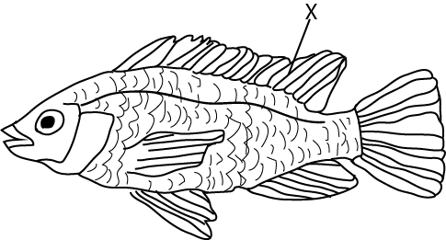The diagram below is of a fish. Study it and answer the questions that follow.
2. Name the part labelled X

……………………………………………………………………………………………………………………………………………………

1. Mark with Y the position of the gills

…………………………………………………………………………………………………………………………………………………..

1. How does the fish take in oxygen?

………………………………………………………………………………………………………………………………………………………………………………………………………………………………………………………………………………………………………..

1. (a) What is an essential drug

…………………………………………………………………………………………………………………………………………………….

…………………………………………………………………………………………………………………………………………………….

(b) Give an example of an essential drug.

…………………………………………………………………………………………………………………………………………………….

(c) Why are prescriptions important in the treatment of sickness?

………………………………………………………………………………………………………………………………………………………………………………………………………………………………………………………………………………………………………………………………………………………………………………………………………………………………………………………………

END