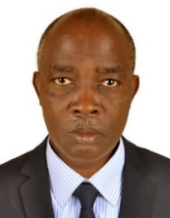UGANDA NATIONAL EXAMINATION BOARD

PRIMARY LEAVING EXAMINATION

Dr. Bbosa Science

Nurture your dreams

d

digitalteachrs.co.ug

**Science 1994**

Time allowed: 2hours 15 minutes

|  |  |  |  |  |  |  |  |  |
| --- | --- | --- | --- | --- | --- | --- | --- | --- |
|  |  |  |  |  |  |  |  |  |

Index No:

Candidate’s Name……………………………………………………………………………………..

Candidate’s signature…………………………………………………………………………………..

District Name…………………………………………………………………………………………………

|  |  |  |
| --- | --- | --- |
| **FOR EXAMINERS**  **USE ONLY** | | |
| **Qn. No** | **MARKS** | **EXR’S NO.** |
| **1-10** |  |  |
| **11-20** |  |  |
| **21-30** |  |  |
| **31-40** |  |  |
| **51** |  |  |
| **52** |  |  |
| **53** |  |  |
| **54** |  |  |
| **55** |  |  |
| **Total** |  |  |

Read the following instructions carefully

1. This paper has two sections **A** and **B.** Section **A** has 50 questions and section **B** has 5 questions. The paper has 15 pages following altogether.
2. Answer all questions. All answers to both sections A and B must be **written** in the spaces provided.
3. All answers must be written using a blue or black ball-point pen or ink. **Any** work written in pencil other than graphs, pictures and diagrams will **not** be marked.
4. Unnecessary change of work may lead to loss of marks.
5. Any handwriting that cannot easily be read may lead to loss to marks.
6. Do not fill anything in the boxes indicated:
7. “For examiners’. Use only and inside the question paper

©1994 Uganda National Examination board

1. How does uncontrolled burning affect our environment?

…………………………………………………………………………………………………………………………………………………………

1. State one method by which breast milk protects newly born baby.

…………………………………………………………………………………………………………………………………………………………

1. In the space provided below, draw a simple diagram of a molar tooth.

………………………………………………………………………………………………………………………………………………………….

1. State one way in which earthworms are important to a farmer.

…………………………………………………………………………………………………………………………………………………………...

1. How does sun rays help in the formation of rains?

………………………………………………………………………………………………………………………………………………………….

1. What takes place in the lungs when one breathes in and out?

………………………………………………………………………………………………………………………………………………………….

1. Bbosa is suffering from a headache. The nurse wishes to measure Bbosa’s body temperature. Why does she put the thermometer under Bbosa arm Pit and not his head?

…………………………………………………………………………………………………………………………………………………………………………………………………………………………………………………………………………………………………………………………

1. How does government control the spread of cattle disease when it breaks out in an area?

……………………………………………………………………………………………………………………………………………………………

1. How does the skin of a person maintain its body temperature on a hot day?

……………………………………………………………………………………………………………………………………………………………

1. Why is it not necessary for a VIP latrine to have a lid for the hole?

……………………………………………………………………………………………………………………………………………………………

1. Why is it not good to pour paraffin into a pit latrine?

…………………………………………………………………………………………………………………………………………………………..

1. A 14-year-old child who is usually well behaved suddenly becomes rude to the parents. State one possible change in the child responsible for such a behavior.

…………………………………………………………………………………………………………………………………………………………

1. What is the advantage of family planning to a mother?

…………………………………………………………………………………………………………………………………………………

1. Why would the control of AIDs be easier than that of malaria?

……………………………………………………………………………………………………………………………………………………

1. Why does milk left in the open becomes sour after some time?

……………………………………………………………………………………………………………………………………………………

1. A child is found to be dehydrated. What is the possible cause of dehydration.

……………………………………………………………………………………………………………………………………………………

1. What causes anemia?

……………………………………………………………………………………………………………………………………………………

1. How does smoke from fire in a room reach other areas in the same room?

……………………………………………………………………………………………………………………………………………………..

1. A block of wood of volume 24cm3 weigh 36grams. What is its density?

……………………………………………………………………………………………………………………………………………………..

1. A female fish lay eggs in water. How are these eggs fertilized?

……………………………………………………………………………………………………………………………………………………..

1. What type of change takes place when a candle wax melts?

……………………………………………………………………………………………………………………………………………………

1. Pregnant women are advised to receive immunization against tetanus. What is the importance of this immunization to unborn baby?

……………………………………………………………………………………………………………………………………………………

1. State any First Aid you would give to a person who is bleeding from a deep cut on the leg?

…………………………………………………………………………………………………………………………………………………..

1. Bob and Agnes are sitting, balanced, on a seesaw as shown in the diagram below.

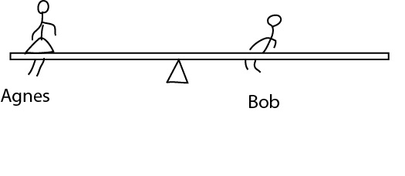

How does the diagram show that Bob is heavier?

……………………………………………………………………………………………………………………………………………………..

1. Why does a heart of a person who is running beat faster than normal?

…………………………………………………………………………………………………………………………………………………….

1. State one advantage of crop rotation.

……………………………………………………………………………………………………………………………………………………

1. What is the difference in the movement between a ball and socket joint and a hinge joint?

……………………………………………………………………………………………………………………………………………………

1. Why should materials made of iron be covered with paint?

……………………………………………………………………………………………………………………………………………………

1. Fish, reptile and birds are vertebrates that lay eggs. State one other characteristic which is common to them.

……………………………………………………………………………………………………………………………………………………..

The diagram below shows an experiment used to find the volume of a regular solid block. Use it to answer questions 30, 31, and 32.

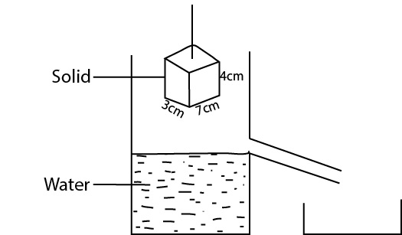

1. What is the volume of the block?

……………………………………………………………………………………………………………………………………………………..

1. If the solid block is lowered into the overflow can, what volume of water will be displaced?

……………………………………………………………………………………………………………………………………………………

1. How would you confirm your answer in question 31 above?

…………………………………………………………………………………………………………………………………………………..

The diagram below shows two boys. Musa and Juma pulling pieces of wood of equal weight up the wall. Use it to answer questions 33 and 34.

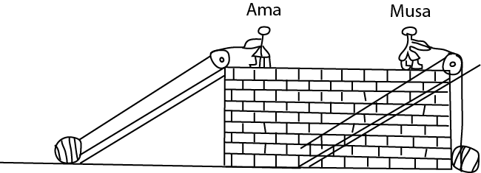

1. Which boy uses less force to pull wood?

……………………………………………………………………………………………………………………………………………………………

1. Explain your answer to question 33 above.

…………………………………………………………………………………………………………………………………………………..

1. Why is resting important for the heath of a person?

………………………………………………………………………………………………………………………………………………….

1. Bbosa is sitting on a chair inside a room. Both feet are bare. His left foot is resting on a bare cemented floor. The right foot is resting on a mat. Why would Bbosa’s left foot feel colder than the right foot?

…………………………………………………………………………………………………………………………………………………..

1. Why is smoking of tobacco harmful to the body?

…………………………………………………………………………………………………………………………………………………..

1. What is the purpose of marriage?

…………………………………………………………………………………………………………………………………………………..

Student was finding out the conditions for germination of beans to take place. She set up the experiment as shown in the diagram below. Use it to answer questions, 39 and 40

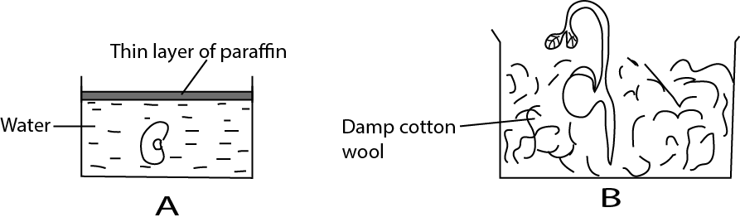

1. Why did the seed A not germinate?

……………………………………………………………………………………………………………………………………………………

1. What is the purpose of the wet cotton wool in B?

………………………………………………………………………………………………………………………………………………….

SECTION B

1. Use the diagram below to answer the following questions

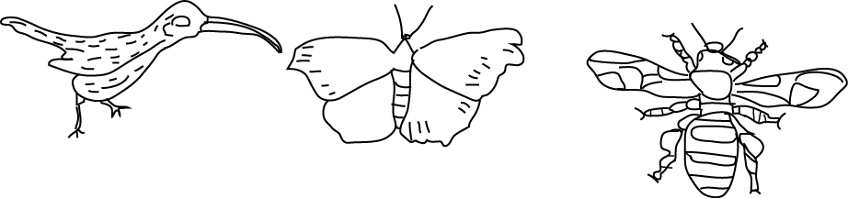

1. In which ways do these animals have similar for
2. Feeding

…………………………………………………………………………………………………………………………………………………….

1. Pollination

……………………………………………………………………………………………………………………………………………

1. Movement

……………………………………………………………………………………………………………………………………………….

1. How does one of the animals differ from others in the life history?

………………………………………………………………………………………………………………………………………………

1. In the diagram below, when the switch was closed, the bulb lit.

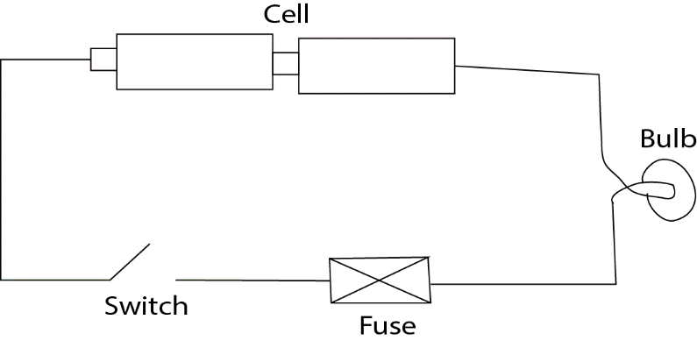

1. How can you increase the brightness of light in the bulb?

……………………………………………………………………………………………………………………………………………………

1. After a short time, the switch was still on, the light in the bulb went off. State three possible causes for the light going off.

……………………………………………………………………………………………………………………………………………………

1. (a) A farmer who practices mixed cropping has the following crops to plant: beans, cassava, ground nuts and potatoes.
2. Which two crops would be advisable for the farmer to plant together.

……………………………………………………………………………………………………………………………………………………

1. Give a reason for your answer in (i) above

……………………………………………………………………………………………………………………………………………………

1. The farmer uses a garden for planting maize crop only for three consecutive years (planting season). During the harvest in the third year, he noticed a drop in maize yield. Suggest a reason why the yield dropped.

…………………………………………………………………………………………………………………………………………………..

1. How can the farmer improve his maize yield in the same garden without using fertilizers?

…………………………………………………………………………………………………………………………………………………..

1. The diagram below is of a human heart. Use it to answer the questions which follow.

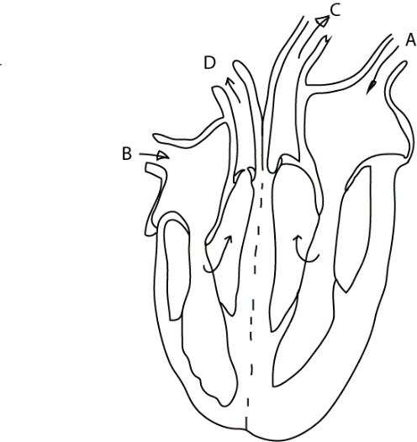

1. What is the function of the valves in the heart?

……………………………………………………………………………………………………………………………………………………..

1. What is the difference between the blood which enters the heart through A and that through B?

……………………………………………………………………………………………………………………………………………………..

1. After leaving the heart at C and D where does the blood go?

C; …………………………………………………………………………………..

D; …………………………………………………………………………….…….

1. in the table below, some of the diseases are given below with their symptoms and prevention/controls. Study it and answer the missing information.

|  |  |  |
| --- | --- | --- |
| Name of disease | symptoms | Prevention/control |
| Sleeping sickness | Loss of body weight, drowsiness, swelling in the Joints | ………………………………………  ………………………………………  ……………………………………. |
| Common cols (flu) | ………………………………………  ………………………………………  ……………………………………. | Isolation, avoid infected people |
| Measles | Rash on the body, high fever, cough, red eyes, sore in mouth, diarrhea and vomiting | ………………………………………  ………………………………………  ……………………………………. |
| ………………………………………  ………………………………………  ……………………………………. | Mild redness and itching of the eyes, pus in eyes after sleep, scarring | Washing of eyes, avoid sharing articles with sick person, e.g. basin, towel, medical treatment |

1. (a) why should water not be used to put out fire from petrol which is burning?

………………………………………………………………………………………………………………………………………………………………………………………………………………………………………………………………………………………………………..

1. Suggest two ways by which fire from petrol burning can be put out.

………………………………………………………………………………………………………………………………………………………………………………………………………………………………………………………………………………………………………….

1. The diagram below is of a flower. Use it to answer the questions that follow.

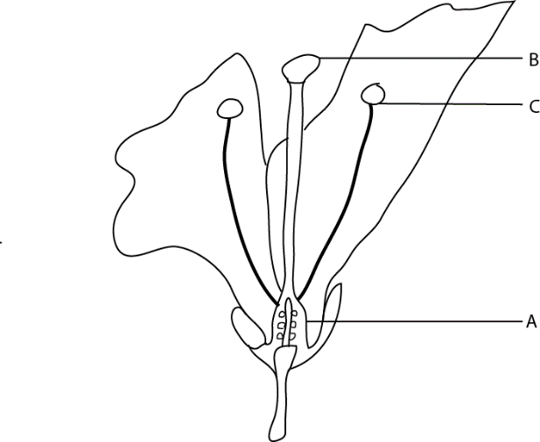

1. What does the part labelled A become after fertilization?

……………………………………………………………………………………………………………………………………………………………

1. What is the function of the parts labelled B and C?

……………………………………………………………………………………………………………………………………………………………

1. Of what value are flowers to man?

……………………………………………………………………………………………………………………………………………………………

1. When a drum is hit, you hear sound.
2. How does the eardrum help you to hear sound?

……………………………………………………………………………………………………………………………………………………………

1. There is wax in the outer ear. What is the function of wax?

………………………………………………………………………………………………………………………………………………………….

1. What is the effect of too much wax in one’s ear?

……………………………………………………………………………………………………………………………………………………………

1. (a) State two factors which should be taken into account when selecting site for building a house.

…………………………………………………………………………………………………………………………………………………………………………………………………………………………………………………………………………………………………………

1. How does a well-built house contribute to the health of a family?

…………………………………………………………………………………………………………………………………………………………………………………………………………………………………………………………………………………………………………

1. 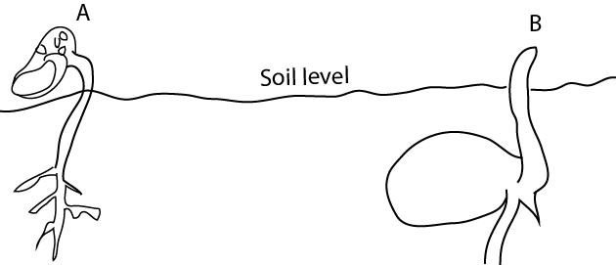The diagram below shows how seeds change into young plants. Use t to answer the questions which follow.
2. what is the main differences between the type of germination shown in A and that in B.

…………………………………………………………………………………………………………………………………………………………………………………………………………………………………………………………………………………………………………..

1. Which of the two types of germination is common in monocotyledonous plants?

…………………………………………………………………………………………………………………………………………………………………………………………………………………………………………………………………………………………………………

1. In what way does the location of the food store in A differ from that of B?

…………………………………………………………………………………………………………………………………………………….

1. 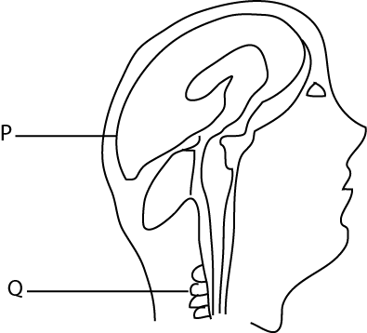Use the diagram below to answer the question which follow.
2. What name is given to the part labelled P

………………………………………………………………………………………………………………………………………………..

1. Give the function of the part marked Q.

……………………………………………………………………………………………………………………………………………….

1. Name two sense organs shown in the diagram above, by which someone can tell that there is something burning?

…………………………………………………………………………………………………………………………………………………………………………………………………………………………………………………………………………………………………………

1. List A below gives two types of misquotes. The drawings in B give the larva and adult stage of mosquitoes. Write the correct number of the drawings in B against the correct mosquito in List A. Each drawing in B can be used once or more than once or not used at all.

|  |
| --- |
|  |
|  |
|  |
| 4. |

A B

Anopheles mosquito …………………...

Culex mosquito ………………………….

1. Nakato harvested her maize crop and dried it. She put the maize in a sack and stored it on the floor, in the corner of the bed room. Akello also harvested and dried her maize crop. Then she hung the maize cob above the fireplace in the kitchen.
2. Explain why Akello would have better maize grains to plant next season.

……………………………………………………………………………………………………………………………………………………………………………………………………………………………………………………………………………………………….

1. Give two ways in which Nakato can improve on the storage method.

……………………………………………………………………………………………………………………………………………………………………………………………………………………………………………………………………………………………….

1. (a) What shows that air is matter?

…………………………………………………………………………………………………………………………………………………………………………………………………………………………………………………………………………………………………………

1. A candle is lit and placed inside a container and sealed as shown in the diagram below.
2. Why does the candle continue burning for some time inside the sealed container?

……………………………………………………………………………………………………………………………………………….

1. Give a reason why the candle light goes off after some time.

…………………………………………………………………………………………………………………………………………………..

1. State four reasons why physical exercise are good for the body.

……………………………………………………………………………………………………………………………………………………………………………………………………………………………………………………………………………………………………………………………………………………………………………………………………………………………………………………………………………………………………………………………………………………………………………………………………………………..

END