****UGANDA NATIONAL EXAMINATION BOARD

PRIMARY LEAVING EXAMINATION

Dr. Bbosa Science

Nurture your dreams

d

digitalteachrs.co.ug

**Science 1995**

Time allowed: 2hours 15 minutes

|  |  |  |  |  |  |  |  |  |
| --- | --- | --- | --- | --- | --- | --- | --- | --- |
|  |  |  |  |  |  |  |  |  |

Index No:

Candidate’s Name……………………………………………………………………………………..

Candidate’s signature…………………………………………………………………………………..

District Name…………………………………………………………………………………………………

|  |  |  |
| --- | --- | --- |
| **FOR EXAMINERS**  **USE ONLY** | | |
| **Qn. No** | **MARKS** | **EXR’S NO.** |
| **1-10** |  |  |
| **11-20** |  |  |
| **21-30** |  |  |
| **31-40** |  |  |
| **51** |  |  |
| **52** |  |  |
| **53** |  |  |
| **54** |  |  |
| **55** |  |  |
| **Total** |  |  |

Read the following instructions carefully

1. This paper has two sections **A** and **B.** Section **A** has 50 questions and section **B** has 5 questions. The paper has 15 pages following altogether.
2. Answer all questions. All answers to both sections A and B must be **written** in the spaces provided.
3. All answers must be written using a blue or black ball-point pen or ink. **Any** work written in pencil other than graphs, pictures and diagrams will **not** be marked.
4. Unnecessary change of work may lead to loss of marks.
5. Any handwriting that cannot easily be read may lead to loss to marks.
6. Do not fill anything in the boxes indicated:
7. “For examiners’. Use only and inside the question paper

©1995 Uganda National Examination board

SECTION A

1. Bbosa caught fish to feed for a month. Suggest one way by which Bbosa’s family can safely keep the fish to last one month.

……………………………………………………………………………………………………………………………………………………..

1. Why are cockroaches classified as invertebrates?

……………………………………………………………………………………………………………………………………………………..

The diagram below is of a clinical thermometer. Use it to answer questions 3 to 6.

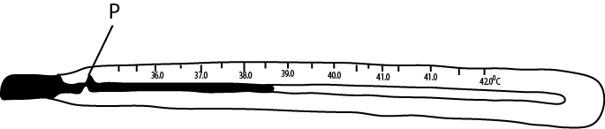

1. What liquid is used in thermometer?

……………………………………………………………………………………………………………………………………………………

1. What is the main function of the part labelled P?

……………………………………………………………………………………………………………………………………………………

1. The temperature of a person was taken and the liquid rose to the level as shown in the diagram above. What was the person’s temperature?

…………………………………………………………………………………………………………………………………………………...

1. Why would you support that person in question 5 above had malaria?

…………………………………………………………………………………………………………………………………………………

1. Mention one way by which the supply of clean water in rural area is being improved.

…………………………………………………………………………………………………………………………………………………

1. State one way in which bacteria is useful to man.

………………………………………………………………………………………………………………………………………………..

1. Why are tape worms called parasites?

………………………………………………………………………………………………………………………………………………….

1. Why does Uganda Electricity Board worker wear rubber gloves when working on wires carrying electricity?

……………………………………………………………………………………………………………………………………………………

1. Name one disease which attacks both poultry and rabbits.

……………………………………………………………………………………………………………………………………………………

1. How can a person become infected with tetanus?

…………………………………………………………………………………………………………………………………………………….

1. State one way in which evaporation is useful to man.

……………………………………………………………………………………………………………………………………………………

1. What is the difference between the organism that cause the AIDs disease and that of gonorrhea?

…………………………………………………………………………………………………………………………………………………….

Below is a table with column for vitamins, source of vitamins and the related deficiency diseases. Fill in the table to answer questions 15 to 17.

|  |  |  |  |
| --- | --- | --- | --- |
|  | Vitamin | Source | Deficiency disease |
|  | ………………………………………. | Milk | Ricket |
|  | A | Paw paw | ……………………………………. |
|  | B1 | ………………………………………. | Beriberi |

1. State one reason why air in the soil is important.

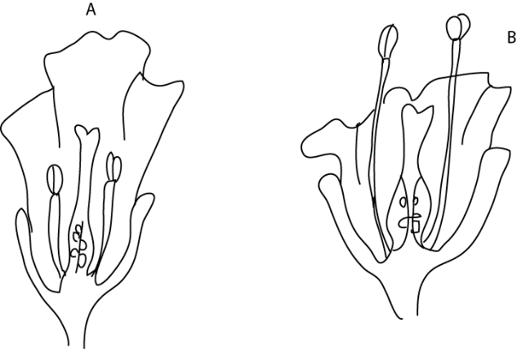The diagram below are of flowers A and B. Use them to answer questions 19 and 21

1. Which of the two flowers is likely to be insects pollinated?

…………………………………………………………………………………………………………………………………………………

1. Give one reason for your answer to question 19.

……………………………………………………………………………………………………………………………………………………

1. How is the other flower likely to be pollinated?

…………………………………………………………………………………………………………………………………………………..

1. Which First Aid would you give to a person who has a burn by fire?

…………………………………………………………………………………………………………………………………………………..

1. The diagram below is of a machine used for picking charcoal. Indicate on it, with letter F, the position of a fulcrum.

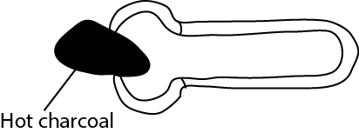

Hot Charcoal

1. Why should a woman eat more food when she is pregnant than when she is not.

……………………………………………………………………………………………………………………………………………………..

1. Complete the rays of light in the diagram below to show a condition of short-sightedness.

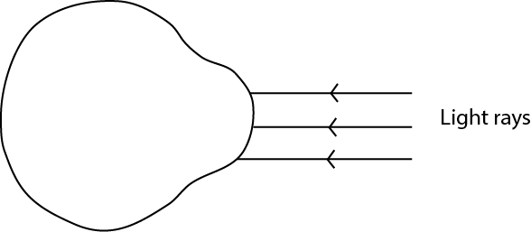

1. Name one function of the small intestine on an animal.

……………………………………………………………………………………………………………………………………………

1. State one reason for juvenile delinquency (wrong behavior by children).

…………………………………………………………………………………………………………………………………………….

1. Give the main reason why crop rotation maintain fertility.

……………………………………………………………………………………………………………………………………………

1. In the diagram below, A, B, C, d. are cards with small holes as shown below. Student at E is trying to see the light at A through the holes.

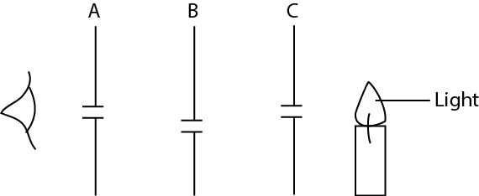

Why can’t the light be seen at E?

…………………………………………………………………………………………………………………………………………………..

1. Why is it more difficult to breath in a room full of smoke than in open compound?

…………………………………………………………………………………………………………………………………………………..

1. What is the use of a nerve to a person?

……………………………………………………………………………………………………………………………………………………

The diagram below shows light falling on a plane mirror. PQ. Use it to answer question 32 and

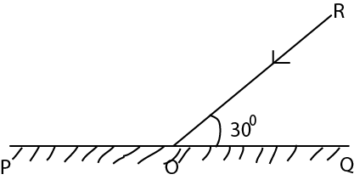

1. Complete the drawing accurately, to see the reflected ray.
2. What is the value of the angle of reflection?

…………………………………………………………………………………………………………………………………………………

1. State one way by which body lice can be avoided?

………………………………………………………………………………………………………………………………………………….

1. Where does a ground nut store most of its food?

………………………………………………………………………………………………………………………………………………….

1. Why are mushrooms carry out photosynthesis?

…………………………………………………………………………………………………………………………………………………...

1. State the main reason for planting seeds in the soil.

…………………………………………………………………………………………………………………………………………………..

1. Bbosa is suffering from severe malaria. Why would you not advise him to take medicine than that prescribed by a medical doctor?

……………………………………………………………………………………………………………………………………………………

1. Science student dropped some oil on a piece of paper. Whey does he fail to write with a ball pen on the sport where oil has dropped?

…………………………………………………………………………………………………………………………………………………..

1. David is asked to find the volume of a piece of stone, the volume of which is about 300cm3. He was provided with 20cm3 of water, a graduated cylinder and an over flow can. He found that this experiment would not work. Suggest one way how it can be made to work.

……………………………………………………………………………………………………………………………………………………

SECTION B

1. (a) State one type of cattle

…………………………………………………………………………………………………………………………………………………….

(b) Name two breed of cattle found in Uganda

…………………………………………………………………………………………………………………………………………………………………………………………………………………………………………………………………………………………………………

(c) give one advantage of cross-breeding with exotic bull.

…………………………………………………………………………………………………………………………………………………….

…………………………………………………………………………………………………………………………………………………….

1. Betty’s home is near a pond.
2. state any two diseases members of Betty’s family are likely to suffer from.

………………………………………………………………………………………………………………………………………………………………………………………………………………………………………………………………………………………………………..

1. Suggest one thing that Betty can do to avoid one of the disease mentioned.

……………………………………………………………………………………………………………………………………………………

1. How is scabies spread?

……………………………………………………………………………………………………………………………………………………..

1. (a) What do you understand by adolescence?

………………………………………………………………………………………………………………………………………………………………………………………………………………………………………………………………………………………………………..

(b) Name two secondary sex characteristic of adolescence.

………………………………………………………………………………………………………………………………………………………………………………………………………………………………………………………………………………………………………….

(c) Give one disadvantage of pregnancy in adolescence.

…………………………………………………………………………………………………………………………………………………….

1. 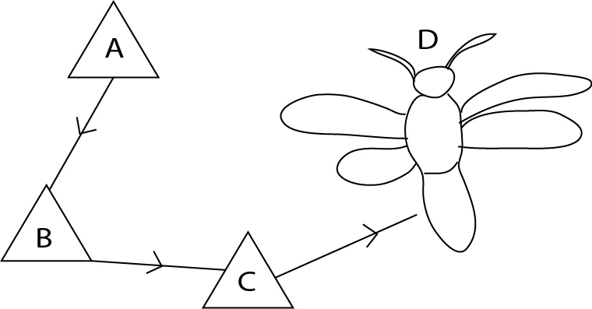The diagram below shows the life cycle of a butterfly. Use it to answer the questions which follow.
2. Name the stages A and B.

A …………………………………………………………………………………………………………………………………

B …………………………………………………………………………………………………………………………………

1. At what stage is a butterfly a pest?

……………………………………………………………………………………………………………………………………

1. State one reason why a butterfly is classified as an insect.

…………………………………………………………………………………………………………………………………..

1. (a) State any two ways of acquiring immunity.

…………………………………………………………………………………………………………………………………………………………………………………………………………………………………………………………………………………………………………………………

(b) Apart from the six killer diseases, state any one other disease where one can acquire immunity.

……………………………………………………………………………………………………………………………………………………………..

(c) Why is it not possible to acquire immunity against AIDs disease?

……………………………………………………………………………………………………………………………………………………..

1. Use the diagram X and Y below to answer the questions that follow.

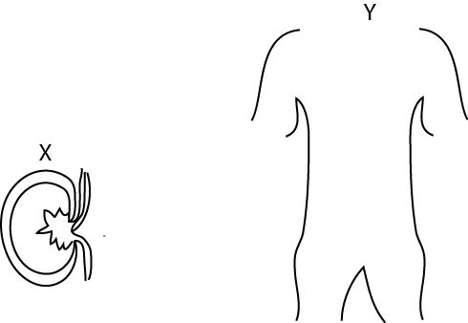

1. Name the organ shown in diagram X.

……………………………………………………………………………………………………………………………………………………………..

1. What is the function of the organ shown in diagram X?

………………………………………………………………………………………………………………………………………………………………...

1. Mark on the drawing Y the position of the organ shown in drawing X.
2. Name another organ in a mammal that carries out a similar function as the organ shown in the drawing X.
3. (a) in the space below, draw an example of:
4. A simple leaf
5. A compound leaf
6. State any one use of a leaf to a plant other than photosynthesis.

………………………………………………………………………………………………………………………………………………………………….

1. Apart from being eaten as food, name one other use of leaves to man.

………………………………………………………………………………………………………………………………………………………………….

1. Use the list of plants given below to answer the questions that follow

Beans, mosses, conifers, mushrooms

1. Which two plants would you group together as members of one family

……………………………………………………………………………………………………………………………………………………………

1. Give a reason for your answer in (a) above

…………………………………………………………………………………………………………………………………………………………………

1. Which one of the above plants reproduces by means of flowers?

………………………………………………………………………………………………………………………………………………………………..

1. In what kind of environment would you find mosses?

………………………………………………………………………………………………………………………………………………………………….

1. 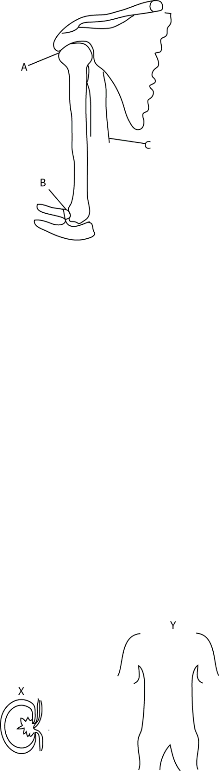The diagram below is of a part of a human arm, use it to answer the questions which follow
2. Name the joint A

………………………………………………………………………………………………………………………………………………………………….

1. What kind of movementt does the joint A allow?

………………………………………………………………………………………………………………………………………………………………

1. Complete the drawing of muscles C to show where its lower end is attached.
2. If the arm is in the position shown, name the muscle which must be contracted.

………………………………………………………………………………………………………………………………………………………………….

1. Two containers A and B containing some water as in the diagram below, were heated.

Heat

A

B

saucepan

saucepan

1. In which container did water boil first?

……………………………………………………………………………………………………………………………………………………………

1. Explain your answer in (a) above.

………………………………………………………………………………………………………………………………………………………………….

1. Matata came back from school and found a piece of left over boiled potato which was not covered. Because he was very hungry, he began to eat it at once.
2. State two good heathy practice which Matata did not follow.

………………………………………………………………………………………………………………………………………………………………….

1. Name a disease Matata could suffer from

………………………………………………………………………………………………………………………………………………………………….

1. Give a reason for your answer in (b) above?

…………………………………………………………………………………………………………………………………………………………………

1. A married couple has 10 children. The oldest is 15 years while the youngest is 3months old.
2. State two problems this family is likely to face.

……………………………………………………………………………………………………………………………………………………………………………………………………………………………………………………………………………………………………………………………………

1. Mention one health problem the mother may face.

………………………………………………………………………………………………………………………………………………………………

1. State one suitable advice you would give to this family.

………………………………………………………………………………………………………………………………………………………………

1. (a) State one way in which you can distinguish between a poisonous snake and a nonpoisonous one

……………………………………………………………………………………………………………………………………………………………

(b) Give an example of a poisonous snake.

……………………………………………………………………………………………………………………………………………………………

(c) What First Aid is given to a person bitten by a poisonous snake?

………………………………………………………………………………………………………………………………………………………….

1. (a) How does heat travel through:
2. Water?

………………………………………………………………………………………………………………………………………………………………..

1. Vacuum?

………………………………………………………………………………………………………………………………………………………………….

1. Explain how the sun heats the air around us.

………………………………………………………………………………………………………………………………………………………………….

1. The figure below is accurately drawn. What is its volume?

………………………………………………………………………………………………………………………………………………………………….

………………………………………………………………………………………………………………………………………………………………….

………………………………………………………………………………………………………………………………………………………………….

……………………………………………………………………………………………………………………………………………………… End