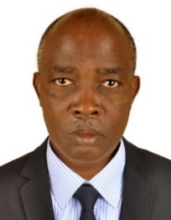UGANDA NATIONAL EXAMINATION BOARD

PRIMARY LEAVING EXAMINATION

Dr. Bbosa Science

Nurture your dreams

d

digitalteachrs.co.ug

**Science 1997**

Time allowed: 2hours 15 minutes

|  |  |  |  |  |  |  |  |  |
| --- | --- | --- | --- | --- | --- | --- | --- | --- |
|  |  |  |  |  |  |  |  |  |

Index No:

Candidate’s Name……………………………………………………………………………………..

Candidate’s signature…………………………………………………………………………………..

District Name…………………………………………………………………………………………………

|  |  |  |
| --- | --- | --- |
| **FOR EXAMINERS**  **USE ONLY** | | |
| **Qn. No** | **MARKS** | **EXR’S NO.** |
| **1-10** |  |  |
| **11-20** |  |  |
| **21-30** |  |  |
| **31-40** |  |  |
| **51** |  |  |
| **52** |  |  |
| **53** |  |  |
| **54** |  |  |
| **55** |  |  |
| **Total** |  |  |

Read the following instructions carefully

1. This paper has two sections **A** and **B.** Section **A** has 50 questions and section **B** has 5 questions. The paper has 15 pages following altogether.
2. Answer all questions. All answers to both sections A and B must be **written** in the spaces provided.
3. All answers must be written using a blue or black ball-point pen or ink. **Any** work written in pencil other than graphs, pictures and diagrams will **not** be marked.
4. Unnecessary change of work may lead to loss of marks.
5. Any handwriting that cannot easily be read may lead to loss to marks.
6. Do not fill anything in the boxes indicated:
7. “For examiners’. Use only and inside the question paper

©1997 Uganda National Examination board

1. Apart form oxygen, name any one other part of air

……………………………………………………………………………………………………………………………………………………

1. Give one difference between algae and fungi

……………………………………………………………………………………………………………………………………………………

1. How is a vector different from a pest?

……………………………………………………………………………………………………………………………………………………

1. Bbosa breathed on a mirror several times. He could not himself clearly later, why?

……………………………………………………………………………………………………………………………………………………

1. Mention one agent of soil erosion.

……………………………………………………………………………………………………………………………………………………

1. Why is water necessary for germination?

……………………………………………………………………………………………………………………………………………………

1. Why is the skull important part of the body?

……………………………………………………………………………………………………………………………………………………

1. Apart from learning about animals and crops, suggest one other reason for starting a farm.

……………………………………………………………………………………………………………………………………………………

1. Name the tooth in the diagram below.

……………………………………………………………………………………………………………………………………………………

1. Why is a concave lens used to correct short sightedness?

……………………………………………………………………………………………………………………………………………………

1. Give one danger of poor disposal of human feces.

……………………………………………………………………………………………………………………………………………………

1. Why should a pit latrine be covered?

……………………………………………………………………………………………………………………………………………………

1. What is the use of a dustbin in a home?

……………………………………………………………………………………………………………………………………………………

1. When does a person become dehydrated?

……………………………………………………………………………………………………………………………………………………

1. What happen when an industry releases a lot of smokes to the atmosphere?

……………………………………………………………………………………………………………………………………………………

1. Explain why a borehole water safe to drink.

……………………………………………………………………………………………………………………………………………………

1. Explain one way of keeping food safe and clean.

……………………………………………………………………………………………………………………………………………………

1. Why should children eat more proteins than the old people?

……………………………………………………………………………………………………………………………………………………

1. State any way in which spiders are different from insects.

……………………………………………………………………………………………………………………………………………………

1. Give one way in which flowering plants are useful to man.

……………………………………………………………………………………………………………………………………………………

1. 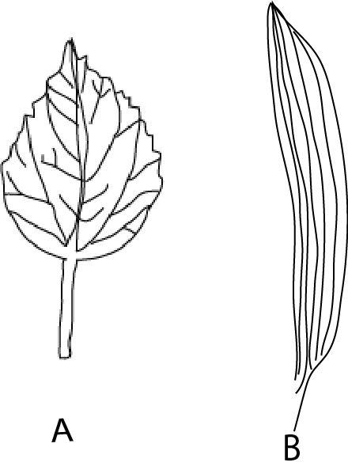The diagram below shows different leaves, A and B.

Which of the following leaves is from monocotyledonous plant?

……………………………………………………………………………………………………………………………………………………

1. Apart from the leaf structure, give one other difference between monocotyledonous plant and dicotyledonous plant.

……………………………………………………………………………………………………………………………………………………

1. Give the main use of leaves to the plant.

……………………………………………………………………………………………………………………………………………………

1. State one reason why burning and breathing are similar.

……………………………………………………………………………………………………………………………………………………

1. What change takes place when you eat food and get energy.

……………………………………………………………………………………………………………………………………………………

1. State the difference between conduction and radiation.

……………………………………………………………………………………………………………………………………………………

1. Explain why light is seen before sound is heard during lightening.

……………………………………………………………………………………………………………………………………………………

1. When drawing water from a borehole, why is the handle led far from the fulcrum?

……………………………………………………………………………………………………………………………………………………

1. The diagram above shows the foot of a driver accelerating the car. Indicate on it with letter L, the position of the load

……………………………………………………………………………………………………………………………………………………

1. State any one way in which the First Aid for a cut is different from First Aid for a burn.

……………………………………………………………………………………………………………………………………………………

1. Why do you wash your hands before eating?

……………………………………………………………………………………………………………………………………………………

1. State one reason one reason why it is not advisable to have many children.

……………………………………………………………………………………………………………………………………………………

1. Why shouldn’t people with AIDS be isolated?

……………………………………………………………………………………………………………………………………………………

1. Name the difference between pit latrine and VIP latrine.

……………………………………………………………………………………………………………………………………………………

1. Apart from the type of soil, name one factor to consider when constructing a house.

……………………………………………………………………………………………………………………………………………………

1. Mention one reason why drinking water should be boiled

……………………………………………………………………………………………………………………………………………………

1. Name the vaccine which is given to a child at birth.

……………………………………………………………………………………………………………………………………………………

1. What does the vaccine mentioned in number 37 protect the child against?

……………………………………………………………………………………………………………………………………………………

1. Mention one of the service of public Health Care (PHC)

……………………………………………………………………………………………………………………………………………………

1. Why should we bathe daily?

……………………………………………………………………………………………………………………………………………………

SECTION B

The diagram below shows the cycle. Use it to answer 41

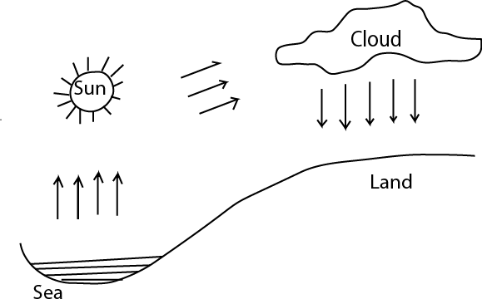

1. Describe how rain is formed.

……………………………………………………………………………………………………………………………………………………

……………………………………………………………………………………………………………………………………………………

……………………………………………………………………………………………………………………………………………………

……………………………………………………………………………………………………………………………………………………

1. The diagram below shows two nails under three different conditions

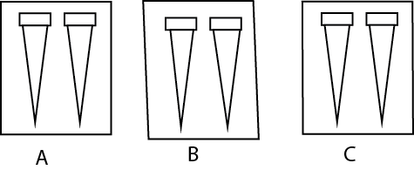

In A – the nails were wrapped in clean wet cloth

In B – the nails were wrapped in clean dry cloth

In C- the nails were smeared with oil and then wrapped in a clean wet cloth.

1. In which case did the nail rust?

……………………………………………………………………………………………………………………………………………………

……………………………………………………………………………………………………………………………………………………

1. What is the importance of smearing with oil

……………………………………………………………………………………………………………………………………………………

……………………………………………………………………………………………………………………………………………………

1. Name two conditions necessary for rusting.

……………………………………………………………………………………………………………………………………………………

……………………………………………………………………………………………………………………………………………………

1. (a) Name three activities performed when preparing a school garden

……………………………………………………………………………………………………………………………………………………

……………………………………………………………………………………………………………………………………………………

(b) why is a school garden fenced

……………………………………………………………………………………………………………………………………………………

……………………………………………………………………………………………………………………………………………………

1. (a) State two types of chicken which are kept for special purpose.

……………………………………………………………………………………………………………………………………………………

……………………………………………………………………………………………………………………………………………………

(b) Name the purpose of keeping one of the type mentioned in (a) above.

……………………………………………………………………………………………………………………………………………………

……………………………………………………………………………………………………………………………………………………

1. Name one advantage of keeping local breeds of chicken.

……………………………………………………………………………………………………………………………………………………

……………………………………………………………………………………………………………………………………………………

1. (a) Mention the structure that joins a bone to a muscle

……………………………………………………………………………………………………………………………………………………

……………………………………………………………………………………………………………………………………………………

(b) give one example of the following types of joints

(i) hinge joint

……………………………………………………………………………………………………………………………………………………

……………………………………………………………………………………………………………………………………………………

(ii) ball and socket joint

……………………………………………………………………………………………………………………………………………………

……………………………………………………………………………………………………………………………………………………

(c) Name the food substance that help in formation of strong bones.

……………………………………………………………………………………………………………………………………………………

……………………………………………………………………………………………………………………………………………………

1. (a) Name one change that occur during adolescence in
2. Male

……………………………………………………………………………………………………………………………………………………

1. Female

……………………………………………………………………………………………………………………………………………………

(b)State two factors you consider when choosing a partner for marriage.

……………………………………………………………………………………………………………………………………………………

……………………………………………………………………………………………………………………………………………………

1. (a) what is STDS?

……………………………………………………………………………………………………………………………………………………

……………………………………………………………………………………………………………………………………………………

(b) Give two examples of STDS.

……………………………………………………………………………………………………………………………………………………

……………………………………………………………………………………………………………………………………………………

(c) State one way in which STDs can be controlled.

……………………………………………………………………………………………………………………………………………………

……………………………………………………………………………………………………………………………………………………

1. 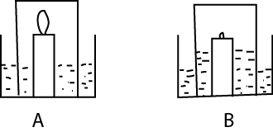The diagram below shows two stages in an experiment. Use it to answer the questions that follow.
2. Why did the candle flame go off in B?

……………………………………………………………………………………………………………………………………………………

1. What happened there after?

……………………………………………………………………………………………………………………………………………………

1. Name the gas inside when the candle flame goes off.

……………………………………………………………………………………………………………………………………………………

1. What is the air used for?

……………………………………………………………………………………………………………………………………………………

……………………………………………………………………………………………………………………………………………………

1. Use the animals below to answer questions that follow.

Mouse, chameleon, frog, python

1. Which two animals can be grouped together?

……………………………………………………………………………………………………………………………………………………

1. Give a reason for your answer in (a) above

……………………………………………………………………………………………………………………………………………………

1. Which animal has a different form of reproduction from others?

……………………………………………………………………………………………………………………………………………………

1. In which environment do you find the frog?

……………………………………………………………………………………………………………………………………………………

1. (a) in the space below, draw an example of:
2. A tap root system
3. A fibrous root system

(b) give one use of roots to a plant and one use to man.

……………………………………………………………………………………………………………………………………………………

1. Use the diagram below to answer the questions that follow

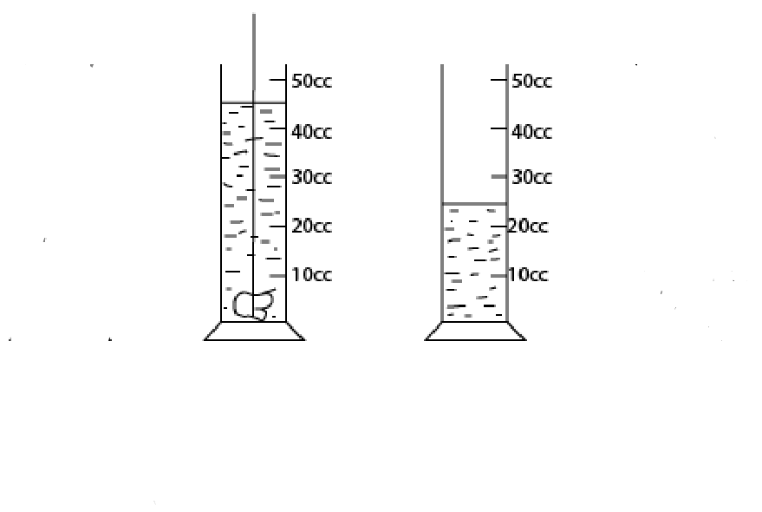

A

B

1. What is the volume of the stone?

……………………………………………………………………………………………………………………………………………………

……………………………………………………………………………………………………………………………………………………

1. Calculate the density of the stone if its mass is 450g.
2. Uganda electricity board generates its electricity at Jinja.
3. How does electricity reach a consumer in mbale?

……………………………………………………………………………………………………………………………………………………

……………………………………………………………………………………………………………………………………………………

1. Give two uses of electricity,

……………………………………………………………………………………………………………………………………………………

……………………………………………………………………………………………………………………………………………………

1. Name the causes of short circuit.

……………………………………………………………………………………………………………………………………………………

……………………………………………………………………………………………………………………………………………………

1. The diagram below shows a machine used to lift a load using an effort of 50kg

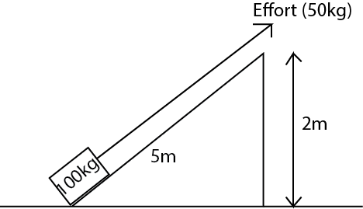

1. Name the machine.

……………………………………………………………………………………………………………………………………………………

1. What distance does the load and effort move through?

……………………………………………………………………………………………………………………………………………………

1. How can you use less than 50kg to pull the load?

……………………………………………………………………………………………………………………………………………………

……………………………………………………………………………………………………………………………………………………

1. (a) Mention two reasons why people drink alcohol.

……………………………………………………………………………………………………………………………………………………

……………………………………………………………………………………………………………………………………………………

1. Name one effect of drinking alcohol has on
2. An individual

……………………………………………………………………………………………………………………………………………………

1. A family

……………………………………………………………………………………………………………………………………………………

1. (a) State two conditions that are likely to a family ill?

……………………………………………………………………………………………………………………………………………………

……………………………………………………………………………………………………………………………………………………

(b) Mention two diseases that people who love in unhealthy conditions can suffer from.

……………………………………………………………………………………………………………………………………………………

……………………………………………………………………………………………………………………………………………………

……………………………………………………………………………………………………………………………………………………

……………………………………………………………………………………………………………………………………………………

……………………………………………………………………………………………………………………………………………………

END