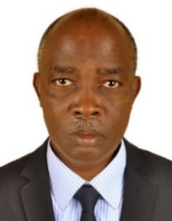UGANDA NATIONAL EXAMINATION BOARD

PRIMARY LEAVING EXAMINATION

Dr. Bbosa Science

Nurture your dreams

d

digitalteachrs.co.ug

**Science 1998**

Time allowed: 2hours 15 minutes

|  |  |  |  |  |  |  |  |  |
| --- | --- | --- | --- | --- | --- | --- | --- | --- |
|  |  |  |  |  |  |  |  |  |

Index No:

Candidate’s Name……………………………………………………………………………………..

Candidate’s signature…………………………………………………………………………………..

District Name…………………………………………………………………………………………………

|  |  |  |
| --- | --- | --- |
| **FOR EXAMINERS**  **USE ONLY** | | |
| **Qn. No** | **MARKS** | **EXR’S NO.** |
| **1-10** |  |  |
| **11-20** |  |  |
| **21-30** |  |  |
| **31-40** |  |  |
| **51** |  |  |
| **52** |  |  |
| **53** |  |  |
| **54** |  |  |
| **55** |  |  |
| **Total** |  |  |

Read the following instructions carefully

1. This paper has two sections **A** and **B.** Section **A** has 50 questions and section **B** has 5 questions. The paper has 15 pages following altogether.
2. Answer all questions. All answers to both sections A and B must be **written** in the spaces provided.
3. All answers must be written using a blue or black ball-point pen or ink. **Any** work written in pencil other than graphs, pictures and diagrams will **not** be marked.
4. Unnecessary change of work may lead to loss of marks.
5. Any handwriting that cannot easily be read may lead to loss to marks.
6. Do not fill anything in the boxes indicated:
7. “For examiners’. Use only and inside the question paper

©1998 Uganda National Examination board

SECTION A

1. Give any one reason why you think that brushing of teeth prevents tooth decay.

…………………………………………………………………………………………………………………………………………………

1. Give one example of where refraction of light can be a disadvantage.

…………………………………………………………………………………………………………………………………………………

1. How is a person get infected with tetanus?

…………………………………………………………………………………………………………………………………………………

1. Suggest one way of preventing poultry from pecking each other.

…………………………………………………………………………………………………………………………………………………

1. What is drug abuse?

…………………………………………………………………………………………………………………………………………………

1. Give the importance of bacteria found in root nodules of leguminous plants to the soil.

…………………………………………………………………………………………………………………………………………………

1. Metals are usually painted to prevent them from rusting. How is painting help in stopping metals from rusting?

…………………………………………………………………………………………………………………………………………………

1. If your friend accidentally pours hot milk on his/her hand, what First Aid would you give him or her.

…………………………………………………………………………………………………………………………………………………

1. Give one reason you think mushrooms are similar to fungi.

…………………………………………………………………………………………………………………………………………………

1. Suggest one way through which foot and mouth disease spread in cattle.

…………………………………………………………………………………………………………………………………………………

1. Give one sign of syphilis.

…………………………………………………………………………………………………………………………………………………

1. How is a habit of bee visiting flowers important to the plant?

…………………………………………………………………………………………………………………………………………………

1. Suggest one reason why dew usually forms at night and not during day?

…………………………………………………………………………………………………………………………………………………

1. What is the importance of mineral salt in a child’s diet

…………………………………………………………………………………………………………………………………………………

1. How do human action controlled by the spinal chord different from those which are controlled by the brain?

…………………………………………………………………………………………………………………………………………………

1. Give an example of a ball and socket joint in human being.

…………………………………………………………………………………………………………………………………………………

1. Give one way in which friction is a disadvantage.

…………………………………………………………………………………………………………………………………………………

1. State any one function of human kidney.

…………………………………………………………………………………………………………………………………………………

1. What is the importance of a nursery bed to a vegetable farmer.

…………………………………………………………………………………………………………………………………………………

1. Give any one reason you think a plant is a living thing.

…………………………………………………………………………………………………………………………………………………

John poured paraffin in the bottle as shown in A below. He added water to fill the bottle as shown in B below. Use the diagram to answer questions 21 and 22.

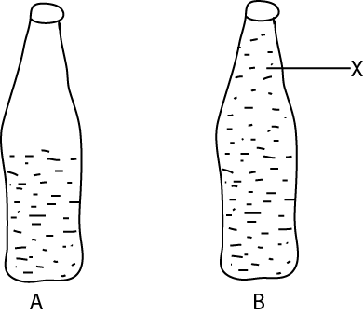

1. Name the liquid labelled X

…………………………………………………………………………………………………………………………………………………

1. Give a reason for your answer in question 21 above.

…………………………………………………………………………………………………………………………………………………

Use the diagram below to answer question 23.

6m

4m

X

Y

1. Isaac who weighs 30kg and Susan who weight 45kg sit on seesaw above, such that Isaac sits at point X and Susan at point Y. which side of the seesaw go down?

…………………………………………………………………………………………………………………………………………………

…………………………………………………………………………………………………………………………………………………

1. How does leprosy spread?

…………………………………………………………………………………………………………………………………………………

1. Apart from being a state of matter, in which way are liquids similar to gases?

………………………………………………………………………………………………………………………………………………

1. Give any one way in which a child can acquire immunity against a disease without being given a vaccine.

…………………………………………………………………………………………………………………………………………………

1. Give one example on how man uses water to produce energy.

………………………………………………………………………………………………………………………………………………

The diagram below shows an animal commonly found in the school surroundings. Use it to answer questions 28 and 29

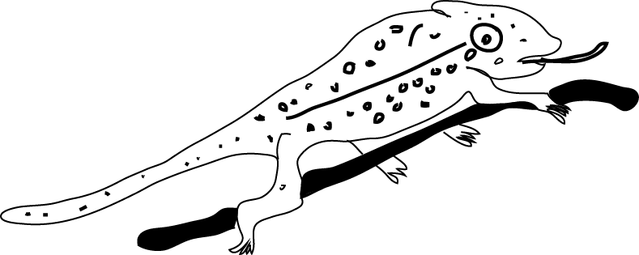

1. To which group of animals does this belong?

…………………………………………………………………………………………………………………………………………………

1. How doe the animal protects itself from its enemies?

…………………………………………………………………………………………………………………………………………………

1. What advice would you give to a mother whose child is suffering from kwashiorkor?

…………………………………………………………………………………………………………………………………………………

1. Which structure of an insect has the same function as gills in fish?

…………………………………………………………………………………………………………………………………………………

1. John threw a blanket on to a burning fire and the fire was put out. How did the blanket help in putting out the fire?

…………………………………………………………………………………………………………………………………………………

1. 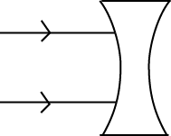Complete the rays through the lens in the diagram below.
2. Suggest one reason why blood goes to the lungs before it circulates to all parts of the body.

…………………………………………………………………………………………………………………………………………………

1. Why do electricity wires hanging on the electric pole sometimes, appear loose and other times tight?

…………………………………………………………………………………………………………………………………………………

1. Which part of the eye function like a film in a camera?

…………………………………………………………………………………………………………………………………………………

1. Which body organ is damaged when you drink a lot of alcohol?

…………………………………………………………………………………………………………………………………………………

1. Give any one reason why it is not advisable to buy and use medicine from local shops?

…………………………………………………………………………………………………………………………………………………

1. Peter’s friend is suffering from scurvy. Suggest reasons why peters friend is suffering from that disease.

…………………………………………………………………………………………………………………………………………………

1. Give any one way a farmer can improve on the local breed of cattle.

…………………………………………………………………………………………………………………………………………………

SECTION B

1. Most of our problems can be solved without use drugs. Suggest any four ways in which this can be done.

…………………………………………………………………………………………………………………………………………………

…………………………………………………………………………………………………………………………………………………

…………………………………………………………………………………………………………………………………………………

…………………………………………………………………………………………………………………………………………………

…………………………………………………………………………………………………………………………………………………

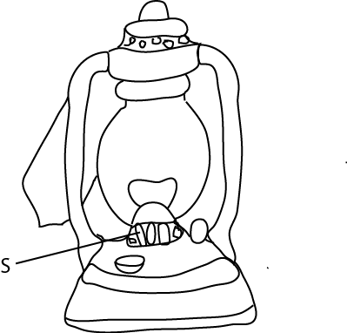Th diagram below shows a lantern lamp. Use it to answer question 42

1. (a) how does paraffin move up through the wick?

…………………………………………………………………………………………………………………………………………………

(b) Name two forms of energy produced by this lantern lamp.

……………………………………………………………………………………………………………………………………………………………………………………………………………………………………………………………………………………………………

(c) what is the use of part marked S.

…………………………………………………………………………………………………………………………………………………

1. (a) Give two ways in which you can prevent malaria in your home?

…………………………………………………………………………………………………………………………………………………

…………………………………………………………………………………………………………………………………………………

(b) Suggest two reasons why HIV/ AIDS infection tends to be more common among female adolescents than in the male adolescents?

…………………………………………………………………………………………………………………………………………………

…………………………………………………………………………………………………………………………………………………

…………………………………………………………………………………………………………………………………………………

1. The diagram below shows the beaks and feet of birds. Use it to answer the questions that follow.

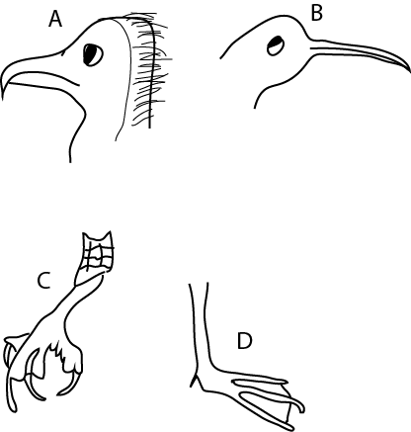

1. Suggest the type of food that part labelled A feed on.

…………………………………………………………………………………………………………………………………………………

1. How does the bird use the claw (foot) labeled C for feeding?

…………………………………………………………………………………………………………………………………………………

1. What type of food is suitable for the bird’s beak labelled B?

…………………………………………………………………………………………………………………………………………………

1. How useful is the foot labelled D to the bird?

…………………………………………………………………………………………………………………………………………………

1. (a) Give two functions of the nerves in e human body.

……………………………………………………………………………………………………………………………………………………………………………………………………………………………………………………………………………………………………

(b) In which ways is food important in the human body?

…………………………………………………………………………………………………………………………………………………

…………………………………………………………………………………………………………………………………………………

1. Give any four method commonly used to preserve meat.

…………………………………………………………………………………………………………………………………………………

…………………………………………………………………………………………………………………………………………………

…………………………………………………………………………………………………………………………………………………

…………………………………………………………………………………………………………………………………………………

1. The graph below shows the number of eggs laid on a poultry farm
2. On which day was the highest production recorded?

…………………………………………………………………………………………………………………………………………………

1. What was the average number of eggs produced per day?

…………………………………………………………………………………………………………………………………………………

1. If an egg cost shs. 100/= how much money did the farmer gat that week?

…………………………………………………………………………………………………………………………………………………

…………………………………………………………………………………………………………………………………………………

1. Suggest the problem which could have caused the low production on Monday and Tuesday?

…………………………………………………………………………………………………………………………………………………

…………………………………………………………………………………………………………………………………………………

1. (a) What is the use of fuse in a circuit?

…………………………………………………………………………………………………………………………………………………

(b) Give three reasons why a bulb of torch may not give light when the switch is on.

…………………………………………………………………………………………………………………………………………………

…………………………………………………………………………………………………………………………………………………

…………………………………………………………………………………………………………………………………………………

…………………………………………………………………………………………………………………………………………………

1. Describe an experiment to show that air has weight?
2. The diagram below shows a common instrument. Use it to answer the questions (a) to (d).

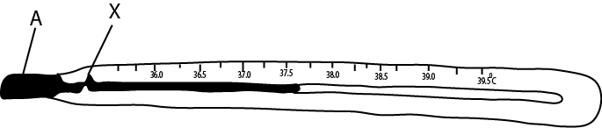

1. What is the use of the above instrument?

…………………………………………………………………………………………………………………………………………………

1. Name the liquid labelled A.

…………………………………………………………………………………………………………………………………………………

1. Why is the liquid named in (b) used in the instrument?

…………………………………………………………………………………………………………………………………………………

1. What is the importance of part marked X?

…………………………………………………………………………………………………………………………………………………

1. (a) Name three things required by leaves for the process of photosynthesis to take place.

……………………………………………………………………………………………………………………………………………………………………………………………………………………………………………………………………………………………………

…………………………………………………………………………………………………………………………………………………

…………………………………………………………………………………………………………………………………………………

(b) Give the importance of photosynthesis to the flowering plants.

…………………………………………………………………………………………………………………………………………………

1. (a) What type of immunity does a child get in each of the following
2. From mother to child.

…………………………………………………………………………………………………………………………………………………

1. After immunization

…………………………………………………………………………………………………………………………………………………

1. After suffering from a disease like measles?

…………………………………………………………………………………………………………………………………………………

(b) Why should a pregnant mother be immunized against tetanus?

…………………………………………………………………………………………………………………………………………………

1. The diagram below shows a charcoal flat iron box.

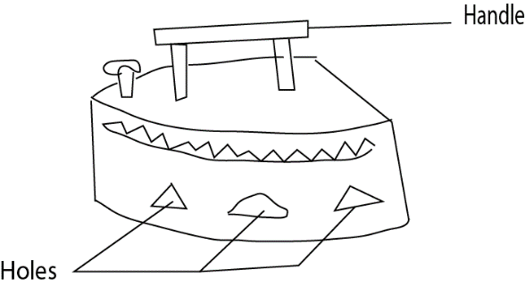

1. Why is the handle of the flat iron box made of wood?

…………………………………………………………………………………………………………………………………………………

1. State two uses of holes in that iron box.

…………………………………………………………………………………………………………………………………………………

…………………………………………………………………………………………………………………………………………………

…………………………………………………………………………………………………………………………………………………

1. How does heat from the iron box reached the user’s body?

…………………………………………………………………………………………………………………………………………………

1. The diagram below shows three metallic rings Q, P, T.

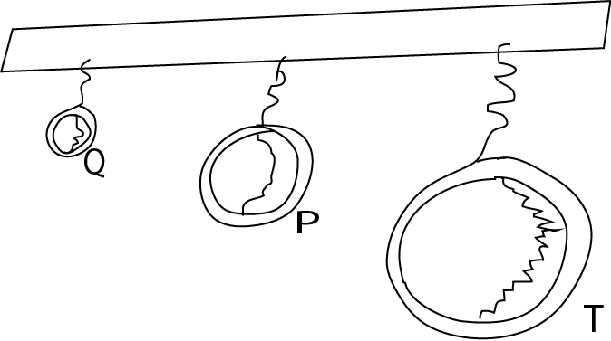

1. Which ring will produce:
2. sound of a low pitch?

…………………………………………………………………………………………………………………………………………………

1. Sound of a high pitch?

…………………………………………………………………………………………………………………………………………………

1. Name any two devices that can be used to store sound.

…………………………………………………………………………………………………………………………………………………

…………………………………………………………………………………………………………………………………………………

1. Suggest four reasons why physical exercise are important to our bodies

…………………………………………………………………………………………………………………………………………………

…………………………………………………………………………………………………………………………………………………

…………………………………………………………………………………………………………………………………………………

…………………………………………………………………………………………………………………………………………………

…………………………………………………………………………………………………………………………………………………

End