****UGANDA NATIONAL EXAMINATION BOARD

PRIMARY LEAVING EXAMINATION

Dr. Bbosa Science

Nurture your dreams

d

digitalteachrs.co.ug

**Science 2000**

Time allowed: 2hours 15 minutes

|  |  |  |  |  |  |  |  |  |
| --- | --- | --- | --- | --- | --- | --- | --- | --- |
|  |  |  |  |  |  |  |  |  |

Index No:

Candidate’s Name……………………………………………………………………………………..

Candidate’s signature…………………………………………………………………………………..

District Name…………………………………………………………………………………………………

|  |  |  |
| --- | --- | --- |
| **FOR EXAMINERS**  **USE ONLY** | | |
| **Qn. No** | **MARKS** | **EXR’S NO.** |
| **1-10** |  |  |
| **11-20** |  |  |
| **21-30** |  |  |
| **31-40** |  |  |
| **51** |  |  |
| **52** |  |  |
| **53** |  |  |
| **54** |  |  |
| **55** |  |  |
| **Total** |  |  |

Read the following instructions carefully

1. This paper has two sections **A** and **B.** Section **A** has 50 questions and section **B** has 5 questions. The paper has 15 pages following altogether.
2. Answer all questions. All answers to both sections A and B must be **written** in the spaces provided.
3. All answers must be written using a blue or black ball-point pen or ink. **Any** work written in pencil other than graphs, pictures and diagrams will **not** be marked.
4. Unnecessary change of work may lead to loss of marks.
5. Any handwriting that cannot easily be read may lead to loss to marks.
6. Do not fill anything in the boxes indicated:
7. “For examiners’. Use only and inside the question paper

©2000 Uganda National Examination board

**SCIENCE 2000**

**SECTION A**

1. Which substance can exist in all of the three states of matter?

…………………………………………………………………………………………………………………………………………………………………

…………………………………………………………………………………………………………………………………………………………………

2. How does a millipede protect it self from danger?

…………………………………………………………………………………………………………………………………………………………………

…………………………………………………………………………………………………………………………………………………………………

3. Why is a mushroom not a true plant?

…………………………………………………………………………………………………………………………………………………………………

…………………………………………………………………………………………………………………………………………………………………

4. Why are canine teeth suitable for tearing food?

…………………………………………………………………………………………………………………………………………………………………

…………………………………………………………………………………………………………………………………………………………………

5. Give one of the secondary sex characteristics that is common in both adolescent boys and girls.

…………………………………………………………………………………………………………………………………………………………………

…………………………………………………………………………………………………………………………………………………………………

6. How is the function of motor nerves different from those of sensory nerves?

…………………………………………………………………………………………………………………………………………………………………

…………………………………………………………………………………………………………………………………………………………………

7. Why is a dry season most suitable for crop harvesting?

…………………………………………………………………………………………………………………………………………………………………

…………………………………………………………………………………………………………………………………………………………………

8. What is the importance of de-beaking in poultry?

…………………………………………………………………………………………………………………………………………………………………

9. State any one sign of a dehydrated child.

…………………………………………………………………………………………………………………………………………………………………

10. In the diagram below, burning charcoal was removed stove (sigiri) and it was covered by a dry saucepan as shown. After a short time, it stopped burning.

Explain why the charcoal stopped burning

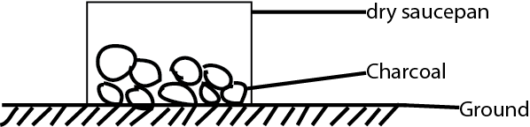

…………………………………………………………………………………………………………………………………………………………………

…………………………………………………………………………………………………………………………………………………………………

11. Give one sign you would use to identify a compound fracture.

…………………………………………………………………………………………………………………………………………………………………

…………………………………………………………………………………………………………………………………………………………………

12. Why is the spacing of children important to a family?

…………………………………………………………………………………………………………………………………………………………………

…………………………………………………………………………………………………………………………………………………………………

13. State one external physical feature one would us to identify a cock in poultry.

…………………………………………………………………………………………………………………………………………………………………

…………………………………………………………………………………………………………………………………………………………………

14. What is soil erosion?

…………………………………………………………………………………………………………………………………………………………………

…………………………………………………………………………………………………………………………………………………………………

15. Give a reason why water passes through sandy soil fastest.

…………………………………………………………………………………………………………………………………………………………………

…………………………………………………………………………………………………………………………………………………………………

16. Alex keeps his left-over food covered. why does it go bad after some time?

…………………………………………………………………………………………………………………………………………………………………

…………………………………………………………………………………………………………………………………………………………………

17. Give one main difference between plants and animals.

…………………………………………………………………………………………………………………………………………………………………

…………………………………………………………………………………………………………………………………………………………………

18. Why is carbon oxide used as a fire extinguisher?

…………………………………………………………………………………………………………………………………………………………………

…………………………………………………………………………………………………………………………………………………………………

19.Mukasa`s baby has these signs:

Very underweight

Always hungry

Pot belly

bony face

Wasted muscles

What disease is the baby likely to be suffering from?

…………………………………………………………………………………………………………………………………………………………………

20 .Beside use of seeds ,what other part of a flowering plant can used for propagation?

…………………………………………………………………………………………………………………………………………………………………

…………………………………………………………………………………………………………………………………………………………………

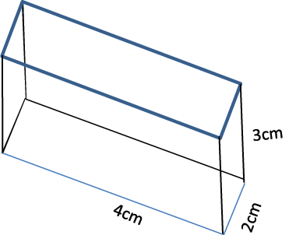21. The diagram below shows a chalk box. Find its volume.

4cm

2cm

3cm

4cm

2cm

3cm

4cm

2cm

3cm

4cm

2cm

3cm

4cm

2cm

3cm

4cm

2cm

3cm

4cm

2cm

3cm

4cm

2cm

3cm

4cm

2cm

3cm

4cm

2cm

3cm

22. State one of the characteristics of the objects that float on water.

…………………………………………………………………………………………………………………………………………………………………

…………………………………………………………………………………………………………………………………………………………………

23. Why is the moon not regard as a star?

…………………………………………………………………………………………………………………………………………………………………

…………………………………………………………………………………………………………………………………………………………………

*Study the animals given in list* ***A*** *and those* ***B*** *.Use it to answer questions 24 and 25*

A: FISH, BIRD, FROG

B: MAN, WHALE, BAT

24. How do animals in list A differ from those in B as regards reproduction?

…………………………………………………………………………………………………………………………………………………………………

…………………………………………………………………………………………………………………………………………………………………

25. How are animals in list **A** similar to those in list **B?**

…………………………………………………………………………………………………………………………………………………………………

…………………………………………………………………………………………………………………………………………………………………

26. What is the source of energy in thermal electricity?

…………………………………………………………………………………………………………………………………………………………………

…………………………………………………………………………………………………………………………………………………………………

27. Give one way in which friction is useful to a person riding a bicycle.

…………………………………………………………………………………………………………………………………………………………………

…………………………………………………………………………………………………………………………………………………………………

28. Josephine could only read her notes when the book was at a distance of not more than one metre from her eyes. What advice would you give Josephine?

…………………………………………………………………………………………………………………………………………………………………

…………………………………………………………………………………………………………………………………………………………………

29. in the diagram ,Moses is pulling a load the ground surface ,as shown below.

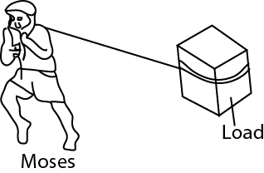

How could Moses make his work easier?

…………………………………………………………………………………………………………………………………………………………………

…………………………………………………………………………………………………………………………………………………………………

30. What is the First Aid for high fever?

…………………………………………………………………………………………………………………………………………………………………

…………………………………………………………………………………………………………………………………………………………………

31. In terms of machines ,how is the hammer similar to the human arm?

…………………………………………………………………………………………………………………………………………………………………

…………………………………………………………………………………………………………………………………………………………………

32. What should be done to a clinical thermometer before taking the temperature of a person?

…………………………………………………………………………………………………………………………………………………………………

…………………………………………………………………………………………………………………………………………………………………

33. How can a child acquire artificial immunity?

…………………………………………………………………………………………………………………………………………………………………

…………………………………………………………………………………………………………………………………………………………………

34. How does a vent help to reduce smell in a VIP latrine?

…………………………………………………………………………………………………………………………………………………………………

…………………………………………………………………………………………………………………………………………………………………

35. What is one possible danger of buying drugs from local shops or markers?

…………………………………………………………………………………………………………………………………………………………………

36. What is near drowning?

…………………………………………………………………………………………………………………………………………………………………

…………………………………………………………………………………………………………………………………………………………………

37. What feature enables a housefly to spread germs?

…………………………………………………………………………………………………………………………………………………………………

…………………………………………………………………………………………………………………………………………………………………

38. Why is budgeting in a family useful?

…………………………………………………………………………………………………………………………………………………………………

…………………………………………………………………………………………………………………………………………………………………

39. Give one example where bacteria are useful to man .

…………………………………………………………………………………………………………………………………………………………………

…………………………………………………………………………………………………………………………………………………………………

40. In the space below ,draw a diagram to show self –pollination in a flower.

**SECTION B**

(a) Give two characteristics of insect pollinated flowers.

(i)………………………………………………………………………………………………………………………………………………………………

(ii)………………………………………………………………………………………………………………………………………………………………

(b) Why is a moth able to pollinate plants at night?

…………………………………………………………………………………………………………………………………………………………………

…………………………………………………………………………………………………………………………………………………………………

(c ) State the difference between self-pollination and cross –pollination .

…………………………………………………………………………………………………………………………………………………………………

…………………………………………………………………………………………………………………………………………………………………

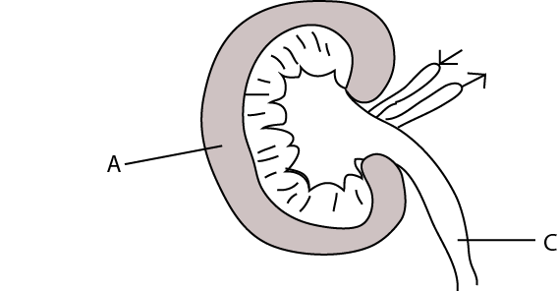42. The diagram below shows the structure of a kidney. Use it to answer question (a) and (b)

(a) Name the part labelled with letter A.

…………………………………………………………………………………………………………………………………………………………………

…………………………………………………………………………………………………………………………………………………………………

(b) What substance goes through the part lebelled **C**?

…………………………………………………………………………………………………………………………………………………………………

(c ) state any two function of the kidney that are similar to those of a skin.

(i)……………………………………………………………………………………………………………………………………………………………

…………………………………………………………………………………………………………………………………………………………………

(ii)………………………………………………………………………………………………………………………………………………………………

…………………………………………………………………………………………………………………………………………………………………

43.(a)state any one characteristics of social insects.

…………………………………………………………………………………………………………………………………………………………………

…………………………………………………………………………………………………………………………………………………………………

(b) Give any two characteristics of flowers which attract bees to visit them.

…………………………………………………………………………………………………………………………………………………………………

…………………………………………………………………………………………………………………………………………………………………

(c ) Why is a worker bees not able to reproduce?

…………………………………………………………………………………………………………………………………………………………………

…………………………………………………………………………………………………………………………………………………………………

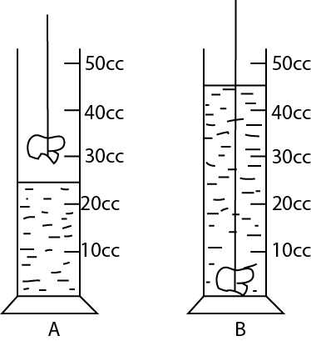44. The diagram below is a method of measuring an irregular object .study it and answer question tha t follow.

(a) Calculate the volume of the stone.

(b) Name the method used to find the volume.

…………………………………………………………………………………………………………………………………………………………………

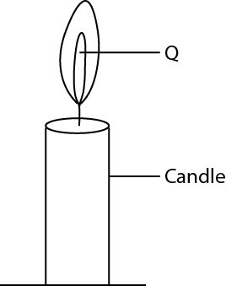45. The diagram below is of a burning candle. Use it to answer question(a) and (b)

(a) What two forms of energy are given off at Q?

(i)……………………………………………………………………………………………………………………………………………………………

(ii)………………………………………………………………………………………………………………………………………………………………

(b) What gas is supporting the process?

…………………………………………………………………………………………………………………………………………………………………

(c ) What other process in living thing produces the same gas as the candle?

…………………………………………………………………………………………………………………………………………………………………

46. Use the list of food stuffs given below and answer the following questions.

**BEANS, RICE, CABBAGE, MILK,ORANGES.**

(a) Give two food stuffs that are a source of proteins.

(i)…………………………………………………………………… (ii)……………………………………………………………………………

(b) How are cabbages useful in one`s diet?

…………………………………………………………………………………………………………………………………………………………………

…………………………………………………………………………………………………………………………………………………………………

(c ) Why would you regard a list of the foods given above a balanced diet?

…………………………………………………………………………………………………………………………………………………………………

…………………………………………………………………………………………………………………………………………………………………

47. In the diagram below, when the nail was brought nearer to the magnet it was attracted as shown. use the diagram to answer questions (a) to (d) below.

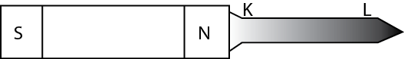

image

(a) How does the nail get magnetized?

…………………………………………………………………………………………………………………………………………………………………

…………………………………………………………………………………………………………………………………………………………………

(b) Name the pole marked **L.**

…………………………………………………………………………………………………………………………………………………………………

(c ) which other method can be used to magnetise the nail without using a magnet?

…………………………………………………………………………………………………………………………………………………………………

(d ) Name the type of a magnet in (c )

…………………………………………………………………………………………………………………………………………………………………

………………………………………………………………………………………………………………………………………………………………

48. (a) What is the use of First Aid box?

…………………………………………………………………………………………………………………………………………………………………

…………………………………………………………………………………………………………………………………………………………………

(b) What is meant by drug abuse?

…………………………………………………………………………………………………………………………………………………………………

…………………………………………………………………………………………………………………………………………………………………

(c ) Give any two pieces of advice to a person who is on drug abuse.

(i)……………………………………………………………………………………………………………………………………………………………

(ii)………………………………………………………………………………………………………………………………………………………………

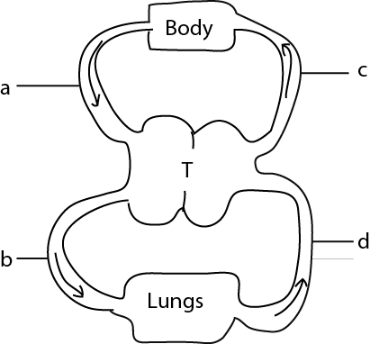49. The diagram below is an illustration of a blood circulation system in a mammal. Study it carefully and use it to answer questions (a) and (b) below.

1. What body organ does part T represent?

…………………………………………………………………………………………………………………………………………………………………

1. What is the difference in the blood carried by blood vessels marked b and c.

…………………………………………………………………………………………………………………………………………………………………

…………………………………………………………………………………………………………………………………………………………………

1. Give the difference between an artery and a vein.

…………………………………………………………………………………………………………………………………………………………………

…………………………………………………………………………………………………………………………………………………………………

50.Complete the table below which shows some disease and how they are spread among people

|  |  |
| --- | --- |
| **Disease** | **How it is spread** |
| Gonorrhea | (i)…………………………………………………………………….  ………………………………………………………………………. |
| (ii)…………………………………… | Infected dog bite |
| Tetanus | (iii)………………………………………………………………  ………………………………………………………………….. |
| (iv)………………………………… | Though air by coughing |

51.(a) What first aid will you give to an accident victim?

…………………………………………………………………………………………………………………………………………………………………

…………………………………………………………………………………………………………………………………………………………………

(b) Explain how you will administer first aid nose bleeding.

(i)……………………………………………………………………………………………………………………………………………………………

…………………………………………………………………………………………………………………………………………………………………

(ii)………………………………………………………………………………………………………………………………………………………………

…………………………………………………………………………………………………………………………………………………………………

(iii)……………………………………………………………………………………………………………………………………………………………

…………………………………………………………………………………………………………………………………………………………………

52. (a) Name two agent of soil erosion.

(i)………………………………………………………………………………………………………………………………………………………………

(ii)………………………………………………………………………………………………………………………………………………………………

(b) How does trees stop soil erosion?

…………………………………………………………………………………………………………………………………………………………………

…………………………………………………………………………………………………………………………………………………………………

(c ) How does tree-cutting in an area lead to soil erosion?

…………………………………………………………………………………………………………………………………………………………………

…………………………………………………………………………………………………………………………………………………………………

53. (a) What is water pollution?

…………………………………………………………………………………………………………………………………………………………………

…………………………………………………………………………………………………………………………………………………………………

(b) Suggest any two ways in which a community can improve on water source.

(i)……………………………………………………………………………………………………………………………………………………………

…………………………………………………………………………………………………………………………………………………………………

(ii)………………………………………………………………………………………………………………………………………………………………

…………………………………………………………………………………………………………………………………………………………………

(c ) Why is borehole water safer to drink than well water?

…………………………………………………………………………………………………………………………………………………………………

…………………………………………………………………………………………………………………………………………………………………

54. Suggest any two methods that can promote the idea of PHC in a school.

(i)………………………………………………………………………………………………………………………………………………………………

…………………………………………………………………………………………………………………………………………………………………

(ii)………………………………………………………………………………………………………………………………………………………………

…………………………………………………………………………………………………………………………………………………………………

(b) What element is promoted in PHC?

…………………………………………………………………………………………………………………………………………………………………

…………………………………………………………………………………………………………………………………………………………………

(c ) identify any two activities that committees should do in your village.

(i)……………………………………………………………………………………………………………………………………………………………

(ii)………………………………………………………………………………………………………………………………………………………………

55. the table below shoes part of child`s immunization card .use it to answer question (a) to (d) below

|  |  |  |  |
| --- | --- | --- | --- |
|  | 1 2 3 | | |
| BCG  POLIO  DPT  MEASLES | 12/8/88  11/8/88  11/8/88  9/5/89 | 16/12/88  16/12/88 | 13/01/89  13/01/89 |
| **COMPLETED** | |

(a) When was this child born? …………………………………………………………………………………………………………………………………………………………………

(b) Give a reason to support your answer in (a) above

…………………………………………………………………………………………………………………………………………………………………

…………………………………………………………………………………………………………………………………………………………………

(c ) At what age was the immunization completed?

…………………………………………………………………………………………………………………………………………………………………

(d)Give a reason for your answer in (c ) above

**END**