****UGANDA NATIONAL EXAMINATION BOARD

PRIMARY LEAVING EXAMINATION

Dr. Bbosa Science

Nurture your dreams

d

digitalteachrs.co.ug

**Science 2001**

Time allowed: 2hours 15 minutes

|  |  |  |  |  |  |  |  |  |
| --- | --- | --- | --- | --- | --- | --- | --- | --- |
|  |  |  |  |  |  |  |  |  |

Index No:

Candidate’s Name……………………………………………………………………………………..

Candidate’s signature…………………………………………………………………………………..

District Name…………………………………………………………………………………………………

|  |  |  |
| --- | --- | --- |
| **FOR EXAMINERS**  **USE ONLY** | | |
| **Qn. No** | **MARKS** | **EXR’S NO.** |
| **1-10** |  |  |
| **11-20** |  |  |
| **21-30** |  |  |
| **31-40** |  |  |
| **51** |  |  |
| **52** |  |  |
| **53** |  |  |
| **54** |  |  |
| **55** |  |  |
| **Total** |  |  |

Read the following instructions carefully

1. This paper has two sections **A** and **B.** Section **A** has 50 questions and section **B** has 5 questions. The paper has 15 pages following altogether.
2. Answer all questions. All answers to both sections A and B must be **written** in the spaces provided.
3. All answers must be written using a blue or black ball-point pen or ink. **Any** work written in pencil other than graphs, pictures and diagrams will **not** be marked.
4. Unnecessary change of work may lead to loss of marks.
5. Any handwriting that cannot easily be read may lead to loss to marks.
6. Do not fill anything in the boxes indicated:
7. “For examiners’. Use only and inside the question paper

©2001 Uganda National Examination board

**Science 2001**

**Section A**

1. Why is a hoe regarded as a simple machine?

…………………………………………………………………………………………………………………………………………………………………

2. How can you increase milk production in a dairy cow?

…………………………………………………………………………………………………………………………………………………………………

………………………………………………………………………………………………………………………………………………………………..

3. Give the function of teeth in the process of digestion.

…………………………………………………………………………………………………………………………………………………………………

………………………………………………………………………………………………………………………………………………………………..

4. What disease is likely to attack children whose diet lacks proteins?

…………………………………………………………………………………………………………………………………………………………………

………………………………………………………………………………………………………………………………………………………………..

5. How can you assist a person who has a foreign body in the ear?

…………………………………………………………………………………………………………………………………………………………………

………………………………………………………………………………………………………………………………………………………………..

6. The razor blade was left outside for a night in the morning it had rusted. What made a razor blade to rust?

…………………………………………………………………………………………………………………………………………………………………

………………………………………………………………………………………………………………………………………………………………..

7. How does the life history of the cockroach differ from that of a butterfly?

…………………………………………………………………………………………………………………………………………………………………

………………………………………………………………………………………………………………………………………………………………..

8. Suggest one possible reason why immunization of children is emphasized in Uganda.

…………………………………………………………………………………………………………………………………………………………………

9. Why is dew formed at night?

…………………………………………………………………………………………………………………………………………………………………

………………………………………………………………………………………………………………………………………………………………..

10. What can be done to lower the temperature of a person with high fever?

…………………………………………………………………………………………………………………………………………………………………

……………………………………………………………………………………………………………………………………………………………….

11. How does paraffin which is poured over stagnant water kill mosquito larva?

…………………………………………………………………………………………………………………………………………………………………

………………………………………………………………………………………………………………………………………………………………..

12. Give any one use of leaves to a plant.

…………………………………………………………………………………………………………………………………………………………………

………………………………………………………………………………………………………………………………………………………………..

13. How do road builders increase friction on the surface of the road?

…………………………………………………………………………………………………………………………………………………………………

………………………………………………………………………………………………………………………………………………………………..

14. Give any bone activity that a teacher can do during a health parade in a school to promote health

…………………………………………………………………………………………………………………………………………………………………

………………………………………………………………………………………………………………………………………………………………..

15. Why does smoke go up when firewood is burning?

…………………………………………………………………………………………………………………………………………………………………

………………………………………………………………………………………………………………………………………………………………..

16. which part of the blood helps in the clotting of blood?

…………………………………………………………………………………………………………………………………………………………………

………………………………………………………………………………………………………………………………………………………………..

17. Why is mulching a good practice to as human growers?

…………………………………………………………………………………………………………………………………………………………………

………………………………………………………………………………………………………………………………………………………………..

18. Why is it necessary to brush teeth after every meal?

…………………………………………………………………………………………………………………………………………………………………

………………………………………………………………………………………………………………………………………………………………..

19. Why does a chameleon change the colour of its body?

…………………………………………………………………………………………………………………………………………………………………

………………………………………………………………………………………………………………………………………………………………..

20 How is the retina of human eye similar n to the firm of a camera?

…………………………………………………………………………………………………………………………………………………………………

………………………………………………………………………………………………………………………………………………………………..

21 How are seeds of a mango dispersed?

…………………………………………………………………………………………………………………………………………………………………

………………………………………………………………………………………………………………………………………………………………..

22. Which method would you use to find the value of an irregular object.

…………………………………………………………………………………………………………………………………………………………………

………………………………………………………………………………………………………………………………………………………………..

23How is the respiration of a tadpole similar to that of a fish?

…………………………………………………………………………………………………………………………………………………………………

………………………………………………………………………………………………………………………………………………………………..

24. Peter water put gout fire caused by petrol but the continued Burning. suggest one thing he should have used to put off the fire.

…………………………………………………………………………………………………………………………………………………………………

………………………………………………………………………………………………………………………………………………………………..

25. Musa sis log –sighted. draw the type of lens he should use to correct his eye problem.

26. Give anyone reason which shows that animals and plants depend on each other.

…………………………………………………………………………………………………………………………………………………………………

…………………………………………………………………………………………………………………………………………………………………

27. Why is it difficult to control poultry disease in free-range system?

…………………………………………………………………………………………………………………………………………………………………

…………………………………………………………………………………………………………………………………………………………………

28. How does a tortoise protect itself against its enemies?

…………………………………………………………………………………………………………………………………………………………………

…………………………………………………………………………………………………………………………………………………………………

29. Why are bacteria in rotting rubbish very useful to man?

…………………………………………………………………………………………………………………………………………………………………

…………………………………………………………………………………………………………………………………………………………………

30. Give one reason why mercury is used in thermometers instead of water.

…………………………………………………………………………………………………………………………………………………………………

…………………………………………………………………………………………………………………………………………………………………

31. Give the difference between freezing and condensation.

…………………………………………………………………………………………………………………………………………………………………

…………………………………………………………………………………………………………………………………………………………………

32. Give the difference between the way man and insects breathe.

…………………………………………………………………………………………………………………………………………………………………

…………………………………………………………………………………………………………………………………………………………………

33. When it is said that Badru is anemic, what is lacking in his blood?

…………………………………………………………………………………………………………………………………………………………………

…………………………………………………………………………………………………………………………………………………………………

34. State one disease that both a passive and active smokers may suffer from.

…………………………………………………………………………………………………………………………………………………………………

…………………………………………………………………………………………………………………………………………………………………

35. Why does blood go to the lungs before it is pumped to all parts of the body?

…………………………………………………………………………………………………………………………………………………………………

…………………………………………………………………………………………………………………………………………………………………

36. Find the density of an object whose mass is 10g and volume is 5cm3

37. Give one reason why a bat is a mammal not a bird.

…………………………………………………………………………………………………………………………………………………………………

…………………………………………………………………………………………………………………………………………………………………

38. Give one way in which the sun is important to plants.

…………………………………………………………………………………………………………………………………………………………………

…………………………………………………………………………………………………………………………………………………………………

39. Give one reason why drugs should be prescribed by health worker before they are used by sick people.

…………………………………………………………………………………………………………………………………………………………………

…………………………………………………………………………………………………………………………………………………………………

40. How is an echo similar to an image?

…………………………………………………………………………………………………………………………………………………………………

…………………………………………………………………………………………………………………………………………………………………

**SECTION B**

41. (a) give any two reasons why school gardens are important

(b) give any two reasons why you m=need to keep school farm records

42. nails were placed in water as indicated below for one week .us the information to answer to answer the question that follow.

-Nail 1 was painted

-Nail 2 was not painted

-Nail 3 was greased.

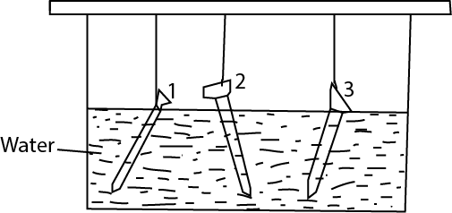

(a) Which of the nails above have changed its colour overnight?

…………………………………………………………………………………………………………………………………………………………………

…………………………………………………………………………………………………………………………………………………………………

(b) What will grease do in nail 3 above?

…………………………………………………………………………………………………………………………………………………………………

………………………………………………………………………………………………………………………………………………………………..

(c ) Why are metal object painted?

…………………………………………………………………………………………………………………………………………………………………

………………………………………………………………………………………………………………………………………………………………..

(d) Which nails will remain unaffected?

…………………………………………………………………………………………………………………………………………………………………

43. (a) If you put a saucepan of water on fire, how does heat travel by convection to make the water boil?

…………………………………………………………………………………………………………………………………………………………………

………………………………………………………………………………………………………………………………………………………………..

(b) State three ways through which convection currents help to improve our environment.

(i)……………………………………………………………………………………………………………………………………………………………

(ii)……………………………………………………………………………………………………………………………………………………………..

(iii)……………………………………………………………………………………………………………………………………………………………

44. Some diseases can be treated without the use of drugs.

…………………………………………………………………………………………………………………………………………………………………

………………………………………………………………………………………………………………………………………………………………..

(a) Give an example of such a disease.

…………………………………………………………………………………………………………………………………………………………………

(b) How would you treat the disease you have named in (a) above?

…………………………………………………………………………………………………………………………………………………………………

………………………………………………………………………………………………………………………………………………………………..

(c ) What do you understand by essential drugs?

…………………………………………………………………………………………………………………………………………………………………

………………………………………………………………………………………………………………………………………………………………..

(d) Give one reason why it is not advisable for two patients to share drugs presented for one person.

…………………………………………………………………………………………………………………………………………………………………

………………………………………………………………………………………………………………………………………………………………..

**The diagram below shows a lever which is balanced .us it to answer question 45.**

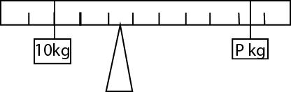

45. The diagram shows a lever which is balanced, calculate the weight of **P.**

46. (a) In which part of the pant does photosynthesis mainly take place?

…………………………………………………………………………………………………………………………………………………………………

(b) Name two raw materials which enable photosynthesis to take place

(i)……………………………………………………………………………………………………………………………………………………………

(ii)……………………………………………………………………………………………………………………………………………………………..

(c )Give the difference between photosynthesis and transpiration.

…………………………………………………………………………………………………………………………………………………………………

………………………………………………………………………………………………………………………………………………………………..

47. (a) Why is it important to feel the pulse (heart beat) of a seriously injured victim of an accident?

…………………………………………………………………………………………………………………………………………………………………

………………………………………………………………………………………………………………………………………………………………..

(b) What can a small boy or girl do when his or her older sister falls into water?

…………………………………………………………………………………………………………………………………………………………………

………………………………………………………………………………………………………………………………………………………………..

(c ) Why is it dangerous to cause a victim who has swallows paraffin to vomit it ?

…………………………………………………………………………………………………………………………………………………………………

………………………………………………………………………………………………………………………………………………………………..

(d) Why is First Aid given?

…………………………………………………………………………………………………………………………………………………………………

………………………………………………………………………………………………………………………………………………………………..

48. (a) How can you tell by looking at the roots ,that a plant is a legume?

…………………………………………………………………………………………………………………………………………………………………

………………………………………………………………………………………………………………………………………………………………..

(b)Give any two examples of crops which are legumes.

(i)………………………………………………………………………………………………………………………………………………………………

(ii)……………………………………………………………………………………………………………………………………………………………..

(c ) How do legumes increase the fertility of the soil?

…………………………………………………………………………………………………………………………………………………………………

………………………………………………………………………………………………………………………………………………………………..

49. Use the diagram of the machine below to answer the question that follow.

Image

(a) What is the name of such a machine?

…………………………………………………………………………………………………………………………………………………………………

………………………………………………………………………………………………………………………………………………………………..

(b) What class is it?

…………………………………………………………………………………………………………………………………………………………………

………………………………………………………………………………………………………………………………………………………………..

(c ) Use letter e to show effort on the diagram.

(d) Which important activity in school is done using this machines?

…………………………………………………………………………………………………………………………………………………………………

50. (a) Give any one example of fungi.

…………………………………………………………………………………………………………………………………………………………………

………………………………………………………………………………………………………………………………………………………………..

(b) How do fungi reproduce?

…………………………………………………………………………………………………………………………………………………………………

………………………………………………………………………………………………………………………………………………………………..

(c )Give one way in which fungi are different from ferns

…………………………………………………………………………………………………………………………………………………………………

………………………………………………………………………………………………………………………………………………………………..

51.(a) What enables a drum to produce sound when it is hit with a stick?

…………………………………………………………………………………………………………………………………………………………………

………………………………………………………………………………………………………………………………………………………………..

(b) Give a clear example that shows that light travels faster than sound.

…………………………………………………………………………………………………………………………………………………………………

………………………………………………………………………………………………………………………………………………………………..

(c ) State two ways in which sound can be stored.

(i)………………………………………………………………………………………………………………………………………………………………

(ii)……………………………………………………………………………………………………………………………………………………………..

52.The diagram below is of an experiment performed in a class .study it and answer the question that follow.

Image

(a) What natural process in he environment does this experiment show?

…………………………………………………………………………………………………………………………………………………………………

………………………………………………………………………………………………………………………………………………………………..

(b) What does a stove (sigiri) represent in the process?

…………………………………………………………………………………………………………………………………………………………………

………………………………………………………………………………………………………………………………………………………………..

52.The diagram below is of an experiment performed in a class. study it and answer the question that follow.

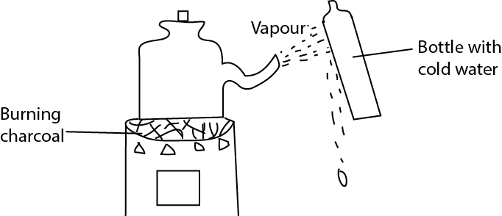

(a) What natural process in he environment does this experiment show?

…………………………………………………………………………………………………………………………………………………………………

………………………………………………………………………………………………………………………………………………………………..

1. What does a stove (sigiri) represent in the process?

…………………………………………………………………………………………………………………………………………………………………

1. ………………………………………………………………………………………………………………………………………………………………..
2. What is the function of the bottle with cold water?

**Condenses the steam to water**

1. Give any other local process that takes place in the same way.

**Distillation**

46. The diagram below are of three pests. Use them to answer questions (a) and (b) below.

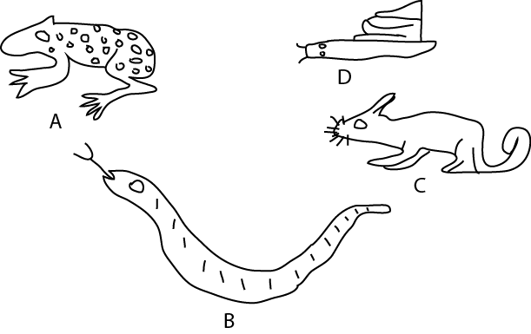

1. in which way are animals A, B and C similar?
2. How is the reproduction in animals C different from that of the other animals?
3. To which animals does animal A belong?
4. How does animal D protect itself against its enemies?

54. Draw a diagram showing how a shadow is formed. Label

Draw a diagram showing how a shadow is formed .label your diagram correctly