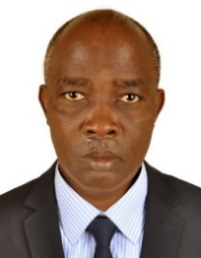**UGANDA NATIONAL EXAMINATION BOARD**

**PRIMARY LEAVING EXAMINATION**

Dr. Bbosa Science

Nurture your dreams

d

digitalteachrs.co.ug

**2003**

**MATHEMATICS**

**Time allowed: 2hours 30 minutes**

|  |  |  |  |  |  |  |  |  |
| --- | --- | --- | --- | --- | --- | --- | --- | --- |
|  |  |  |  |  |  |  |  |  |

**Index No:**

**Candidate’s Name……………………………………………………………………………………..**

**Candidate’s signature…………………………………………………………………………………..**

**District Name…………………………………………………………………………………………………**

|  |  |  |
| --- | --- | --- |
| **FOR EXAMINERS**  **USE ONLY** | | |
| **Qn.No** | **MARKS** | **EXR’S NO.** |
| **1-5** |  |  |
| **6-10** |  |  |
| **11-15** |  |  |
| **16-20** |  |  |
| **21-22** |  |  |
| **23-24** |  |  |
| **25-26** |  |  |
| **27-28** |  |  |
| **29-30** |  |  |
| **31-32** |  |  |
| **TOTAL** |  |  |

**Read the following instructions carefully**

**Read the following instructions carefully**

1. **This paper has two sections A and B.**
2. **All the working. For both section A and B must be shown in the spaces provided**
3. **All working must be done using a blue or black ball**

**Point pen or fountain pen Diagram should be drawn in pencil**

1. **No calculators are allowed in the examination room.**
2. **Unnecessary change of work may lead to loss of marks**
3. **Any hand writing that cannot easily be read may lead to loss of marks**
4. **Do not fill anything in the boxes indicated:**

**“For examiners use only”. And those inside the question paper**

**©2012 Uganda National Examination board**

**Turn over**

**SECTION A**

1. What kind of change take place when ice melts to form water?

Physical change (because it is reversible)

2. Give any one reason why farmers prefer keeping cross-breed cattle other than the exotic ones.

To increase resistance to disease

***The diagram below is of a simple machine. use it to answer questions 3 and 4***

Effort

Effort

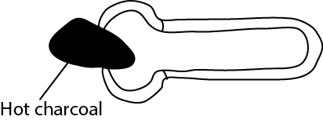

3. Indicate with letter E the position of the effort.

4. What class of lever is this machine?

Third class level

5. What is the importance of leaves to a plant?

For photosynthesis

For transpiration

For vegetative reproduction

Some have tendrils for support

Leaves have stomata for gaseous exchange

6. In which way is the breathing of crocodile different from that of a fish?

Crocodile breath through lungs while fish breathe through gills

7. The same amount of oil and water were poured into the container shown in A below beginning with oil and then water. When the container was checked after sometime, oil was found on top of the water as shown in B. Use the diagram to answer the question that follow:

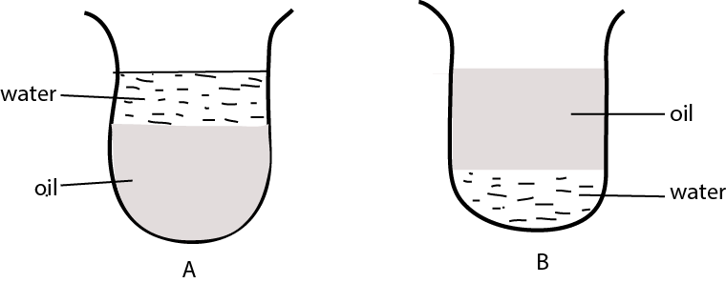

Why did oil come on top of the water?

Oil is less dense than water or water is denser than oil

8. Why is it a bad habit to cut finger nails using teeth?

A person may transmit germs to the mouth

9. Give any one problem that may be faced by a school girl who becomes pregnant.

- pregnant girls are forced out of school

- pregnant girl may experience obstructed labour

- the girls may not be able to look after her baby after giving birth due to lack of money.

- she may be tempted to abort

10. Give any one reason why a latrine should be 10 metres away from the living house.

To prevent flies from carrying germs to the house

11. Give any one practice in a home that would help in the control of malaria

- sleeping in insecticide treated nets

- draining stagnant water

- slashing around the house

- spraying with insecticide

12 Apart from teeth, which other weapon does a dog use for protection?

Sharp claws/ nail

13. What is the duty of the queen bee in a hive?

To lay eggs

15. How are animals different from plants in the way they get food?

Plants make their own food whereas animals feed on food manufactured by the plant

16. Give any one reason why a patient should take a drug only when it is prescribed by a medical person.

- to prevent taking a wrong drug

- to prevent taking wrong doses

- to prevent taking overdose

- to prevent taking drugs at wrong time

17. State any one agent responsible for dispersing mango seeds

Animals

bird

18. In the space below, draw an example of a compound fracture

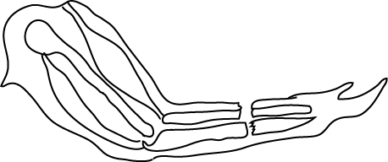

NB: compound fracture has more than one bone broken and the tissue torn

19. Whenever Bbosa runs on a sunny day, he sweats. What is the importance of sweeting to his body?

Evaporation of sweat cools the body

20. The below shows a pin-hole camera with an object. The image been left out. Complete the diagram drawing the image in the pin-hole camera.

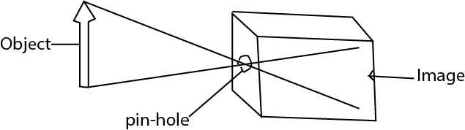

21. Which organ in your body helps you to find out whether something in sweet or bitter?

Tongue

22. Give the general name of blood vessels which carry blood away from the heart to various parts of the body.

Arteries

23. Give any one use of cow-dung to farmers.

- for making manure

- for making biogas

24. Give any one reason why it is not advisable to breath through the mouth.

You may take germs because the air is not filtered by air and mucus in the nose

25. Why does blood go to the kidneys during circulation?

To remove metabolic wastes and excess water

26. At what time of the day are shadows shortest?

At noon or midday

27. Why do tyres of cars wear out more quickly on tarmac roads than marram roads?

Tarmac roads have high friction than marram roads

28. Give any one other system of poultry farming, apart from a free –range system.

Deep litter system

Fold pen system

Battery system

29. In which class of animals do you put a tortoise and as lizard?

Reptiles

30. Our school pit latrine smells a lot and is always full of flies. What measures can we take to prevent this situation?

Put on a vent pipe

Smoking it

Disinfect it

**Susan shouted loudly in a big house ,as she shouted ,she heard another similar sound.**

***Answer the questions 31 and 32 using this information***.

31. Give the name of the similar sound Susan heard after shouting.

Echo

32. How was the sound you have named in question 31 formed?

Due to reflection of sound waves

33. Give any one factor to be considered when choosing a site to build a home, apart from security, raised nearness to the main road and availability of water.

Availability of money

Availability of building materials

34. Give any one state of matter.

Solid, liquid, gas

35. Why is transpiration important in green plants

To lose excess water

To cool the plant

36. State any one effect of air pollution on people.

Lead to formation of acid rain

Leads to suffocation

Leads to heart attack

37. **In the diagram below a candle was burning as shown in A then it was covered with a tin as shown in B. after sometimes the candle stopped burning.**

***Use the diagram to answer the question below***

**A**

**B**

Tin

Candle

Candle

Flame

Why did the candle flame in B go off after sometime?

Because oxygen is used up

38. Give any one function of a spinal cord in human body.

Connects peripheral nervous system with the brain

Conducts impulse between the brain and rest of body

39. What type of energy do you have when you are seated in the class?

Potential energy

40. Suggest one reason why an individual should promote personal hygiene?

- prevent spread of diseases

- to get rid of diseases

- to look smart

**SECTION B**

41. (a) What is a crop pest?

……………………………………………………………………………………………………………………………………………………………………………………………………………………………………………………………………………………………………………………………………

(b) Give any one example of a crop pest.

……………………………………………………………………………………………………………………………………………………………………………………………………………………………………………………………………………………………………………………………………

(c ) Apart from spraying with chemical, give other two ways of controlling crop pests.

(i)…………………………………………………………………………………………………………………………………………………………………………………………………………………………………………………………………………………………………………………………………

(ii)…………………………………………………………………………………………………………………………………………………………………………………………………………………………………………………………………………………………………………………………………

42.(a)Give any one habit that may lead a person to catch AIDS

……………………………………………………………………………………………………………………………………………………………………………………………………………………………………………………………………………………………………………………………………

(b) Suggest the best way of controlling the spread of AIDS.

……………………………………………………………………………………………………………………………………………………………………………………………………………………………………………………………………………………………………………………………………

(c ) Give any two sign that shows that n individual is suffering from AIDS.

……………………………………………………………………………………………………………………………………………………………………………………………………………………………………………………………………………………………………………………………………

43. (a) What is the use of a clinical thermometer?

……………………………………………………………………………………………………………………………………………………………………………………………………………………………………………………………………………………………………………………………………

(b) Give any one reason why there is a bend in the tube of a clinical thermometers.

……………………………………………………………………………………………………………………………………………………………………………………………………………………………………………………………………………………………………………………………………

(c) Which liquid is mainly used in thermometers?

……………………………………………………………………………………………………………………………………………………………………………………………………………………………………………………………………………………………………………………………………

(d) Why is the liquid you have named used instead of other liquids?

……………………………………………………………………………………………………………………………………………………………………………………………………………………………………………………………………………………………………………………………………

44. (a)Name any one disease that is immunized against at birth.

……………………………………………………………………………………………………………………………………………………………………………………………………………………………………………………………………………………………………………………………………

(b) Which site on the body is measles immunization usually given?

……………………………………………………………………………………………………………………………………………………………………………………………………………………………………………………………………………………………………………………………………

(c ) Why are pregnant women immunized against tetanus?

……………………………………………………………………………………………………………………………………………………………………………………………………………………………………………………………………………………………………………………………………

(d) How does tetanus get into our bodies?

……………………………………………………………………………………………………………………………………………………………………………………………………………………………………………………………………………………………………………………………………

45. (a)Give one process in plants in which:

(i) oxygen is used,

……………………………………………………………………………………………………………………………………………………………

(ii) carbon dioxide is used.

…………………………………………………………………………………………………………………………………………………………………

(b) What useful by-product in (a) above?

……………………………………………………………………………………………………………………………………………………………………………………………………………………………………………………………………………………………………………………………………

(c ) Give any other natural process that uses oxygen

……………………………………………………………………………………………………………………………………………………………………………………………………………………………………………………………………………………………………………………………………

46. show the difference between the first class lever and the second –class lever by drawing and labeling the two diagrams.

(a) First –class lever

(b) Second –class lever

47. In which one way is the function of the skin similar to that of lungs?

……………………………………………………………………………………………………………………………………………………………………………………………………………………………………………………………………………………………………………………………………

(b) Give an example of a practice which will prevent the skin to function properly.

……………………………………………………………………………………………………………………………………………………………………………………………………………………………………………………………………………………………………………………………………

(c) Suggest any two ways in which the proper functioning of the skins can be promoted.

(i)…………………………………………………………………………………………………………………………………………………………………………………………………………………………………………………………………………………………………………………………………

(ii)…………………………………………………………………………………………………………………………………………………………………………………………………………………………………………………………………………………………………………………………………

48 (a) Give one two reasons for preserving meat

(i)…………………………………………………………………………………………………………………………………………………………………………………………………………………………………………………………………………………………………………………………………

(ii)…………………………………………………………………………………………………………………………………………………………………………………………………………………………………………………………………………………………………………………………………

(b) Give any traditional way of preserving fish in Uganda

…………………………………………………………………………………………………………………………………………………………………………………………………………………………………………………………………………………………………………………………………

(c) Give one modern way of preserving meat.

…………………………………………………………………………………………………………………………………………………………………………………………………………………………………………………………………………………………………………………………………….

49. You are running home with your friend after school and one of your friends accidentally falls down and his thigh bone breaks

(a) what do we call the injury he got.

…………………………………………………………………………………………………………………………………………………………………………………………………………………………………………………………………………………………………………………………………

(b) Give two things you will do to give him First Aid

(i)…………………………………………………………………………………………………………………………………………………………………………………………………………………………………………………………………………………………………………………………………

(ii)…………………………………………………………………………………………………………………………………………………………………………………………………………………………………………………………………………………………………………………………………

(c) What would you prepare to enable you carry him properly

(i)…………………………………………………………………………………………………………………………………………………………………………………………………………………………………………………………………………………………………………………………………

50. (a) What type of electricity is generated at Jinja?

……………………………………………………………………………………………………………………………………………………………………………………………………………………………………………………………………………………………………………………………………

(b) What is the difference between solar ant thermal electricity?

……………………………………………………………………………………………………………………………………………………………………………………………………………………………………………………………………………………………………………………………………

(c) Give any two advantage of solar electricity over the thermal electricity.

(i)…………………………………………………………………………………………………………………………………………………………………………………………………………………………………………………………………………………………………………………………………

(ii)…………………………………………………………………………………………………………………………………………………………………………………………………………………………………………………………………………………………………………………………………

51. The diagram below shows the alimentary canal of the human being

***Use it to answer that question that follow.***

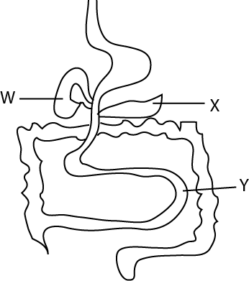

(a) Name the part marked: **W.**..............................................................................................

**X**……………………………………………………………………………………………….

(b) State any one process that takes place labelled **Y**

………………………………………………………………………………………………………………………………………………………………

(c) Give one function of the organ labelled **X**

…………………………………………………………………………………………………………………………………………………………………

52. The diagram below shows a ray of light striking the mirror

**Study it and answer question that follow**

C

D

E

F

a

b

(a) Name the part marked **C** …………………………………………………………………………………………………..

(b) Put an arrow on line D to show the diagram of the ray of light

(c) If angle b=400, what is the size of angle **a**?

(d) Give a reason for your answer in (c) above.

……………………………………………………………………………………………………………………………………………………………………………………………………………………………………………………………………………………………………………………………………

53.(a) Which vector spreads dysentery?.................................................................................................

(b) Give any two ways of controlling dysentery in our homes

(i)………………………………………………………………………………………………………………………………………………………………………………………………………………………………………………………………………………………………………………………………

(ii)…………………………………………………………………………………………………………………………………………………………………………………………………………………………………………………………………………………………………………………………………

(c ) Why should a person suffering from dysentery be given oral Rehydration salts(ORS)?

…………………………………………………………………………………………………………………………………………………………………………………………………………………………………………………………………………………………………………………………………

54. study the table below and answer the question that follow

|  |  |
| --- | --- |
| **LIST A** | **LIST B** |
| Tilapia  Frog  Crocodile  Dove | Rat  Goat  Lion  whale |

(a) What is the similarity in the way animals in list **A** reproduce?

……………………………………………………………………………………………………………………………………………………………………………………………………………………………………………………………………………………………………………………………………

(b) To which class of animals do those in list **B** belong?

……………………………………………………………………………………………………………………………………………………………………………………………………………………………………………………………………………………………………………………………………

(c ) In which way is tilapia in list A similar to a whale in list **B** ?

……………………………………………………………………………………………………………………………………………………………………………………………………………………………………………………………………………………………………………………………………

(d) What is common about the animals in list **A** and list **B?**

……………………………………………………………………………………………………………………………………………………………………………………………………………………………………………………………………………………………………………………………………

55. (a) Draw bean seed and show: (i) a scar

(ii) a micropyle.

(b) Draw a spilt bean seed and show: (i) a plumule

(ii) a radical

**END**