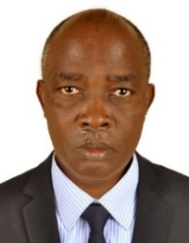**UGANDA NATIONAL EXAMINATION BOARD**

**PRIMARY LEAVING EXAMINATION**

Dr. Bbosa Science

Nurture your dreams

d

digitalteachrs.co.ug

**2004**

**MATHEMATICS**

**Time allowed: 2hours 30 minutes**

|  |  |  |  |  |  |  |  |  |
| --- | --- | --- | --- | --- | --- | --- | --- | --- |
|  |  |  |  |  |  |  |  |  |

**Index No:**

**Candidate’s Name……………………………………………………………………………………..**

**Candidate’s signature…………………………………………………………………………………..**

**District Name…………………………………………………………………………………………………**

|  |  |  |
| --- | --- | --- |
| **FOR EXAMINERS**  **USE ONLY** | | |
| **Qn. No** | **MARKS** | **EXR’S NO.** |
| **1-5** |  |  |
| **6-10** |  |  |
| **11-15** |  |  |
| **16-20** |  |  |
| **21-22** |  |  |
| **23-24** |  |  |
| **25-26** |  |  |
| **27-28** |  |  |
| **29-30** |  |  |
| **31-32** |  |  |
| **TOTAL** |  |  |

**Read the following instructions carefully**

**Read the following instructions carefully**

1. **This paper has two sections A and B.**
2. **All the working. For both section A and B must be shown in the spaces provided**
3. **All working must be done using a blue or black ball**

**Point pen or fountain pen Diagram should be drawn in pencil**

1. **No calculators are allowed in the examination room.**
2. **Unnecessary change of work may lead to loss of marks**
3. **Any hand writing that cannot easily be read may lead to loss of marks**
4. **Do not fill anything in the boxes indicated:**

**“For examiners use only”. And those inside the question paper**

**©2012 Uganda National Examination board**

**Turn over**

**SECTION A**

1. Air a mixture of gases. Which of the of gases forms the greatest percentage of air in the atmosphere?

………………………………………………………………………………………………………………

……………………………………………………………………………………………………………….

2. Give any one characteristic which is common to all vertebrates

………………………………………………………………………………………………………………

……………………………………………………………………………………………………………….

3. What first aid would you give a person who is suffering from diarrhea?

………………………………………………………………………………………………………………

……………………………………………………………………………………………………………….

4. In which process can water be changed into water vapour?

………………………………………………………………………………………………………………

……………………………………………………………………………………………………………….

5. Give any one way in which ringworm is spread.

………………………………………………………………………………………………………………

……………………………………………………………………………………………………………….

6. Give any one reason why you would choose to use solar energy stead of wood fuel as a source of energy.

………………………………………………………………………………………………………………

……………………………………………………………………………………………………………….

7. Give any one reason why people should cut their fingernails

………………………………………………………………………………………………………………

……………………………………………………………………………………………………………….

8. Apart from having bright colours, state any other characteristic of insect –pollinated flowers.

………………………………………………………………………………………………………………

……………………………………………………………………………………………………………….

9. Give ay one reason why the burning of wood is a chemical change.

………………………………………………………………………………………………………………

……………………………………………………………………………………………………………….

10 How is the air we breathe in different room the air we breathe out?

………………………………………………………………………………………………………………

……………………………………………………………………………………………………………….

11. Give any one characteristic that can help you distinguish between a hen and a cock.

………………………………………………………………………………………………………………

……………………………………………………………………………………………………………….

12. Mary suspended three magnets on strings near each other and observed that some ends came close but other ends moved away from each other. Why did this happen?

………………………………………………………………………………………………………………

……………………………………………………………………………………………………………….

13. Apart from hearing, give any one other function of the human ear.

………………………………………………………………………………………………………………

……………………………………………………………………………………………………………….

14. How do animals benefit from photosynthesis?

………………………………………………………………………………………………………………

……………………………………………………………………………………………………………….

15. Give any one way in which a P7 pupils can help in the control of polio in a community.

………………………………………………………………………………………………………………

……………………………………………………………………………………………………………….

16. Give any one way in which a Child Card is important to a school Health Committee.

………………………………………………………………………………………………………………

……………………………………………………………………………………………………………….

17. Suggest any one reason why people drink alcohol.

………………………………………………………………………………………………………………

……………………………………………………………………………………………………………….

18. Peter uses a wheel barrow to carry potatoes from his garden to the market. What is the advantage of using such a machine?

………………………………………………………………………………………………………………

……………………………………………………………………………………………………………….

*The diagram below shows parallel rays striking a comes lens. study it and answer question 19 and 20.*

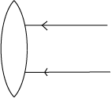

19. Complete the diagram to show the path of the rays after passing through the lens

20. What eyes defect does this type of lens correct?

………………………………………………………………………………………………………………

……………………………………………………………………………………………………………….

21. Give the part of an insect that has the same function as the gills of a fish.

………………………………………………………………………………………………………………

……………………………………………………………………………………………………………….

22. Apart from the animal kingdom, which other of organisms makes up living things?

………………………………………………………………………………………………………………

……………………………………………………………………………………………………………….

23. How can a poultry farmer prevent hens from eating their own eggs?

………………………………………………………………………………………………………………

……………………………………………………………………………………………………………….

24. Which property of air enables one to drink water from a bottle using a straw?

………………………………………………………………………………………………………………

……………………………………………………………………………………………………………….

25. In which way do bacteria help in soil formation?

………………………………………………………………………………………………………………

……………………………………………………………………………………………………………….

26. Indicate on the diagram below the missing part that would improve the movement of air in the house.

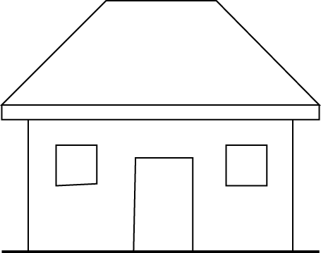

27. In which way is a pool of water near a home likely to be a source of malaria to the people in that home?

………………………………………………………………………………………………………………

……………………………………………………………………………………………………………….

28. How does a bat differ from all the other mammals?

………………………………………………………………………………………………………………

……………………………………………………………………………………………………………….

29. Apart from contracting sexually transmitted diseases, why would you advise a girl has started menstruating to abstain from sex?

………………………………………………………………………………………………………………

……………………………………………………………………………………………………………….

30. Draw an example of a foot of a swimming bird in the space provided below.

31 Why is a splint necessary when giving First Aid to someone with broken limb?

………………………………………………………………………………………………………………

……………………………………………………………………………………………………………….

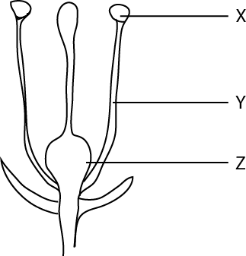The diagram below is of a flower. Use t to answer question 32 to 34.

32. Name the part labeled **X**……………………………………………………………….

33. What is the use of the part labelled Y to the flower?

………………………………………………………………………………………………………………

……………………………………………………………………………………………………………….

34. What does the part labeled Z become after fertilization?

………………………………………………………………………………………………………………

……………………………………………………………………………………………………………….

35. Give any one reason why it is important to weed crops.

………………………………………………………………………………………………………………

……………………………………………………………………………………………………………….

36. If a person enters a room and begin smoking, how does that habit affect the health of the people in the room?

………………………………………………………………………………………………………………

……………………………………………………………………………………………………………….

37. In which part of the human body are the red blood cells made?

………………………………………………………………………………………………………………

……………………………………………………………………………………………………………….

38. What process will you use to recover salt which has dissolved in water?

………………………………………………………………………………………………………………

……………………………………………………………………………………………………………….

39. Which instrument is used to measure the temperature of human body?

………………………………………………………………………………………………………………

……………………………………………………………………………………………………………….

40. What first aid would you give to a child who has drunk paraffin?

………………………………………………………………………………………………………………

……………………………………………………………………………………………………………….

**SECTION B**

41. The diagram bellow show two types of simple machines labelled a and b

***Use it to answer the questions that follow.***

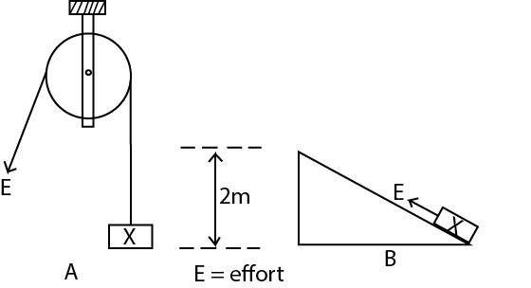

(a) Name each of the machines shown in the diagram

(i) **A**…………………………………………………………………………………………..

(ii) **B**…………………………………………………………………………………………

(b) Which of the two machines would you choose to use to lift the load **X** to a height of two metres?

………………………………………………………………………………………………………………

(c ) Give a reason for your choice of machine in (b) above.

………………………………………………………………………………………………………………

………………………………………………………………………………………………………………

42. The diagram below shows as onions

***Use it to answer the questions that follow***

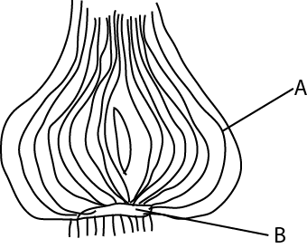

(a) Name the part labelled **B**……………………………………………………………………………

(b) What is the function of the part labelled **A**?

………………………………………………………………………………………………………………

……………………………………………………………………………………………………………….

(c) what types of root system does this plant have?

………………………………………………………………………………………………………………

……………………………………………………………………………………………………………….

(d) How is this plant propagated?

………………………………………………………………………………………………………………

……………………………………………………………………………………………………………….

43. The two lists a and b below ,show the diagram and the animals they affect .match the items in list a with those in list b correctly by completing the table below.

**List A List B**

New castle cattle

African swine fever Dogs

Rabies pigs

Rinderpest fowls

|  |  |
| --- | --- |
| (a)New castle  (b)African swine fever  (c )Rabies  (d)Rinderpest | ……………………………………………………  …………………………………………………….  ……………………………………………………  …………………………………………………… |

44. (a) Why should water not be used to put out a fire caused by petrol?

………………………………………………………………………………………………………………

………………………………………………………………………………………………………………

(b) Suggest any two ways in which such a fire can be put out.

………………………………………………………………………………………………………………

(c) How is a burn different from a scald?

………………………………………………………………………………………………………………

………………………………………………………………………………………………………………

45. How does each of the following animals protect itself against its enemies?

(a)Tortoise……………………………………………………………………………………………………

………………………………………………………………………………………………………………

(b)Wasp………………………………………………………………………………………………………

………………………………………………………………………………………………………………

(c) Millipede…………………………………………………………………………………………………

………………………………………………………………………………………………………………

(d)Chameleon………………………………………………………………………………………………

………………………………………………………………………………………………………………

46.Give any four main causes of motor accidents in Uganda

(a)…………………………………………………………………………………………………………….

(b)…………………………………………………………………………………………………………….

(c )……………………………………………………………………………………………………………

(d)……………………………………………………………………………………………………………

47. (a) What advice would you give to a person wishing to construct a pit latrine at his home?

(i)……………………………………………………………………………………………………………

………………………………………………………………………………………………………………

(ii)……………………………………………………………………………………………………………

………………………………………………………………………………………………………………

(b) Give any one characteristic of a Ventilated Improved Pit Latrine

………………………………………………………………………………………………………………

………………………………………………………………………………………………………………

(c ) Give any one reason why people should use latrines /toilets properly.

………………………………………………………………………………………………………………

………………………………………………………………………………………………………………

48. Mention any one reason why copper wires are commonly used to distribute electricity from one point to another.

………………………………………………………………………………………………………………

………………………………………………………………………………………………………………

(b) Why do people who work on electric wires wear rubber gloves?

………………………………………………………………………………………………………………

………………………………………………………………………………………………………………

(c ) Give any one use of each of the following:

(i) a switch ………………………………………………………………………….

(ii) a fuse ………………………………………………………………………….

49. (a) Which bone joint the pelvis and the tibia?

………………………………………………………………………………………………………………

(b) Apart from movement, give any other two functions of the human skeleton.

(i)……………………………………………………………………………………………………………

(ii)……………………………………………………………………………………………………………

(c) What is the function of tendons in a human body?

………………………………………………………………………………………………………………

………………………………………………………………………………………………………………

50. (a) In which way does the cutting of tress (deforestation) cause soil erosion?

………………………………………………………………………………………………………………

………………………………………………………………………………………………………………

(b)Suggest any three methods of farming which can prevent soil erosion.

(i)……………………………………………………………………………………………………………

(ii)……………………………………………………………………………………………………………

(iii)……………………………………………………………………………………………………………

51.(a) Give any one danger to a person who gets used to taking drug of dependency.

………………………………………………………………………………………………………………

………………………………………………………………………………………………………………

(b ) Suggest any three reasons why it is not advisable to take drugs bought from local shops.

(i)……………………………………………………………………………………………………………

(ii)……………………………………………………………………………………………………………

(iii)……………………………………………………………………………………………………………

52 (a) What do you understand by ‘dual purpose’ cattle?

………………………………………………………………………………………………………………

………………………………………………………………………………………………………………

(b) Give any two common local breeds of cattle kept in Uganda

(i)……………………………………………………………………………………………………………

(ii)……………………………………………………………………………………………………………

(c ) suggest any one reason why cattle keepers practice cross-breeding.

………………………………………………………………………………………………………………

………………………………………………………………………………………………………………

53. The diagram below shows the human arm holding a stone

***Use it to answer the question that follow***

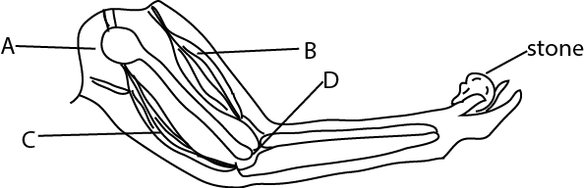

(a) Which muscle acts as the effort in order to lift the stone?

………………………………………………………………………………………………………………

(b) What kind of movement is possible at each of the following joint?

(i) joint **A**………………………………………………………………………………………………

(ii) joint **D**……………………………………………………………………………………………

(c ) Which class of lever is represented by the diagram above?

………………………………………………………………………………………………………………

54. Use one sentence to explain the meaning of each of the following:

(a) reflection of light

………………………………………………………………………………………………………………

………………………………………………………………………………………………………………

(b) conduction of heat

………………………………………………………………………………………………………………

………………………………………………………………………………………………………………

(c ) transpiration

………………………………………………………………………………………………………………

………………………………………………………………………………………………………………

(d) condensation

………………………………………………………………………………………………………………

………………………………………………………………………………………………………………

55. The table below shows food stuffs prepared in different families

***Study it and answer questions that follow***

|  |  |  |  |
| --- | --- | --- | --- |
| **Family A** | **Family B** | **Family C** | **Family D** |
| Matooke  Yams  Meat  beans | Cassava  Beans  Posho  yams | Potatoes  Posho  Cassava  yams | Millets  Fish  Goat milk  Mangoes |

(a) Which family will be able to have vitamin **C**?..........................................................................

(b) Which family has proteins but lacks fats?.................................................................................

(c) What food nutrients are lacking in family A?

………………………………………………………………………………………………………………

(d) Which family has almost a balanced diet?

………………………………………………………………………………………………………………

**END**