**UGANDA NATIONAL EXAMINATION BOARD**

**PRIMARY LEAVING EXAMINATION**

Dr. Bbosa Science

Nurture your dreams

d

digitalteachrs.co.ug

**2005**

**MATHEMATICS**

**Time allowed: 2hours 30 minutes**

|  |  |  |  |  |  |  |  |  |
| --- | --- | --- | --- | --- | --- | --- | --- | --- |
|  |  |  |  |  |  |  |  |  |

**Index No:**

**Candidate’s Name……………………………………………………………………………………..**

**Candidate’s signature…………………………………………………………………………………..**

**District Name…………………………………………………………………………………………………**

|  |  |  |
| --- | --- | --- |
| **FOR EXAMINERS**  **USE ONLY** | | |
| **Qn.No** | **MARKS** | **EXR’S NO.** |
| **1-5** |  |  |
| **6-10** |  |  |
| **11-15** |  |  |
| **16-20** |  |  |
| **21-22** |  |  |
| **23-24** |  |  |
| **25-26** |  |  |
| **27-28** |  |  |
| **29-30** |  |  |
| **31-32** |  |  |
| **TOTAL** |  |  |

**Read the following instructions carefully**

**Read the following instructions carefully**

1. **This paper has two sections A and B.**
2. **All the working. For both section A and B must be shown in the spaces provided**
3. **All working must be done using a blue or black ball**

**Point pen or fountain pen Diagram should be drawn in pencil**

1. **No calculators are allowed in the examination room.**
2. **Unnecessary change of work may lead to loss of marks**
3. **Any hand writing that cannot easily be read may lead to loss of marks**
4. **Do not fill anything in the boxes indicated:**

**“For examiners use only”. And those inside the question paper**

**©2012 Uganda National Examination board**

**Turn over**

**SCIENCE 2005**

**SECTION A**

1. Give any one reason why animals move from one place to another

………………………………………………………………………………………………………………

……………………………………………………………………………………………………………….

2. Give any one form of energy produced when a carpenter driver drives a nail into a piece of wood a harmer.

………………………………………………………………………………………………………………

……………………………………………………………………………………………………………….

3. Give any one animal fibre found in the environment

………………………………………………………………………………………………………………

……………………………………………………………………………………………………………….

4. What change of state takes place when water is frozen to ice?

………………………………………………………………………………………………………………

……………………………………………………………………………………………………………….

5. What structures on the leaf of a plant help in the process of transpiration?

………………………………………………………………………………………………………………

……………………………………………………………………………………………………………….

6. How are houseflies able to spread germs?

………………………………………………………………………………………………………………

……………………………………………………………………………………………………………….

7. Give any one proper way of disposing off rubbish in a home.

………………………………………………………………………………………………………………

……………………………………………………………………………………………………………….

Use the diagram of a seed given below to answer questions 8 and 9.

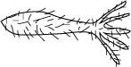

8. How is the seed in the diagram dispersed?

………………………………………………………………………………………………………………

9. Give a reason to support your answer in question 8 above.

………………………………………………………………………………………………………………

……………………………………………………………………………………………………………….

10 In which way is crop rotation a good method of controlling crop pest?

………………………………………………………………………………………………………………

……………………………………………………………………………………………………………….

11. Give any one reason why people commonly use free range system of keeping poultry.

………………………………………………………………………………………………………………

……………………………………………………………………………………………………………….

12. What structure in an insect work like lungs in a mammal?

………………………………………………………………………………………………………………

……………………………………………………………………………………………………………….

13. What is a stretcher useful in giving First Aid?

………………………………………………………………………………………………………………

……………………………………………………………………………………………………………….

14. Give any one use of saliva in the digestive system.

………………………………………………………………………………………………………………

……………………………………………………………………………………………………………….

15. In which state of matter does heat travel by convection?

………………………………………………………………………………………………………………

……………………………………………………………………………………………………………….

16. Why is thunder heard after lighting has been during a rainy day?

………………………………………………………………………………………………………………

……………………………………………………………………………………………………………….

17. How does painting a metal prevent it from rusting?

………………………………………………………………………………………………………………

……………………………………………………………………………………………………………….

18. What a structure enables the absorption of food to take place in small intestines?

………………………………………………………………………………………………………………

……………………………………………………………………………………………………………….

19. Give any one characteristics that makes a butterfly and a cockroach to be classified as insects.

………………………………………………………………………………………………………………

……………………………………………………………………………………………………………….

20. Suggest any one problem of early pregnancy to a school girl below 18 years.

………………………………………………………………………………………………………………

……………………………………………………………………………………………………………….

21. How can the school health committee tell whether a child is already immunized against Tuberculosis without referring to the Child- Health Card?

………………………………………………………………………………………………………………

……………………………………………………………………………………………………………….

22. Mention any one reason for thinning crops like cotton.

………………………………………………………………………………………………………………

……………………………………………………………………………………………………………….

23. Why is a clay soil able to retain water much longer than the other types of soil?

………………………………………………………………………………………………………………

……………………………………………………………………………………………………………….

24. What force enables a match-stick to light when it is struck at the side of its box?

………………………………………………………………………………………………………………

……………………………………………………………………………………………………………….

25. Give the difference between heat and temperature.

………………………………………………………………………………………………………………

……………………………………………………………………………………………………………….

25. Give any one way in which bees benefit from plants.

………………………………………………………………………………………………………………

……………………………………………………………………………………………………………….

27. How is the method of propagation of a sweet potato different from that of an Irish potato?

………………………………………………………………………………………………………………

……………………………………………………………………………………………………………….

28. How does the breathing of an adult frog differ from of a tadpole?

………………………………………………………………………………………………………………

……………………………………………………………………………………………………………….

29. Draw a compound leaf in the space provided below.

30. What is the importance of immunizing a pregnant woman against Tetanus?

………………………………………………………………………………………………………………

……………………………………………………………………………………………………………….

The diagram below show a garden tool

***Use it to answer questions 31 and 32***

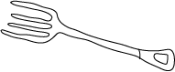

31. Name this garden tool.

………………………………………………………………………………………………………………332. Give any one use of the tool to the farmer.

………………………………………………………………………………………………………………

……………………………………………………………………………………………………………….

33. Give any one reason why doctors prescribe drugs for patients.

………………………………………………………………………………………………………………

……………………………………………………………………………………………………………….

34. The diagram below shows an object 2 metres away from the mirror.

*.*

Two magnets A and B were suspended as shown in the diagram below

Use it to answer question 35.

N

X

A

B

35. If the pole marked N magnet A is the north pole, what is the pole marked X on magnet B?

………………………………………………………………………………………………………………

36. A cow and a bat are classified as mammals. To which class do the tortoises and lizard belong?

………………………………………………………………………………………………………………

……………………………………………………………………………………………………………….

The diagram below shows a simple lever system

***Use it to answer question 37, 38 and 39.***



37. Show on the diagram, with an arrow, the direction of movement of the effort at P as load is being lifted.

………………………………………………………………………………………………………………

……………………………………………………………………………………………………………….

38. At which of the two points D and P shown on the diagram will less effort be used to lifted the load?

………………………………………………………………………………………………………………

39. Give a reason for your answer in 38 above.

………………………………………………………………………………………………………………

……………………………………………………………………………………………………………….

40. Why does 1 kg of iron have less volume than 1 kg cotton wool?

………………………………………………………………………………………………………………

……………………………………………………………………………………………………………….

**SECTION B**

41. Give any four ways in which plants depend on each other.

(a)……………………………………………………………………………………………………………

……………………………………………………………………………………………………………….

(b)……………………………………………………………………………………………………………

……………………………………………………………………………………………………………….

(c )……………………………………………………………………………………………………………

……………………………………………………………………………………………………………….

(d)……………………………………………………………………………………………………………

……………………………………………………………………………………………………………….

42.(a) What is the use of the hairs found in the nose of a human being?

………………………………………………………………………………………………………………

……………………………………………………………………………………………………………….  
(b) Name any one disease that attacks the respiratory system.

………………………………………………………………………………………………………………

……………………………………………………………………………………………………………….

(c ) What happens to the diaphragm when we breathe

1. in?....................................................................................................................................

(ii) out?..............................................................................................................................

43.(a)What are communicable diseases?

………………………………………………………………………………………………………………

……………………………………………………………………………………………………………….

(b) Give any two examples of communicable diseases.

(i)……………………………………………………………………………………………………………

(ii)……………………………………………………………………………………………………………

(c) State any one practice in a community that would help in the control of communicable diseases.

………………………………………………………………………………………………………………

……………………………………………………………………………………………………………….

44. (a) Give any two ways in which bacteria are useful to human beings.

………………………………………………………………………………………………………………

……………………………………………………………………………………………………………….

(b ) Give any two ways in which bacteria are dangerous to human beings.

………………………………………………………………………………………………………………

……………………………………………………………………………………………………………….

45. Give any two ways of controlling the spread of the following diseases without using drugs

(a) AIDS

(i)………………………………………………………………………………………………..

(ii)……………………………………………………………………………………………….

(b) Malaria

(i)……………………………………………………………………………………………….

(ii)………………………………………………………………………………………………...

46. The diagram below shows a stone being put into a measuring cylinder A containing water. The level of water rose to that shown in cylinder

Use the information to answer the questions that follow.

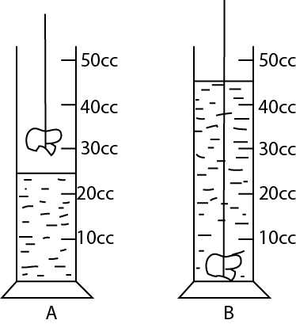

(a) Work out the volume of the stone.

(b) If the mass of the stone is 60g, calculate it density.

47. (a) Give any three characteristics of living things

(i)…………………………………………………………………………………………………………….

(ii)…………………………………………………………………………………………………………….

(iii)……………………………………………………………………………………………………………

(b) How are plants different from animals in the way they get their food?

………………………………………………………………………………………………………………

……………………………………………………………………………………………………………….

48. The diagram below the even colors of a rainbow

Completer the missing bands in the spaces provided in the diagram below

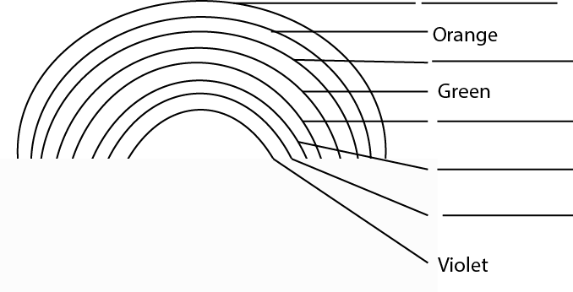

49. Bbosa kept one goat and one rabbit in different houses. He used to put different types of food in their houses. He recorded the number of times they ate each type of food. The following was his daily record:

|  |  |  |  |  |  |  |
| --- | --- | --- | --- | --- | --- | --- |
| **Animal** | **Number of times each food was eaten** | | | | | |
| Sweet potato  leaves | Cassava leaves | Sorghum leaves | Grass | Maize leaves | Banana leaves |
| Goat | 3 | 1 | 0 | 3 | 2 | 4 |
| Rabbit | 4 | 2 | 1 | 2 | 3 | 2 |

(a) What was the most favorable food for the:

(i) goat?.......................................................................................................................................................

(ii) rabbit?...................................................................................................................................................

(b)What was the least favorable food for the rabbit?

………………………………………………………………………………………………………………

(c) If Bbosa were to use only one type of food ,which one would be the most favorable for both the goat and the rabbit?

………………………………………………………………………………………………………………

50. In the space provided below, draw a diagram to show the germination of :

(a) a monocotyledonous seed.

(b) a dicotyledonous seed

(c) What is the importance of a cotyledon in a seed?

………………………………………………………………………………………………………………

……………………………………………………………………………………………………………….

(d) In which way is a seed important to a plant?

………………………………………………………………………………………………………………

……………………………………………………………………………………………………………….

51. (a) What does blood move from the heart to the lungs before it moves round the body?

………………………………………………………………………………………………………………

……………………………………………………………………………………………………………….  
(b) Give ant one function of each of the following

(i) White blood cells ………………………………………………………………………………………………………….

………………………………………………………………………………………………………………..

(ii)Red blood cells………………………………………………………………………………………….

………………………………………………………………………………………………………………

(ii) Platelets…………………………………………………………………………………………………

………………………………………………………………………………………………………………

52. The diagram below is of an electric circuit

***Use it to answer the question that follow***

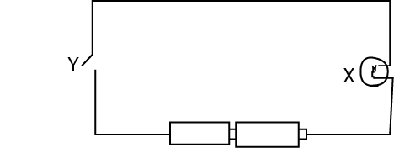

(a) Name the parts labeled **Y** and **X** in the diagram

(i)**Y**…………………………………………………………………………………………..

(ii**)X**......................................................................................................................................

(b) Apart from light give any one other form of energy produced by the part labeled **X** when **Y** is closed.

………………………………………………………………………………………………………………

……………………………………………………………………………………………………………….

(c) Show with the help of arrows the flows of current in the above diagram.

53. Health Committee members in your school visited an old man`s home and found out that home did not have the main requirement for proper sanitation .

Suggest any four activities that should carry out to ensure proper sanitation in the old man`s home.

(a)…………………………………………………………………………………………………………

(b)…………………………………………………………………………………………………………

(c)…………………………………………………………………………………………………………

(d)…………………………………………………………………………………………………………

54. Give any two ways in which an umbilical cord is important to a baby in the womb.

(i)……………………………………………………………………………………………………………

……………………………………………………………………………………………………………….

(ii)……………………………………………………………………………………………………………

……………………………………………………………………………………………………………….

(b) Suggest ant two things a pregnant woman must do to promote the health of her baby in the womb.

(i)……………………………………………………………………………………………………………

……………………………………………………………………………………………………………….

(ii)……………………………………………………………………………………………………………

……………………………………………………………………………………………………………….

55. Explain how to prepare Oral Rehydration Solution (ORS).

………………………………………………………………………………………………………………

……………………………………………………………………………………………………………….

………………………………………………………………………………………………………………

……………………………………………………………………………………………………………….

………………………………………………………………………………………………………………

……………………………………………………………………………………………………………….

………………………………………………………………………………………………………………

……………………………………………………………………………………………………………….

………………………………………………………………………………………………………………

……………………………………………………………………………………………………………….

………………………………………………………………………………………………………………

……………………………………………………………………………………………………………….

**END**