****UGANDA NATIONAL EXAMINATION BOARD

PRIMARY LEAVING EXAMINATION

digitalteachrs.co.ug

Nurture your dreams

d

Dr. Bbosa Science

Science 2007

Time allowed: 2hours 15 minutes

|  |  |  |  |  |  |  |  |  |
| --- | --- | --- | --- | --- | --- | --- | --- | --- |
|  |  |  |  |  |  |  |  |  |

Index No:

Candidate’s Name……………………………………………………………………………………..

Candidate’s signature…………………………………………………………………………………..

District Name…………………………………………………………………………………………………

|  |  |  |
| --- | --- | --- |
| **FOR EXAMINERS**  **USE ONLY** | | |
| **Qn. No.** | **MARKS** | **EXR’S NO.** |
| **1-10** |  |  |
| **11-20** |  |  |
| **21-30** |  |  |
| **31-40** |  |  |
| **51** |  |  |
| **52** |  |  |
| **53** |  |  |
| **54** |  |  |
| **55** |  |  |
| **Total** |  |  |

Read the following instructions carefully

1. This paper has two sections **A** and **B.** Section **A** has 50 questions and section **B** has 5 questions. The paper has 15 pages following altogether.
2. Answer all questions. All answers to both sections A and B must be **written** in the spaces provided.
3. All answers must be written using a blue or black ball-point pen or ink. **Any** work written in pencil other than graphs, pictures and diagrams will **not** be marked.
4. Unnecessary change of work may lead to loss of marks.
5. Any handwriting that cannot easily be read may lead to loss to marks.
6. Do not fill anything in the boxes indicated:
7. “For examiners’. Use only and inside the question paper

©2009 Uganda National Examination board

**SECTION A**

(questions ***1*** to ***40*** marks each)

1. Which reptile change the colour of its body as its moves from one place to another ?

……………………………………………………………………………………………………..

2. Give any one way in which bush burning leads to soil erosion.

……………………………………………………………………………………………………..

……………………………………………………………………………………………………..

3. How are bats different from hens in their way of reproduction?

……………………………………………………………………………………………………..

……………………………………………………………………………………………………..

4. How does immunization promote health in a child?

……………………………………………………………………………………………………..

……………………………………………………………………………………………………..

5. Give any one property of air shown in the diagram below

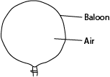

6. Give the difference between evaporation and condensation

……………………………………………………………………………………………………..

……………………………………………………………………………………………………..

7. Why is an earth-worm called an invertebrate?

……………………………………………………………………………………………………..

……………………………………………………………………………………………………..

8. Give any one function of the human skeleton.

……………………………………………………………………………………………………..

……………………………………………………………………………………………………..

9. Give any one way in which the spread of scabies can be controlled.

……………………………………………………………………………………………………..

……………………………………………………………………………………………………..

10. Mention a disease which makes a person to pass out watery stool with blood.

……………………………………………………………………………………………………..

……………………………………………………………………………………………………..

|  |
| --- |
|  |

11 State the difference between volume and mass

……………………………………………………………………………………………………..

……………………………………………………………………………………………………..

12. Give any one body characteristic which is common to a spider and a tick

……………………………………………………………………………………………………..

……………………………………………………………………………………………………..

13. What is the main cause of fainting?

……………………………………………………………………………………………………..

……………………………………………………………………………………………………..

14. Suggest any one way in which human beings use energy light the sun.

……………………………………………………………………………………………………..

……………………………………………………………………………………………………..

15. Give any one way in which sweating is important in a human body.

……………………………………………………………………………………………………..

……………………………………………………………………………………………………..

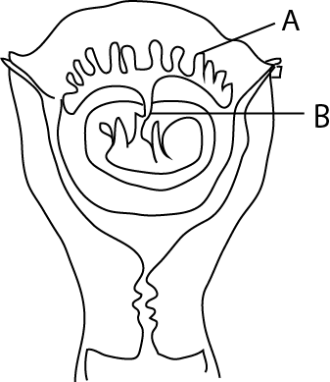The diagram below a foetus in the womb. Use it to answer questions 16 and 17

16. Name the part marked with letter A

……………………………………………………………………………………………………..

17. State any one way in which the part marked with letter B is useful to the foetus

……………………………………………………………………………………………………..

……………………………………………………………………………………………………..

18. Which part of human eye works like a film in camera?

……………………………………………………………………………………………………..

……………………………………………………………………………………………………..  
19. Give any one activity that can be done at home to control the spread of malaria.

……………………………………………………………………………………………………..

…………………………………………………………………………………………………..

20. In which way is a person who HIV positive different from the one who has developed AIDS?

……………………………………………………………………………………………………..

……………………………………………………………………………………………………..

|  |
| --- |
|  |

21. Give any one way in which a transparent object differs from an opaque object.

……………………………………………………………………………………………………..

……………………………………………………………………………………………………..

22. What causes kwashiorkor in children?

……………………………………………………………………………………………………..

……………………………………………………………………………………………………..

23. Why is photosynthesis important to plants?

……………………………………………………………………………………………………..

……………………………………………………………………………………………………..

24. Give any one reason why human beings breathe in.

……………………………………………………………………………………………………..

……………………………………………………………………………………………………..

25. What is an enzyme?

……………………………………………………………………………………………………..

……………………………………………………………………………………………………..

26. Give any one reason why plants and animals are classified as living things.

……………………………………………………………………………………………………..

……………………………………………………………………………………………………..

27. State any one way in which health parades are important in primary schools.

……………………………………………………………………………………………………..

……………………………………………………………………………………………………..

28. Apart from painting, give any one other way in which metal can be prevented from rusting.

……………………………………………………………………………………………………..

……………………………………………………………………………………………………..

29. Which type of soil does not allow water to go through it easily?

……………………………………………………………………………………………………..

.

30. Why is a sling used when giving First Aid to a person with a broken hand?

……………………………………………………………………………………………………..

……………………………………………………………………………………………………..

|  |
| --- |
|  |

31. State any one practice on a school garden that will help to improve soil fertility.

……………………………………………………………………………………………………..

……………………………………………………………………………………………………..

32. Why is a tick called a parasite?

……………………………………………………………………………………………………..

……………………………………………………………………………………………………..

33. State the difference between the function of a pulmonary vein and that of a pulmonary artery in blood circulation.

……………………………………………………………………………………………………..

……………………………………………………………………………………………………..

34.Give any one form of energy that is produced during the process of splitting firewood with an axe.

……………………………………………………………………………………………………..

35. Give any one way in which plants benefits from animals.

……………………………………………………………………………………………………..

……………………………………………………………………………………………………..

36. Give any one sign on a school compound which shows that the school environment is degraded.

……………………………………………………………………………………………………..

……………………………………………………………………………………………………..

37. In which way is the function of kidneys similar to that of the skins in a human body?

……………………………………………………………………………………………………..

38.Apart from the brain , give any one other body organ which is greatly damaged by alcoholism.

……………………………………………………………………………………………………..

……………………………………………………………………………………………………..

39. How does heat from the sun reach the ground?

……………………………………………………………………………………………………..

……………………………………………………………………………………………………..

40. Give any one way in which teeth are important in the digestion of food.

……………………………………………………………………………………………………..

……………………………………………………………………………………………………..

|  |
| --- |
|  |

**SECTION B**

*(Questions* ***41*** *to* ***55*** *carry four marks each.)*

41. The diagram below shows a human joint .

**Use it to answer the questions that follow.**

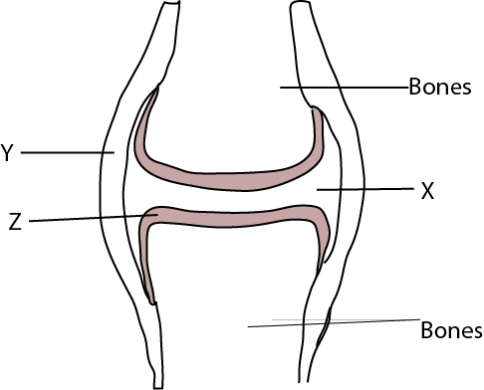

(a) Name the part marked with letter **Y** and  **Z**

(i) **Y** ……………………………………………………………………………………………………….

(ii) **Z** ……………………………………………………………………………………………………….

(b) Give any one function of the fluid found in the place marked with letter **X**

……………………………………………………………………………………………………..

……………………………………………………………………………………………………..

(c ) What type of joint is shown in the diagram above?

……………………………………………………………………………………………………..

42.An experiment was done by a P 7 class as shown in the diagram below**. *Use it to answer the question that follow.***

Can

water

object

20cc

10cc

(a) When is such a method of finding volume used?

……………………………………………………………………………………………………..

……………………………………………………………………………………………………..

If the object above has a density of 2 g/cm3 .find its mass.

43. (a) Give any two characteristics that are common to a frog and as crocodile apart from being vertebrates.

(i)……………………………………………………………………………………………………..

(ii)…………………………………………………………………………………………………….

(b) How is fertilization of a frog different from that of a crocodile?

……………………………………………………………………………………………………………

……………………………………………………………………………………………………………

(c ) Name any one other vertebrate that can be classified with a frog

……………………………………………………………………………………………………………

……………………………………………………………………………………………………………

44. The diagram below shows a saucepan with some water on fire.

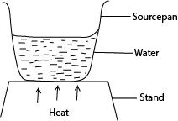***Use it to answer the questions that follow.***

(a) How will heat from the fire move to reach the water at the bottom of the saucepan?

……………………………………………………………………………………………………………

……………………………………………………………………………………………………………

(b) Which method will enable that heat all the water in the saucepan?

……………………………………………………………………………………………………………

(c ) Use arrow to show the movement of water in the saucepan after it has been heated for sometime.

(d) What will happen to the water in the saucepan to show that it is boiling?

……………………………………………………………………………………………………………

……………………………………………………………………………………………………………

45. The diagram below is of a fish

***Study it and answer the questions that follow***

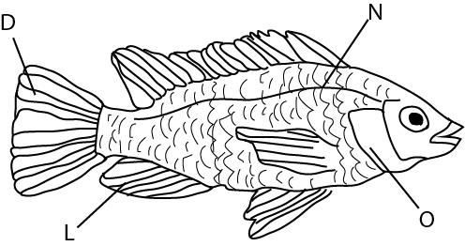

(a) Name the structure marked **L**

……………………………………………………………………………………………………………

(b) What is the function of each of the structure marked **D** and **N?**

(c ) state the unction of the structure covered by the part marked **O**

……………………………………………………………………………………………………………

……………………………………………………………………………………………………………

46. The diagram below ,show a seeding in a box

***Study it and answer the question that follow.***

Seedling

Box

H

Open cut

(a) What colour will the leaves of the seeding be if left in this box with H covered for a week?

……………………………………………………………………………………………………………

(b) Give a reason for your answer in (a) above.

……………………………………………………………………………………………………………

……………………………………………………………………………………………………………

(c ) Give any two things that are likely to happen to the seeding if the part marked with letter H is left is left open.

(i)…………………………………………………………………………………………………………

……………………………………………………………………………………………………………

(ii)………………………………………………………………………………………………………..

……………………………………………………………………………………………………………

|  |
| --- |
|  |

47 (a) Give any one reason why a magnet cannot attract pieces of wood.

……………………………………………………………………………………………………………

……………………………………………………………………………………………………………

(b) Give any three practices that can lead to the destruction of a magnet

(i)……………………………………………………………………………………………………………

……………………………………………………………………………………………………………

(ii)……………………………………………………………………………………………………………

……………………………………………………………………………………………………………

(iii)……………………………………………………………………………………………………………

……………………………………………………………………………………………………………

48. Bbosa is a poultry farmer. He has 100 layers on his farm. Give any four reasons why he should keep farm records?

(a)……………………………………………………………………………………………………………

……………………………………………………………………………………………………………….

(b)……………………………………………………………………………………………………………

………………………………………………………………………………………………………………..

(c )……………………………………………………………………………………………………………

……………………………………………………………………………………………………………….

(d)……………………………………………………………………………………………………………

49 (a) Why is it a bad practice to apply soil or cow dung on any burnt area of our skin?

……………………………………………………………………………………………………………

……………………………………………………………………………………………………………

(b) Suggest any two reasons why the injured part with a born or scald is dipped into cold water.

(i)……………………………………………………………………………………………………………

……………………………………………………………………………………………………………

(ii)……………………………………………………………………………………………………………

……………………………………………………………………………………………………………

(c ) Give any one way of a voiding burns while lifting hot objects.

……………………………………………………………………………………………………………

|  |
| --- |
|  |

50. The diagrams numbered 1 and 2 below show an experiment done by a P7 class.

Diagram 1 shows burning candle in an open jar. In diagram 2, the jar was covered as shown.

***Use the diagrams to answer the question that follow.***

Glass jar

Candle flame

Candle

Cover

1

2

(a) What would happen to the flame in diagram 2 if the cover was removed after a short time?

……………………………………………………………………………………………………………

……………………………………………………………………………………………………………

(b) Give a reason for your answer in question (a) above.

……………………………………………………………………………………………………………

……………………………………………………………………………………………………………

(c ) If the cover had been left on the jar in diagram 2 for a long time what would have happened to the flame?

……………………………………………………………………………………………………………

……………………………………………………………………………………………………………

(d) Give a reason for your answer in question (c ) above.

……………………………………………………………………………………………………………

……………………………………………………………………………………………………………

51.(a) What is environmental degradation?

……………………………………………………………………………………………………………

……………………………………………………………………………………………………………

(b) Give any three natural causes of environment degradation.

(i)……………………………………………………………………………………………………………

(ii)……………………………………………………………………………………………………………

(iii)……………………………………………………………………………………………………………

52. (a) Give any two ways in which mulching is important to the soil.

(i)……………………………………………………………………………………………………………

……………………………………………………………………………………………………………

(ii)……………………………………………………………………………………………………………

……………………………………………………………………………………………………………

(b) Suggest any two materials that are commonly used for mulching gardens.

(i)……………………………………………………………………………………………………………

(ii)……………………………………………………………………………………………………………

|  |
| --- |
|  |

53. State any one function of each of the following parts in simple electric circuit:

(i) Wire………………………………………………………………………………………………………

……………………………………………………………………………………………………………

(ii) Battery……………………………………………………………………………………………………

……………………………………………………………………………………………………………

(b) Mention any two causes of a short circuit

(i)……………………………………………………………………………………………………………

(ii)……………………………………………………………………………………………………………

54. The diagram below shows a machine used for lifting loads

Use it to answer the question that follow.

A

B

C

80kg load

Effort 40kg force

4m

(a) What distance is the load to be lifted?

……………………………………………………………………………………………………………

……………………………………………………………………………………………………………

(b) Give the advantage of lifting the load alongside **CA.**

……………………………………………………………………………………………………………

……………………………………………………………………………………………………………

(c ) find the mechanical advantage of the machine above.

(d) How can the machine be improved so that less effort is used to lift loads.

……………………………………………………………………………………………………………

……………………………………………………………………………………………………………

The diagram below is of a ventilated improved Pit (VIP) latrine.

***Use it to answer the question that follow.***

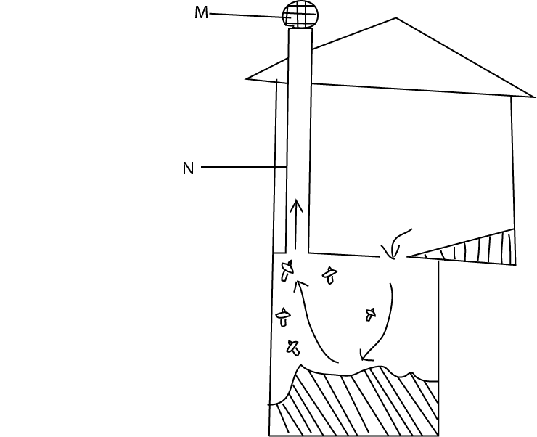

(a) Name the parts marked m and n

(i) **M**..............................................................................................................................................................

(ii) **N**.............................................................................................................................................................

(b) Give the function of the part marked **M**

……………………………………………………………………………………………………………

……………………………………………………………………………………………………………

(c ) what do the arrows in the diagram show?

……………………………………………………………………………………………………………

……………………………………………………………………………………………………………

|  |
| --- |
|  |

**END**