UGANDA NATIONAL EXAMINATION BOARD

Dr. Bbosa Science

Nurture your dreams

d

digitalteachrs.co.ug



PRIMARY LEAVING EXAMINATION

Science 2015

Time allowed: 2hours 15 minutes

|  |  |  |  |  |  |  |  |  |
| --- | --- | --- | --- | --- | --- | --- | --- | --- |
|  |  |  |  |  |  |  |  |  |

Index No:

Candidate’s Name……………………………………………………………………………………..

Candidate’s signature…………………………………………………………………………………..

District Name…………………………………………………………………………………………………

|  |  |  |
| --- | --- | --- |
| **FOR EXAMINERS**  **USE ONLY** | | |
| **Qn.No** | **MARKS** | **EXR’S NO.** |
| **1-10** |  |  |
| **11-20** |  |  |
| **21-30** |  |  |
| **31-40** |  |  |
| **51** |  |  |
| **52** |  |  |
| **53** |  |  |
| **54** |  |  |
| **55** |  |  |
| **Total** |  |  |

Read the following instructions carefully

1. This paper has two sections **A** and **B.** Section **A** has 50 questions and section **B** has 5 questions. The paper has 15 pages following altogether.
2. Answer all questions. All answers to both sections A and B must be **written** in the spaces provided.
3. All answers must be written using a blue or black ball-point pen or ink. **Any** work written in pencil other than graphs, pictures and diagrams will **not** be marked.
4. Unnecessary change of work may lead to loss of marks.
5. Any handwriting that cannot easily be read may lead to loss to marks.
6. Do not fill anything in the boxes indicated:
7. “For examiners’. Use only and inside the question paper

©2009 Uganda National Examination board

1. Which type of immunity do babies get from the mother.

…………………………………………………………………………………………………………………………………………………………

1. Name the blood vessel which takes blood from the heart to the lung.

…………………………………………………………………………………………………………………………………………………………

1. Name the energy resource obtained from animal dung and urine

…………………………………………………………………………………………………………………………………………………………

1. Mention any **one** factor that affects the rate of evaporation.

…………………………………………………………………………………………………………………………………………………………

1. State the difference in units to measure weight and mass.

…………………………………………………………………………………………………………………………………………………………………………………………………………………………………………………………………………………………………………………………

The diagram below shows a simple machine

Use it to answer questions 6 and 7.

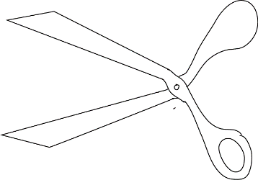

1. To which class of levers does the machine above belong?

…………………………………………………………………………………………………………………………………………………………

1. Use an arrow with letter P to show the fulcrum on the diagram.
2. Give any **one** way in which litter is important in a poultry house.

…………………………………………………………………………………………………………………………………………………………………………………………………………………………………………………………………………………………………………………………

1. Apart from the brightly colored petals, state **one** other thing that attracts insects to the flowers.

…………………………………………………………………………………………………………………………………………………………………………………………………………………………………………………………………………………………………………………………

1. State any **one** way in which drought affects food production in a community.

…………………………………………………………………………………………………………………………………………………………

1. State the difference between the feeding of tape worm and a Hook worm.

…………………………………………………………………………………………………………………………………………………………………………………………………………………………………………………………………………………………………………………………

1. Why is water obtained by distillation method not good for drinking?

…………………………………………………………………………………………………………………………………………………………………………………………………………………………………………………………………………………………………………………………

1. State the sense organ for feeling in the human body.

…………………………………………………………………………………………………………………………………………………………

1. Which property of a magnet enables a magnet compass to work.

…………………………………………………………………………………………………………………………………………………………

1. State any **one** way in which the spread of scabies can be prevented.

…………………………………………………………………………………………………………………………………………………………………………………………………………………………………………………………………………………………………………………………

1. Why do some plants shed their leaves during dry season?

…………………………………………………………………………………………………………………………………………………………………………………………………………………………………………………………………………………………………………………………

1. Mention **one** permanent method of birth control in males.

…………………………………………………………………………………………………………………………………………………………

1. Why a fish does dies soon after it has been removed from water?

…………………………………………………………………………………………………………………………………………………………………………………………………………………………………………………………………………………………………………………………

1. Give the use of a drenching gun to cattle farmer.

…………………………………………………………………………………………………………………………………………………………………………………………………………………………………………………………………………………………………………………………

1. Give **one** reason why pregnant mothers are advised to feed on food rich in proteins.

…………………………………………………………………………………………………………………………………………………………………………………………………………………………………………………………………………………………………………………………

The diagram below shows part of a joint.

Study and use it to answer questions 21 and 22.

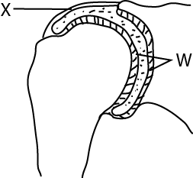

1. Name the part marked X

…………………………………………………………………………………………………………………………………………………………

1. Using letter W, label the part that reduces friction in the joints, apart from the synovial fluid.
2. State the method of controlling soil erosion where a farmer plough land across a slope

…………………………………………………………………………………………………………………………………………………………

1. Which element of primary Health care helps to prevent tooth decay?

…………………………………………………………………………………………………………………………………………………………

1. State the role of enzymes during food digestion.

…………………………………………………………………………………………………………………………………………………………………………………………………………………………………………………………………………………………………………………………

1. Apart from camera and microscope, name any **one** other optical instrument that uses a lens.

…………………………………………………………………………………………………………………………………………………………………………………………………………………………………………………………………………………………………………………………

1. Give one way in which mosses are similar to mushrooms in the way they reproduce.

…………………………………………………………………………………………………………………………………………………………………………………………………………………………………………………………………………………………………………………………

1. Why tepid sponging is is an important First Aid to a person with high fever?

…………………………………………………………………………………………………………………………………………………………………………………………………………………………………………………………………………………………………………………………

1. Why are sun bird able to suck nectar from the bottom of the flowers?

…………………………………………………………………………………………………………………………………………………………………………………………………………………………………………………………………………………………………………………………

1. Give an example of mollusc which is a vector to human.

…………………………………………………………………………………………………………………………………………………………

1. Name the human body system which eliminated wastes.

…………………………………………………………………………………………………………………………………………………………

1. Give any one way in which a VIP latrine is different from an ordinary pit latrine.

…………………………………………………………………………………………………………………………………………………………………………………………………………………………………………………………………………………………………………………………

1. Name the root crop which is attacked by the mosaic disease.

…………………………………………………………………………………………………………………………………………………………………………………………………………………………………………………………………………………………………………………………

1. Give any one reason why sheep farmers carry out docking.

…………………………………………………………………………………………………………………………………………………………………………………………………………………………………………………………………………………………………………………………

1. Apart from a flat iron, give any other one appliance used at home that changes electric energy to heat energy.

…………………………………………………………………………………………………………………………………………………………

1. 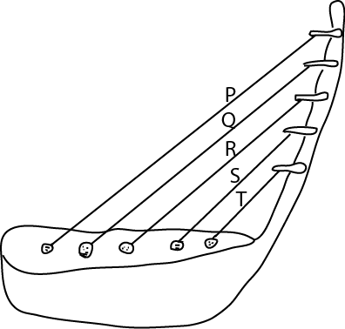The diagram below shows a well-tuned musical instrument. The string P, Q, R, S and T are of uniform thickness. Use it to answer the question that follows

Why does string T produce sound of the highest pitch?

………………………………………………………………………………………………………………………………………………………………………………………………………………………………………………………………………………………………………………………..

1. State any one way in which smoking affects the human respiratory system.

……………………………………………………………………………………………………………………………………………………………………………………………………………………………………………………………………………………………………………………

1. Give the importance of plants in a food chain.

……………………………………………………………………………………………………………………………………………………………………………………………………………………………………………………………………………………………………………………

1. Name the fungal-caused sexually transmitted disease, which is spread through poor hygiene.

…………………………………………………………………………………………………………………………………………………………………………………………………………………………………………………………………………………………………………………………

1. State one reason why farmer stake tomato plants.

…………………………………………………………………………………………………………………………………………………………………………………………………………………………………………………………………………………………………………………………

SECTION B: 60 MARKS

Questions 41 to 55 carry four marks each.

1. (a) give two examples of natural fertilizers
2. …………………………………………………………………………………………………………………………………….
3. …………………………………………………………………………………………………………………………………….

(b) state any two ways in which natural fertilizers are better than artificial fertilizers.

(i) …………………………………………………………………………………………………………………..………………………… ……………………………………………………………………………………………………………………………………………………

(ii) ………………………………………………………………………………………………………………………………………………

…………………………………………………………………………………………………………………………………………………….

1. The diagram below shows a flowering plant

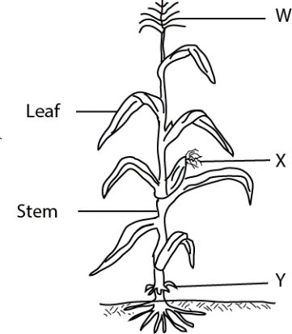Study and use it to answer the questions that follow.

1. To which group of flowering plants does the above plant belongs?

……………………………………………………………………………………………………………………………………………………

1. What type of root system does the plant have?

……………………………………………………………………………………………………………………………………………………

1. State the importance of root marked Y to the plant.

…………………………………………………………………………………………………………………………………………………………………………………………………………………………………………………………………………………………………………

1. In which **one** way is part **W** different from X in their reproductive function?
2. (a) Give any **two** conditions in which women are vulnerable
3. …………………………………………………………………………………………………………………………………….
4. …………………………………………………………………………………………………………………………………….

(b) State any **two** ways in which family members can care for vulnerable women.

(i) …………………………………………………………………………………………………………………..………………………… ……………………………………………………………………………………………………………………………………………………

(ii) ………………………………………………………………………………………………………………………………………………

…………………………………………………………………………………………………………………………………………………….

1. (a) Name the respiratory organ which are protected by the rib cage.

(b) What happen to the rib cage during the following process:

(i) breathing in?

…………………………………………………………………………………………………………………………………………………………………………………………………………………………………………………………………………………………………………

1. breathing out?

…………………………………………………………………………………………………………………………………………………………………………………………………………………………………………………………………………………………………………

(c) Give the use of oxygen we breath in

……………………………………………………………………………………………………………………………………………………

1. The table below shows diseases, the vectors that spread them and disease-causing germs. Study and complete it correctly.

|  |  |  |
| --- | --- | --- |
| Disease | Vector | Germ |
| Cholera | housefly | …………………………………………. |
| Yellow fever | …………………………………………… | Virus |
| …………………………………………. | Infected cats | virus |
| River blindness | Blackflies | ………………………………………….. |

1. (a) Give the functions of each of the following part of a modern bee hive.
2. The brood chambers.

…………………………………………………………………………………………………………………………………………………………………………………………………………………………………………………………………………………………………………

1. The honey chambers

…………………………………………………………………………………………………………………………………………………………………………………………………………………………………………………………………………………………………………

(b) Apart from being used as food, give two other ways in which honey is useful to people

(i) …………………………………………………………………………………………………………………..………………………… ……………………………………………………………………………………………………………………………………………………

(ii) ………………………………………………………………………………………………………………………………………………

…………………………………………………………………………………………………………………………………………………….

1. (a) What kind of food is made by green plants during photosynthesis?

……………………………………………………………………………………………………………………………………………………

(b) State any one raw material used by green plants for photosynthesis.

……………………………………………………………………………………………………………………………………………………

(c) How is chlorophyll important during the process of photosynthesis?

……………………………………………………………………………………………………………………………………………………

1. Give one reason why photosynthesis does **not** take place at night.

……………………………………………………………………………………………………………………………………………………

1. The diagram below shows firing bricks in a kiln

Study and use it to answer the questions that follows.

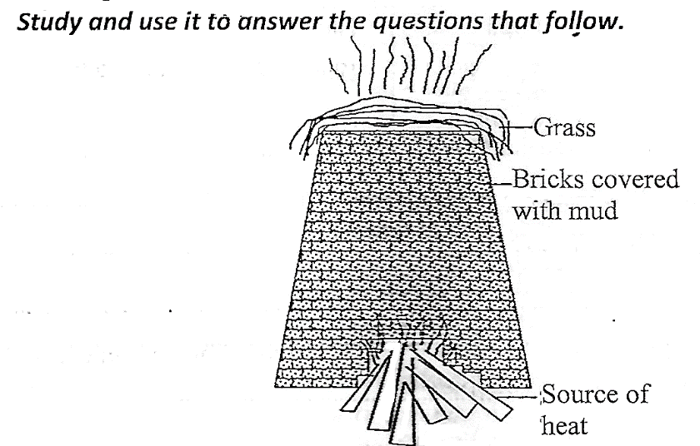

1. Name the source of heat energy used in the firing the bricks.

……………………………………………………………………………………………………………………………………………………

1. Give any one reason why the bricks are covered with mud before firing starts.

…………………………………………………………………………………………………………………………………………………………………………………………………………………………………………………………………………………………………………

1. What is the importance of the grass put on top of the kiln during firing?

…………………………………………………………………………………………………………………………………………………………………………………………………………………………………………………………………………………………………………

1. State any one disadvantage of using the above method of firing bricks to the environment.

……………………………………………………………………………………………………………………………………………………

1. The table **below shows part of human eye in A and that of a lens camera in B.**

|  |  |
| --- | --- |
| **A** | **B** |
| Iris  Pupil  Eye lid  Retina | Shutter  Film  Diaphragm  Aperture |

For each of the parts of the human eye, write the part of the lens camera from B which performs a similar function.

1. Iris ………………………………………………………………………………………………………………
2. Pupil ………………………………………………………………………………………………………………
3. Eye lid ………………………………………………………………………………………………………………
4. Retina ……………………………………………………………………………………………………………..
5. (a) Which communicable disease shows sign and symptoms similar to that of tuberculosis?

……………………………………………………………………………………………………………………………………………………

(b) Name one cattle product through which tuberculosis can be spread to human beings.

……………………………………………………………………………………………………………………………………………………

(c ) When is the vaccine against tuberculosis administered to babies?

……………………………………………………………………………………………………………………………………………………

(d) Apart from immunization, give one other way in which the spread of tuberculosis can be controlled in human.

…………………………………………………………………………………………………………………………………………………………………………………………………………………………………………………………………………………………………………

1. (a) Give any two ways in which alcohol is used in hospitals.

(i) …………………………………………………………………………………………………………………..………………………… ……………………………………………………………………………………………………………………………………………………

(ii) ………………………………………………………………………………………………………………………………………………

…………………………………………………………………………………………………………………………………………………….

(b) State any two effects of alcoholism to an individual.

(i) …………………………………………………………………………………………………………………..………………………… ……………………………………………………………………………………………………………………………………………………

(ii) ………………………………………………………………………………………………………………………………………………

…………………………………………………………………………………………………………………………………………………….

1. (a) Apart from the respiratory gases and body wastes, name any other two materials carried in blood.

(i) …………………………………………………………………………………………………………………..…………………………

(ii) ………………………………………………………………………………………………………………………………………………

(b) Name the component of blood which transport oxygen in the human body.

……………………………………………………………………………………………………………………………………………..

(c) Which disease-causing germ attacks the white blood cells in humans?

……………………………………………………………………………………………………………………………………………..

1. The diagram below shows a weather instrument.

Study and use it to answer the questions that follow

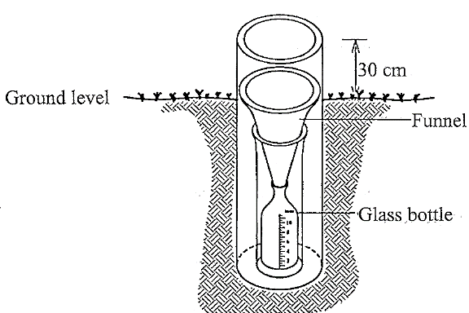

1. Name the weather instrument shown in the diagram above

……………………………………………………………………………………………………………………………………………………

1. What is the use of the instrument above at a weather station?

…………………………………………………………………………………………………………………………………………………………………………………………………………………………………………………………………………………………………………

1. Give a reason why people are advised to:
2. Put the instrument in an open ground when using it.

……………………………………………………………………………………………………………………………………………………

1. Raise the instrument 30cm above the ground when using it.

……………………………………………………………………………………………………………………………………………………

1. (a) To Which class of vertebrates does a toad belong?

(b) Give one way in which the breathing of a toad is different from that of a tadpole

(c) State any two ways in which the jelly round the eggs of a toad in important.

(i) …………………………………………………………………………………………………………………..………………………… ……………………………………………………………………………………………………………………………………………………

(ii) ………………………………………………………………………………………………………………………………………………

…………………………………………………………………………………………………………………………………………………….

1. (a) Apart from ticks, name any one other cattle pest.

……………………………………………………………………………………………………………………………………………………

(b) state any two diseases spread by ticks to cattle.

(i) ………………………………………………………………………………………………………………………………………………

(ii) ……………………………………………………………………………………………………………………………………………….

(c) Give any way in which the tick-borne diseases can be controlled.

…………………………………………………………………………………………………………………………………………………