UGANDA NATIONAL EXAMINATION BOARD

Dr. Bbosa Science

Nurture your dreams

d

digitalteachrs.co.ug



PRIMARY LEAVING EXAMINATION

INTEGRATED SCIENCE 2017

Time allowed: 2hours 15 minutes

|  |  |  |  |  |  |  |  |  |
| --- | --- | --- | --- | --- | --- | --- | --- | --- |
|  |  |  |  |  |  |  |  |  |

Index No:

Candidate’s Name……………………………………………………………………………………..

Candidate’s signature…………………………………………………………………………………..

District Name…………………………………………………………………………………………………

|  |  |  |
| --- | --- | --- |
| **FOR EXAMINERS**  **USE ONLY** | | |
| **Qn.No** | **MARKS** | **EXR’S NO.** |
| **1-10** |  |  |
| **11-20** |  |  |
| **21-30** |  |  |
| **31-40** |  |  |
| **51** |  |  |
| **52** |  |  |
| **53** |  |  |
| **54** |  |  |
| **55** |  |  |
| **Total** |  |  |

Read the following instructions carefully

1. This paper has two sections **A** and **B.** Section **A** has 50 questions and section **B** has 5 questions. The paper has 15 pages following altogether.
2. Answer all questions. All answers to both sections A and B must be **written** in the spaces provided.
3. All answers must be written using a blue or black ball-point pen or ink. **Any** work written in pencil other than graphs, pictures and diagrams will **not** be marked.
4. Unnecessary change of work may lead to loss of marks.
5. Any handwriting that cannot easily be read may lead to loss to marks.
6. Do not fill anything in the boxes indicated:
7. “For examiners’. Use only and inside the question paper

©2017 Uganda National Examination board

1. State the injury caused by steam to a human body.

……………………………………………………………………………………………………………………………………………………

1. What type of electricity is lightening?

…………………………………………………………………………………………………………………………………………………..

1. Give any **one** way in which termites benefit from soil.

…………………………………………………………………………………………………………………………………………………..

1. State **one** effect of gonorrhea on female reproductive system.

……………………………………………………………………………………………………………………………………………………

1. What is the importance of gap filling in crop growing?

…………………………………………………………………………………………………………………………………………………….

The diagram below shows reflection of light. Study and use it to answer questions 6 and 7

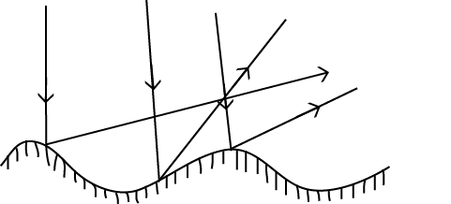

1. What type of reflection is shown above?

…………………………………………………………………………………………………………………………………………………

1. Why are the rays reflected as shown in the diagram?

………………………………………………………………………………………………………………………………………………..

1. State any **one** way in which alcoholism affects a family.

………………………………………………………………………………………………………………………………………………….

1. State any **one** reason why animals make sound.

……………………………………………………………………………………………………………………………………………………..

1. Name the process through which water turns into ice.

…………………………………………………………………………………………………………………………………………………….

1. In which **one** way does toothpaste promote oral health?

……………………………………………………………………………………………………………………………………………………

1. State any **one** physical change that takes place during the process of distillation of alcohol.

……………………………………………………………………………………………………………………………………………………

1. What is the importance of the rings of cartilages of the trachea in the respiratory system?

……………………………………………………………………………………………………………………………………………………

1. Why does a nail sink in water?

……………………………………………………………………………………………………………………………………………………

1. Give any **one** danger of wetland drainage to water animals.

……………………………………………………………………………………………………………………………………………………

1. Sate any **one** principle of primary Health care.

……………………………………………………………………………………………………………………………………………………

1. Why are laying boxes put in dark corners of a poultry house?

……………………………………………………………………………………………………………………………………………………

1. Apart from causing diseases, give one other way in which fungi are harmful to people?

…………………………………………………………………………………………………………………………………………………….

1. How is reflected sound helpful to sailors?

……………………………………………………………………………………………………………………………………………………..

1. Give **one** way in which molluscs are different from other invertebrates.

……………………………………………………………………………………………………………………………………………………

1. Give any **one** mineral deficiency disease in humans.

…………………………………………………………………………………………………………………………………………………….

1. Name the type of bees, which develops from unfertilized eggs.

…………………………………………………………………………………………………………………………………………………….

1. State any **one** way in which the spread of germs by houseflies can be controlled.

…………………………………………………………………………………………………………..…………………………………..

The diagram below shows a germinating seed. Study and use it to answer questions 24 and 25.

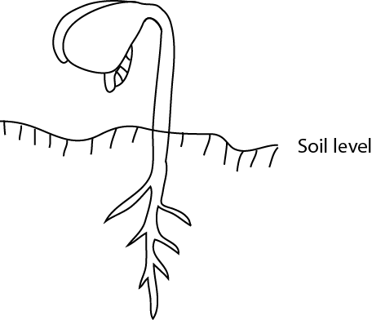

1. What type of germination is shown in the diagram above?

……………………………………………………………………………………………………………………………………………………

1. To which group of flowering plants does the germinating seed belong?

……………………………………………………………………………………………………………………………………………………..

1. State any **one** way in which saliva is useful in the process of digestion.

……………………………………………………………………………………………………………………………………………………

1. Name the vaccine which is given to prevent three childhood immunizable diseases.

……………………………………………………………………………………………………………………………………………………

1. Give **one** reason why less effort is applied to move a load using first class levers.

……………………………………………………………………………………………………………………………………………………

1. The diagram below shows a bar magnet with iron fillings around it. Study and use it to answer the question that follows

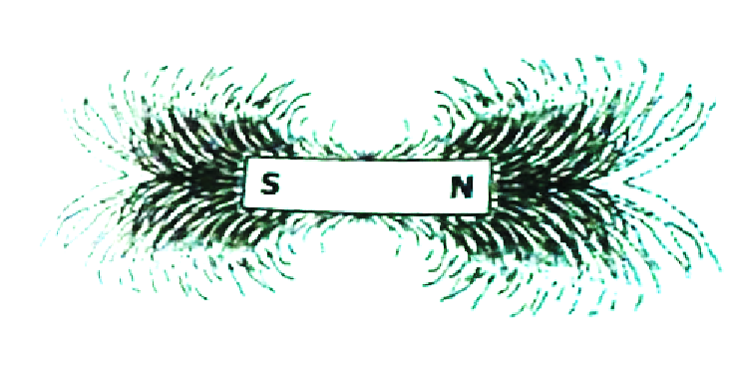

1. State any **one** sign of disease on the plant leaves.

………………………………………………………………………………………………………………………………………………..

1. Name the organ, which regulates the human body temperature.

………………………………………………………………………………………………………………………………………………..

1. State any **one** way in which animals can be used as energy resource.

……………………………………………………………………………………………………………………………………………………

1. Which method of harvesting trees allows new shoots to grow for the stump?

……………………………………………………………………………………………………………………………………………………

1. Give any**one** way of controlling the bad smell in an ordinary pit latrine.

…………………………………………………………………………………………………………………………………………………….

1. The diagram below shows an object in a glass of water. Study and use it to answer the questions that follows.

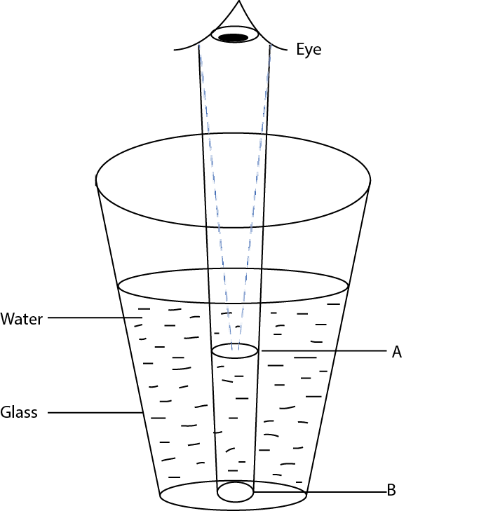

Why does the object seem to appear at point **A** yet it is at point **B**?

…………………………………………………………………………………………………………………………………………………..

1. State any **one** sign of snuffle disease in rabbits.

……………………………………………………………………………………………………………………………………………………

1. Which property of air makes the lungs to expand when we breathe in?

…………………………………………………………………………………………………………………………………………………..

1. Apart from curing diseases, give **one** other characteristic of essential drugs.

……………………………………………………………………………………………………………………………………………………

1. Why is biogas regarded as an environmentally friendly source of energy?

……………………………………………………………………………………………………………………………………………………

1. State any **one** characteristic of seeds dispersed by wind.

……………………………………………………………………………………………………………………………………………………

SECTION B: 60MARKS

Question 41 and 55 carry four marks each

|  |  |  |  |
| --- | --- | --- | --- |
| 41. | (a) |  | Give any two signs which show that a baby is dehydrated |
|  |  | (i) | ………………………………………………………………………………………………………………………………. |
|  |  | (ii) | ………………………………………………………………………………………………………………………………. |
|  | (b) |  | State any **two** pieces of advice to give to a mother whose baby is dehydrated. |
|  |  | (i) | ……………………………………………………………………………………………………………………………….. |
|  |  | (ii) | ……………………………………………………………………………………………………………………………….. |
| 42 | (a) |  | Use the living things listed below to complete the given food chain  Lion, Goat, grass  ………………….. Goat …………………………………………. |
| (b) |  |  | Which one of the livings in the food chain above is a producer?  …………………………………………………………………………………………………………………………………. |
| (c) |  |  | What is the source of energy for the producer in the food chain above?  ………………………………………………………………………………………………………………………………… |
| 43 |  |  | C:\Users\science\Desktop\pictures\heart17.pngThe diagram below shows circulation of blood in the body. Study and use it to answer the questions that follow. |
|  | (a) |  | Name the organ marked with letter X  …………………………………………………………………………………………………………………………………. |
|  | (b) |  | Which blood vessel is marked with letter W?  …………………………………………………………………………………………………………………………………. |
|  | (c) |  | State the similarity between blood vessel Y and bllod vessel Z.  …………………………………………………………………………………………………………………………………  …………………………………………………………………………………………………………………………………. |
|  | (d) |  | Why does vessel W bring blood back to the heart?  ……………………………………………………………………………………………………………………………………  ………………………………………………………………………………………………………………………………….... |
| 44. | (a) |  | Write down any two causes of soil erosion |
|  |  | (i) | …………………………………………………………………………………………………………………………………… |
|  |  | (ii) | ………………………………………………………………………………………………………………………………….. |
|  | (b) |  | Which agent of soil erosion causes gullies? |
|  |  |  | …………………………………………………………………………………………………………………………………… |
|  | (c) |  | How does soil erosion lead to soil infertility? |
|  |  |  | ………………………………………………………………………………………………………………………………….. |
|  |  |  | ………………………………………………………………………………………………………………………………….. |
| 45. |  |  | |  |  |  |  |  | | --- | --- | --- | --- | --- | | Homes | Sanitation items checked | | | | | Latrine | Rubbish pit | Bathing shelter | Drying rack | | A | X | X |  | X | | B |  |  |  |  | | C | X |  |  |  | | D | X | X | X |  | | E | X |  |  | X |   The table below shows information collected from five homes during a healthy survey. Study it to answer the question that follow.  Key  X = item missing  = item present |
|  | (a) |  | Which home had all the sanitation items? |
|  |  |  | …………………………………………………………………………………………………………………………..……. |
|  | (b) |  | Identify the sanitation item missing in most of homes surveyed. |
|  |  |  | ………………………………………………………………………………………………………………………………… |
|  | (c) |  | Name any one disease that is likely to attack homes A, C, D and E. |
|  |  |  | ………………………………………………………………………………………………………………………………….. |
|  | (d) |  | Give any one other sanitation item which could be added in the health survey. |
|  |  |  | ………………………………………………………………………………………………………………………………….. |
| 46. | (a) |  | What causes fainting? |
|  |  |  | ………………………………………………………………………………………………………………………………….. |
|  |  |  | ………………………………………………………………………………………………………………………………….. |
|  | (b) |  | State any two conditions that can lead to fainting. |
|  |  | (i) | ………………………………………………………………………………………………………………………………….. |
|  |  | (ii) | ………………………………………………………………………………………………………………………………….. |
|  | (c) |  | Why are the legs of a person who has fainted raised higher than the head when giving first Aid? |
|  |  |  | ………………………………………………………………………………………………………………………………….. |
|  |  |  | …………………………………………………………………………………………………………………………. |
| 47. |  |  | Use the list of crops given to answer the questions that follow.  Conifer, coffee, cassava, groundnuts |
|  | (a) |  | Which crop on the list is propagated by use of stem cutting? |
|  |  |  | ………………………………………………………………………………………………………………………………….. |
|  | (b) |  | Identify any one crop on the list which is: |
|  |  | (i) | An annual crop. |
|  |  |  | ………………………………………………………………………………………………………………………………….. |
|  |  | (ii) | A perennial crop. |
|  |  |  | ………………………………………………………………………………………………………………………………….. |
|  | (c) |  | Give any one way in which a conifer is different from all the other crops on the list |
|  |  |  | ………………………………………………………………………………………………………………………………….. |
|  |  |  | ………………………………………………………………………………………………………………………………….. |
| 48. |  |  | The diagram below shows a man using a simple machine to load a drum on to a truck. Study and use it to answer the questions that follow.  C:\Users\science\Desktop\pictures\truck.png |
|  | (a) |  | What type of simple is the man using? |
|  |  |  | …………………………………………………………………………………………………………………………………. |
|  | (b) |  | Give any examples of the type of simple machine you have named in (a) above. |
|  |  | (i) | ………………………………………………………………………………………………………………………….. |
|  |  | (ii) | ………………………………………………………………………………………………………………………………. |
|  | (c) |  | How can the man improve on this simple machine above in order to make his work easier? |
|  |  |  | ………………………………………………………………………………………………………………………………… |
|  |  |  | ………………………………………………………………………………………………………………………………… |
| 49 | (a) |  | Which breed of cattle is obtained by making a pure local breed and an exotic breed? |
|  |  |  | ………………………………………………………………………………………………………………………………….. |
|  | (b) |  | Give any **two** reasons why some farmers prefer keeping local breeds of cattle to exotic breeds. |
|  |  | (i) | ………………………………………………………………………………………………………………………………….. |
|  |  | (ii) | ………………………………………………………………………………………………………………………………….. |
|  | (c) |  | State any one characteristic of dairy cattle |
|  |  |  | ………………………………………………………………………………………………………………………………….. |
| 50 | (a) |  | Name any two bones that form the joint at the knee of the human body. |
|  |  | (i) | ………………………………………………………………………………………………………………………………….. |
|  |  | (i) | ………………………………………………………………………………………………………………………………….. |
|  | (b) |  | What name is given to the joint at the knee? |
|  |  |  | ………………………………………………………………………………………………………………………………….. |
|  | (c) |  | In which one way friction reduced at a joint? |
|  |  |  | ………………………………………………………………………………………………………………………………… |
|  |  |  | ………………………………………………………………………………………………………………………………….. |
| 51 |  |  | The table below shows some common infection, organisms that cause it and the body part affected. Study and complete it correctly.   |  |  |  | | --- | --- | --- | | **Common infections** | **Organism that cause it** | **Body parts affected** | | ……………………………………. | Chlamydia | Eyes | | Tuberculosis | bacteria | ……………………………………… | | ……………………………………. | Virus | Muscle and bones | | scabies | ……………………………………… | Skin | |
| 52 | (a) |  | Apart from rainfall, give one other element of weather necessary for plant growth. |
|  |  |  | ………………………………………………………………………………………………………………………………….. |
|  | (b) |  | In which two ways is rainfall important for plant growth? |
|  |  | (i) | ……………………………………………………………………………………………………………………………….. |
|  |  | (ii) | ……………………………………………………………………………………………………………………………….. |
|  | (c) |  | State any one disadvantage of too much rainfall to plants. |
|  |  |  | ……………………………………………………………………………………………………………………………… |
|  |  |  | …………………………………………………………………………………………………………………………………. |
| 53 |  |  | The diagrams below show animals in the arthropods group. Studt and use them to answer the questions that follow.  C:\Users\science\Desktop\pictures\1753.png |
|  | (a) |  | Name the group of arthropods to which animals **X** and **Y** belong |
|  |  | (i) | X ………………………………………………………………………………………………………………….. |
|  |  | (ii) | Y ………………………………………………………………………………………………………………….. |
|  | (b) |  | Give any one reason why animal **Y** does not belong to the same group as animal Z. |
|  |  |  | ………………………………………………………………………………………………………………………………… |
|  | (c) |  | How are animals X, Y and Z similar in the way they reproduce? |
|  |  |  | ……………………………………………………………………………………………………………………………….. |
|  |  |  | ………………………………………………………………………………………………………………………………… |
| 54 | (a) |  | Apart from raising the temperature of substances, give any two effects of heat on matter. |
|  |  | (i) | ……………………………………………………………………………………………………………………………….. |
|  |  | (ii) | ……………………………………………………………………………………………………………………………….. |
|  | (b) |  | State any two ways in which heat transfer by conduction is important to people. |
|  |  | (i) | ………………………………………………………………………………………………………………………………… |
|  |  | (ii) | ……………………………………………………………………………………………………………………………… |
| 55. |  |  | The diagram below shows a simple method of making water clean.  Study and use it to answer the questions that follow.  C:\Users\science\Desktop\pictures\1755.png |
|  | (a) |  | Name the method shown above |
|  |  |  | ………………………………………………………………………………………………………………………………… |
|  | (b) |  | Apart from the coarse stones, name any **two** other local materials which are placed in container **T.** |
|  |  | (i) | …………………………………………………………………………………………………………………………………. |
|  |  | (ii) | …………………………………………………………………………………………………………………………………. |
|  | (c) |  | Why should the clean water obtained in container s e boiled before drinking? |
|  |  |  | ………………………………………………………………………………………………………………………………….. |
|  |  |  | ………………………………………………………………………………………………………………………………….. |
|  |  |  | END |