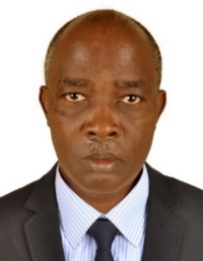**UGANDA NATIONAL EXAMINATION BOARD**

**PRIMARY LEAVING EXAMINATION**

Dr. Bbosa Science

Nurture your dreams

d

digitalteachrs.co.ug

**2003**

**MATHEMATICS**

**Time allowed: 2hours 30 minutes**

|  |  |  |  |  |  |  |  |  |
| --- | --- | --- | --- | --- | --- | --- | --- | --- |
|  |  |  |  |  |  |  |  |  |

**Index No:**

**Candidate’s Name……………………………………………………………………………………..**

**Candidate’s signature…………………………………………………………………………………..**

**District Name…………………………………………………………………………………………………**

|  |  |  |
| --- | --- | --- |
| **FOR EXAMINERS**  **USE ONLY** | | |
| **Qn.No** | **MARKS** | **EXR’S NO.** |
| **1-5** |  |  |
| **6-10** |  |  |
| **11-15** |  |  |
| **16-20** |  |  |
| **21-22** |  |  |
| **23-24** |  |  |
| **25-26** |  |  |
| **27-28** |  |  |
| **29-30** |  |  |
| **31-32** |  |  |
| **TOTAL** |  |  |

**Read the following instructions carefully**

**Read the following instructions carefully**

1. **This paper has two sections A and B.**
2. **All the working. For both section A and B must be shown in the spaces provided**
3. **All working must be done using a blue or black ball**

**Point pen or fountain pen Diagram should be drawn in pencil**

1. **No calculators are allowed in the examination room.**
2. **Unnecessary change of work may lead to loss of marks**
3. **Any hand writing that cannot easily be read may lead to loss of marks**
4. **Do not fill anything in the boxes indicated:**

**“For examiners use only”. And those inside the question paper**

**©2012 Uganda National Examination board**

**Turn over**

SECTION A

1. Why does a bedbug produce a very bad smell when it is touched?

…………………………………………………………………………………………………………………………………………………………………

……………………………………………………………………………………………………………………………………………………………….

2. Give any one reason why a child`s diet should more proteins than that of an adult.

…………………………………………………………………………………………………………………………………………………………………

……………………………………………………………………………………………………………………………………………………………….

3. Give any one way in which flowers are important to a plant.

…………………………………………………………………………………………………………………………………………………………………

……………………………………………………………………………………………………………………………………………………………….

4. Give one sign which is common between the people suffering from tuberculosis (TB) and those from AIDS.

…………………………………………………………………………………………………………………………………………………………………

……………………………………………………………………………………………………………………………………………………………….

5. Give any one example of an animals which an amphibian.

…………………………………………………………………………………………………………………………………………………………………

……………………………………………………………………………………………………………………………………………………………….

6. Give any one characteristic which is common to all insects.

…………………………………………………………………………………………………………………………………………………………………

……………………………………………………………………………………………………………………………………………………………….

7. Why does sugar disappear when it is mixed with water?

…………………………………………………………………………………………………………………………………………………………………

……………………………………………………………………………………………………………………………………………………………….

8. Which property of air demonstrated when air is pumped into a ball, and the ball becomes bigger?

…………………………………………………………………………………………………………………………………………………………………

9. How is the absence of iodine harmful to our health?

…………………………………………………………………………………………………………………………………………………………………

……………………………………………………………………………………………………………………………………………………………….

10. Explain why sandy soil cannot retain water like clay soil.

…………………………………………………………………………………………………………………………………………………………………

……………………………………………………………………………………………………………………………………………………………….

11. What is the importance of red blood cells in the body?

…………………………………………………………………………………………………………………………………………………………………

……………………………………………………………………………………………………………………………………………………………….

12. Give any one characteristic of an image formed in a pin hole camera.

…………………………………………………………………………………………………………………………………………………………………

……………………………………………………………………………………………………………………………………………………………….

13. Which of the following animals: fish, frog, lizard, rat and snail is warm blooded?

…………………………………………………………………………………………………………………………………………………………………

……………………………………………………………………………………………………………………………………………………………….

14. Why is proper disposal of refuse important in a home?

…………………………………………………………………………………………………………………………………………………………………

……………………………………………………………………………………………………………………………………………………………….

15. The diagram below are of three types of metals. Study them and answer the question that follows

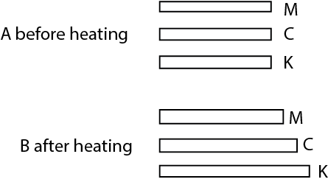

Explain the cause of the difference in length after they have been heated.

…………………………………………………………………………………………………………………………………………………………………

16. in the space provide, draw a convex lens

17. Why do you think that seeds of an orange are likely to be dispersed by a person?

…………………………………………………………………………………………………………………………………………………………………

……………………………………………………………………………………………………………………………………………………………….

18. When water is heated it changes into water vapour .What is this process called?

…………………………………………………………………………………………………………………………………………………………………

……………………………………………………………………………………………………………………………………………………………….

19. Apart from using more energy, name one other disadvantage of friction.

…………………………………………………………………………………………………………………………………………………………………

……………………………………………………………………………………………………………………………………………………………….

20.What is the importance of bees to plant?

…………………………………………………………………………………………………………………………………………………………………

……………………………………………………………………………………………………………………………………………………………….

21. Explain the difference between temperature and heat.

…………………………………………………………………………………………………………………………………………………………………

……………………………………………………………………………………………………………………………………………………………….

22. What is the disadvantage of having anthills near gardens?

…………………………………………………………………………………………………………………………………………………………………

……………………………………………………………………………………………………………………………………………………………….

23. The diagram below shows a certain shape of an object, which has been dismantled.

**Study it and answer the question that follows.**



What shape can you get that diagram if folded along dotted lines?

…………………………………………………………………………………………………………………………………………………………………

24. What First Aid would you give to a person whose finger has been burnt by fire?

…………………………………………………………………………………………………………………………………………………………………

……………………………………………………………………………………………………………………………………………………………….

25. Why is it possible to control the spread of cattle diseases in a paddock system?

…………………………………………………………………………………………………………………………………………………………………

……………………………………………………………………………………………………………………………………………………………….

26. Name any cereal which is used as food.

…………………………………………………………………………………………………………………………………………………………………

……………………………………………………………………………………………………………………………………………………………….

27. Mukasa has a pool of water in this compound and he has a problem of mosquitoes. What advice would you give him to reduce the number of mosquitoes without praying the pool?

…………………………………………………………………………………………………………………………………………………………………

……………………………………………………………………………………………………………………………………………………………….

28. Why s it important to bathe with soap?

…………………………………………………………………………………………………………………………………………………………………

29. In the space provide below ,draw a compound leaf.

30. Vultures, kites and crows were found feeding on a dead cow. What group of birds are these?

…………………………………………………………………………………………………………………………………………………………………

……………………………………………………………………………………………………………………………………………………………….

31. Give any one special characteristics of the air we breath out.

…………………………………………………………………………………………………………………………………………………………………

……………………………………………………………………………………………………………………………………………………………….

32. Give anyone way in which a human skull is important.

…………………………………………………………………………………………………………………………………………………………………

……………………………………………………………………………………………………………………………………………………………….

33. Give an example of a hinge joint in a human body.

…………………………………………………………………………………………………………………………………………………………………

……………………………………………………………………………………………………………………………………………………………….

34. Give any one sign of dehydrated person.

…………………………………………………………………………………………………………………………………………………………………

……………………………………………………………………………………………………………………………………………………………….

35. Give an example of a plant which grows from stem cuttings.

…………………………………………………………………………………………………………………………………………………………………

……………………………………………………………………………………………………………………………………………………………….

36. Explain what ante-natal care is.

…………………………………………………………………………………………………………………………………………………………………

37. Suggest any one way you would help one to avoid drug dependency.

…………………………………………………………………………………………………………………………………………………………………

……………………………………………………………………………………………………………………………………………………………….

38. Give any one reason why parents should take their children for immunization.

…………………………………………………………………………………………………………………………………………………………………

……………………………………………………………………………………………………………………………………………………………….

39. On a hot day, a boy ran 1500 metres but there was not a lot of sweat on his face. Immediately he came under the shade of a tree, the whole face was full of sweat .Explain the reason for the sweating under the shade.

…………………………………………………………………………………………………………………………………………………………………

……………………………………………………………………………………………………………………………………………………………….

40. Why are windows put at a lower than the ventilators?

…………………………………………………………………………………………………………………………………………………………………

……………………………………………………………………………………………………………………………………………………………….

**SECTION B**

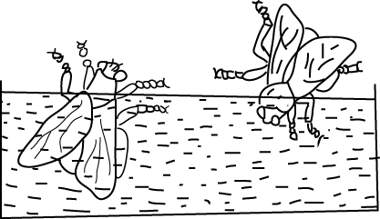41. In the diagram below, two insects were placed in water as shown.

(a) (i) which insect died?

…………………………………………………………………………………………………………………………………………………………………

(ii) Give a reason for your answer in (a) (i) above.

…………………………………………………………………………………………………………………………………………………………………

……………………………………………………………………………………………………………………………………………………………….

(b) In which way are the insects shown in the diagram harmful to man?

…………………………………………………………………………………………………………………………………………………………………

……………………………………………………………………………………………………………………………………………………………….

(c) Give any other insect that causes the harm similar to that in (b) above.

…………………………………………………………………………………………………………………………………………………………………

……………………………………………………………………………………………………………………………………………………………….

42. (a) After it has rained, earthworm come out of their holes. Why do they come out?

…………………………………………………………………………………………………………………………………………………………………

……………………………………………………………………………………………………………………………………………………………….

(b) Give two reasons why an earthworm is very important to a farmer.

…………………………………………………………………………………………………………………………………………………………………

……………………………………………………………………………………………………………………………………………………………….

(c ) Why does worm die if oil is poured on its body?

…………………………………………………………………………………………………………………………………………………………………

……………………………………………………………………………………………………………………………………………………………….

43. Give any four ways in which fish can be preserved.

(a)………………………………………………………………………………………………………………………………………………………………

(b)………………………………………………………………………………………………………………………………………………………….

(c)……………………………………………………………………………………………………………………………………………………………

(d)………………………………………………………………………………………………………………………………………………………….

44. The diagram below shows the way n which one of the systems of the human body

Works. Use it to answer the question that follow

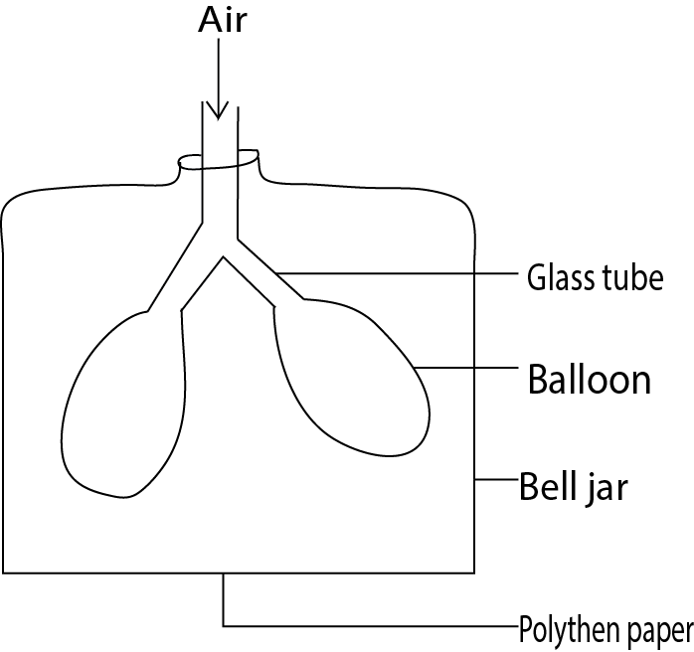

1. Name the system.

…………………………………………………………………………………………………………………………………………………………………

(b) What does a balloon represents?

…………………………………………………………………………………………………………………………………………………………………

(c) What does the polythene paper represent?

…………………………………………………………………………………………………………………………………………………………………

(d) What would happen to the polythene paper if air filled the balloon?

…………………………………………………………………………………………………………………………………………………………………

45 (a) some bacteria are useful and others are harmful. Give an example of each.

1. Useful bacteria

…………………………………………………………………………………………………………………………………………………………………

…………………………………………………………………………………………………………………………………………………………………

1. Harmful bacteria

…………………………………………………………………………………………………………………………………………………………………

…………………………………………………………………………………………………………………………………………………………………

1. Give any two examples of when bacteria are useful to man

…………………………………………………………………………………………………………………………………………………………………

…………………………………………………………………………………………………………………………………………………………………

46. The diagrams below are of pests. Use them to answer questions (a) and (b) below

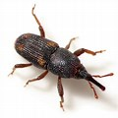 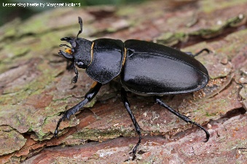

A

B

1. Name the pests:
2. A ………………………………………………………………………………………………………………………………………….
3. B …………………………………………………………………………………………………………………………………………….
4. What is the disadvantage of the above insects to a farmer?

…………………………………………………………………………………………………………………………………………………………………

…………………………………………………………………………………………………………………………………………………………………

47. Match items of group A with those of group B by completing the table below

A B

Heart Sensory organ

Kidney memory

Skin carbon dioxide

Lungs circulation

Brain urine

Complete the table below

|  |  |
| --- | --- |
| A | B |
| 1. …………………………………………………………… 2. Skin 3. …………………………………………………………… 4. Lung | Circulation  …………………………………………………….  Memory  ……………………………………………… |

48 (a) Name materials used to measure the volume of an irregular objects

…………………………………………………………………………………………………………………………………………………………………

…………………………………………………………………………………………………………………………………………………………………

1. How would you get the mass of an object is its density is 6g/cc and the volume is 10cc.

…………………………………………………………………………………………………………………………………………………………………

…………………………………………………………………………………………………………………………………………………………………

…………………………………………………………………………………………………………………………………………………………………

…………………………………………………………………………………………………………………………………………………………………

49. The diagram below shows an underground stem.

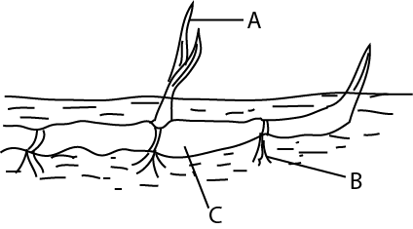

1. State the type of underground stem shown in the diagram

…………………………………………………………………………………………………………………………………………………………………

1. Suggest the functions of the parts labelled A, B and C
2. …………………………………………………………………………………………………………………………………………………………………………………………………………………………………………………………………………………………………………
3. …………………………………………………………………………………………………………………………………………………………………………………………………………………………………………………………………………………………………………
4. …………………………………………………………………………………………………………………………………………………………………………………………………………………………………………………………………………………………………………

50. (a) Name two practices that lead to the destruction of wet lands.

…………………………………………………………………………………………………………………………………………………………………………………………………………………………………………………………………………………………………………

…………………………………………………………………………………………………………………………………………………………………………………………………………………………………………………………………………………………………………

1. What is the difference between contour ploughing and mulching?

…………………………………………………………………………………………………………………………………………………………………………………………………………………………………………………………………………………………………………

1. How are the two practices in (b) similar?

…………………………………………………………………………………………………………………………………………………………………………………………………………………………………………………………………………………………………………

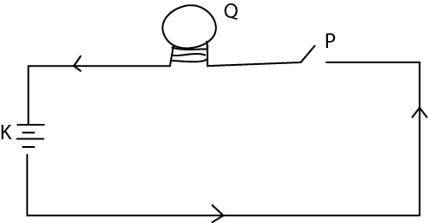51. the diagram below shows an electric circuit. Use it to answer the questions that follow.

1. Name part K …………………………………………………………………………………………………………………………
2. Name part P …………………………………………………………………………………………………………………………
3. Give the type of energy that are produces at Q when P is closed.

…………………………………………………………………………………………………………………………………………………………………………………………………………………………………………………………………………………………………………

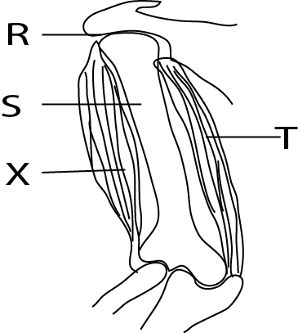52. The diagram below shows the arm. Study it and answer the questions that follow.

1. Name the Joint labelled R ………………………………………………………………………………………………………..
2. Name the bone labelled S …………………………………………………………………………………………………………
3. What happens to muscles T and X when the fore arm is raised?

T …………………………………………………………………………………………………………………………………………………

X …………………………………………………………………………………………………………………………………………

53. As a pupil in a school, you are of the school health committee. What do you expect to do to make health improve in the school?

…………………………………………………………………………………………………………………………………………………………………………………………………………………………………………………………………………………………………………..……………

……………………………………………………………………………………………………………………………………………………………………………………………………………………………………………………………………………………………………..…………………

54. (a) in the list of objects: rabbit bacteria, sun, pig and plant.

(i) Name a producer ………………………………………………………………………………………………………………….

(ii) Name a primary consumer…………………………………………………………………………………………………….

1. What is the role of bacteria from the above list? ………………………………………………………………..
2. what is the difference between a primary consumer and a secondary consumer?

……………………………………………………………………………………………………………………………………………………………………………………………………………………………………………………………………………………………………………………………………

55. The diagram below is of an experiment performed by a p& class. Study it and answer the question that follow.

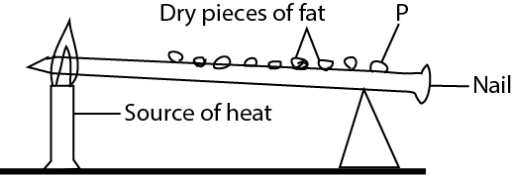

1. what is the experiment about?

……………………………………………………………………………………………………………………………………………………………………………………………………………………………………………………………………………………………………………………………………

1. What is the importance of fats pieces

……………………………………………………………………………………………………………………………………………………………………………………………………………………………………………………………………………………………………………………………………

1. What will happen to piece P after sometimes?

…………………………………………………………………………………………………………………………………………………………………………………………………………………………………………………………………………………………………………………………………

1. Give a reason for your answer in (c).

……………………………………………………………………………………………………………………………………………………………………………………………………………………………………………………………………………………………………………………………………

END