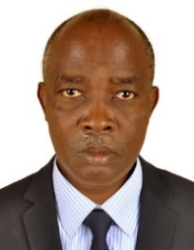UGANDA NATIONAL EXAMINATION BOARD

PRIMARY LEAVING EXAMINATION

Dr. Bbosa Science

Nurture your dreams

d

digitalteachrs.co.ug

Science 2012

Time allowed: 2hours 15 minutes

|  |  |  |  |  |  |  |  |  |
| --- | --- | --- | --- | --- | --- | --- | --- | --- |
|  |  |  |  |  |  |  |  |  |

Index No:

Candidate’s Name……………………………………………………………………………………..

Candidate’s signature…………………………………………………………………………………..

District Name…………………………………………………………………………………………………

|  |  |  |
| --- | --- | --- |
| **FOR EXAMINERS**  **USE ONLY** | | |
| **Qn.No** | **MARKS** | **EXR’S NO.** |
| **1-10** |  |  |
| **11-20** |  |  |
| **21-30** |  |  |
| **31-40** |  |  |
| **51** |  |  |
| **52** |  |  |
| **53** |  |  |
| **54** |  |  |
| **55** |  |  |
| **Total** |  |  |

Read the following instructions carefully

1. This paper has two sections **A** and **B.** Section **A** has 50 questions and section **B** has 5 questions. The paper has 15 pages following altogether.
2. Answer all questions. All answers to both sections A and B must be **written** in the spaces provided.
3. All answers must be written using a blue or black ball-point pen or ink. **Any** work written in pencil other than graphs, pictures and diagrams will **not** be marked.
4. Unnecessary change of work may lead to loss of marks.
5. Any handwriting that cannot easily be read may lead to loss to marks.
6. Do not fill anything in the boxes indicated:
7. “For examiners’. Use only and inside the question paper

©2009 Uganda National Examination board

1. Give any one example of a root tuber

………………………………………………………………………………………………………

2. State one disadvantage of keeping finger nails long.

………………………………………………………………………………………………….

3. What is the importance of including calcium in chicken feed?

………………………………………………………………………………………………….

4. What is the use of a wedge as a simple machine?

………………………………………………………………………………………………….

5. Name the type of lens used to correct long sightedness

………………………………………………………………………………………………….

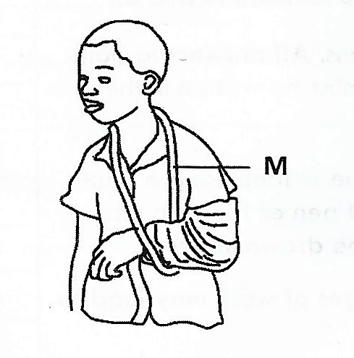The diagram below shows a person with an injury .**Use it to answer question 6**

6. How useful is the structure marked **M** to the injured person?

………………………………………………………………………………………………….

………………………………………………………………………………………………….

7. Apart from mosses, give one other example of a spore bearing non-flowering plant

………………………………………………………………………………………………….

8. Name any one mammal that lives in water.

………………………………………………………………………………………………….

9. Give a reason why people keep cats in their homes.

………………………………………………………………………………………………….

10. Why does a farmer cut off leaves of a banana sucker before planting it?

………………………………………………………………………………………………….

………………………………………………………………………………………………….

|  |
| --- |
|  |

11. Apart from pasteurizing, give any one way milk can be prevented from going bad.

………………………………………………………………………………………………….

………………………………………………………………………………………………….

12. Why is it important for a husband and his wife to be treated together if they have got gonorrhea?

………………………………………………………………………………………………….

………………………………………………………………………………………………….

13. Why do farmers carry out de –beaking in poultry farms?

………………………………………………………………………………………………….

………………………………………………………………………………………………….

14. State any one habit which helps to promote oral health.

………………………………………………………………………………………………….

Turn over

15. State one use of soil to earthworms.

………………………………………………………………………………………………….

………………………………………………………………………………………………….

The diagram below shows a crop rotation cycle

CASSAVA

BEANS

MILLET

SWEET OOTATOES

16. What is the importance of beans in this cycle to the rest of the crops?

………………………………………………………………………………………………….

………………………………………………………………………………………………….

17. Which communicable disease in human affects both the skins and the skeletal system?

………………………………………………………………………………………………….

………………………………………………………………………………………………….  
18. Apart from carbohydrates, name one other class of food that gives the body energy.

………………………………………………………………………………………………….

………………………………………………………………………………………………….

19. In which way is the sun important in the formation of rain?

………………………………………………………………………………………………….

………………………………………………………………………………………………….  
20. State any one method used to make dirty water clean.

………………………………………………………………………………………………….

|  |
| --- |
|  |

21. How does a sweater help to keep a person warm during cold days?

………………………………………………………………………………………………….

………………………………………………………………………………………………….

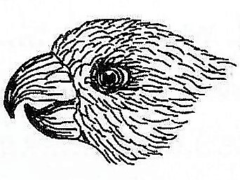The diagram is a head of a bird .use it to answer question 22

22. What does a bird with this type off beak eat?

………………………………………………………………………………………………….

………………………………………………………………………………………………….

23. Give any one affect of poor disposal of human wastes in the environment.

………………………………………………………………………………………………….

………………………………………………………………………………………………….

24. Apart from the egg stage, at what other stage of development is a housefly not active?

………………………………………………………………………………………………….

………………………………………………………………………………………………….

25. Why does a clay-made charcoal stove use less charcoal than a metallic one?

………………………………………………………………………………………………….

………………………………………………………………………………………………….

26. Apart from production of eggs (ova), mention one other use of the ovaries in the human body.

………………………………………………………………………………………………….

………………………………………………………………………………………………….

27. State one way in which a child gets natural immunity

………………………………………………………………………………………………….

………………………………………………………………………………………………….

28. State the injury that results from tearing of muscles.

………………………………………………………………………………………………….

………………………………………………………………………………………………….

29. Which gas is used by food manufacturers for preserving drinks like sodas?

………………………………………………………………………………………………….

………………………………………………………………………………………………….

**The diagram below is of a common animal. Use it to answer question 30**

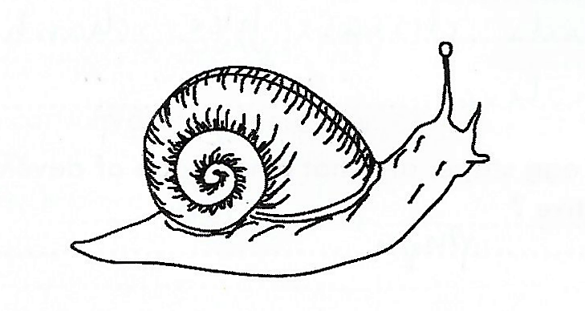

30. Which disease does the above animal spread humans?

………………………………………………………………………………………………….

………………………………………………………………………………………………….

|  |
| --- |
|  |

31. Why are the legs of a person who has fainted raised higher than the head as a way of giving first aid?

………………………………………………………………………………………………….

………………………………………………………………………………………………….

32. What name is given to a pace where a seedling are grown before transplanting?

………………………………………………………………………………………………….

………………………………………………………………………………………………….

33. Which part of the human ear equalises pressure in and outside the ear?

………………………………………………………………………………………………….

………………………………………………………………………………………………….

34. Name one other disease caused by fungi in human s apart from ring worm.

………………………………………………………………………………………………….

35. What class of food is digested in the stomach?

………………………………………………………………………………………………….

………………………………………………………………………………………………….

36. Give any one advantage of castrating farm animals.

………………………………………………………………………………………………….

………………………………………………………………………………………………….

37 in the space below draw a simple diagram of a fibrous root system.

38. How are plastics and glass materials dangerous to soil?

………………………………………………………………………………………………….

………………………………………………………………………………………………….

39. Apart from liquids, name one other state of mater through which heat is transferred by convection.

………………………………………………………………………………………………….

………………………………………………………………………………………………….

40. In which human body organ does gases exchange take place?

………………………………………………………………………………………………….

………………………………………………………………………………………………….

**SECTION B: MARKS 60 MARKS**

Questions **41** to **55** carry fourmarks each

41(a) Gives any two example of a physical change

(i)…………………………………………………………………………………………………

(ii) ……………………………………………………………………………………………….

(b) State two characteristics of a chemical change

(i) …………………………………………………………………………………………………

(ii) …………………………………………………………………………………………………

The diagram below of a human skin. Use it to answer questions 42

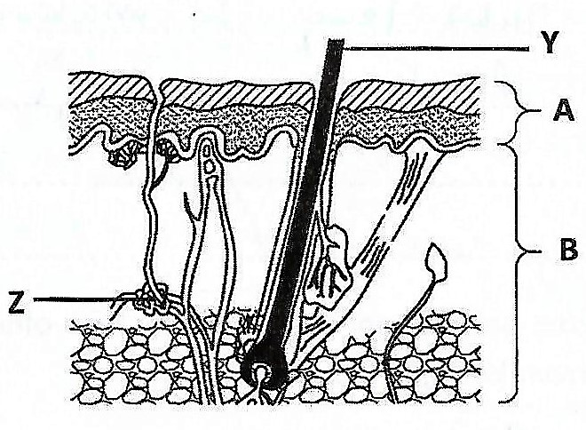

42.(a) Name the layers A and B

(i) A…………………………………………………………………………………………………

(ii)B…………………………………………………………………………………………………

(b) Give the function of the part labeled Y and Z

(i)Y…………………………………………………………………………………………………

…………………………………………………………………………………………………

(ii)Z…………………………………………………………………………………………………

…………………………………………………………………………………………………

43. (a) Name the two types of pollination in flowering plants

(i) …………………………………………………………………………………………………

(ii) …………………………………………………………………………………………………

|  |
| --- |
|  |

Turn over

44. (a) Give any two disadvantages of keeping local breeds of poultry

(i) …………………………………………………………………………………………………

………………………………………………………………………………………………………

(ii) …………………………………………………………………………………………………

……………………………………………………………………………………………………..

(b) Apart from getting money, give any two ways a farmer benefits from keeping poultry.

(i) …………………………………………………………………………………………………

…………………………………………………………………………………………………….

(ii) …………………………………………………………………………………………………

……………………………………………………………………………………………………

45. Match each animal in A with the correct group to which it belong in B

|  |  |
| --- | --- |
| A | B |
| Chameleon  Toad  Bat  Ostrich | Mammals  Birds  Reptiles  Amphibians |

(a) Chameleon………………………………………………………………………………………

(b) Toad……………………………………………………………………………………………

(c) Bat……………………………………………………………………………………………..

(d) Ostrich………………………………………………………………………………………..

The diagram below shows how light passes through a glass block**.**

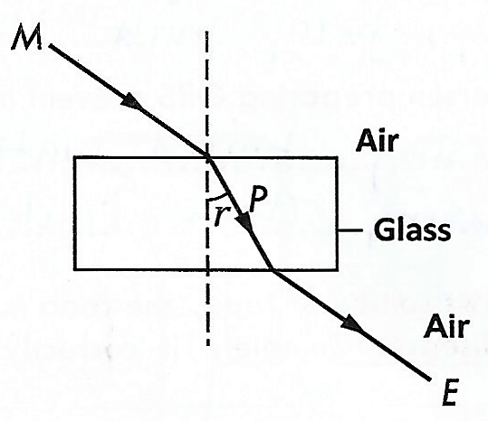**Study and use it to answer question 46.**

46. (a) Name the rays M and P

(i) M………………………………………………………………………………………

(ii) P………………………………………………………………………………………

(b) Name the angle marked ***P***

…………………………………………………………………………………………………

(c ) Give a reason why ray ***P*** bend as shown in the diagram

……………………………………………………………………………………………………

…………………………………………………………………………………………………….

|  |
| --- |
|  |

47(a) Give one reason why dehydration is dangerous to humans

………………………………………………………………………………………………………

………………………………………………………………………………………………………

(b) In which way is oral re hydration solution (ORS) a good treatment for diarrhea?

……………………………………………………………………………………………………..

……………………………………………………………………………………………………...

Turn Over

(c)Apart from taking ORS, how else can one prevent dehydration?

…………………………………………………………………………………………………..

…………………………………………………………………………………………………...

(d) How can a person preparing ORS prevent it from contamination?

………………………………………………………………………………………………….

………………………………………………………………………………………………….

48.The table below, shows source of food, the food nutrients in it and the related deficiency disease. Complete it correctly.

|  |  |  |
| --- | --- | --- |
| **Source of food** | **Food nutrient** | **Deficiency disease** |
| Fruit | Vitamin c | ………………………….. |
| Beans | ……………….. | Kwashiorkor |
| ……………………… | vitamin | Night blindness |
| Iodized salt | Iodine | …………………. |

49.(a) Which type of blood vessels return blood to the heart?

………………………………………………………………………………………………….

(b) What is the function of valves in the blood vessels during blood circulation?

………………………………………………………………………………………………….

………………………………………………………………………………………………….

(C) What type of blood is carried by most blood vessels during with valves?

………………………………………………………………………………………………….

(d) Give any one waste materials carried by blood.

………………………………………………………………………………………………….

The diagram below shows one of the methods of preparing alcohol. Study and use it to answer questions 50.

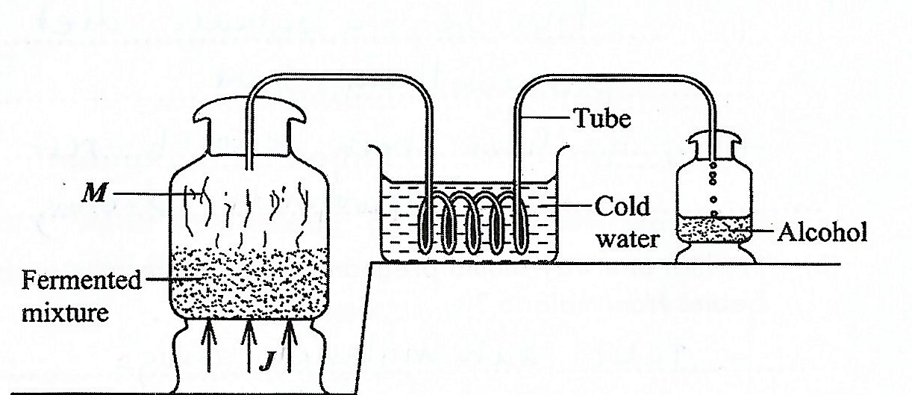

50(a) Name the methods used in the diagram

………………………………………………………………………………………………….

………………………………………………………………………………………………….

(b) What do the arrows labeled ***J*** represent?

………………………………………………………………………………………………….

………………………………………………………………………………………………….

(c ) Why is the tube passes through cold water?

………………………………………………………………………………………………….

………………………………………………………………………………………………….

(d) What process forms ***M?***

………………………………………………………………………………………………….

Turn over

51(a) Apart from ante –natal care, give two other ways of caring for pregnant women.

(i) ………………………………………………………………………………………………….

………………………………………………………………………………………………………

(ii) ………………………………………………………………………………………………….

………………………………………………………………………………………………………

(b) In which one ways should pregnant women protect their unborn babies from malaria?

………………………………………………………………………………………………….

………………………………………………………………………………………………….

(c) Why are pregnant women advised not to smoke?

………………………………………………………………………………………………….

………………………………………………………………………………………………….

52. (a) Name the force that brings down all objects thrown up .

………………………………………………………………………………………………….

(b) (i) When a piece of paper and as rubber dare dropped from the same height, which one reaches the ground first?

………………………………………………………………………………………………….

(ii) Give a reason for your answer in(b) (i) above.

………………………………………………………………………………………………….

………………………………………………………………………………………………….

(c) Why do some objects float on water?

………………………………………………………………………………………………….

………………………………………………………………………………………………….

|  |
| --- |
|  |

53. (a) State any two reasons why farmers thin their crops

(i) ………………………………………………………………………………………………….

………………………………………………………………………………………………….

(ii) ………………………………………………………………………………………………….

………………………………………………………………………………………………….

(b) Apart from thinning, give any two other ways farmers care for their crops.

(i) ………………………………………………………………………………………………….

……………………………………………………………………………………………………..

(ii) ………………………………………………………………………………………………….

…………………………………………………………………………………………………….

54.(a) Name the type of joint found in each of the following parts of the human body.

(i) Shoulder…………………………………………………………………………………………

(ii)Wrist…………………………………………………………………………………………

(b) What advice would you give to a person to keep the skeletal system in healthy working condition

(i) ………………………………………………………………………………………………….

……………………………………………………………………………………………………..

(ii) ………………………………………………………………………………………………….

……………………………………………………………………………………………………..

**Study the diagram of an electric bell below and use it to answer question 55**.

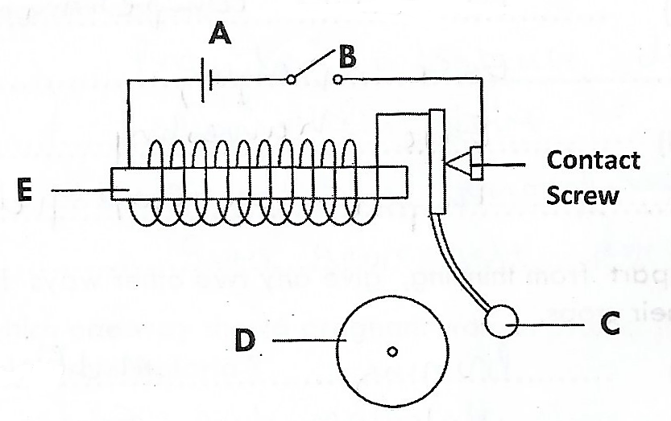

55(a) Name the part marked A and C

(i)A………………………………………………………………………………………………….

(ii)C………………………………………………………………………………………………….

(b)What will happen to E when B is closed

………………………………………………………………………………………………….

………………………………………………………………………………………………….

(C ) How useful is part D on the electric bell?

………………………………………………………………………………………………….

………………………………………………………………………………………………….

|  |
| --- |
|  |

END