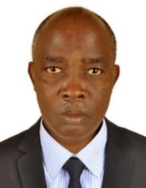UGANDA NATIONAL EXAMINATION BOARD

PRIMARY LEAVING EXAMINATION

Dr. Bbosa Science

Nurture your dreams

d

digitalteachrs.co.ug

Science 2013

Time allowed: 2hours 15 minutes

|  |  |  |  |  |  |  |  |  |
| --- | --- | --- | --- | --- | --- | --- | --- | --- |
|  |  |  |  |  |  |  |  |  |

Index No:

Candidate’s Name……………………………………………………………………………………..

Candidate’s signature…………………………………………………………………………………..

District Name…………………………………………………………………………………………………

|  |  |  |
| --- | --- | --- |
| **FOR EXAMINERS**  **USE ONLY** | | |
| **No.** | **MARKS** | **EXR’S NO.** |
| **1-10** |  |  |
| **11-20** |  |  |
| **21-30** |  |  |
| **31-40** |  |  |
| **51** |  |  |
| **52** |  |  |
| **53** |  |  |
| **54** |  |  |
| **55** |  |  |
| **Total** |  |  |

Read the following instructions carefully

1. This paper has two sections **A** and **B.** Section **A** has 50 questions and section **B** has 5 questions. The paper has 15 pages following altogether.
2. Answer all questions. All answers to both sections A and B must be **written** in the spaces provided.
3. All answers must be written using a blue or black ball-point pen or ink. **Any** work written in pencil other than graphs, pictures and diagrams will **not** be marked.
4. Unnecessary change of work may lead to loss of marks.
5. Any handwriting that cannot easily be read may lead to loss to marks.
6. Do not fill anything in the boxes indicated:
7. “For examiners’. Use only and inside the question paper

©2009 Uganda National Examination board

1. Give any one example of a swimming bird.

………………………………………………………………………………………………

1. Name the animal product used in leather industry.

………………………………………………………………………………………………

1. Sate any one property of matter.

………………………………………………………………………………………………

1. Name the part of the human eye that works like the firm in a camera.

………………………………………………………………………………………………

1. In which way is the message in the sign post below helpful to school children?

Image

SAY NO TO SEX

………………………………………………………………………………………………

………………………………………………………………………………………………

6. Give any way in which a single fixed pulley is used in a school.

………………………………………………………………………………………………

7. Name the body organ which helps a person to know whether there is enough sugar in tea or not

………………………………………………………………………………………………

8. Give any one advantage of pruning tress.

………………………………………………………………………………………………

………………………………………………………………………………………………

9. Which method of heat transfer helps farmers to dry their harvested crops?

………………………………………………………………………………………………

10. How does a fish benefit from its slippery body?

………………………………………………………………………………………………

………………………………………………………………………………………………

|  |
| --- |
|  |

11. In which way does the use of biogas conserve the environment?

………………………………………………………………………………………………

………………………………………………………………………………………………

The diagram below shows a garden tool. Use it to answer questions 12 and 13

12. Name the garden tool above.

………………………………………………………………………………………………

13. How is the garden tool above important to farmers?

………………………………………………………………………………………………

………………………………………………………………………………………………

Turn over

14. Which deficiency disease is caused by lack of vitamin d in children`s diet?

………………………………………………………………………………………………

15. Why is the water obtained through filtration not necessarily safe for drinking?

………………………………………………………………………………………………

………………………………………………………………………………………………

16. What plant system does the plumule make when it grows?

………………………………………………………………………………………………

17. How does leaching reduce soil fertility?

………………………………………………………………………………………………

………………………………………………………………………………………………

18. Why is it a devisable to leave the pit of a VIP latrine open?

………………………………………………………………………………………………

………………………………………………………………………………………………

19. Name the cattle disease whose sign is a swollen and painful udder.

………………………………………………………………………………………………

20. In which part of the female reproductive system does fertilization take place?

………………………………………………………………………………………………

|  |
| --- |
|  |

21. Why is the left side of the heart able to pump blood to most body parts?

………………………………………………………………………………………………

………………………………………………………………………………………………

22. State any one way in which trees are able to reduce air pollution.

………………………………………………………………………………………………

………………………………………………………………………………………………

23. In the space provided below, draw a lens used to correct short sightless.

24. How is a safety pin in a first –Aid kit important?

………………………………………………………………………………………………

………………………………………………………………………………………………

25. In which type of change are the properties of the substance formed permanently different from those of the original one?

………………………………………………………………………………………………

………………………………………………………………………………………………

26. How is the function of stomata in a leaf similar to that of gills in a fish?

………………………………………………………………………………………………

………………………………………………………………………………………………

27. Which components of soil is used by plants to make their food?

………………………………………………………………………………………………

………………………………………………………………………………………………

28. Which structures enable the trachea to remain open all the time?

………………………………………………………………………………………………

………………………………………………………………………………………………

29**. Four bar magnets marked 1, 2, 3 and 4 were placed next to each other as shown below. They attracted each other**.

N 1 S

4 X

2

3

Name the pole of magnet 4 marked with letter **X**

………………………………………………………………………………………………

30. Apart from brushing, how else can dental carries be prevented?

………………………………………………………………………………………………

………………………………………………………………………………………………

|  |
| --- |
|  |

31. State any one way in which friction in moving parts of a machine can be reduced.

………………………………………………………………………………………………

………………………………………………………………………………………………

32. Give any one way in which yeast is useful to people.

………………………………………………………………………………………………

………………………………………………………………………………………………

33. Apart from making food, mention one other use of leaves to plants.

………………………………………………………………………………………………

………………………………………………………………………………………………

34. State any one characteristic of the images formed by plane mirrors.

………………………………………………………………………………………………

………………………………………………………………………………………………

35. Why do the people installing electricity wear rubber gloves?

………………………………………………………………………………………………

………………………………………………………………………………………………

The diagram below is of a mosquito larva .**use it to answer questions 36 and 37**

36. Name the mosquito which develops from such a larva.

………………………………………………………………………………………………

37. What disease does the mosquito you have named above transmits to human beings?

………………………………………………………………………………………………

38. How is the propagation of Irish potatoes different from that of sweet potatoes?

………………………………………………………………………………………………

………………………………………………………………………………………………

39. Apart from running windmills, give one other way wind is used as an energy resource.

………………………………………………………………………………………………

………………………………………………………………………………………………

40. How do the silvery walls of a vacuum flask reduce heat loss?

………………………………………………………………………………………………

………………………………………………………………………………………………

|  |
| --- |
|  |

**SECTION B: 60 MARKS**

*Question* ***41*** *to* ***55*** *carry four mark each*

41. The diagram below shows an insect. Use it to answer the question that follow.

C

D

(a) Name the parts marked C and D

(i) C…………………………………………………………………………………………

(ii) D………………………………………………………………………………………

(b) State the function of the part marked D

………………………………………………………………………………………………

………………………………………………………………………………………………

(c) Why would the insect above die when the whole of its abdomen is dipped in oil?

………………………………………………………………………………………………

………………………………………………………………………………………………

42 (a) Apart from the lack of conditions necessary for germination, give any two other factors that can make a seed fail to germinate.

(i) ………………………………………………………………………………………………

………………………………………………………………………………………………

(ii) ………………………………………………………………………………………………

………………………………………………………………………………………………

(b) Write down any two ways farmers can control pests in the garden without using chemicals

(i) ………………………………………………………………………………………………

………………………………………………………………………………………………

(ii) ………………………………………………………………………………………………

………………………………………………………………………………………………

43(a) Give any two advantages of modern beehive.

(i) ………………………………………………………………………………………………

………………………………………………………………………………………………

(ii) ………………………………………………………………………………………………

………………………………………………………………………………………………

(b) write down two things a bee-keeper should consider before a salting up beehives.

(i) ………………………………………………………………………………………………

………………………………………………………………………………………………

(ii) ………………………………………………………………………………………………

………………………………………………………………………………………………

44*. The diagram below is part of the human digestive system . Use it to answer the questions s that follows*

Y

Z

X

W

(a) Name the parts marked Y and W

(i) Y………………………………………………………………………………………………

(ii) W………………………………………………………………………………………………

(b) State the functions of the parts marked Z

………………………………………………………………………………………………

………………………………………………………………………………………………

(c ) Give any one disease that affects the parts marked ***X***

………………………………………………………………………………………………

45. Match the diseases in list **A** with the system and symptoms in the B

A B

Polio swollen neck

Measles stiffness of muscle

Tetanus paralysed tissues

Diphtheria skin rash

(a)Polio……………………………………………………………………………………………

(b)Measles…………………………………………………………………………………………

(c)Tetanus………………………………………………………………………………………

(d)Diphtheria……………………………………………………………………………………

46. (a) Give any one two ways which drug dependence can affect an individual

(i) ………………………………………………………………………………………………

(ii) ………………………………………………………………………………………………

(b)State two ways in which an individual can void drug dependence

(i) ………………………………………………………………………………………………

………………………………………………………………………………………………

(ii) …………………………………………………………………………………………

………………………………………………………………………………………………

47. An irregular object was lowered into an overflow can **A** containing water. he water it displaced was collected in container **B** as shown below.

10cc

20cc

30cc

Thread

Overflow can

water

Irregular object

(a) What is the volume of the irregular object?

………………………………………………………………………………………………

(b) Calculate the density of the irregular object if its mass is 60 g

48. *The table below shows lists of animals. Use it to answer the question s*

*That follow*

|  |  |  |
| --- | --- | --- |
| **P** | **Q** | **R** |
| Toad | Chameleon | rat |
| Newt | Snake | Monkey |
| frog | lizard | Cow |

(a) Which characteristic is common to all the animals in the table?

………………………………………………………………………………………………

………………………………………………………………………………………………

(b) How is the reproductive in the animals in list P similar to those in list Q?

………………………………………………………………………………………………

………………………………………………………………………………………………

(c) Which list has warm blooded animals?

……………………………………………………………………………………………

(d) Why would you place a tortoise in list Q?

………………………………………………………………………………………………

………………………………………………………………………………………………

49. (a) Name any one organism that makes fresh meat go bad.

………………………………………………………………………………………………

(b) State any three ways of preventing fresh meat from going bad

(i) ………………………………………………………………………………………………

………………………………………………………………………………………………

(ii) ………………………………………………………………………………………………

………………………………………………………………………………………………

(iii) ………………………………………………………………………………………………

………………………………………………………………………………………………

50(a) Name the human body organ where each of the following takes place:

(i) Filtration of blood

………………………………………………………………………………………………

(ii) Blood gets oxygen while carbon dioxide is removed.

………………………………………………………………………………………………

(b) Give the use of the following components of blood in the body

(i) White blood cells

………………………………………………………………………………………………

………………………………………………………………………………………………

(ii) Blood platelets

………………………………………………………………………………………………

………………………………………………………………………………………………

5.1 *Study the diagram of the f human ear below and use it to answer the questions that follow.*

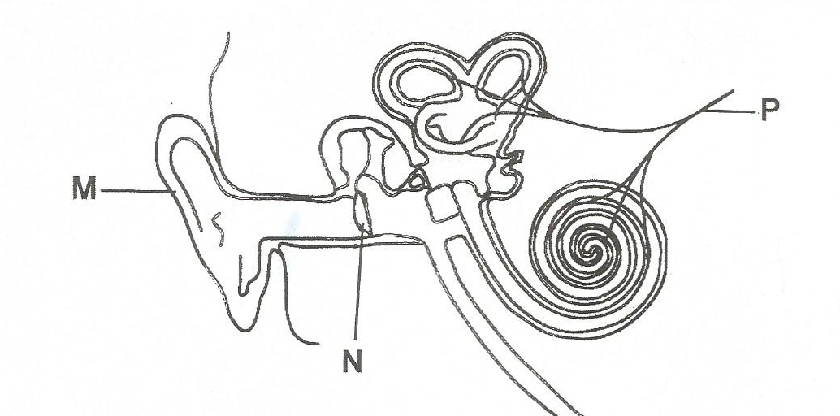

(a) Name the parts marked M and N

(i) M………………………………………………………………………………………………

(ii) N………………………………………………………………………………………………

(b) Give the function of the part marked **P**.

………………………………………………………………………………………………

………………………………………………………………………………………………

Use letter B to show the part of the ear responsible for balancing the body

52(a) Name any two water –borne diseases

(i) ………………………………………………………………………………………………

(ii) ………………………………………………………………………………………………

(b) In which two ways can water –borne diseases be preventing in the community?

(i) ………………………………………………………………………………………………

………………………………………………………………………………………………

(ii) ………………………………………………………………………………………………

………………………………………………………………………………………………

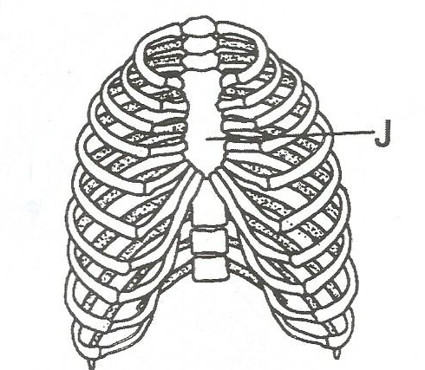53. The diagram m below shows part of the human skeleton. Use it to answer the questions that follow

(a) Name the part marked ***J***

………………………………………………………………………………………………

(b) State any two delicate body organ protected by the part of the skeleton shown

(i) ………………………………………………………………………………………………

………………………………………………………………………………………………

(ii) ………………………………………………………………………………………………

………………………………………………………………………………………………

(c) How is the part of the human skeleton shown above used during breathing out?

………………………………………………………………………………………………

………………………………………………………………………………………………

54(a) Write down any two activities ant two activities that can be done by an individual to promote personal hygiene

(i) ………………………………………………………………………………………………

………………………………………………………………………………………………

(ii) ………………………………………………………………………………………………

………………………………………………………………………………………………

(b) State two ways community members can promote sanitation in there are.

(i) ………………………………………………………………………………………………

………………………………………………………………………………………………

(ii) ………………………………………………………………………………………………

55. Arrange the part of an electric circuit below by drawing to show a complete circuit.

Image

